THE CIVIL SOCIETY FUND
SMALL-SCALE INTERVENTION

Engaging Local Communities in Waste innovation in Freetown

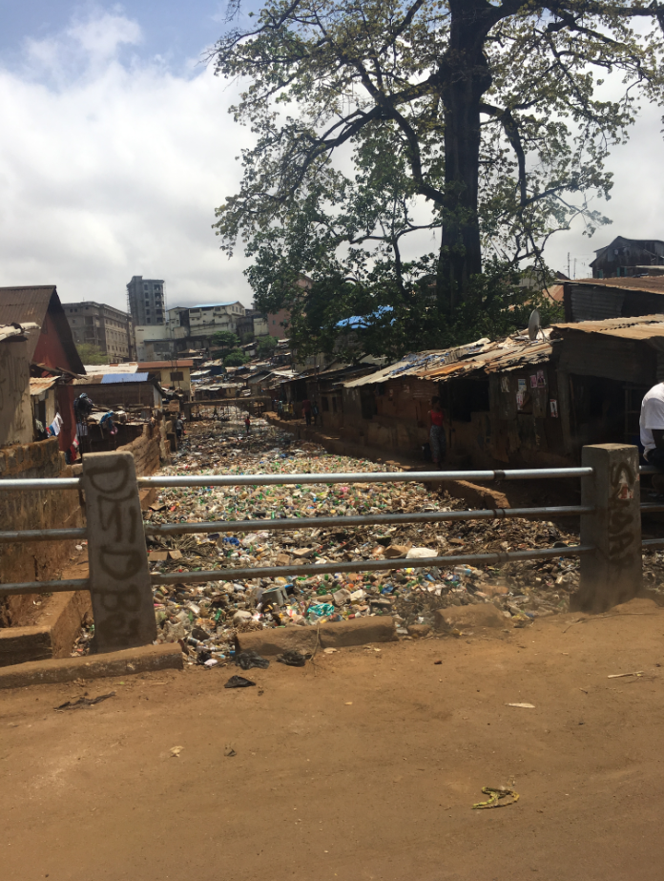
Contents
1 Objective and relevance - the world around us 1
1.1 What we aim to achieve through the intervention 1
1.2 Why the intervention is important 2
1.3 Context of the intervention 3
1.4 How the intervention will contribute to social justice 3
1.5 Climate- and environmental conditions to be addressed 3
2 Partnerships/partners - our starting point 4
2.1 Previous cooperation/experience to be used in the intervention 4
2.2 Roles and responsibilities 4
3 The actual intervention 5
3.1 Beneficiaries 5
3.2 Implementation of the intervention – activities to be carried out 5

1 Objective and relevance - the world around us

1.1 What we aim to achieve through the intervention
The aim of the initiative is to demonstrate a viable community based technical and economical approach to the recycling of plastic. The initiative will adapt and integrate a simple technical solution to address grooving climate change and environmental impacts in the participating community, integrating a focus on value-chain and circular economy. In the medium/long term perspective, the initiative is also to demonstrate forms of successful local business management and organization to manage community income generation; however, present application and action are focused on the demonstration of the technical and economic viability in order to secure a buy-in and further interest from local stakeholders. The initiative seeks to demonstrate the value of using local resources (waste) as a platform for income generation, hence thereby improve livelihoods and drive social and environmental change. The partnership aims at achieving this by integrating plastic waste recycling activities in Pottor and Kaningo, in Freetown. The specific area of intervention is to be identified as the first action between the NSP and EWB-DK (hereafter project team). The selection will be based on several criteria; availability of recycling site in the area to limit transportation, distance to a source of water for cleaning, the local ability to mobilize themselves and environmental impact. NSP already runs a municipality supported community waste collection scheme in the area of intervention. It is therefore, assumed that NSP is successful in mobilizing and securing the participation of the local community in the collection, sorting, and processing of plastic waste – particularly the youth. In the medium-long run, the business model to be demonstrated will give the local people a possibility to increase their income. Hopefully, the present initiative will ignite further interest from the local stakeholders to be engaged in further actions on the platform created. It will also result in better health and environmental conditions in Freetown and reduce the volume of plastic that ends up in Aberdeen Creek, which eventually flows into the ocean.
Through the initiative, the partners will initiate awareness in the local community about the negative impact of plastic waste, and demonstrate that it is possible to recycle plastic with low-cost technology and produce products, which the communities can benefit from.
The medium-long term perspective of the initiative is improved livelihood for the poorest communities by locally establishing low cost sustainable systems for the collection and handling of plastic waste.
The present initiative is the first step in that direction, as the concept, based on the open-source Precious Plastic concept, will be tested through a consultative and participatory process based on joint on-site learning and capacity building. The outcome of the initiative are expected to be an assessment of the feasibility of the technical solution and the preparation of a viable plan for the long-term implementation of the concept focusing on lesson learned and a future business plan. The initiative will not only document the viable technical solution, but also motivate the community for further engagement. The initiative will engage the community and the selected participants (youth) on the following strategic elements:
- Establish a clear picture of strategic factors influencing the future of the initiative, stakeholders involved, technological/economic/social bottlenecks, and potential financial support.
- Jointly map different technical options and evaluate if the concept from Precious Plastic is an adequate solution. The viable technical solution to be implemented will be decided in collaboration with relevant local stakeholders.
- Planning of the intervention including identification of one or more low-tech manufacturing methods from Precious Plastic, development of a business model for collecting the plastic waste from the communities, as well as setting up the recycling facility.
- Training and capacity building seminar in Freetown – testing of viability and production.
- Community and participatory analysis of lessons learned and identification of economic viability of the products, which can be produced.
- A final assessment and feasibility study of the project with lessons learned and recommendations regarding requirements for a continuation and scale-up.
- Ensure a safe start-up, operation and maintenance training of the local staff in order to ensure local management and ownership of this project.

1.2 Why the intervention is important
The project is important because it will strengthen the communities in several ways:
- The mobilisation around handling plastic waste will be a showcase to inspire the two communities on how to mobilise themselves within other areas as well.
- It will show in particular the youth that there are alternative opportunities for establishing small businesses and make a living.
- Increase the experience and capacity of NSP to support the communities and advocate for locally led environmental actions as well as establishing and running income-generating activities.
- The gained knowledge and knowhow about the planning of collection of waste, the data about the composition of the waste, and the results from the process of the recycling facility could be used in the further planning of a plastic treatment system for the whole town. The people involved in this initiative, especially the selected NSP project groups, will be able to contribute to insure implementation in other parts of Freetown later.
- In general, better handling of plastic waste will contribute with an improvement of both the local and the global environment, and it will inspire and motivate the communities to focus on waste as a resource.
In a future perspective, the local production of recycled plastic products designed for the local homes or schools will bring value to the communities, and it will generate income and skills to a group of young (currently) unemployed men and women. Figure 1 illustrates benefits of the new waste management system compared to the current situation.
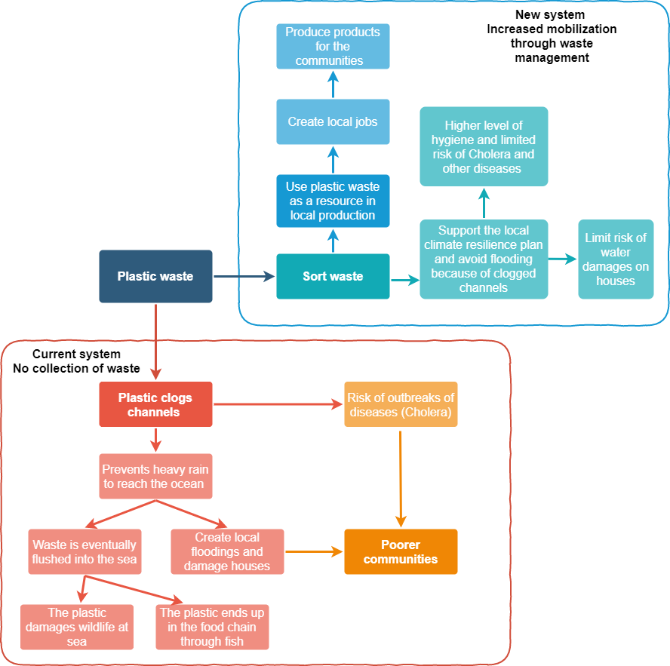
The current situation with lack of waste management results in a range of issues related to health/hygiene, resilience to flooding, food supply and damage of life in the sea (the red box). It also illustrates the unused potentials both related to capacity building, creation of jobs, awareness of the local resources, and reduction of the pressure on the channels that are supposed to lead the water from heavy rain away and avoid flooding in the communities. The purpose is to make the community realize that the opportunities illustrated in the blue box can be achieved even with limited resources.

1.3 Context of the intervention
During the current joint climate adaptation project the partners has implemented a community risk assessment based on household interviews. The findings clearly identify four central risk elements: 1) high levels of poverty 2) severe risk of impact of climate change, 3) uncontrolled urbanisation, and 4) the absence of government action and basic social service. Extreme rainfalls are occurring more frequently and severely due to climate change. Central urban zones are already densely populated, slums are expanding into the once forest-covered hills surrounding Freetown, and residential areas are expanding into hazard prone zones. Government plans for addressing urbanisation are still insufficient and decades of civil unrest during the civil war has caused many state institutions to collapse. While the authorities are slowly reclaiming control, a backlash caused by the Ebola outbreak in 2015, financial limitations, corruption, and the absence of political power continue to incapacitate the government. Because of climate change and environmental degradation, Freetown experienced the devastating mudslide followed by several flash floods in August 2017. Even though Freetown municipality with the present Mayor is engaged in addressing the impact of climate change and environmental issues, there is still a lack of required services and systems, for instance, waste collection and management. See video documentation from the communities in question: https://www.linkedin.com/feed/update/urn:li:activity:6660949164500877312/

Potter and Knaingo, where the sub-community will be selected, consists of poor communities, which were and still are very much affected by the mudslide in 2017. They suffer from high average unemployment rates of approximately 60%, out of which around 70% has neither technical knowledge nor skills. The communities differ in level of ability to mobilize themselves. Some are well organized, while in other they lack a clear definition of roles and responsibilities.

1.4 How the intervention will contribute to social justice
Through the cooperation with and support to NSP its capacity to organise the poor and disadvantaged communities and advocate for the communities to get organised and address their own problems in order to improve their livelihood will empower them and give them a voice in order to progress further, and address more of the issues that impacts their daily lives and keeps them back from getting out of poverty. As the project through job creation also target SDG 8 these aspects of the project will contribute to gradual improved justice of the targeted community.

1.5 Climate- and environmental conditions to be addressed
The devastating mudslide followed by several flash floods hit Freetown in 2017, claiming more than 1000 lives and leaving over 5000 people homeless was caused by deforestation and poor urban development in combination with particularly high amounts of rainfall and the drainage system being blocked by waste. Flooding, which occur every year during the rainy season, are getting more extreme, causing severe damages as a consequence of climate change. Despite the efforts of the current Mayor of Freetown in addressing environmental issues and climate change, improvements in the livelihood, especially for poorer communities, are envisaged only with behaviour changes and active participation of the population in implementing possible solutions. This engagement is a pilot project testing ways to engage members of a poor climate impacted community in Freetown in collection and recycling of plastic in order to improve their livelihood. Limiting the environmental pressure though choice of design and ensuring safety around the recycling facility is of high priority. NSP’s affiliation with the communities is a key factor for communicating the enhancement of the environmental issues to the local communities and creating awareness about how the communities themselves can handle the issues of climate change and the environment. The experiences from this project will be documented by a local journalist and disseminated through e.g. articles in order to inspire other communities to be more aware of climate and environmental issues and how their own actions can mitigate the negative impact.

2 Partnerships/partners - our starting point

2.1 Previous cooperation/experience to be used in the intervention
EWB-DK is at present cooperating with NSP and World Hope International (WHI-SL) on implementation of a larger project in the same two communities, Climate resilience in suburban Sierra Leone: working towards more resilient communities through risk mitigation and climate change adaptation from a community-based perspective, which is also supported by CISU. The project is managed by the EWB-DK Climate Resilience Group. This waste innovation project has emerged from the findings of the Climate Resilience Group. The two groups are working together in EWB, using each other as sparring partners, especially considering upgrading NSP’s skills within project management and daily communication with EWB. NSP is participating in the consortium cooperation, bridging between the community and WHI-SL, and actively engaging the communities implementation of climate mitigation measures such as construction of canals and tree planting within the communities. There are strong synergies between the two projects as this waste innovation project is formulated based on problems with plastic waste identified by the Climate Resilience group whom introduced this project idea to NSP. NSP is eager to enhance its cooperation with EWB-DK not least/only on job creation and income generation.
One of the first activities the Climate resilience project conducted in the two communities was the baseline risk assessment. The purpose of this assessment was to identify and map local organisational resources and structures, combined with identification of vulnerability and risk elements at family and community level in Pottor and Kaningo. Close to 750 households participated in the survey, which was mainly carried out by NSP. NSP has through this exercise gained a unique insight into the communities including their perception and understanding of climate change and environmental issues. This information will be valuable when designing the training and workshops for the plastic recycling project. NSP communicates on a regular basis with the Climate Resilience group and they are good at documenting the activities they have carried out with pictures and texts, which will be of significant importance for this project as well. Furthermore, the workshops the project group will facilitate will be based on the experience from the workshops that NSP will be engaged in conducting in the communities with the Climate Resilience group.

2.2 Roles and responsibilities
EWB-DK is a technical-humanitarian organization of volunteer members with a large range of technical skills and backgrounds. EWB-DK bases activities on the delivery of strategic services and encompasses community development work with a strong focus on achieving sustainable changes in behaviour of targeted groups to improve their livelihood on a permanent basis. In doing so, EWB-DK collaborates with local and international NGOs. EWB-DK has been engaged in international development for almost 20 years, and has substantial experience working in Sierra Leone including in Kaningo and Potter. EWB started supporting these communities in 2017 after the landslide by constructing five water points, with a strong emphasis on community empowerment through awareness raising and capacity building. EWB-DK has since 2009 been working with community engagement related to WASH in now 26 communities in Kenema district in the eastern part of Sierra Leone in order to improve the livelihood of the communities through engagement and interaction with the authorities at community and district level there. Our partner in that project is SEND. Jointly we see a potential of engaging them as they have more than 15 year of experience in engaging communities improving their livelihoods and eager to embrace the agenda of circular economy and waste to income. An official invitation to the capacity building will be extended to the SEND team.
The key role of EWB-DK in this initiative is to create motivation and incentives to sort and use plastic waste as a resource in Freetown. First of all through our experience in engaging local communities through and together with our partners. Secondly, through the engagement of our volunteers that through their top notch technical expertise and in cooperation with the local partners will be able to design and demonstrate the most appropriate and low cost technical solutions to address specific local environmental challenges. EWB-DK is responsible for knowledge sharing, introduction of the Precious Plastic concept and facilitation of workshops with the communities in order to ensure that the recycling facility is set up and used in a safe way, the concept is properly tested and the experiences and adjustments are reflected in a project document for a full implementation phase.
National Skills Pool (NSP) is a registered local volunteer driven organisation specialising in mobilisation, citizen participation and community engagement. NSP was established as a youth development CBO in 2016 with a strong focus on building resilience in marginalised and vulnerable communities. NSP was likewise active during the disaster that evolved around the landslide and flooding in 2017, mobilising especially the youth in the communities to take action. Today NSP has approximately 50 members and continues to be involved with the affected communities, promoting schooling on disaster risk reduction, managing waste collection and engaging the communities in planning and implementation of climate adaptation interventions. NSP stands very strong in their relationship with the community and they have demonstrated the ability to reach out to the communities and especially the youth. However, they are still in the process of gaining project management capacity and developing their administrative systems. Through this project, their project management capacity will be improved, and the technical skills set will be advanced with regard to recycling of plastic, job creation and management of income generating activities.
NSP will be responsible for community mobilisation, citizen engagement, selection of facility sites, project management, operation and maintenance of the facility and sales of the plastic products.

3 The actual intervention

3.1 Beneficiaries
The people living in the selected communities of Pottor and Kaningo will be the overall main target group benefitting from reduced flooding a cleaner environment, which is a couple of thousand households. The initial number of people who will be included in this phase of the project in sorting of household waste is around 30 to 50 depending on the agreed approach. They will participate in the workshops and receive detailed information about waste handling and the potential of utilising waste as a resource for the communities. Community leaders will be included in the project and in the workshops to share their perspectives regarding community mobilizing and to ensure local buy-in and ownership. All groups will be part of a large knowledge sharing process during the whole intervention that will generate awareness about the current issues of plastic waste and the potential of the waste to help the communities. Through the activities, (questionnaires and workshops) people from the communities will be organised into groups with different responsibilities and roles based in interests and capabilities. The structure of the roles and responsibilities will be defined in consultation with community managers and NSP. As the purpose of the activities also is to inspire others to do similar projects, it is envisaged that more jobs will be created in the longer run. In all activities attention will be paid to ensure an equal representation of women and men.

3.2 Implementation of the intervention – activities to be carried out
The Outputs and activities of the project are shown in the LFA:

Objective: Improved livelihood for the poorest communities by establishing low cost sustainable systems for collection and handling of plastic waste locally
Outputs | Activities
1.Community is mobilized and engaged in collection and recycling of plastic waste | 1.1 Online kick-off/planning meeting with NSP
 | 1.2 Introduction of the project in the communities (community engagement)
 | 1.3 Identification and selection of project participants
 | 1.4 Establish an overview of types and amounts of plastic waste in the communities
 | 1.5 Prepare presentations and training materials for and organise workshops
 | 1.6 EWB-DK and NSP meetings and training sessions in Freetown
 | 1.7 Conduction of workshop 1: sorting of plastic and how to build the equipment
 | 1.8 Conduction of workshop 2: Installation, testing and operation of equipment
2. Feasibility of concept for recycling with potential for income generation tested and documented | 2.1 Design/conduction of rapid market survey for locally produced plastic products
 | 2.2 Prepare and conduct feasibility study
 | 2.3 Participatory assessment of initiative and its future viability
 | 2.4. Documentation of lessons learned and potential for project continuation/scale up
 | 2.5 Advocacy and awareness raising (articles and video clips to share on SoMe)
The project will be kicked off by an online planning session with EWB-DK and NSP, during which the work plan is revisited, and the tasks and responsibilities are discussed and distributed between the two partners. The first activities to be initiated include a rapid market survey for recycled plastic products, presentation of the project in the communities, identification and selection of participants from the communities and identification of project recycling facility site. The project sites will consist of sorting, cleaning, shredding processes, molding and refining of products. Then follows preparation of presentations and training materials and organisation of two workshops to be conducted in Freetown by EWB-DK and NSP. The goals of these workshops are to initiate the project, share knowledge and test the concept. The first workshop will explain the concept and train the project participants in sorting plastic waste into the different plastic types, and how to build the machines. During the second workshop, the machinery will be installed, tested and the project participants will get a crash course on how operate and maintain the machinery. The capacity of NSP will during this phase be enhanced through the joint planning and cooperation with EWB-DK. Specific training in business planning and management will also be conducted by EWB-DK, as NSP will manage the recycling facility, do marketing and sell the products. The pilot project will be assessed, lessons learned derived and recommendations regarding requirements for a continuation and scale-up of collection and recycling of plastic will be prepared. A local journalist will document the project activities through articles and small video clips to be shared with both the local and global community through local and social media. The estimated duration of the pilot project is 7 weeks:
Activity |  | Week
 |  | 1 | 2 | 3 | 4 | 5 | 6 | 7
1.1 | Online kick-off/planning meeting with NSP
1.2 | Introduction of the project in the communities (community engagement)
1.3 | Identification and selection of project participants
1.4 | Establish overview of types and amounts of plastic waste in the communities
1.5 | Prepare presentations and training materials for and organise workshops
1.6 | EWB-DK and NSP meetings and training sessions in Freetown
1.7 | Conduction of workshop 1: sorting of plastic and how to build the equipment
1.8 | Conduction of workshop 2: Installation, testing and operation of equipment
2.1 | Design and conduction of rapid market survey for locally produced plastic products
2.2 | Prepare and conduct feasibility study
2.3 | Identification of recycling facility site
2.4 | Assessment of lessons learned and the potential for continuation and scale up of the project
2.5 | Advocacy and awareness raising (articles and video clips to share on social media)

