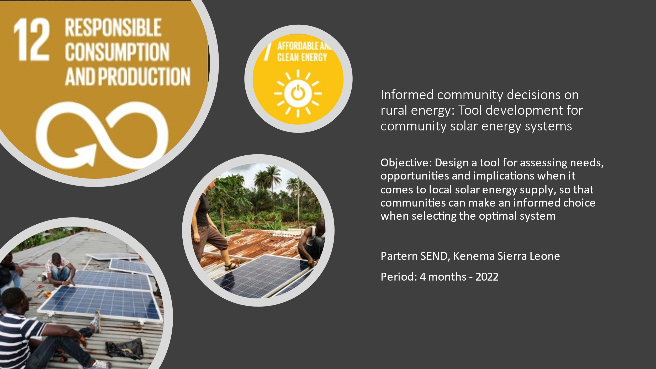

Danish organisation | Engineers Without Borders (EWB-DK)
Title of the intervention | Informed community decisions on rural energy: Tool development for community solar energy systems
Partner name(s) | Social Enterprise Development (SEND)
Amount applied for | 99.707 DKK
Country(ies) | Sierra Leone
Period (# of months) | 1 July – 31 October 2022 (4 months)

Content

- Objective and relevance (the world around us)
- What do you want to achieve through the intervention?

Objective: Design a tool for assessing needs, opportunities and implications when it comes to local solar energy supply, so that communities can make an informed choice when selecting the optimal system (named “tool”). The tool will in the first instance be used by SEND, but it can also be used by other NGOs and when commercial companies offer solar energy systems.

Although Sierra Leone is endowed with energy potential in various forms including biomass from agricultural wastes, hydro and solar power, it remains underutilized. Energy consumption is largely dominated by biomass sourced from fuelwood and accounts for around 80 percent of the energy used. Imported petroleum products, the next largest source of energy, are mainly for power generation and account for 13 percent of energy consumption.

Sierra Leone has one of the lowest rates of electricity access in the world; the country has a national electrification rate of 26%, with this figure declining to only 6% in the rural areas where the majority of the population lives. With no prospect of getting electricity from main grid-based solutions in a foreseeable future, there is a huge demand for affordable alternative electricity solutions particularly in rural areas.

In Sierra Leone there is a growing supply of various types of renewable energy solutions, especially based on solar energy, including dealers in equipment, service providers and electricians. The vibrant private sector, including some large African based companies, donors and NGOs are increasingly getting involved. Increasing supply of renewable energy sources is in full accordance with the government’s Renewable Energy Policy of 2016.

- Why is the intervention important?
There exists different opportunities for providing electricity to villages in remoter areas, each of which having pros and cons, including mini-grids powered by solar or diesel, community solar energy systems or individual household based systems. The tool to be developed will assist stakeholders in selecting the most suitable system taking into account a.o. the specific local context, availability of technical solutions, human resources for operation and maintenance, the socio-economic situation, gender equality and improved livelihood.

At present there exist no such tool with the result that there is a high risk of installing local energy systems which are not rooted in the community, reducing ownership and hence the prospect for sustainability. From its work in Kenema district, SEND has several examples where private suppliers have established systems without sufficient dialogue and with only marginal involvement of the community population: Low energy supply compared to demand leading to customer grievances, low customer satisfaction since most staff that work with service providers do not reside in the area, services do not power local local enterprises leading to frustrations among enterprise owners, and insufficient knowledge of the contract and nature of services provided has led to conflict between customers and service providers. Often private suppliers focus on individual solutions and not the broader community solutions. Having an objective of reaching out to the poorest of the poorest and not increasing inequality, systematic involvement of communities in design and selection of energy systems is essential. With such a tool, the process of dimensioning energy systems can be expected to be improved immensely. A realistic and accurate estimate of energy needs in a community is essential for the success of future projects in the region. An over dimensioned system will incur unnecessary additional costs and potentially be more difficult for the local users to maintain. Meanwhile, an under dimensioned system will obviously not be able to service all its users, and expansion of such a system is expected to be more costly than an accurate first estimate.

Hence the joint SEND EWB-DK initiative will through a participatory based approach develop a method in order to give communities a platform to:
1) assess the need and demand for electricity;
2) assess social impact in the community;
3) assess economic viability of a system (operation and future maintenance), and
4) assess the organizational and managerial base from which to operate a system from.

Specifically for SEND, the tool will strengthen its possibility, together with communities in Kenema but also in other districts, to work with other NGOs, donors, the private sector and other funds to install sustainable electricity systems in villages. Hence, development of the tool will strengthen the capacity of SEND to provide services related to solar energy supply at community level, using a rights based approach. This also includes assisting communities to select the most suitable among more suppliers and supporting communities in management in relation to private energy service providers. Considering the needs for rural energy and the many initiatives presently being taken, it is expected that there is a significant potential for application of the tool. Just in Kenema there are 7 chiefdoms without solar energy supply.

- Describe the context of the intervention:
The rate of extreme poverty in the Kenema district is amongst the highest in the country (24.2%). Extending and securing access to affordable electricity in particular for households but also for productive use of energy in the district, plays an important role in reducing absolute poverty. Rural communities in Kenema mainly derive income from agricultural production and artisan fabrication of produce.

During the last 6 years EWB-DK and its partner SEND have in various initiatives implemented and installed sustainable energy solutions such as solar based systems at educational facilities, rural health clinics and in form of solar based mobile charging devices at community level in Kenema district. An experience from this cooperation has been that it is needed to a.o. unveil social practices, norms and customs in relation to introduction of new technologies to secure sustainability of these, a lesson which is found in other places as well. This led to the decision of preparing a tool which can address these issues and increase the possibility for communities to select sustainable solutions.

As planning for development of the tool, a preliminary needs assessment has been made. SEND and EWB-DK has during the last half a year jointly carried out a process in which a locality in Kenema has been identified as a “case community”. This community, Mendekelema, will be used to design the tool. The process included gathering of information from a total of eight communities in six chiefdoms. Enumerators were trained to administer the assessment method and supervised by a project manager from SEND in all covered communities. Eight focus group discussions and four key informant interviews were conducted during the data collection process. The data collection methodology attracts a cross-section of community stakeholders such as section chief, town chief, chiefdom speakers, town speakers, women leaders, youth leaders, bike riders, male youth, women youth, councillors, village development committees, business people, and people with disabilities, all engaged during the data collection to get their experiences on solar energy in their communities. It was on the basis of this thorough preparatory process that Mendekelema was chosen as “case community”.

Mendekelema has an estimated total population of 2,425 people. Of these about 40% are children below 18 years, and 52% of the total population are females. It covers about 150 hectares of land. It has 15 catchment communities, situated between 2 and 19 kilometers away from the main community. There are 34 primary schools and one secondary school in the entire Guara Chiefdom, whilst two primary schools are in Mendekelema community.

The most common income generating activities at household level in Mendekelema community are agriculture and petty trading. Social activities mainly engaged by youths that use energy in the community are disco, weddings, naming ceremonies and school events such as sports activities. Service providers existing in the community includes Gola Rainforest (protecting deforestation), Gold tree (supporting education), Welt Hunger Hilfe (promoting agriculture) and Orange Mobile money (providing money transactions through mobile phones). Orange and Africell provide mobile network coverage, with Orange having the most robust network coverage. Up to 1,000 users use the network coverage for communication and internet browsing. There are 5 generators used for commercial purposes in the community.

- Describe how this intervention can contribute to supporting collaboration, public engagement and civil organising and how this in time will contribute to social justice (realisation of people’s rights, reducing inequality and fighting poverty, participation in decision-making processes, equal access to resources, and just institutions).
An objective of the tool to be developed is to secure that, when applied, technical aspects of solar energy systems are complemented with socio-cultural and socio-economic aspects in design processes. Access to affordable energy is a right for all, also for the poor and extremely poor. Therefore a proactive and gender sensitive consultation with, and participation of, these groups should be part of any design of solar energy systems in communities. The potential for including gender aspects into the various aspects to be analyzed will be part of the tool development. The objective of reaching out to the most disadvantaged groups might conflict with a financial sustainability objective of a system, depending on the ability and willingness to pay by all groups in a community. The tool will attempt to address such issues. As the goal is to enable use of the tool in different districts and communities, it will emphasize the importance of local contexts.

Application of the tool will enable communities to make joint informed decisions on which type of system to be established, tariffs to be set, managerial set-ups and to secure that all groups of society are heard in the process.

Development of the tool will further strengthen the collaboration between SEND and EWB-DK.

- What climate- and environmental conditions do the partnership and/or the intervention need to respond to? And how have the partners responded to it? This could be in relation to the conditions of the target groups, the number of flights or the activities of the intervention, and how these affect the environment or climate in the area.

The climate and environmental conditions being addressed are the future dissemination in rural areas of Sierra Leone of zero CO2 emission renewable energy solutions. In rural communities throughout Sierra Leone there is a potential for e.g. existing and new micro enterprises to shift from use of diesel to solar power with a resulting positive effect on the climate; for reducing the utilization of diesel generated electricity and diminishing use of kerosene in households for lighting purposes. Apart from substituting non-green solutions with zero CO2 emission solutions, the tool will also play a crucial role in providing electricity to households which until now have been deprived of this opportunity. The tool, when developed, will enable communities to decide on using green energy solutions and it will capacitate SEND to promote environmental sustainable rural energy solutions in Sierra Leone.

- Describe the partners and other actors’ contributions, roles, and responsibilities in relation to this intervention.

EWB-DK is a technical-humanitarian organisation of volunteers with a large range of technical skills and backgrounds. EWB-DK collaborates with local and international NGOs to improve the living conditions for marginalised and vulnerable people in developing countries. EWB-DK’s efforts to ensure local anchorage and lasting solutions are founded in the UN's Sustainable Development Goals.

EWB-DK has more than 20 years of experience in working in partnerships around the world and make technology work for the poorest communities. EWB-DK has a long-lasting presence and experience from Sierra Leone, and thereby has vast knowledge on the context and activities to be carried out. EWB-DK has established itself as a relevant international partner for development initiatives, especially in the Kenema District, and has engaged in partnerships with other organisations in the area, like SEND. In Denmark, EWB-DK has a large member base providing expertise in various technical areas, including sustainable energy systems, community mobilisation, income-generating service delivery and business planning. EWB-DK will contribute to the intervention with this specific expertise.

Social Enterprise Development (SEND) Sierra Leone is a non-profit national NGO registered in Sierra Leone since 2000 and has a staff of more than 70 persons. SEND has a strong profile in community mobilisation, gender equality, improved livelihood, rights-based approaches and capacity enhancement of governance structures at the community and district level. Together with several international partners such as Welt Hunger Hilfe, Irish Aid, and UK Aid, it has implemented many community-based projects in several districts, including Kenema where its main office is located. It engages in strong cooperation with the authorities at both district and community levels.

SEND and EWB-DK have known each other for several years as both have been working with local communities in Kenema district on establishing WASH and, since January 2020, have been partners on a WASH project, including the 26 communities in Kenema and the District, and with support from DERF COVID-19 funding provided relief to the most vulnerable households in these communities. In 2021, the partners have conducted an evaluation of a previous income generation project on community solar mobile charging stations as well as finalizing a joint capacity building project on Core Humanitarian Standards. Additionally, SEND and EWB-DK, together with World Hope International at present jointly implement the Citizen Driven Climate Sensitive Wash Management project in Kenema district. SEND has proved to be a strong and reliable partner in engaging and supporting both the communities and the relevant stakeholders at the district level and ensuring the appropriate coordination and exchange of information between the involved partners.

The experience of thorough community involvement for the purpose of sustainability from the ongoing SEND/EWB-DK project, Enhanced Community Health Resilience project in Baoma, also a village in Kenema district, will be applied in preparation of the tool.

For a successful development of the tool including knowledge sharing / harvesting, it is of high value for the partnership between SEND and EWB-DK to develop the tool jointly in Kenema district. The Danish experts will participate in the activities in Sierra Leone, as SEND at present only has incipient experience with this kind of activity. Knowledge sharing not only strengthens partnerships in compliance with UNSDG #17, but more importantly installs technical, organisational and business-oriented knowledge locally by strengthening partner organisations and local communities in participating actively in their own development. EWB-DK sees transfer of knowledge as help to self-help and one of the prerequisites for securing sustainability of interventions. For the activities in this intervention, EWB-DK will provide various important skills through its member base and the Danish project team.

EWB-DK will provide two volunteers from Denmark with specific experience in development economics and technical oriented skills regarding solar power.

SEND, with their extensive experience in community mobilisation, gender and rights based approaches will be a joint partner with EWB-DK in preparation of the tool. In addition, SEND will provide local support on detailed planning and local coordination in cooperation with EWB-DK. Further, SEND will also contribute to collection of technical and non-technical experience from the selected community, as well as facilitating dialogues with the local communities and regional authorities.

SEND will provide a gender expert with experience in community mobilisation and willingness to pay assessments, and a solar technical expert. SEND will also involve students from the University of Kenema in data collection.

- Justify substantial payroll costs, and if payroll costs are included for the Danish organisation, describe the tasks and why Danish personnel are best positioned to undertake these tasks. N/A

- Target groups, objectives, and expected results (our intervention)
- Who will benefit from the intervention? How many people will benefit in total? How will they participate in the intervention?
The primary beneficiary will be SEND. Secondary beneficiaries will be other communities in Kenema district as well as in other districts, together with local authorities, when they get opportunities for solar energy investments. SEND, together with citizens of Mendekelema, will be directly involved in preparation of the tool.
The output of the participatory community-based process will be a practical tool, describing all aspects to be analyzed when embarking on installing solar energy in a community.
The tool, in the form of a report, will a.o. include the following considerations:
- Local context, including population density, main sources of livelihood, existing supply and use of electricity;
- The market for the service, i.e. a gender based need assessment including willingness and ability to pay for solar energy and re-chargeable appliances;
- Methods for community sensitization, consumer education and training around electricity usage;
- Availability of equipment and spareparts for a system as well as appliances demanded by households and micro enterprises for productive use of energy;
- Location, including site selection, and building, engineering and technological solutions;
- Potential safety hazards to be ensured against;
- Organisation and management, including Human Resource requirements and availability;
- Sustainability analysis, including financial assessment, tariff setting and subsidy mechanisms;
- Potential for increase in industrial/agricultural output in the community through improvements of access to electricity;
- Additional requirements for equipment to ensure extended lifetime of systems.

- Describe how the intervention will be implemented: what activities will be carried out? With whom? And when?

Activities to be carried out:
- Mobilisation of Mendekelema community, undertaken by SEND (July);
- Involvement of local authorities, undertaken by SEND (July);
- EWB-DK on-site discussions with SEND on specific content of tool (July);
- Data collection in case community, by SEND (July-August) and EWB-DK (July);
- Preparation of draft tool, by SEND and EWB-DK (August-September);
- Discussions between EWB-DK and SEND and between SEND and Mendekelema community on draft tool (September-October), and
- Finalisation of tool report (October).

The assessment tool is to be constructed with the use of a significant number of prior experiences in EWB-DK. This includes a previous evaluation of installed solar income generation systems in the region, which provides an insight of the optimal construction of the units in the climate of Sierra Leone. Furthermore, technical students from Sierra Leone have provided a list of the most common agricultural machinery in the region, which will assist in the assessment of what equipment could prove feasible/relevant for future energy systems.

- Project-related information work in Denmark
N/A.

