Danish organisation | Nunca Mas
Title of the intervention | Documentation of Massacres in Matabeleland Zimbabwe:  the Right to Truth, the Right to Know and the Right to Heal
Partner name(s) | Ukuthula Trust and Tree of Life
Amount applied for | DKR 999.916
Country(ies) | Zimbabwe
Period (# of months) | 13 months

- Objective and relevance (the world around us)
1.1. Purpose of the Project
The main purpose of the project is to contribute to the building of sustainable communities that have reconciled with their past experiences of politically motivated violence rooted in the Gukurahundi Massacres in Matabeleland, Zimbabwe in the 1980s and are able to claim their rights and participate in development, demanding transparency and accountability from the duty-bearers.

Gukurahundi: Apart from being affected by the violence of the Zimbabwe liberation war, Matabeleland inhabited by the Ndebele people was severely affected by post-independence massacres, in which an estimated 20,000 civilians died at the hands of the 5 Brigade, or “Gukurahundi” Brigade. The ‘Gukurahundi era’ refers to the years from 1982 to 1987, when a Unity Accord was signed that ended the state-ordered killings, and also created a one-party state. This had been the intention of the then President of Zimbabwe Robert Mugabe and ZANU PF, the main political party since 1980. In that time Matabeleland was the stronghold of Joshua Nkomo’s opposition ZAPU party. Longstanding antagonisms from the war of independence were ‘settled’ by Mugabe once in power, by the attempt to terrorise ZAPU’s supporters into submission to ZANU PF, ostensibly to rid the country of ‘dissidents.’ However, people in rural areas who suffered most acutely, simply perceived that a Shona Brigade came and killed them, because they were Ndebeles: it is remembered as an ethnic cleansing attempt. Most of those massacred in Matabeleland were unarmed rural farmers that included women and children. Some villages saw almost every man massacred. To date there has been no official explanation or apology: enforced disappearances and mass graves remain unresolved issues, and the government is still seen by many as malicious and untrustworthy. The ethnically-based power grip on the Ndebele people continued and strengthened over the years leaving few champions for the cause of recognizing the massacres. The Ndebele communities in rural Matabeland affected by the massacres are still heavily affected by them: the memories of the events and the losses are very strong today and are passed on to the next generations. Reluctance to take leadership roles for fear of being politically targeted is one example. ZANU PF, during election campaigns, still regularly threatens to ‘disappear’ people, and to burn huts, of those who vote for or represent the opposition. Election violence still occurs during every election, making these threats plausible.

Breaking the Silence: Except for in the areas affected, the massacres went almost completely unnoticed nationally and internationally until 1997 when The Catholic Commission for Justice and Peace in Zimbabwe & The Legal Resources Foundation published “Breaking the Silence, Building True Peace: A Report on the Disturbances in Matabeleland and the Midlands, 1980 – 1988”. The document recorded that the massacres in fact did take place. Despite the documentation, official recognition of the misdeed did not and has still not taken place primarily because those behind have continued to stay in power.

At the same time, it has left communities fragmented and disintegrated due to the trauma inflicted and leading to mistrust between communities and community members. The first organisation to take up the task of trying to heal the communities and individuals was a predecessor to Ukuthula Trust (UT) known as Amani Trust, consisting largely of the same staff as UT.

Amani Trust carried out in-depth documentation of the atrocities that took place through proper testimonies and forensic exhumations of the remains of those who were killed by Gukurahundi and buried in shallow, mass and single graves in Matabeleland, mainly in Gwanda district of Matabeleland South province. The purpose was twofold, one to provide further documentation of the atrocities with the hope of achieving recognition and eventually justice and two, to facilitate healing of individuals, families and communities affected by the Gukurahundi massacres. This gave the families and communities an opportunity to mourn their dead, bury them according to their traditions, cultural norms and values. They also got an opportunity to carry out memorialisation to appease the spirits of the dead for their peace of mind.

When the ZANU PF government felt threatened by the opposition in the form of Movement for Democratic Change (MDC) in the beginning of the 2000s, the government violently attacked it. At the same time, it clamped down on the civil society organisations that could be seen as a threat to its hegemony. Consequently Amani Trust, Matabeland was compelled to shut down and reorganise in South Africa under the new name Solidarity Peace Trust (SPT) due to the lack of political space. SPT documented what they called current torture and politically motivated violence for lobbying and advocacy purposes. During the SPT era the government promulgated draconian legislation that suppressed the journalism and information dissemination and completely shut out the international and foreign journalists.

The grip on civil society was only loosened with the government of National Unity from 2008 to 2013. This saw SPT resurfacing and operating as Ukuthula Trust in 2014 to avoid a direct link with advocacy work that was still in the public domain. More work was carried out with Gukurahundi survivors but, it was still very limited because the political environment was still volatile.

1.1.1 Previous interventions
Attempts to redress the past in Matabeleland: the Government of National Unity changed the 1979 Constitution of Zimbabwe. The new constitution which was promulgated in 2013 had a provision for the appointment of the National Peace and Reconciliation Commission (NPRC). This raised hopes among many Zimbabweans that Gukurahundi would finally be resolved. According to the Constitution, the NPRC was given a life-time of 10 years to resolve all issues related to violence, past, present and future, a mandate so huge as to be meaningless. The commissioners were appointed in 2013 but the following five years saw a drawn-out process of finalizing the enabling legislation, which remained contested for its lack of independence from the state. Robert Mugabe, then President of Zimbabwe did not sign the Bill into an Act and was deposed by a coup at the end of 2017. The Bill was signed into an Act by Emmerson Mnangagwa, the new President, in February 2018. This meant that the NPRC did not function between 2013 and February 2018.

When the Act was finally put in place it, however, became unclear whether the life of NPRC started in 2013 to 2023 or from 2018 to 2028. At the moment, the constitutionally mandated term of the NPRC will cease to function in 2023. The NPRC rolled out its operations by doing a stakeholder mapping and analysis process that led to the establishment of various committees at national and provincial levels. NPRC also put in place national and provincial secretariats. It did not do much beyond establishing structures and making promises to the partners and the victims to do community level hearings.

In 2021 most of the NPRC commissioners were replaced by new ones as their five-year terms of office had expired. The new commissioners seem to have taken a back seat, as by 2022, almost nothing had been accomplished. It has become clear that the NPRC (supposedly an independent commission) does not have the power to make decisions on transitional justice in Matabeleland. It seems unlikely that the commission will be able to do anything worthwhile with only one year left of its constitutional mandate.

The First CISU Funded Project: The project partners, UT and Tree of Life (ToL) became key partners of NPRC where programme officers of UT occupied influential positions in the NPRC’s national and provincial structures. NPRC asked the two organisations to help them with psychosocial management of survivors. Supported by Nunca Mas through CISU-funding, UT and ToL got into a joint project where community based counsellors were identified and trained to provide psychosocial support before, during and post NPRC hearings. The two Zimbabwean partners did succeed in establishing a good rapport with relevant community members, identified and trained 30 counsellors in Bulawayo, Lupane and Tsholotsho districts, who went on to identify and counsel more than 180 survivors who should have testified before NPRC. Despite delays due to COVID 19 the project did score considerable results. The traditional leaders through chiefs lobbied for their inclusion into the NPRC processes arguing that hearings and other processes were going to be difficult without them. The President eventually shifted the mandate of dealing with Gukurahundi massacres from the NPRC to the chiefs in 2021. The chiefs received the mandate with both hands. UT and ToL had already a long-standing relationship with twelve chiefs from the Gukurahundi affected areas of Matabeleland South and North Provinces. These chiefs approached UT and ToL to provide them guidance in carrying out the new mandated vested on them by the President of Zimbabwe.

The Second CISU Funded Project: The chiefs are a traditional structure provided for in the constitution of Zimbabwe. Their operations are governed by the Traditional Leaders Act giving them power to preside over the resolution of all matters affecting communities in their jurisdictions in order to forge ahead and champion meaningful development. This lead to the CISU-funded project “Empowerment of Survivors from the Gukurahundi Massacres in Matabeleland, Zimbabwe Through the Traditional Chiefs.” The project will come to completion by the end of April 2022. The project registered a number of preliminary results as follows:

- The community members have access to, and have sought, counselling services provided by the counsellors trained by UKT and ToL. People have been counselled for a range of problems including historical political violence, gender-based violence and infidelity.
- The village heads shifted significantly from a position of acting merely as a court, to counsel in resolving conflicts in the communities. Before, they would summon, cause the complainants to present their and the defendants to defend, then hand down the judgement after assessing and establishing the right and the wrong one between the conflicting parties. This was causing more conflicts.
- Victims of political violence are no longer walking alone in the healing processes. They have a support system consisting of traditional leaders, church leaders, counsellors and themselves (victims). A good foundation for making a support system is in place to ensure that the healing processes are driven by traditional leaders, victims and counsellors (victim-centred).
- The victims and their communities in general finally have begun to talk more freely and openly about what happened to them during counselling sessions and also in public meetings with their chiefs and or traditional leaders.
- The victims have had an opportunity to identify and map graves of their beloved ones that were murdered during Gukurahundi and buried in single or mass graves, ant bear holes and caves. This is an important result for victims because who believes that the spirits of the dead are wandering and causing all sorts of misfortunes in their lives.

The encountered challenges during implementation of ongoing project ending in April 2022:

- COVID 19 hampered the progress of the project because of the restrictions and lockdowns imposed by the government, which meant that meetings, workshops and gatherings were minimized.
- Traditional leaders, including the chiefs, were placed in a complicated position by mixed messaging from the state about whether it was permissible to talk about Gukurahundi or not. Nevertheless, twelve chiefs out of 20 chiefs have moved forward without waiting for instructions and resources from the state. Three chiefs more have expressed interest in being included in the process. Although being a breakthrough for the project, this great interest for dealing with the issue, the present project can/could not live up to it.

1.1.2 Project justification
Every community needs development in their area. The perception of development in the eyes of many is about structural facilities like good roads, safe water supplies, good schools, functioning health facilities and so on. In essence, however, development is a mindset more than structural facilities. Providing the ‘hardware development’ to communities that do not have the ‘software component of development’ means that apathy, low scale depression and unresolved community fractures will undermine outcomes. In the contrary the communities that have a sound developmental mindset, will treasure development, and sustain it through consistent maintenance. People with a sound development mindset subscribe to basic tenants of development such as the capacity to act together, taking full responsibility of their actions, having a sense of ownership and belonging, demanding accountability and transparency to name just a few. In our observations in Matabeleland, in many instances development agents have moved in with structural developmental interventions to a community that has been affected by politically motivated violence, without considering mental transformation and restoration of the social fabric (basically working around conflict as opposed to working in conflict).

“Recent experience demonstrates that narrow development efforts that exclude justice and rights considerations, fail to achieve sustainable human development. Some countries that had been considered success stories owing to the progress they had made on Millennium Development Goals were subsequently confronted by massive political upheavals with protestors demanding personal security, good governance and access to justice, alongside economic opportunities. These and other events strongly contradict the thinking of certain governments that justice, security and development are independent aims that can be merely sequenced or worse, pursued one at the expense of the other”.

These basic tenants of development are usually interfered with by politically motivated violence as depicted by the diagram below:

HOW GUKURAHUNDI HAS RESULTED IN POVERTY AND UNDER DEVELOPMENT IN MATABELELAND

Loss of sense of Indescribable pain, suffering
Having rights: Pervasive fear, ‘normative Distrust & Anger
Weakening of ability Disorientation
To raise claims

Human Rights Violations:
Gukurahundi Massacres
And 40 years of continued oppression, marginalization

Silence and Denial

Defeat of ‘Normative Expectations’
Fundamental to any sense of agency in the world

Lack of voice Limited social networks

Uncertainty of
What you have a
Right to expect
Corruption: lack of
accountability
Reduced ability to act together:
to expect
Severe social coordination problems

The project under proposal seeks to redress the problems brought about by the Gukurahundi massacres, leaving the social fabric of the community torn. Today, Ndebele rural communities are divided, there is lack of trust, lack of participation, lack of assertiveness, resulting in lack of accountability and transparency. This project is expected to lay a foundation for community healing that will be driven by communities themselves through their traditional leadership structures.

The President of Zimbabwe has opened a window of opportunity to enable the redress of Gukurahundi massacres through use of traditional chiefs as alluded to already previously in this document. Chiefs now have the mandate to oversee the ‘resolving’ of Gukurahundi. In December 2020, Chief Charumbira, head of the Council of Chiefs (CC), announced that chiefs had been given the mandate to oversee the ‘resolving’ of Gukurahundi, via an order from President Mnangagwa. This position was reaffirmed and expanded upon in August 2021, after the CC, including 11 chiefs from Matabeleland, met with civic groups from the region to seek guidance on policies to repair the damage of Gukurahundi. This outreach led to a press release in 2021, which outlined in more detail the role of the chiefs and intention of this exercise to ‘resolve’ Gukurahundi. Extracts from the press release below have emphasis added , showing the specific parts of this order that are the core focus areas in this project proposal.

“Today, this 21st day of August, 2021, His Excellency the President of the Republic of Zimbabwe Cde. Dr. E.D. Mnangagwa met members of the National Council of Chiefs to receive recommendations to resolve the issues related to Gukurahundi.
(…)
……. , on the 22nd of August, 2019 it was proposed that the Gukurahundi issue was to be spearheaded by the Traditional Leaders (…) Further, on the 30th of October 2020, the President met the National Council of Chiefs and endorsed the Traditional Leaders to take a lead of resolving the Gukurahundi issue (…)
Notably, it has been resolved that each Chief will spearhead the resolution of the issue in his or her area of jurisdiction (emphasis added).
(…)
The National Council of Chiefs highlighted the following key issues:
1. Documentation (Birth, National IDs and Deaths Certificates);
2. Underdevelopment and Marginalisation of Matabeleland region;
3. National Healing, Reconciliation and National Building;
4. Counselling and Psychosocial support;
5. Consultation of victims;
6. Reburials, Exhumations and Memorials;
7. Reparations and Compensation; and
8. Social Security Benefits (Pensions, Free Education, Social Welfare and Health Services).
(…)
Conclusion
It has to be emphasised that this process will be led by Chiefs and their affected communities. The President made it clear that a one size fits all approach would be inappropriate for this program. As a way forward, Chiefs are to go back to their respective areas to consult on the issues raised. So whichever Chief is ready, the President will deploy resources to their area to support the resolution of issues in that area.“

The project is entirely premised on the fact that the chiefs proactively demand to be part of the process because they live with the survivors of Gukurahundi. Initially the mandate to deal with the massacres was placed under the NPRC, but as it became apparent that the NPRC was not able to deal with this issue, the chiefs have taken up the responsibility to own the process and history of what happened to them and their people. However, the President’s motive behind giving the chiefs the mandate is entirely unclear. It must be noted that Mnangagwa himself is deeply implicated in the atrocities of the 1980s, having been the Minister of State Security, in charge of the secret police (CIO) at that time. Possibly, he realizes that the Gukurahundi atrocities need to be dealt with at least superficially, as part of his desire to show the state is prepared to be accountable by offering reparations of some sort. Possibly, the state anticipates that the chiefs will be politically timid and malleable and will fall in line with whatever predetermined outcome the government wants from this process. It may be a focus on offering a few developmental projects for the region, in return for an agreement to cease talking about Gukurahundi and the atrocities of the past. Unclear as it may be, the chiefs strongly feel that they can do what can be done, where nothing can be done. The urgency of them doing what they can do cannot be over emphasized because it must be done before the window of the space opened by the President may shut.

UT has worked systematically with a dozen chiefs since 2019, building a strong network of chiefs who have common positions on the way forward. These chiefs are more than willing to listen to their people and are ready to facilitate truth telling, psycho-social support and memorial activities. Therefore, the relationships with the chiefs are already concrete and that is why they proactively approached these organizations for guidance and support. It should be noted that the chiefs accepted the mandate given by the President, but quickly acknowledge their skill gaps in handling the matter, hence they approached UT and ToL to assist them in the process. The chiefs have indicated that they are overwhelmed by the task in many ways, and have asked for their headmen and others in their chieftainship to be resourced with training, in particular in documentation and psycho-social support.

The urgency for documentation and archiving of scenes of crime
The need for documentation of Gukurahundi crimes and crime scenes remains urgent. It is now nearly 40 years since Gukurahundi and witnesses are growing older, and are dying and some have moved from their villages and are not traceable. This means that if the massacres are not documented, the first-hand information from eye witnesses will be lost. Yet, it cannot be used in influencing future transitional justice processes. In the last twenty years, UT has documented hundreds of eye witness testimonies from Gukurahundi victims as well as recording GPS coordinates of the crime scenes. The information has been mapped and preserved. It is important that the story of Gukurahundi be placed on permanent record for posterity and for restorative justice processes in the future. The political space being given to the Chiefs through the current proclamation that they should ‘heal’ their people from Gukurahundi’s traumatic experiences gives a unique and important opportunity for UT and ToL, both of whom have years of experience working with victims, to work together with the chiefs.

The need for psychosocial support
Our previous work with victims has highlighted the need for psychosocial support. Many victims have suffered with their trauma for almost forty years. It is essential that if the chiefs begin to call their people together to talk about the past, that they have those in attendance who can offer at least the most basic of psycho-social support, as well as a network of others to whom they can refer the most traumatized victims for further management.

This is thus an excellent opportunity to shed more light on the Gukurahundi era by documenting what took place from witness statements, so that the healing processes will be informed by the outcomes of this documentation project. As the massacres took place 40 years ago, there is also an urgency to it, as this may be the last opportunity to take the testimonies of those who were the actual eyewitnesses and for whom it remains an open wound. Many chiefs in Matabeleland are committed to allowing truth telling as the trauma from the event is still very vivid among community members of their constituencies. They can however not do it without support. Therefore, they have requested the assistance of UT and ToL in the process. Due to the volatile political situation it is not known whether or for how long this window of opportunity for collecting testimonies will exist. Therefore, it is also a matter of urgency to exploit this opportunity. UT and ToL have now agreed with 12 chiefs to start the process of undertaking the documentation of atrocities and prepare for the healing of the affected populations. The location of these 12 chiefs can be seen in the map below.

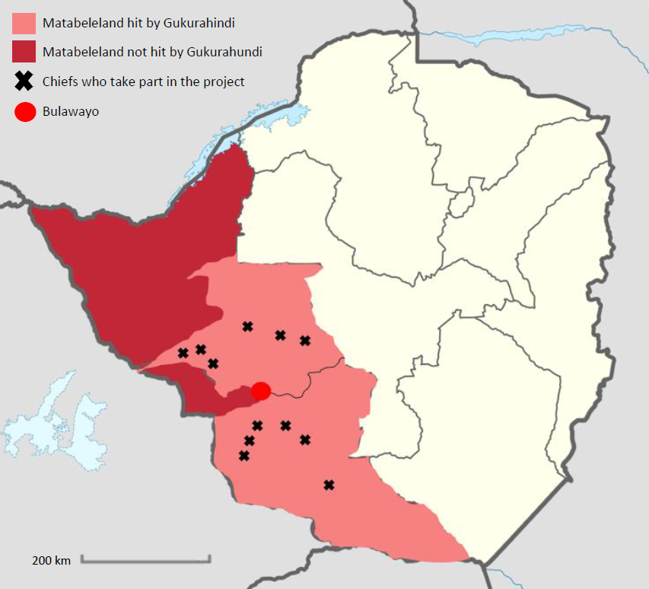
Map of chiefs in Matabeleland taking part in the present project

This is the core of this application leading to the following two project objectives:

- To promote an accurate record of the impact of Gukurahundi in 12 chieftainships to facilitate lobbying the state for reparation, preserving the history and facilitating a space to heal.

- To establish and maintain a basic psychosocial support system for the victims that will participate in 12 chiefs’ consultative meetings in their jurisdictions during 2022/23.
1.2 Zimbabwe

Zimbabwe with its population of 15,248,678 (2022) is currently experiencing a myriad of socio-political and economic challenges. The Bill of Human Rights as enshrined in the Constitution of Zimbabwe seems to exist only on paper. The reality on the ground is that people do not have genuine rights to freedom of association, expression and movement. Robert Mugabe ruled Zimbabwe with an iron fist from 1980 until 2017, when he was displaced by a coup by Emmerson Mnangagwa. Desperate to present himself as a popular leader through winning the 2018 general elections, Mnangagwa nonetheless found himself facing a contested Presidential election result. As protestors took to the streets, demanding an end to delays in releasing the full Presidential election outcome, six citizens were shot in cold blood by the Zimbabwe National army. This sent signals to the entire nation, SADC region and international community that the administration of Mnangagwa would be as repressive as the one that preceded it. Since 2018, there have been multiple incidents of abductions, abuse and politically motivated arrests, and most recently, the murder of an opposition activist attending a rally, in February 2022. On June 20 2020, UN Experts called in vain on the government of Zimbabwe to stop abductions and torture that appeared to be aimed at suppressing protests and dissent. The next general election will be in 2023, which means that this project will take place in a politically charged context.

Economically, Zimbabwe continues to face challenges despite the robust and ambitious economic agenda of 2019. Zimbabwe remains among the 25 poorest countries in the world. At the same time, a recent report outlined how Zimbabwe’s political elite, in collusion with some in the private sector, have a tight grip on the economy, ensuring massive riches for a few:

…there is consensus across political parties, academics, and wider society that cartels go against the public interest, and they are characterised by collusion between the private sector and influential politicians to attain monopolistic positions, fix prices and stifle of competition. Zimbabwe’s institutions for regulating property rights, law and finance have been ensnared, and are actively abused to facilitate rent-seeking by cartels…. The cartels impact Zimbabweans in multiple ways – entrenching their patrons’ hold on power, retarding democratisation, destroying service delivery for citizens and creating an uncompetitive business climate – which leaves Zimbabweans poorer, more severely underserved by their government and disempowered to hold the state to account.

Corruption is rampant. As an indication of the level of corruption taking place in the country, Zimbabwe appeared as number 157 out of 180 in the Transparency International World Corruption Index (2020). The economy of Zimbabwe is characterised by heavy reliance on the primary sector and this has not performed well because the industries on which the sector depends have been in precipitous decline. Consequently, a culture of widespread informal trade, mainly in imported goods and services, is fast taking root. The official unemployment rate stands at 11 percent although the vast majority of the people considered to be employed are engaged in subsistence peasant farming (70% of the population) or low paying temporary insecure work and petty trade in the informal sector (a further 15- 20%).

All the forms of service delivery are collapsing. People of Zimbabwe as a whole and Matabeleland in particular are severely demoralized and dealing with the fractures and divisions of a long, economically and politically violent past. The health sector is severely under-resourced both in terms of financial and human resources, with doctors and nurses striking regularly over poor remunerations, or leaving for greener pastures. Instead of improving working conditions, the state has now outlawed such strikes, now punishable by three years in jail. The education sector has similarly collapsed, with schoolchildren facing a dire situation after two years of Covid lockdowns. Teachers are now on almost continuous strike as they claim ‘incapacitation’ on the grounds that their salaries are not even enough to cover their transport to work. The situation is most dire in rural Matabeleland north, where in 2021, more than 50 schools had a ZERO pass rate at Grade 7. Children with a zero pass rate cannot attend high school, although many children who pass, fail to access high school in any case, owing to shortage of places and prohibitively-long walking distances to schools. In Matabeleland North, for example, there are 611 primary schools (gr 1-7) but only 198 secondary schools.

This takes place in a context where there is an extreme gender inequality as indicated by the UNDP in its Gender inequality Index where Zimbabwe ranks 150 out of 179 countries in the world (HDR UNDP 2020).

The Political Development
After the Gukurahundi in the 1980s, the 1990s were a time of relative political stability, although all attempts to form any political opposition continued to be crushed systematically. This intensified with the formation of the Movement for Democratic Change (MDC) in 1999, itself a response to growing economic hardship. Political violence immediately increased, with thousands tortured, detained, abducted, and around 300 killed in the ensuing years in what has become known as the ‘Zimbabwe Crisis’. This crisis of governance continues to date. While Robert Mugabe was removed by a coup in 2017, the new regime is almost identical to the last, containing one faction of the old guard, and with a continuity of the policies of repression that encompass unconstitutional behaviour and the abuse of the judiciary to promote the economic and political interests of an increasingly small ZANU PF elite. All serious threats to this elite are violently crushed. As an indication of the lack of democracy in Zimbabwe the country is considered not free in Freedom House’s world democracy index (2022).

Zimbabwe is ethnically divided with 82% of the population being Shona and 14% being Ndebele (2021).

“Historical tension between the Shona majority and the Ndebele minority resulted in continued marginalization of the Ndebele by the Shona-dominated government” (US State Department, 2022).

1.2.1 Matabeleland
The project is going to be located in Matabeleland North and South provinces, which are two out of the three poorest provinces in Zimbabwe (UNICEF 2021). In Matabeleland South it is going to be in Gwanda, Bulilimamangwe and Matobo districts and in Matabeleland North it is going to be in Tsholotsho, Lupane and Nkayi districts. The sizes of districts vary, but consist of an average of 20 to 25 wards. A ward consists of five to six villages and a village of plus or minus 100 households. Each province has around 700,000 residents, of which around 600,000 are living in remote rural villages, accessible only by a poorly maintained network of dirt roads. Most years, people here barely grow enough food for subsistence. These two provinces are among the poorest in Zimbabwe, and also the most drought-prone. The twelve chiefs included in this project represent approximately 200,000 rural citizens between them, the vast majority of these being under the age of 15 years.

In recent years, rural villages have faced mass diasporisation, so that in some villages there are barely any able-bodied men capable of manual labour to be found, as they have left for neighbouring countries such as South Africa. While some have done well there, many more suffer very marginalised lives as undocumented migrants in an increasingly xenophobic context. Many lost their jobs during the COVID 19 lock-downs. Grandmothers have been left to raise multitudes of grandchildren, who often have to walk long distances to very poorly resourced schools, on empty stomachs. The communities in these two provinces are highly polarised and community conflicts abound because of unresolved historical conflicts, political party affiliations and other related social and economic factors, such as a general feeling amongst citizens of this region of being marginalised.

Ethnicity is a big issue in Matabeleland. The communities have a strong feeling that they were affected by Gukurahundi by virtue of being Ndebele speaking. They view Gukurahundi as a project that still continues to date. In the 1980s, they say it was in the form of soldiers killing, torturing, raping and destroying property belonging to the Ndebele speaking ethnic group. Currently Gukurahundi is perceived to be institutional, with every institution and department being dominated by Shona speaking people. The examples given included ministry of education, health policy, registrar and so on. For example, schools in Matabeleland are often run by Shona speaking heads and teachers. The communities feel unsafe to use such institutions as police because senior officers are usually Shona speaking which is intimidatory as almost without exception, people living in rural Matabeleland are fluent only in Ndebele, and sometimes speak some English.

1.3 Intervention in a fragile situation

The project takes place in a politically fragile environment. Both UT and ToL have decades of experience of working in the politically fragile and violent context of Zimbabwe. Over decades the organisations have built a support network both in rural areas, of facilitators, pastors and traditional leaders, including chiefs, who offer support, protection and community access even when times are very hard.

In the Bulawayo-urban context, UT and ToL are both members of an increasingly vibrant and directed Matabeleland Forum, consisting of almost twenty civic organisations engaged in promoting the interests of the region and working with Gukurahundi issues. This creates a safety net, and makes it hard for the state to target just one organisation, when activities and positions are shared.

1.4 Strengthening of civil society and advancing social justice.

The project seeks to support the initiative primarily driven by chiefs and other traditional leadership structures in facilitating documentation of the victims of Gukurahundi’s narratives. The role of UT and ToL will be to capacitate the chiefs, their secretaries and grassroots counsellors/facilitators who will in turn go down to the last person on the ground to provide community meetings in which they can be heard. As communities tell their narratives to the chiefs and talk about what should be done to help them move forward from the past, this will begin a process of reconciliation with the past. This may lay the ground for improved community participation, development, and increase demands for transparency and accountability, as families are able to trust one another better, and release energy previously trapped in pain, towards development projects.

The documentation of atrocities of the past will form the basis of strong lobbying positions for the chiefs, who can use this history to argue for improved access to all aspects of citizenship for their people, including birth and death certificates - some outstanding since the killings - and also the right to know, the right to mourn, the right to truth about the past. The state has indicated the possibility of material reparations in the form of community development, and this chiefs’ outreach will allow victims to lobby for what they think their area needs in the form of communal reparation, be it infrastructure or other opportunities.

1.5 Climate and Environment

Matabeleland provinces are generally characterised by erratic rainfall patterns that result in persistent droughts. The populations of these provinces rely heavily on food handouts from NGOs, the Department of Social Welfare and not less important from World Food Programme, because they are already impacted by climate change. This sometimes results in crop failure, empty dams and animals dying for lack of grazing. Poor infrastructure makes accessing these areas slow and erratic. The project itself will not impact either way on the environment. Indirectly the project will empower the communities by overcoming the present mistrust and fragmentation. Thereby, they will be better capable of mitigating the effects of climate change that has already had a severe impact on the region with continuous years’ with drought leading to hunger due to crop failures.

2. The partnership/collaborators (our starting point)

Ukuthula Trust (meaning ‘peace’ in IsiNdebele) is an NGO that has operated under various titles since 1998: as Amani Trust until 2002, and from 2003 - 2014 as Solidarity Peace Trust. Ukuthula Trust (UT) was registered in Zimbabwe in 2014. While the names have changed, the work has been continuous, with a largely stable staff, since 1998. Ukuthula has proven that it can work effectively even in extremely limited and dangerous political spaces, such as that which existed from 2003-2014. The space to operate in is currently more open. UT has recognition and support internationally, and communicates on a regular basis with EU ambassadors in Harare, as well as with UK, USA, Australian and Canadian ambassadors. UT receives core funding from Swedish International Development Agency (SIDA); Church of Sweden; Sigrid Rausing Foundation. Ukuthula also received activity-specific funding from the Swiss Embassy in Harare, as well as from the Open Society Foundation and Heinrich Boll.

UT’s goal is to deepen democracy by empowering people to release their energy towards taking an active part in the development and governance of their communities, through rehabilitation of survivors of historical and current torture, and through prevention of conflict in Zimbabwe in the future by generating knowledge and promoting accountability.

UT has a website (see for instance more than 30 reports on www.solidaritypeacetrust.org) and an extensive network in the rural churches and among the chiefs of Matabeleland, who strongly support the work on the ground. UT also collaborates with elected councillors and Members of Parliament, and appointed District and Provincial Administrators.

Tree of Life (ToL) is an NGO that has worked nationally for more than a decade, dealing specifically with victims of collective violence. They have a specific approach based on a testimonial therapy adapted to incorporate cultural understandings of well-being. The approach, which has been externally verified for effectiveness by the Centre for Victims of Torture, Minnesota, facilitates victims to work through trauma using a tree as a metaphor for human life. The roots are ancestral history, the trunk childhood and youth, where often the foundation of resilience to trauma (or lack of it) is laid. The branches are the support networks and strengths, and the fruits the future of a life with hope. The ToL approach helps participants integrate and strengthen all aspects to heal and move forward in a healthy way. Victims are brought together in small numbers and work through a structured process of sharing and witnessing testimony telling, identifying the parts of their whole – past, present and future – over two days. ToL has extensive experience working with narratives of Gukurahundi using this technique. ToL and UT previously worked together as part of a loose NGO gathering, known as the ‘Trauma Healers’ Network’ in Zimbabwe, and have cooperated in the field and in previous trainings ToL is bringing its unique experience to this project and has the capacity to both train civic partners and to accompany victims at hearings.

ToL’s Psychosocial Support First Aid intervention provides coping strategies to address basic needs and reduce psychological distress by supporting community networks to provide a caring and comforting presence in situations of on-going violence or other trauma triggers. The tools normalise survivor’s feelings, and help them find and use existing and effective ways of coping with their stress. The process involves mapping referral pathways to natural support networks and appropriate services where there is a need.

Nunca Mas (NM) is a member-based organization from 2013, whose vision is a world free of collective violence providing a platform for psycho-social actors who - combining solidarity with professionalism - want to accompany partners in their struggle for human rights and a just society in violent-ridden resource poor settings in the global south. This is done by partnering with like-minded organisations, research, and advocacy efforts. Its core member base consists of professionals with considerable experience in psycho-social interventions and human rights. Nunca Mas has presently projects with partners in four different countries: Besides Zimbabwe, the Philippines, Honduras and Ecuador. Nunca Mas will play a key role in connecting UT and ToL with other partners engaged in similar work. Nunca Mas will ensure exchange of ideas for UT and ToL, in various psychosocial approaches. It will amplify the voices of victims, through publicizing UT on human rights abuses to ensure there is greater acknowledgement in the EU, incl. Denmark of this history of crime against humanity in post-independence Zimbabwe. UT’s collaboration with Nunca Mas means a stronger fight for justice for a hitherto ignored and neglected community. It places the human rights violations experienced in the Matabeleland region on the international map, thereby giving the victims a voice. More importantly it will bring about much needed closure and justice, and a chance to move forward in a constructive and productive way. While UT has good core funding from multiple sources as indicated, these partners do not offer human resource development or physical solidarity in the way that NM will. To ensure sustainable positive changes vis-à-vis social justice in Zimbabwe, international attention seems to be required. This is an uphill battle as Zimbabwe is receiving still less international attention. It is years since Zimbabwe was a target country for Danish development assistance and few European social actors show an interest in the development of Zimbabwe. To counter this NM has a) become a member of ZEN – Zimbabwe European Network, which consists of several European organisations with activities in Zimbabwe, and b) initiated the Danish Zimbabwe network of Danish CSOs with interest/activities in Zimbabwe.

The relationship between UT and members of the NM project group goes back more than 20 years where a considerable level trust between the organizations/persons has evolved over this time. Based on this relationship, UT and NM designed and successfully implemented the CISU-funded project “Empowerment of Survivors of 1980s Massacres, Zimbabwe, to take part in the proposed truth telling outreach through the NPRC together with ToL. Due to recent political events in Zimbabwe, the idea of relying on the NPRC is not anymore considered a viable route to achieve the objective of the co-operation. Instead, this project will amplify the focus on the chiefs who play a central role in rural communities and who still have some independent political space to operate in. While the relationship of NM with UT goes long back the relationship with ToL is newer and has until recently been handicapped by the COVID-19 that prevented visits to Zimbabwe and meet Tol Staff in persons. This lacunae was fortunately rectified by a NM visit in February 2022 under the present project. ZOOM is not sufficient to build up trust between organisations. During that visit the present project proposal was further discussed and finalised.

The Chiefs is a traditional structure enshrined in the constitution of Zimbabwe and governed by the Traditional Leaders Act of 2008. Chiefs are the highest level of the traditional structure that starts from a line kraal head to village head, headman and then chief. They play a significant role in rural Zimbabwe, where more than 60% of the population reside. The size of a chieftainship varies from area to area, but all rural citizens are answerable to a chief for certain issues, including localised crimes, land usage and allocation, village and family disputes. The chiefs are generally highly respected and very influential at all levels, even though they are by virtue of being traditional, rather autocratic and almost entirely men. While UT and ToL cannot influence the gender make-up of chieftainships, we maintain our gender focus by targeting women, youth and men at project level. The chiefs in question also pay attention to gender equality when implementing their programs. The targeted chiefs are mostly young, in their thirties or forties, and several are university-educated. Thus, they are open to being influenced on gender issues, and have agreed that any Gukurahundi hearing has to include a gender aspect, as well as specific support for women with histories of sexual violence.

The chiefs come with a package of headmen, village heads, secretaries and counsellors. The headmen form the second tier in the structure of traditional leaders. They receive cases of community and individual conflicts and local crimes from the village head who would have failed to resolve them. The secretaries and counsellors are not provided for in the Traditional Leaders Act. They are both appointed on ad hoc basis by the chief, directly or indirectly through head men and village heads.

The chiefs have been asked by UT and ToL to resource this specific Gukurahundi consultative meetings with two secretaries each, who will be those most trusted by each chief, and considered by the chief to have the appropriate capacity to undertake documentation activities for the outreach meetings. The secretaries will not be professionals, but will be capable people identified by the traditional structures as capable and trusted. As indicated under ‘selection of counsellors’ above, civic groupings including ourselves have already mapped potential psychosocial support persons for this proposal, across the twelve chiefs. This will include grassroots counsellors that have already received counselling training under the previous UT and ToL project, which covers two chieftainships. ToL and UT both have contacts and facilitators on the ground as a result of previous years of work, and these resource people will be pulled into this forthcoming activity, but will need specific top-up training to meet the demands of the chiefs’ public meetings.

2.1 Contributions, Roles and Responsibilities

Ukuthula Trust | Tree of Life | Nunca Mas | Chiefs
Responsibility for overall project on in Zimbabwe, & accounting for expendi-ture there | Report on their activities and account for their expenses to UT | Responsibility for overall project to  CISU and overall reporting, accounting | Provide political space, for victims and NGOs
Liaise with chiefs & other traditional leaders in identification of secreta-ries & persons capable of basic psychosocial support | Assist Ukuthula Trust in identification and training of secretaries and those offering psychosocial support | Support the process financially and receive overall reports on the activities | Participate in the identification of secretaries and psycho-social support persons
Ensure a good standard of psychosocial support for victims who testify to the chief, and data management of narratives, including collation, processing transcribing, and archiving. | Assist UT in maintaining good psychosocial support to the victims of collective violence and participate in information management | Provide reflections on best practice standards of care, receive & keep documents incl. periodic reports & documentation reports. Use information provided by UT & ToL to inform Denmark & EU of issues raised by victims of collective violence | Allow victim support team and secretaries to work and receive finalised documentation reports for further action in their respective areas
Mobilise & train secreta-ries on documentation, & give training in empathy & basic support, to pre-identified, community-based support persons | Assist Ukuthula Trust in training support per-sons & facilitate follow up counselling sessions where complex cases are referred | Receive periodic reports | Remain accessible to victims, UT and ToL.
Conduct in situ follow up in chiefs’ gatherings to observe capacity of secre-taries to document, & ca-pacity of psycho-social support persons to mana-ge emotions in the com-munity setting | Assists UT in attending chiefs’ consultative meetings and observing capacities of by secretaries and psychosocial support persons | Continue to support the processes financially | Facilitate secretaries´ documentation of con-sultative proceedings & promote the contri-butions of psychosocial support persons to the proceedings

2.2 The future development of the partnership

UT and ToL will continue to benefit from each other through sharing of experiences and approaches. The fact that we co-facilitate at workshops avails huge opportunities for hands on learning from each other. UT normally operates in different communities to ToL. This means that besides benefiting from each other, the mutual benefits will cascade directly to the communities. UT and ToL will offer one another moral and logistical support in a very difficult field and historical moment. It is emotionally tough to listen day after day to terrifying testimonies and the two organisations can work to debrief and support one another during feedback meetings and supervision.

The three organisations will learn from one another during the process of training and supervision of the counsellors and networking with chiefs and other civics and use it for advocacy purposes following the principle of “doing no harm” and not putting people and staff at unnecessary risk.

The chiefs and other traditional leaders will learn from both UT and ToL on conflict management and transformation. On the other hand, UT and ToL will learn a lot from the chiefs and other traditional leaders on traditional and cultural ways of working with communities.

2.3 Relation building to other actors

UT and ToL do not operate in isolation. The two organisations are part of the CSO group Matabeleland Forum (MF). The Forum consists of organisations that have varied mandates ranging from peace building and conflict transformation, women empowerment, counselling, trauma management and lobbying and advocacy. MF has worked with the chiefs to a level where a clear direction forward has been mapped. The chiefs have taken the lead in suggesting that they want to go ahead with consultations with their communities in order to determine what needs to be done for the healing of Gukurahundi victims. This intervention will certainly solidify MF because for a long time, most of the work on healing of victims was at planning phase. The organisations within MF have been charged with a responsibility to review their budgets and make commitments on how will they contribute each towards implementation of the chiefs’ ideas. The experience of working with victims and chiefs that UT and TOL have will significantly contribute to the broader MF initiative. MF partners will be strengthened and will gain in cohesiveness and capacity as a result of working together on the chiefs’ initiative.

The need to have organisations with strong collaborative capacities cannot be over emphasised in Zimbabwe. Apart from avoiding duplication of resources and activities, collaboration offers mutual opportunities to share skills and experiences, and also makes any single organisation harder to target politically. This will facilitate attainment of results from a much wider geographical area and maximise the benefits of the targeted communities. The other key stakeholder could under normal circumstances have been government structures, but after a careful assessment UT and ToL have concluded that a closer co-operation with these entities would be counterproductive at this stage. The communities view any government entity as a perpetrator of Gukurahundi massacres. Thus, there is a high risk that the chances of accessing communities will be compromised. However, the two organisations ensures to get the necessary government permissions to operate in the project areas.

3. Target groups, objectives, strategy, and expected results (our intervention)

The target group consists of
- Primary and secondary victims of political violence in Matabeleland South, in the three districts of Gwanda, Matobo, Bulilimamangwe, and in Matabeleland North, in Nkayi, Tsholotsho and Lupane.
The primary target of the project will be:
- 12 chiefs
- 24 Secretaries (two secretaries, one male and one female per chief)
- 96 counsellors (four males and four females per chief)
- 6.600 primary and secondary victims (in each chieftainship 400 women and 150 males). The estimates used are based on the smallest chieftaincy (the size of one ward). There is more women, as they dominate in rural areas. The males are generally fewer, as many keep moving from one place to another looking for jobs and other means of survival.
- 900 public testimonies of primary and secondary victims
- 300 private testimonies of primary and secondary victims
Secondary target group:
- The ultimate beneficiary will be the Ndebele community at large.
- In Mat. South there are five chiefs that will be in the project. Among them there is a total of 18 wards with an average of 2500 people per ward. Therefore, in Mat. South there is a total of 45 000 secondary victims which shall consist of males, females and youth.
- In Mat. North there are seven chiefs with a total of 42 wards with and estimated average of 2500 people ward. This gives and estimated total population of 105 000. This figure shall consist of adult females, males and youth.

3.1 The participation of the target groups and their benefits (Roles in the Project)

The chiefs: They will be driving the consultative processes by chairing or assigning another to chair the consultative meetings. As the leaders of the targeted communities they have participated actively during meetings organised by UT over the last two years, and more recently involving other civic partners from the Matabeleland Forum (MF). The chiefs and selected civic groups have agreed to walk together in outreach meetings to be headed by the chiefs. The chiefs have acknowledged that the task of holding meetings to discuss Gukurahundi is a task unlike any they have previously had to accomplish, and that they lacked skills in documentation and psychosocial support in particular. The chiefs have asked members of MF to provide historical background to them, prepare them to the task and to train their secretaries and counsellors in order to effectively carry out the work.

The chiefs will benefit by gaining deep understanding of the Gukurahundi issues affecting their people. Most of the chiefs are also victims of collective violence directly or indirectly. The consultative meetings while healing to the communities will have an equal effect to the drivers of the processes. Should the healing begin to take place within the chiefs’ areas, this will benefit them (chiefs) in the sense that now they will have communities that may begin to be more able to contribute to development in a meaningful way.

The secretaries: They will fill out the form together as a team of two. One of them will ensure that the private data is written into the form as well. They have been trained in filling out the form. Due to the capacity of secretaries two have to work together for quality assurance. The will also ensure that the testimonies are tape recorded. They may benefit by going through a process that may have a healing effect on them as well. The fact that they will be listening to horrendous stories of people they will later participate in debriefing processes that shall enable them to move forward in some ways.

The counsellors: They will be present in all consultative meetings in order to respond to any victims that might break down during or after these meetings. UT and ToL have already mapped pastors, psycho-social facilitators and other long-standing civic contacts rooted in rural communities, drawing from work on the ground by four civic groups (UT, ToL, Zimbabwe Christian Alliance, Centre for Innovation and Technology). Collectively, sufficient persons with appropriate backgrounds in situ in each of the 12 chieftainships have already been identified. These are almost all individuals who have pre-existing experience in working with trauma, violence and/or bereavement. Involvement in this project will further strengthen them as individuals, and will also strengthen links between Bulawayo-based civics as they collaborate on this shared venture by sharing their contacts and training and follow up. As those identified under the chiefs already have some understanding of how to offer psychosocial support, this will enable the training under this proposal to be very simple, focusing on containment of extreme emotions in a community setting, as opposed to individual interventions. How to offer empathy and time-out when necessary to those testifying before the chief will be focused on. Any more complicated needs of victims will be referred on to ToL and UT. It will mean aiding these grassroots psycho-social support structures in ensuring that there is a gender-specific, and/or confidential structure in place for those who wish to go on record about their violent pasts, but not by testifying in a public venue.

The victims: This group consists of the ordinary population of women and men, and youth who will contribute by telling the narratives and listen to the narratives. They are expected to benefit from telling these narratives and getting them documented. The assumption is that at the end of the day the community members under the targeted chiefs should feel empowered enough to participate in development, demand transparency and accountability and contribute to influencing policy making. The state has indicated an intention to offer community compensation to affected districts, although this may turn out to be empty promises. However, if the state listens to the most urgent material needs of these communities and delivers roads, clinics, training centres, mobile phone cover, exhumations, memorials and whatever else is requested, then this will be profoundly beneficial (if unlikely!).

3.2. The strategy of the intervention

In the previous CISU funded project the chiefs, secretaries and grassroots counsellors were given capacity building according to their needs. Some chiefs also got through the training with secretaries and counsellors so that they get to appreciate both roles since they will be in charge of the whole consultative process. The secretaries from all the targeted chiefs were brought into Bulawayo for a one-day documentation training workshop. The secretaries, who received training in documentation of gatherings, will attend the consultative meetings in order for them to document the narratives.

The chiefs have already had 4-5 workshops with training in how to handle, setting the tone and using empathy during the consultative meetings. Therefore, this is not part of this present project’s budget.

The 24 secretaries have already had extensive training in documentation method and procedures by the previous CISU-funded project. This training included learning to follow a specific record sheet, how to deal with victim information (ethics and anonymising) and lastly how use recorders and file and secure the digital data received during the meetings. The record sheet is in English and Ndebele. In addition, the narratives will be recorded using digital voice recorders so no information is missed out.

The record sheet used in the project was developed by UT and other organisations who have 20+ years’ experience with documentation of human rights violations.

Strategy for organizing the chiefs’ consultative meetings
As part of the project preparations UT has held several meetings with the 12 chiefs. The chiefs are ultimately responsible for how their consultative meetings with the victims will materialize. The strategy of the meetings has been elaborated from this:

- A sequential timetable for the chiefs’ consultative meetings will be developed by the chiefs themselves. The timetable will show who go first, second etc. during the first 12 months.
- It is up to the individual chief how they will manage their consultative meetings. In general, it is expected that the meetings are public and will involve both victims coming to document their narratives, but also villagers from the chieftainship, who want to hear and support the narratives of the victims.
- It will be up to the individual chief how many people will be allowed into each meeting. The chiefs will take into consideration, that too many people could be problematic in more than one instance. Security-wise it is easier to manage and avoid the infiltration of outside disrupters. If too many people join the meetings, it makes it harder to check if only people from the chieftainship are joining. Additionally, too many people will not make it possible for each individual to tell and have their narrative documented within the timeframe of the meetings.
- All consultative meetings will involve 8 counsellors and 2 secretaries. The training and roles of these will be elaborated below.

Strategy for documentation
- After each consultative meeting, the two secretaries present will hand over to the chief, the data (the record sheet and the audio recordings) from the meeting. The data will then be handed over to UT during their regular visits to each of the 12 chieftainships.
- UT will digitally scan the record sheets and file all the recordings safely for future evidencing of Gukurahundi. Afterwards, the original data will be anonymised and handed back to the chiefs, so that they have the possibility for future lobbying of the state. Ownership of the information will reside with the respective chiefs and those testifying, and how it should be used in future is a subject for negotiation, but the most important aspect is to ensure that any testifying victim is respected by their narrative being captured and future-proofed.
- UT will begin to transcribe recorded audios generated by all the 24 secretaries, through use of transcribers engaged on part-time consultancy basis for this purpose.
- Experts in simultaneous translation and transcription will be identified to transcribe all voice messages, on a part-time consultancy basis.
Strategy for the training of the counsellors
- Each of the 12 chiefs have been matched up with 8 counsellors (4 men and 4 women) identified by UT (by having sufficient background for psychosocial work). These 8 counsellors will accompany their respective chief at each of the consultative meetings.
- The counsellors will be trained for two days in each of their respective chieftainships:
The first day of the counselling training will include talking about their own traumatic experiences from Gukurahundi. This is necessary since many of the counsellors themselves suffered under Gukurahundi.
On the second day, the trainees will be trained in basic counselling skills. This comprises the following:
- To expect and how to manage intense emotions of victims during the consultative meetings. For instance, it is not normally considered proper for women to “cause a scene” and cry out, but for this specific setting the counsellors will be taught that they need to support and not suppress this for the individual person during the consultative meetings. Similarly, they will be taught how to emphasize and handle other emotions like anger and guilt.
- To handle accusations of collaborations with the state and soldiers. It has been a problem before, that people from the same chieftainship accuse each other of contributing to the lists of names of those to be killed that the soldiers arrived with during Gukurahundi. These ‘sell-out’ accusations need to be expected and dealt with, by suggesting these accusations are mediated outside of the main meeting to prevent disruption.
- To recognize the need for creating private spaces for 1-1 counselling, for people who do not want to have their narrative documented in public. This is especially expected to be relevant for women, but also men, who have been raped and who want to share and document this privately with only one counsellor.
- To recognise symptoms of extreme trauma still evident in the victims, so they know which people to refer to UT and ToL for extra counselling by professionals.

Strategy for improving the consultative meetings
- Throughout the project, the chiefs will have meetings in Bulawayo, where they will be able to encourage each other and share experiences from their respective consultative meetings.
- The chiefs will have meetings with their own secretaries, where it will be up for discussion if they need to do separate meetings for men and women or if gender-mixed meetings will work out. This is especially relevant as it is expected that many of the narratives will involve delicate matters such as rape or other kinds of humiliating violence.
- Children will not be joining the consultative meetings for adults as this could mean an unintended transference of trauma and anger from the grown-up victims. However, the chiefs will discuss with each of their secretaries whether consultative meetings for children could be relevant in their chieftainships, such as where there are mass graves in school yards, affecting children.

Strategy for improving documentation and counselling during the project
- In the first phase of the project implementation, UT and ToL will attend 3 consultative meetings per chief to observe the capacity of psychosocial support the counsellors offer. This will involve staying two nights in the rural setting for each of the three meetings in the 6 chieftainships in Matabeleland North. In Matabeleland South, distances are shorter, and day trips will be possible.
- UT and ToL will make follow ups to the chiefs, secretaries and counsellors to provide support as and when needed, provide more in depth trauma counselling to referred clients.
- UT will hold a one-day debriefing workshop in Bulawayo with 24 secretaries from 12 chiefs.
- To hold two review meetings in Bulawayo (half yearly) with secretaries to assess the progress and effectiveness of the project.

Strategy for handling extreme cases:
- 1-2 weeks after each consultative meeting, 1-2 counsellors who were part of the meeting will go to the chieftainship to do a follow up visit. Here they will assess how victims are coping, counsel where needed and refer severe cases onto professionals from UT or ToL.

3.3 Objectives, activities, expected results and indicators

The development objective of the project is to contribute to the building of sustainable communities that have reconciled with their past experiences of politically motivated violence rooted in the Gukurahundi Massacres in Matabeleland, Zimbabwe in the 1980s and are able to claim their rights and participate in development, demanding transparency and accountability from the duty-bearers.

The following are the proposed project objectives:

- To promote an accurate record of the impact of Gukurahundi in 12 chieftainships to facilitate lobbying the state for reparation, preserving the history and facilitating a space to heal.

- To establish and maintain a basic psychosocial support system for the victims that will participate in 12 chiefs’ consultative meetings in their jurisdictions during 2022/23.
Documentation of Massacres in Matabeleland Zimbabwe:
the Right to Truth, the Right to Know and the Right to Heal
Immediate Objective | Expected Results | Activities | Indicators
To promote an accurate record of the impact of Gukurahundi in 12 chieftainships to facilitate lobbying the state for reparation, preserving the history and facilitating a space to heal | By 31st May 2023, 1.200 narratives available & accessible as written documents captured during chiefs’ meetings.  Digital voice memos of chiefs meetings available  By 31st May 2023, 12 chiefs have consolidated requests from victims for specific reparation projects in order to lobby the state | - Local Partner Activities  - Documentation  - Training Workshop for secretaries in Bulawayo  UT & ToL will attend two meetings per chief, to observe & to support the capacity of secretaries already trained in using documentation tools  - Semi-annual Review meetings with secretaries in Bulawayo  To hold two review meetings in Bulawayo (half yearly) with secretaries to assess the progress & effectiveness of the project.  - Information Management Trips  To establish & implement a system for safe retrieval & management of narratives for twelve chiefs (co-ordinating transfer of data forms & recordings to Bulawayo)  - Transcriptions  To begin to transcribe recorded audios generated by 24 secretaries, through use of transcribers engaged on part-time consultancy basis for this purpose. | An appropriate number of victims participating in meetings (not too many/few)  Secretaries are in place and performing the task of recording the narratives at meetings  Available and accessible raw data  Project implementation reviewed and redirected accordingly  Digitised back up of narratives exists  Transcriptions archived appropriately
To establish and maintain a basic psychosocial support system for the victims that will participate in 12 chiefs’ consultative meetings in their jurisdictions during 2022/23. | By 31st May 2023, a survey shows that victims report to UT and ToL that they felt supported when relating their narratives of trauma to the chief.  By 31st May 2023, 12 psychosocial support teams are reported by victims to offer support during meetings: complex cases referred on to UT and ToL. | - Psychosocial Support  - Training workshops for psychosocial support persons in Matabeleland North (6 workshops) and Matabeleland South (6 workshops)  To hold 12 x 1-day workshops for psychosocial support persons, one in each chieftainship.  - Consultative Meetings  UT and ToL to attend two consultative meetings per chief to observe the capacity of the counsellors to deal with victim’s testimony in a public setting. This will involve staying two nights in the rural setting for each of the three meetings in the 6 chieftainships in Matabeleland North. In Matabeleland South, distances are shorter, and day trips will be possible. | Psychosocial support persons are in place and prepared to participate in capacity building.  Support persons have basic skills in empathy and emotional support by the time chiefs’ outreach occurs, and are able to offer confidential testimony spaces when required, as well as to manage emotions in the public setting.  Victims of political violence have an opportunity to be heard and go on record with their histories, and to add their voices to the lobbying efforts of their chiefs to bring development to their villages.  Victims reported having benefitted from basic psychosocial support services  Victims exhibiting complex trauma are referred to UT and ToL

3.4.1 The workplan*
Activity | Month |  |  |  |  |  |  |  |  |  |  |  | Responsible person
 | Jun | July | Aug | sept | Oct | Nov | Dec | Jan | Feb | Mar | Apr | May
One day training workshop for secretaries | 1 |  |  |  |  |  |  |  |  |  |  |  | Vusa, Dickens
Review meetings with secretaries |  |  |  |  |  | 1 |  |  |  |  |  | 1 | Vusa, Dickens
Transcription of audios | 8 | 8 | 8 | 8 | 8 | 8 | 8 | 8 | 8 | 8 | 8 | 8 | Vusa, Dickens
Counselling workshops | 6 | 6 |  |  |  |  |  |  |  |  |  |  | Vusa, Sehlu
UT and ToL attending chiefs’ meetings to support counsellors | 2 | 2 | 2 | 2 | 2 | 2 | 2 | 2 | 2 | 2 | 2 | 2 | Vusa, Sehlu

*to be refined into quarterly plans with more details around weeks of implementation. The given numbers explains the frequency of that particular activity in that particular month.

3.5 Sustainability

Sustainability is an important aspect of this project for UT and ToL. There are three important stakeholders that will be key in the sustainability of the project. These are Chiefs, chiefs’ secretaries and most importantly the grassroots psychosocial support persons. The chiefs are custodians of culture. The government has officially given the chiefs the mandate to oversee Gukurahundi related healing processes, however problematic this might be. This mandate will continue way beyond the life of this project, as it will not be possible to ‘resolve’ the scars of genocide and forty years of ensuing neglect in any short space of time, if ever. This means that the simple psychosocial support training that this project will offer, will be called on at the village level after the end of the project. While this project will allow for only very basic training, there is the scope to return and train certain of these facilitators in more depth if required and relevant.

The chiefs’ secretaries are the eyes and ears of chiefs at village level. They are based where the grassroots counsellors are. In terms of a previous project involving training grassroots counsellors, it was observed that the chiefs’ secretariat had accepted and introduced counsellors as key stakeholders in the community. The village heads have also introduced our counsellors to the general community and co-opted the counsellors into their development structures. The counsellors are thus viewed as a resource in the community and they have started providing other counselling services besides psychosocial management of victims of collective violence such as domestic violence and infidelity cases. The counsellors trained during the previous project continue to work with victims of collective violence despite the fact that allowances stopped at the end of the previous project. It supports the assumption that the project will be sustainable beyond its cycle. For UT and ToL they will be crucial as the counsellors will be used as key informants who will refer complex cases for management, and will be used as counsellors through other programs of the two organisations.

3.6 Risk and Mitigation

Risk | Mitigation
Political space shrinks | We will continue capacitating victims but in a more covert manner.
Security of victims compromised | Ukuthula Trust has security protocols in that include evacuating the victims. The chiefs will also play a protective role to the victims.
Security of staff compromised | Staff to adhere to security protocols. Should need arise the affected staff will be evacuated out of the country until security threats vanish
COVID 19 rages on | Staff will follow laid down restriction measures & reach out to victims at individual level to small groups of two to five people at house hold level
The President of Zimbabwe and the President of the Council of Chiefs (CC) can revoke this decision at any time. They may also seek to exclude civic organisations from participation. | UT & ToL to move quickly to ensure that training will take place as fast as possible, to ensure the 12 chiefs have sufficient capacity to continue to document & offer psychosocial support whether or not it has official endorsement from the CC.

3.7 Monitoring, collection and use of experiences

The experiences and lessons learned will be systematized during the planning and implementation of the planned activities and how these have contributed to achieving the proposed objective and non-expected effects by the project.

Below you will find the reporting system that is the foundation for assessing the needs for changes in the project implementation and the reporting.

Activity | Output Indicator | Output | Means of Verification | Frequency | Reporting & use of reports | Responsible person
One day training workshop for secretaries | Number of trained secretaries | Enhanced ability to accurately document victims narratives | Records of audios and filled forms | 2 follow ups per month per chief | For lobbying and advocacy and future proofing | Vusa, Dickens
Follow up meetings with secretaries | Number of follow ups | Secretaries feel suppor-ted & capaci-ted through feedbacks | Report meetings by staff | Once half yearly per chief | For hands on training and support | Vusa. Dickens
Review meetings with secretaries | Number of review meetings | Redirection of the project should there be need | Field visit reports and attendance registered | Once half yearly | To redirect and refocus the project | Vusa, Dickens
Transcription of audios | Number of transcriptions per month | Transcriptions available for further use | Transcriptions | Eight transcriptions per month | Archivable records | Vusa, Dickens
Workshops for psychosocial support | Number of workshops | Enhanced ability to provide empathetic psychosocial support | Staff reports, attendance registers | 12 work-shops in 2 months covering 12 chiefs | Improved skills to support victims | Vusa, Sehlule
UT & ToL at-tending chiefs’ meetings to support counsellors | Number of trips made and counsellors visited | Improved ability to provide psychosocial support | Field reports | 2 meetings per chief through the project | To improve quality of psychosocial services provided | Vusa, Sehlule

The information to be collected includes reports from meetings with relevant social actors, agreements and commitments established for the execution of the project, database with names of participants, satisfaction surveys at the end of the workshop and hearings. Additional information to the collected includes the objective, proposed activities, number of individuals that actively participated in the activities, monthly reports, and final reports.

UT will prepare monthly financial and narrative reports documenting using prepared formats (see appendix 1). Based on these monthly Zoom meetings will be held. At the end of the project month Nunca Mas will visit the Project and participate in an internal process and learning-oriented evaluation will take undertaken together with the two Zimbabwean partners.

4. Intervention-related information work in Denmark

The purpose of the information work is to keep the public and decision makers aware of the development in Zimbabwe.

Concretely, targets for the information are members of NM, followers on Facebook and those potentially interested in the political development in Zimbabwe and its implication on the civil society and rule of law in the country. Targets are also member of the Danish-Zimbabwean Network that Nunca Mas has recently initiated.

NM will provide relevant information on Zimbabwe and the project on the facebook, home page, and at minimum one public meeting in co-operation with other organizations working with the Zimbabwe, among these other CISU members. Learnings from the project in relation to shrinking space and advocacy will be presented together with experiences from other NM projects. A representative from Zimbabwe will be invited to a public event for in particular organisations and individuals having a stake in Zimbabwe. This will take place together with the Copenhagen University. Furthermore, an informal meeting will be arranged with organisations members of the Danish – Zimbabwean Network.

Appendix 1: Chiefs’ record sheet for village meetings, developed collaboratively with civic partners.

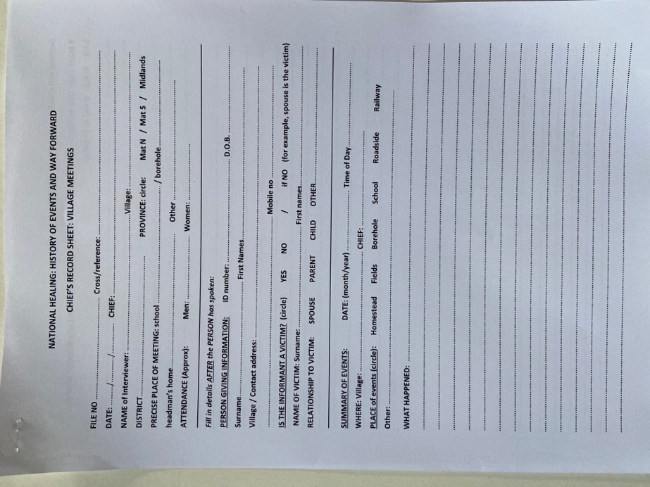
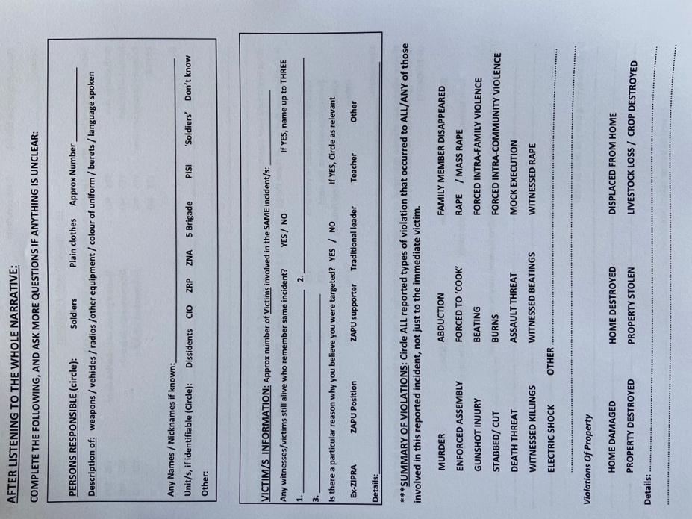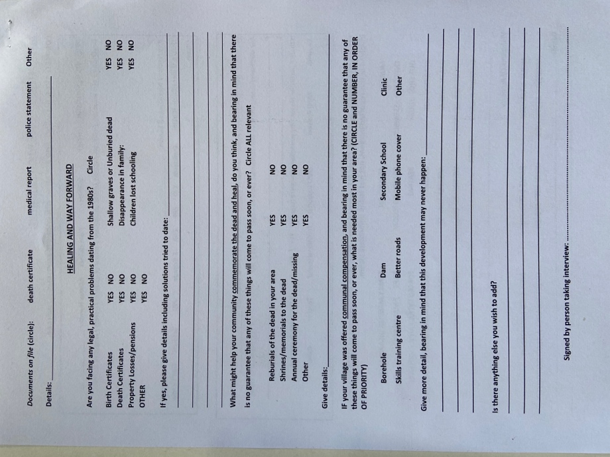

IsiShona word referring to the ‘first rains of spring that wash away the chaff from the last season’. The Ndebele see themselves as the ‘chaff’, or rubbish, that had to be ‘washed away’ by this violent brigade.
Emerson Mnangagwa (now President, then Minister of State) referred to the number of dissidents being ‘no more than 300 at their peak’, when interviewed in 1985 about events in Matabeleland.
http://solidaritypeacetrust.org/reports/ for 32 reports on the repressive political context in Zimbabwe, including election monitoring: http://solidaritypeacetrust.org/1791/old-beginnings-the-political-context-of-zimbabwe-and-a-report-on-biometric-voter-registration-bvr-a-national-and-matabeleland-perspective/ : political abuse of food by ZANU PF: http://solidaritypeacetrust.org/400/vote-zanu-pf-or-starve/ : political violence: http://solidaritypeacetrust.org/326/desperately-seeking-sanity/ : poverty: http://solidaritypeacetrust.org/1122/hard-times/ diasporisation and its economic impact on rural areas: http://solidaritypeacetrust.org/127/gone-to-egoli/
https://www.researchgate.net/publication/285269435_'Bones_in_the_Forest'_in_Matabeleland_Zimbabwe_Exhumations_as_a_Tool_for_Transformation.
“Empowerment of survivors of 1980s Massacres in Matabeleland, Zimbabwe to take part in truth telling outreach through the National Peace & Reconciliation Commission” 2020-21.
The village heads are the lowest structure of the traditional leaders. They are based at village level and one of their major roles is to provide conflict resolution and transformation.
UN Special Rapporteur on the promotion of truth, justice, reparation and guarantee of non-recurrence Pablo De Greiff, to the United Nations’ Sixty Eight General Assembly on 23rd August 2013.
Partly also due to the fact that the dominant ethnic group tends to take more and more control over the Ndebele dominated areas. More and more positions taken over by Shona and Shona-speaking people in Ndebele-talking areas.
https://africa.businessinsider.com/local/markets/mapped-the-25-poorest-countries-in-the-world/f2tg0wr.
https://www.pindula.co.zw/images/c/ce/Cartel-Power-Dynamics-02-FEB-2021-Optimized.pdf
https://www.bloomberg.com/news/articles/2021-07-26/zimbabwe-seeks-to-limit-doctors-nurses-striking-over-pay
https://www.ei-ie.org/en/item/26294:zimbabwe-strike-action-by-teachers-as-government-leaves-them-in-a-financial-crisis
https://news.pindula.co.zw/2022/03/06/over-50-matabeleland-north-schools-register-zero-pass-rate-at-grade-7/ https://kubatana.net/2021/02/08/low-matland-pass-rate-calls-for-urgent-corrective-measures/.
http://mopse.co.zw/sites/default/files/public/downloads/2017_Matabeleland_North_Province_Statistics_Profile.pdf.
An example of the violence taking place 11 participants at a rally in Kwekwe of a candidate from the opposition were killed by thugs crashing the rally the day before a Nunca Mas team arrived in Bulawayo 27th February. The incident was reported in the daily news (see for instance (NewsDaysZimbabwe 28/2/2022) and BBC world. 16 were arrested and few days after most were released again (NewsDaysZimbabwe 2/3/2022).
http://solidaritypeacetrust.org/1192/perils-and-pitfalls/, for context of Zimbabweans in South Africa.
Primary victims are those who died, was endured the violence directly or witnessed it. The secondary may be siblings, spouses or other family members, colleagues etc. related to a primary victim.

