Empowering change agents to improve access to NCD service delivery in Kamuli district, Uganda

1. Objective and relevance (the world around us)
The overall impact aimed at in this project, is to improve health of citizens in Kamuli district, Uganda.
The project’s development objective is to “Promote access to NCD health services in Kamuli district, Uganda, by December 2021”.
Three of UN’s Sustainable Development Goals are supported by the project:
SDG 3: Good health and wellbeing: Ensure healthy lives and promote well-being for all at all ages.
SDG 16: Peace, justice, and strong institutions: Promote peaceful and inclusive societies for sustainable development, provide access to justice for all and build effective, accountable, and inclusive institutions at all levels.
SDG 17: Partnerships for the goals: Strengthen the means of implementation and revitalize the global partnership for sustainable development.

Challenges
The major causes for focusing on the project’s development objective, were identified by the partners in a joint, online workshop in September 2020. The first five challenges have previously been identified, while three new ones were mentioned:
- Inadequate knowledge at community level about NCDs.
- Inadequate knowledge and skills at community level to change to a healthier livelihood behaviour.
- NCDs are not yet a funded priority for the local government nor the national government.
- The NA (Neighbourhood Assembly, see description of NAs later) priorities differ from the national priorities as determined by the Ministry of Health and Parliament. Decisions directly affecting the citizens are made at the central government level, leading to a situation of inadequate NCD services at the district and sub county health centre levels.
- The communities have limited awareness about their rights to demand services from their leaders.
- The communities do not know what people with NCDs need to be aware of in relation to Covid-19 and other communicable diseases
- Communities do not know how they can help protect the vulnerable NCD patients
- The onset of COVID-19 pandemic affected the communities, KANENGO and the Neighbourhood Assemblies. Both the NAs and KANENGO need to be oriented to the new situation.

Previous projects
The project is based on experiences from these projects:
15-1644-MP-apr: Strengthening the capacity at community level to prevent, detect and treat NCDs in 5 sub-counties in Kamuli district, Uganda
17-2070-MI-jun Promoting awareness, capacity, advocacy, and accountability for NCDs in 7 sub-counties in Kamuli district, Uganda
19-2342-MI-feb: Strengthening engagement between communities and duty bearers to improve NCD service delivery in Kamuli district, Uganda

The three projects have revealed that a focused effort has had a great effect in the communities involved, by creating awareness about NCDs and their risk factors among citizens and duty bearers, training volunteer Village Health Workers (VHWs) in detecting and referring patients, and having NAs advocate for NCD services.

The first NCD project focused on NAs and their Village Health Workers’ capacity to create awareness and to detect NCDs. Secondly, to encourage the NAs to advocate for policy change and improved service delivery, related to NCDs, at local, LC3, level.
The main results were:
By the end of the project 51.3% in the target group were able to mention three NCDs and 21% could mention three risk factors. The baseline was 2.4% and 0.7% respectively.
At the end of the project the majority of the VHWs from the involved NAs were able to correctly measure blood pressure (100%) and blood sugar (87,5%).
The 8 involved NAs were able to advocate for changes at Sub-county level, where the duty bearers were made aware of NCDs and their risk factors.

The second project continued to create awareness about NCDs, in 7 sub-counties. It focused on strengthening both NAs’ and KANENGO’s capacity in advocacy and self-governance to consistently advocate local duty bearers to prioritize NCDs, and to hold them accountable for their plans and promises.
The main results were:
Even though drama proved to be a very efficient tool to create awareness about NCDs and outreaches proved successful in detecting and referring potentially sick patients to health centers, the expected increase in awareness of NCDs was not achieved. A major factor was the lack of engagement and motivation by some change agents and Village Health Workers (VHWs).
The capacity in advocacy and management improved considerably, both by KANENGO and the now 21 involved NAs. But most NAs are still weak organizations, and they need constant dialogue and encouragement to sustain and develop.
The project greatly improved the relationship between Kanengo and NAs on one side and local government on the other side. Unfortunately, no increase in funding for NCD equipment nor medicine was reported on sub-county level.

The third project, which ended September 30th, 2020, aimed at reaching as many citizens as possible in the whole district of Kamuli, using means like radio shows, radio spot messages, newspapers and social media, to create more awareness about NCDs. In order to involve the whole district, NAs were formed in sub-counties without any NA, with the aim for the NAs and sub-counties to join forces in advocating for NCD services at district, and even at national level.
The main results were:
- Increased awareness among citizens in Kamuli district about NCD. The evaluation shows a 72% increase in adult 20+ who can mention 3 NCD risk factors compared to the previous project.
- There is an increased community capacity to advocate for NCDs, both by KANENGO’s change agents and the now 33 NAs.
- Local duty bearers were also engaged and 10 out of 13 sub-counties have signed social contracts with KANENGO in working for NCDs to become a priority area in the National Health strategy. The District has also promised to include a budget for NCDs in the District budget 2020-2021.
- KANENGO has forged linkages with different national actors to influence decisions on NCDs.

About half-way through the project, the Covid-19 restrictions hit the world, including Kamuli district. The project received approval from CISU to change its service delivery to focus on sensitising the community in how to prevent the spread of Covid-19 and particularly how to help vulnerable NCD-affected citizens to avoid being infected with Covid-19. The fast response of KANENGO gave the organisation credibility and visibility in the Sub-counties and recognition in the District.

The partners aim for this project to be the last one focusing on NCDs. To ensure sustainability, the fourth project will empower the change agents to assist the NAs and their Village Health Workers in the continued effort of creating awareness, detecting citizens with NCD, and referring them to health centres.
As the previous projects have revealed, the budget for NCD services is allocated almost exclusively at national level. Therefore, Uganda’s parliamentary committee for NCDs needs to be fed with information about which interventions work best at local level. Contacts have been made, and the project aims to establish an advocacy link from local communities to national duty bearers. Now, KANENGO and its change agents will use their change strategy and experiences at sub-county and district level, even at national level.

Context of the intervention
The proposed project focuses on Kamuli district in Busoga region in Eastern Uganda.
Health service delivery at community level is still poor. Several factors account for this situation, including inadequate financial funds and leakages of resources, due to weak internal controls and corruption. There is also a weak capacity of local communities and citizens to monitor the implementation of service delivery in the community. Furthermore, there is a lack of forums for citizens and their leaders to engage each other on effective service delivery. The COVID-19 epidemic has made access to NCD services even more difficult as Covid-19 is now the priority of the government.
In Uganda, communicable diseases still contribute to the major disease burden (more than 50 %), but the burden of NCDs is markedly increasing, posing a threat of double burden of communicable and non-communicable diseases. According to WHO, NCDs are estimated to be responsible for 33 percent of all deaths in Uganda.
A high prevalence of NCD risk factors has been documented in Uganda. A connection between obesity, hypertension, and risk of type 2 diabetes was found in a study among women, of whom nearly 80% were overweight. The STEPS survey from 2014 found that 24.3% had high blood pressure and 76.1% of those with raised blood pressure were untreated.
Dr Diana Atwine from Uganda’s health ministry has mentioned that “Non-communicable diseases are becoming an increasing burden on Uganda’s healthcare system and their increase is being attributed to lifestyle changes. The 2014 STEPwise survey pointed to a high prevalence of risk factors such as tobacco use, alcohol abuse and obesity among respondents calling for need to increase and sustain awareness and prevention campaigns in Uganda,”
In 2020, Healthy Heart Africa, a programme under AstraZeneca, was launched to help prevent and control the increasing burden of cardiovascular diseases, with major emphasis on hypertension (high blood pressure) and diabetes.

In August 2020 at a District dialogue meeting, KANENGO presented the results from a sample survey of the prevalence of hypertension and diabetes in Kamuli District. The survey showed that 26.4% of the population in Kamuli District had high blood pressure and 9.4% had high blood sugar levels.
The results are derived from a sample population of 1627 people above the age of 18 from one Zone in each of 13 Sub-counties in Kamuli District. 48% of the respondents were women and 51.1% men. Only 11% of the people diagnosed with either high blood pressure or high blood sugar level, stated that they are taking medicine.
The communities are not well sensitized and mobilized on how they can access better medical services. The communities do not know what people with NCDs need to be aware of in relation to COVID-19 and even other communicable diseases, and how they can help them. These activities are expected to be the responsibility of the local authorities, but in most districts in Uganda they are not functioning. Alternative structures like Neighbourhood Assemblies are instead seen as more active and relevant in complementing the responsibilities of local government.

The health units at community level are lacking clinical staff, medical equipment, medical supplies, and facilitation that can ably respond to the huge medical needs. However, the health budget is decided on national level, so if there is to be a change in priorities and a greater resource allocation towards NCD prevention and treatment it is necessary to advocate on National level. Kamuli District has agreed to advocate alongside KANENGO, if KANENGO continues the advocacy efforts at National level.

Strengthening the organisation of civil society
The core instrument in the NCD projects carried out by KANENGO and Hope Danmark, are the Neighbourhood Assemblies in Kamuli district and their Village Health Workers. A Neighbourhood Assembly (NA) is non-governmental, it is a democratically elected parliament operating at local community level. Fundamentally, an NA is based on voluntariness, and the purpose is active citizenship, i.e. finding ways to make citizens take active responsibility for their own lives. A Neighbourhood Assembly is organized like the national Parliament of Uganda. An NA is led by ministers of sectors (Education, Agriculture, Health etc.), just like key sectors at national level. The NA is governed under the leadership of a speaker, elected by the ministers. Below the ministers, there are sector working committees, which are made up of members representing geographical zones. The members are elected by the people from 5-7 villages, usually forming a parish. In each NA five of the members are appointed as Village Health Workers. The NAs often choose the government’s Village Health Teams to be their VHWs, if they will work voluntarily.

According to DENIVA (a national network of NGOs and CBOs in Uganda, with over 700 members), NAs help to build peoples’ knowledge and capacities, which any community, region or country needs in order to challenge or question what their leaders do and how they represent the community interests and concerns. There are NAs in several parts of the country and Moses Kyewalyanga, coordinator in KANENGO, has been appointed national NA facilitator by Deniva.
KANENGO, through its volunteer change agents, supervise, monitor and guide the NAs on their activities. Thus, the change agents play a crucial role in the KANENGO organisation, each given a zone with a number of NAs to coordinate and follow up on a quarterly basis. They also coordinate dialogue meetings with local authorities and follow up on promises given.

This intervention will strengthen civil society organisation by making community members better understand that health is their right and therefore will be able to demand for NCD services from Government. KANENGO’s change agents and Village Health Workers will mobilize and empower people on a voluntary basis, and work to engage duty bearers and policy makers to ensure citizens’ access to NCD services.

Climate- and environment impact
There are several climate and environmental conditions the intervention needs to respond to:
- Food security, which is key in NCD, is a serious challenge caused by poor production and productivity of food resulting from poor methods of farming, leading to soil degradation.
- Most citizens in Kamuli district depend on fuelwood for survival. Forests have been destroyed to grow food, burn bricks and charcoal, firewood, among others.
- Sanitation and personal hygiene in families and communities is poor, and waste disposal is generally poor.
The partnership plans to intervene in the above situation by:
- Providing knowledge and skills to change agents on environmental and climate change so that they, in turn, pass the information to the communities
- Promoting use of biogas, solar energy, and energy saving stoves to reduce biofuel use and reduce impact on the environment
Furthermore, the project will use online meetings facilities as much as possible.

2. The partnership/collaborators (our starting point)
Hope Danmark and KANENGO have worked together for about 6 years, and through 3 projects. The cooperation confirms that we share the same general vision and values. In December 2014 the two organizations signed a partnership agreement. During the projects there have been challenges, they have been discussed openly, and actions have been taken to solve the problems. The boards of both partners have been involved and have jointly agreed to the changes made.
Board members meet as often as practically possible. Due to the current restrictions to international travel, leaders from the partners will occasionally meet online, to exchange experiences and ideas.

The partnership has until now shown good results, through Hope Danmark’s expertise in health, organisational development and financial control, and KANENGO’s long experience in civil society development “on ground”. In 2018 Hope Danmark registered Hope Danmark (UG) as an independent NGO and opened an office in Kamuli. The administrator of Hope Danmark (UG), Lydia Mukoda, who has great experience in financial management, has performed monthly accountability checks on behalf of Hope Danmark.

KANENGO has a strong network in Kamuli District, good relationships with local leaders, and its coordinator has excellent lobbying skills. KANENGO still need to improve in its aim to become more self-sustainable, as well as improve their assistance to the NAs to become sustainable. This requires even better skilled change agents, who are volunteers in the KANENGO organization.

In the project KANENGO will be responsible for the implementation of project activities, as well as monitoring and evaluation of the project activities carried out by change agents, Neighbourhood Assemblies (NAs), and their Village Health Workers (VHWs). KANENGO will coordinate advocacy activities related to NCD at national level.

Hope Danmark has the overall project responsibility of ensuring that the project is implemented within the guidelines of CISU. Hope DK will contribute with its expertise in working with donors in Denmark and will use its extensive networks and experiences in both Denmark and Uganda. Locally, Hope Danmark has established contacts to several companies and organizations to provide expertise and training.
Hope Danmark’s local organization in Kamuli, Hope Danmark Ltd. (UG), will provide technical support to its partner in financial accountability, its Administrator will perform monthly accountability checks of the project. At the end of the project the Administrator will assist in the project audit.
Hope Danmark’s financial controller in Denmark will have the overall financial responsibility of the project.

The project will be implemented in partnership. Online coordination meetings to review progress will be held. The project, through monitoring and evaluation, will assess how the partnership has been functioning and any gaps and constraints will be identified, and appropriate amendments taken.

As mentioned above, the NAs not only focus on improving the health of citizens, but are just as concerned about education, climate change and agriculture. During this intervention the partners plan to meet and discuss how the partners can plan interventions to address other major challenges prioritized by change agents and NAs.

3. Target groups, objectives, and expected results (our intervention)
In September 2020 KANENGO and Hope Denmark had a joint online evaluation and planning workshop about this project. Board members from Hope DK and KANENGO, KANENGO staff and volunteers participated, together with representatives from the target groups, NA members and Village Health Workers.

Target groups
Target | Composition | Number | Dis-aggregation | Participation and benefit
Primary | Neighbourhood Assemblies | 35 (1750 members) | 13 sub-counties and 2 Town councils | Address issues affecting the communities and propose solutions to local councils, sub-county offices and District authorities
 | Change agents | 15  (one from each Sub-county and 2 in the office) | 7 men and 8 women | Train and supervise NAs and VHWs  Assist as field officers for Kanengo  A few will be trained in administration to supplement Kanengo staff  Advoacate and lobby together with NAs and Kanengo
 | Village health workers | 135 | 50% men 50% women | Sensitize citizens  Health data collection
 | National Parliamentary NCD committee | 15 |  | Equipped with knowledge about NCDs at community level in Kamuli/Uganda  To be an instrument to push for policy change  To push for a supplementary budget allocation to NCDs  To work on better service provision of National Medical Store (NMS)
Secondary | Citizens in 15 sub-counties | Total population  20+: 201.130 | 50% men and 50% women | By changing lifestyles  Providing the collective voice needed for policy change
 | Duty bearers at sub-county level | 75 |  | Recipients of the petition to local councils
 | Duty bearers at district level | 10 |  | Will put the decisions into action  Support national advocacy case
 | Speaker of Parliament | 1 |  | To initiate the link between Kanengo and the Parliamentary committee on NCDs. (gate keeper)  To spearhead policy change
 | Parliamentary candidates  from Kamuli | 3 |  | To include more resources to NCD in their election manifestos. (will be contacted before the starting day of the project)
 | Elected candidates from Busoga region | 10 |  | Elected candidates will be followed up and equipped with information and data about NCDs to improve decision making

Objectives of the intervention
- To ensure an attitude change in communities about NCDs and Covid-19
- To ensure a sustainable organizational structure involving KANENGO and the 35 NAs
- To ensure that the NCD priorities of the NAs in Kamuli are heard and recognised at National level
Objective | Output | Activities
1. To ensure an attitude change in communities about NCDs and Covid 19 | 1.1. Increased skills and support of change agents to enable them to provide support to NAs and VHWs in Kamuli district | 1.1.1 Refresher training of change agents in NCD and COVID-19  1.1.2 Collection, review and dissemination of messages to be used by NAs and VHWs  1.1.3 Collecting and documenting best practices about NCDs to be used at both local and national level (to be done by a documentarist)  1.1.4 2 Radio talk shows in Kamuli  1.1.5 1 radio show at a national radio station  1.1.6 1 newspaper advert
 | 1.2. Increased skills of 135 VHW to create awareness about NCDs and COVID-19 prevention, detection, and referral. | 1.2.1. Training of all 135 VHW in awareness raising, preventing, detecting and referring people with NCDs and COVID-19.  1.2.2 VHW equipment maintenance, fixing and replacing malfunctioning equipment  1.2.3. Participate in 3 National outreach events (World Health day, World Diabetes day etc.) Participation by drama groups and VHWs  1.2.4. Conduct 14 Local and district outreaches (1 outreach in a sub-county, includes follow up and brush-up training for VHW)
2.To ensure a sustainable organizational structure involving KANENGO and the 36 NAs | 2.1. Increased sustainability of NAs | 2.1.1 Support NAs to manage their Village Savings and Credit Association (VSLA)  2.1.2 Identifying best practices of small-scale business carried out by NAs  2.1.3 Encourage NAs to set up small scale business  2.1.4 Mobilise and support NAs to establish a common platform for their VSLAs.  2.1.5 Participate in planned national advocacy activities  2.1.6. Quarterly follow-up meetings with 35 NAs by Change agents  2.1.7. 12 NA Exchange visits for mutual inspiration  2.1.8 One day retreat for KANENGO board and senior management to review NCD programme and develop a strategy for the future.
 | 2.2. Increased empowerment of change agents | 2.2.1 Develop a comprehensive training programme, package and manual for Change agents  2.2.2 Training of Change agents in community mobilization, VLSA and entrepreneurship.  2.2.3 Training of Change agents in administration, management, and accountability.  2.2.4 Training of Change agents in Environment and Climate change  2.2.5 Monthly planning meetings for Change agents  2.2.6 Facilitation of Change agents  2.2.7 Graduation of Change agents
3. To ensure that the NCD priorities of the NAs in Kamuli are heard and recognised at National level | 3.1. NCD advocacy at sub-county and district level strengthened | 3.1.1. Train Change agents in advanced knowledge and skills in data collection, advocacy and good governance.  3.1.2 Conduct 15 Interface meetings at Sub-county level  3.1.3 Conduct 4 interface meetings at District level  3.1.4 Conduct 1 District dialogue meetings  3.1.5 Conduct 4 District Follow up meetings  3.1.6 Conduct 4 Manifesto days  3.1.7 Collect, analyse and share data for advocacy case  3.1.8 Collect analyse and share data for project baseline and evaluation  3.1.9 Follow up Visits  3.1.10 Follow up Contacts
 | 3.2. NCD policy and program at national level reviewed. | 3.2.1. Develop advocacy material to be given to parliamentarians and other stakeholders  3.2.2 Review of current Health Policies  3.2.3 Develop petition to the parliamentarian committee on NCDs  3.2.4 Conduct 3 live or zoom meetings with other NGOs, including UNCDA and development partners and form a strategic alliance to advocate for policy change at national level.  3.2.5 Conduct 5 interface meetings live or zoom with parliamentarians to ensure that their manifestoes includes NCDs.  3.2.6 Conduct one day advocacy workshop with the NCD Parliamentary committee and other stakeholders, live or zoom.  3.2.7 Conduct 1 National Dialogue meeting  3.2.8 Present petition on NCDs to Parliament  3.2.9 Conduct 3 follow up meetings with Ministry of Health, the Commissioner for NCDs and NCD Parliament committee to ensure NDCs to be prioritized in policy and planning  3.2.10 Consultation with Sam Okounzi, Health advisor  3.2.11 Consultation with John Kyankulago, M&E and data collection expert

Indicators and means of verification
Obj. | Indicator | Source (MoV) | Baseline | Target
1 | Number of adults 20+ who can mention 3 NCD risk factors | Project survey reports | 86% | 90%
 | Number of best practice stories on how to prevent NCDs and COVID-19 in Kamuli | 1 newspaper and 3 radio stations | 4 | 8 (+50%)
2 | % of NAs which have income sources for their sustainability | Project survey reports | 78% | 100%
 | Number of change agents graduated | Number of certificates | 0 | 10
3 | Number of sub-counties with budget for NCDs | Sub-county budgets | 4 | 8 sub-counties have budgets for NCDs
 | Number of social contracts with individual national parliament members on NCD committee | Signed documents | 0 | 10

Strategy
The three projects about NCD carried out by the partners have shown that focused information about NCDs to individuals and duty bearers has resulted in greatly improved NCD awareness. The third project aimed at reaching the whole district with “the NCD message”, using radio broadcasts, newspaper articles and social media to supplement the communication tools, which have proved to work well: NA meetings, outreaches, drama groups, and videos of drama.
An evaluation survey carried out by KANENGO, shows that 89% out of 925 respondents stated that they got information about NCDs from VHWs. 80% received information through the NAs themselves and 66% stated that radio talk shows were a source of information.
This project will collect, review, and disseminate messages and testimonials of “best practices” about what works best for KANENGO and the VHWs in communicating and enhancing healthy lifestyles.

The evaluation of the third project concluded that KANENGO’s community change agents have shown to be a very efficient tool in the implementation of the projects. The role of the change agents was strengthened in the third project and this project will strengthen their role even further.
The change agents will be empowered, so that they have the necessary capacity to strengthen the VHW and the NAs to reach citizens in Kamuli district with NCD, COVID-19 and other health messages and to promote behavioural change on a sustainable basis.
This requires further training and provision of technical support, so that they themselves devise means of reaching out to people. The change agents will be enrolled in a comprehensive one year training programme, including data collection, community mobilization, participatory planning and management, lobbying and advocacy, as well as the influence of environmental and climate change.

These activities are expected to greatly increase the demand for NCD services. These services are not available at the health units, and particularly missing at health centers in the sub-counties. The evaluation of the third NCD project found that advocacy for NCDs at sub-county and district levels is not enough to realize the results, because the NCD budget depends on the policies at national level. Therefore, the project plans, together with other stakeholders like AstraZeneca, UPMD, UNCDA and ACTED, to form an alliance to advocate for policy change. This will involve the Commissioner for NCDs in the Ministry of Health, the Parliamentary Committee for NCDs and the Speaker of Parliament.

The advocacy strategy will be closely aligned with the annual Ugandan public budget plan, to be as effective as possible.
To embrace the national level in KANENGO’s Advocacy Circle (the change theory), KANENGO has developed the following model. The aim of the model is to align priorities, identified at community level by the NAs, to priorities identified at National level.

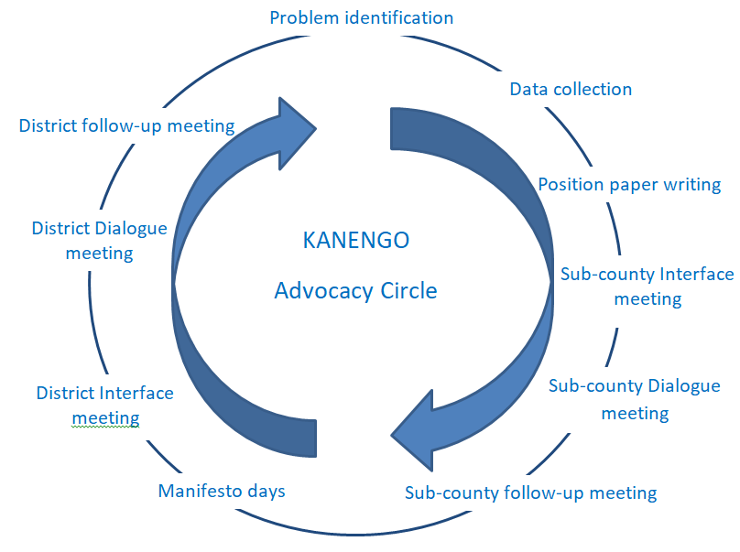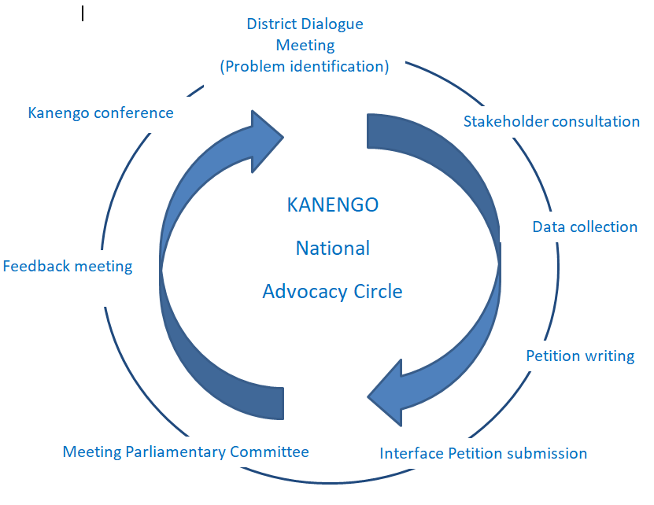

Uganda is to hold General Elections in January-February 2021. KANENGO aims to receive commitment from Presidential candidates, political parties and newly elected MPs to promote increased funding and support for NCDs activities including drugs, staffing, and equipment through signing commitment letters and incorporation of NCDs in their campaign manifestos. When members include NCDs in their manifesto, they will implement them when they are elected, justifying such an initiative.

The partners wish to continue working to make KANENGO and NAs more self-sustainable, so that the advocacy process described above may continue for NCDs, and even in other areas. KANENGO will encourage and inspire NAs to adopt VSLA and other income generating projects for self-sustainability.

- Intervention-related information work in Denmark
CISU has funded a planned information activity by the partners, Oplysningspuljen ID 19-581. The Covid-19 pandemic has so far made it impossible to fulfil, but hopefully it will be possible in 2021. The partners do not have any other information activities planned.

Non-communicable diseases (NCDs) will be defined as only lifestyle diseases such as: - Chronic cardiovascular diseases: heart attack, hypertension, stroke - Chronic lung diseases: asthma, chronic obstructive lung disease - Cancer: all kinds of cancers - Diabetes NCD Risk factors are: - Lack of exercise, drug abuse e.g. alcohol, smoking, poor/unbalanced diet.

