STUDY on Community driven income-generating INITIATIVES in Kenema, Sierra Leone based upon harvesting of experience and lessons learned on past projects
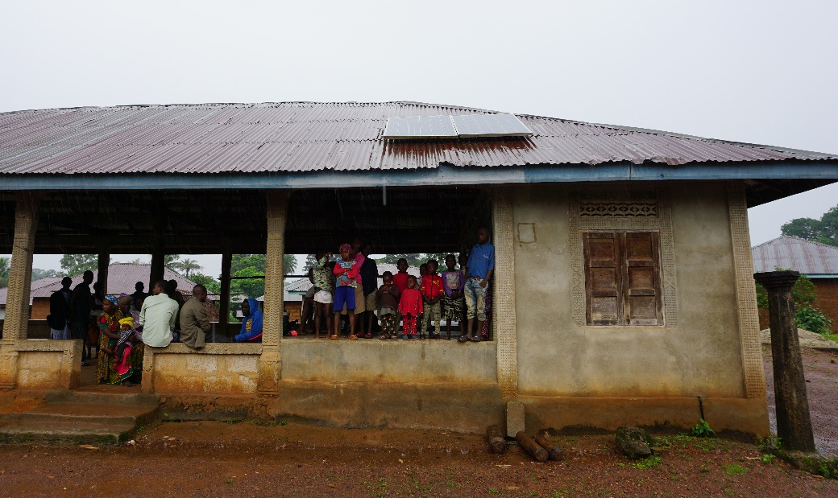

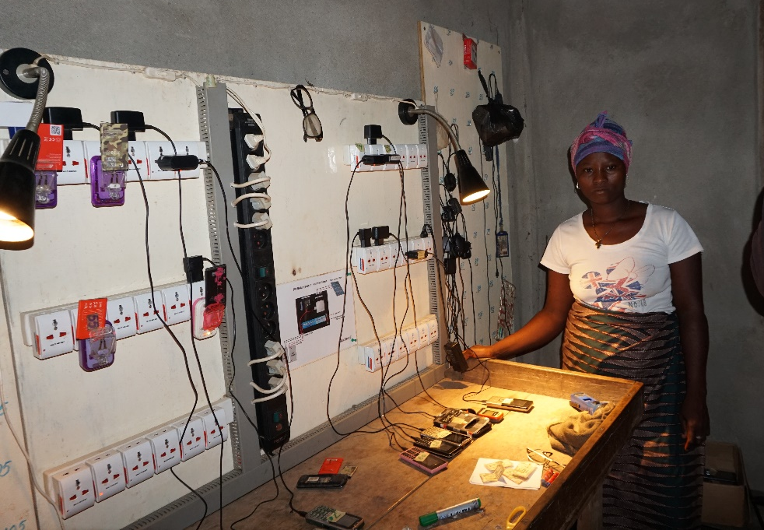

Engineers without Borders Denmark
Application November 2020

the civil society fund
Small-scale intervention

Background
Engineers without Borders Denmark (EWB-DK) and its partner in Sierra Leone implemented during 2014-2016 a community-based income generation project in connection to service delivery, financed by Danish private funding. The partners installed solar energy systems in five rural villages in the Kenema district that would also be used for charging mobile phones in areas where there is mobile coverage but no access to the national electricity grid. The mobile phones are used either for business purposes, enabling a direct contact between local businesses and their markets, or for social purposes like connecting to relatives who have moved away from the villages. The systems are operated by the local communities and a small user fee required for charging generates an income for the communities, as shown in the 2 videos: https://www.youtube.com/watch?v=mtTPciO1z9k and https://www.youtube.com/watch?v=uC2773qOYw0.

Objective and relevance (the world around us)

What we aim to achieve through the intervention
The purpose of the proposed project is to study how income generating projects/activities can be carried out in the Kenema District in Sierra Leone in order to ensure that projects contribute to the development of the communities in a sustainable and socially responsible way. The study takes point of departure in an assessment of the long-term results of the completed technical community-based income generation activities. By gathering knowledge and identification of key issues to be taken into consideration for a future intervention in the surrounding communities. Local cooperation is an important aspect of the project, and the project partners will collectively gather and analyse knowledge and lessons learned and share experiences with other relevant local actors or organisations in the district. This includes EWB-DK’s partners in Kenema, the Opportunity Training Centre (OTC) and SEND. Also the German INGO Welthungerhilfe will participate based on their experience in income generating interventions in the area.

The aim of the project is to identify community driven strategies (popular participation) on the management and utilisation of community funds generated by the initiative. In order to ensure continuity with previous projects, information will be collected on the pilot mobile charging project implemented in 2011 - 2015 and by assessing the state of the systems: utilisation, system operation, need, operator qualifications, village commitment and possibilities for support in case of needs for repair or maintenance. Further, data from other recent EWB-DK projects within the WASH area will be used as background for the study. The activities will investigate and analyse how future projects can be set up, structured and organised in order to turn them into successful sustainable income generating initiatives. This shall lead to a business model that covers investment, ownership, operation, training, management and roles and responsibilities. The data collected will be used for design of future income generating projects, including future mobile charging initiatives in rural areas in Sierra Leone as well as projects within other sectors.

The results of the study will be shared and discussed within EWB-DK and other relevant parties in Denmark. Further, the results will be communicated to the partners and communities in Sierra Leone as part of future projects.

Why is the intervention important?
The UN Sustainable Development Goals are both technical and humanitarian, and the contribution from rich countries cannot only be political or economic, but requires a technical humanitarian assistance. The transfer of knowledge from North to South is critical in assisting infrastructure projects in communities and building the infrastructure needed to ensure higher living standards and further development. Building rural infrastructure from scratch is both a political, social and technical process, and therefore it is paramount to enable and support local communities in the best possible utilisation of their resources.

EWB-DK and its partners are increasingly incorporating community management of fee-generating resources such as water supply systems, waste management and energy systems. The present initiative will strengthen the partners’ future strategies on community income generation and user fee payments in joint projects and across partnerships. Based on lessons learned from past projects as seen from EWB-DK, project partners and the beneficiaries, i.e. the local communities, the study will create a business model for future income generating projects. The focus will be income generation, market assessments, technical conditions, systems ownership, management, operation and maintenance. In order to conduct a comprehensive joint learning process, other relevant local organisations and partners with experience on community income generation shall also be invited to share strategies and lessons learned, in order to enrich applied concepts and approaches. The study results shall be used to inform the design of future EWB-DK projects by increasing the focus on sustainable income generation in the communities.

Context of the intervention
Sierra Leone is a post-conflict country in Western Africa of roughly 72,000 square kilometres and with about 7.5 million inhabitants, still struggling to rebuild itself after the end of 11 years of civil war in 2002, and the more recent Ebola epidemic of 2015. Much work in terms of reconciliation, reconstruction and rehabilitation has been done with international support, albeit inadequately, and much focus remains on the reestablishment of public service delivery and reforming and strengthening governance systems. In general, economic recovery has been slow, and basic infrastructure is still scarce across the country’s rural areas.

The country has de facto two administrative systems:
- The traditional hereditary chieftaincy, established by the British in the 1880s, with Town Chiefs referring to the Paramount Chiefs, who refer directly to the President, and
- A modern democratic system, granted by the British in 1953, with national ministerial powers and a new constitution ensuring a parliamentary system.
In rural areas in particular, the importance of the chieftaincy in the political processes is greater than the importance of the official councils, at least in the eyes of the population. Legal reforms have taken place since 2002, but despite the recognised quality of the new Sierra Leonean laws, the level of implementation remains weak. The State does demonstrate willingness to respond to the populations’ demands for service delivery but its capacity is almost non-existent. The balance between the two administrative systems is important as it indicates to what extent local communities can initiate new initiatives based upon their own assessments and decisions. This is especially important for public projects regarding infrastructure (roads, electricity, communications, water and waste) and shared facilities, i.e. storage facilities, which the generated community revenue might contribute to.

Climate and environmental Conditions to be addressed
As the energy source for charging the mobiles is solar panels on clinics and other buildings, it has no negative impact on the environment. It provides an example for the local communities outside the grid on how solar energy provides an affordable and sustainable solution that contributes to improved service delivery combined with income generation and thereby improved livelihood of the communities.

Partnership/collaborators (our starting point)

Previous cooperation with partner and how experiences will be used in the intervention
EWB-DK has many years of experience working with development and advocacy initiatives in Sierra Leone. Therefore, EWB-DK has a broad knowledge of establishing relationships and contact to local authorities on district, regional and national level, as well as with mobilising, organising and capacity building within a Sierra Leonean context.

One element of the project is to identify the long-term results of the completed project and collect, lessons learned as input for the study. The study will draw on experience from former technical projects (incl. sustainable energy and WASH) from all participating partners and enrich futures strategies locally and internationally. In particular in Kenema district where EWB-DK has been present for almost 10 year strong partnerships are developing with OTC and SEND. Both organisations have substantial experience in establishing income generating activities. OTC are managing several indicatives from their five workshops, and are in the process of establishing more indicatives. SEND has particular experience in mobilising and empowering local communities to improve local services, including WASH, and generate revenue to sustain these services, as well as providing support to creating income generating activities for in particular women and youth. The local knowledge and specific experience of these two partners is required in the development the development of a robust business model.

The partner’s role and contribution in pursuit of the intervention’s objective
EWB-DK is a technical-humanitarian organisation of volunteers with a large range of technical skills and backgrounds. EWB-DK collaborates with local and international NGOs to improve the living conditions for marginalised and vulnerable people in developing countries. EWB-DK’s efforts to ensure local anchorage and lasting solutions and are founded in the UN's Sustainable Development Goals.

EWB-DK holds a long-standing experience in working in partnerships around the world and make technology work for the poorest communities. EWB-DK has a long-lasting presence and experience from Sierra Leone, and thereby has vast knowledge on the context and activities to be analysed. EWB-DK has established itself as a relevant international partner for development initiatives, especially in the Kenema District, and has established partnerships with other organisations in the area, like the OTC. In Denmark, EWB-DK has a large member base providing expertise in various technical areas, including sustainable energy systems, community mobilisation, income-generating service delivery, business planning and will contribute to the intervention with this specific expertise. With many years of experience with technical development initiatives, promoting advocacy in developing countries and strengthening local CSOs, EWB-DK contributes with valuable knowledge within project design, knowledge harvesting, context adaptation and facilitation of experience exchanges.

For a successful evaluation and knowledge harvesting and implementation of the activities mentioned below, it is vital for Danish experts to participate in the activities on-ground, as the local partner has limited experience with this kind of activity. Knowledge sharing across the north/south not only strengthens partnerships in compliance with UNSDG #17, but more importantly installs technical, organisational and business oriented knowledge locally by strengthening partner organisations and local communities in participating actively in their own development. EWB-DK sees transfer of knowledge as help to self-help and one of the core activities for development, as it enables communities to become more sustainable in future development initiatives. For the activities in this intervention, EWB-DK will provide various important skills through its member base and the Danish project team. This includes the project manager who has experience in rural technology utilisation and related cultural, socio-economic assessments and preparation of business plans, and technical experts within rural technology and its utilisation in the local community context, including assessment of past initiatives.

As part of the project team, a project engineer from Dansk IngeniørService (DIS/CREADIS) will be responsible for the technical aspects of the project. By introducing and implementing an engineer from DIS in the project team, the project can benefit from the knowledgebase within the entire engineering organization of DIS/CREADIS, and at the same time secure continuity in the process towards the purpose and goal of the project.

EWB-DK cooperated with EWB-SL on the previous project in the Kenema District, which provided technical input for the project. In order to ensure that local support can be provided on detailed planning and local coordination in cooperation with EWB-DK, SEND will provide these services. Further, SEND will also contribute to collection of technical and non-technical experience on the completed project, as well as facilitating dialogues with the local communities where the five pilot installations were set up and utilised. SEND will also support EWB-DK in gathering market information regarding potential new income generating projects, which can be initiated and implemented based upon the results of the study. The market information shall include amongst others community needs, willingness to pay and the existing market for similar services. The latter is important for EWB-DK initiatives, as new projects shall not lead to distortion of an existing market.

SEND promotes income generation activities in Kenema district since 2009 with extensive experience in community engagement, Credit Unions Development, Microfinance activities, Village Savings and Loans, and
health related interventions appropriate for present intervention. SEND has developed good capacities and experience in promoting rural resources mobilization and investment in community development, community mobilisation for addressing gender and nutrition related awareness creation at community level.

In the Kenema district, EWB-DK also cooperates with OTC, a technical vocational school with a purpose of providing education and technical skills to disabled youth. The OTC works together with EWB-DK on upgrading facilities to meet the needs of disabled persons, and on capacity building regarding advocacy and awareness raising, strengthening the OTC on an organisational level. The OTC provides training within technical disciplines including electrical equipment, and is therefore a relevant participant in the knowledge sharing activities. They also sell the products produced in their technical workshops, and thereby have experience with income generating activity and possible business models. OTC will contribute to the investigation into how installation of future systems and their operation and maintenance services can be organised in an efficient and reliable way.

The overall aim of the knowledge and experience sharing activities is to provide skills in the local area that can improve the qualifications of actors within the field, improve the quality of service delivery, and thus strengthen development in the district.

Target groups, objectives, and expected results (our intervention)

Groups to benefit from the intervention
With the focus on joint learning and experience exchange, the activities in this intervention target various groups that will benefit from the intervention.

The primary target group consists of the local communities in the Kenema district, already benefitting from the existing mobile charging stations, or potentially benefitting from future systems to be established. These rural communities have in average ca. 700 inhabitants, and the review and evaluation of existing systems is thereby to the benefit of at least 3,500 people. However, it is estimated that the actual beneficiaries of the mobile charging systems are higher, as inhabitants from neighbouring communities also travel to the charging stations, rather than walking a much longer distance into bigger cities. If/when additional mobile charging systems are set up in the future, these will thus not only benefit approx. 700 people in the selected community, but also a high number of people in close by communities. These issues will be addressed as part of the market study. The communities will participate actively in the evaluation and knowledge harvesting of existing systems, as they are the most vital source of information on their operation and functionality. Further, the preliminary findings and conclusions will be shared/discussed with the communities before completion of the visit to Sierra Leone.

As the study will only be completed after the visit to Sierra Leone, the communication of the results of the study will be made available to the communities as part of other EWB-DK project interventions in the area and/or from EWB-DK’s local partners, including OTC.

In addition to the end beneficiaries, a second target group consist of the participating organisations in the joint activities and the knowledge/experience exchange workshop. This includes as already mentioned the local partners SEND and OTC, as they will gain experience in networking and utilising existing resources to achieve objectives and realise goals. SEND will participate actively in the evaluation and assessment of existing systems and identification of potential communities for additional systems. Furthermore, the local partner will gain important knowledge on feedback, evaluation and follow up on long-term project results, and gain valuable experience in how to apply collected knowledge in future project design. Along the same line, EWB-DK will gain important insight in the long-term results of technical development initiatives, evaluation and verification of internal reports, and successful income-generation within the local context. The OTC will participate actively in the knowledge-sharing workshop, where they are both able to share their own experience with income generating, but also are able to gain inspiration and valuable input for improving their current business model.

All partners will be able to apply the new knowledge in the formulation of future projects, thereby strengthening their positions as relevant (international) partners for technical development and income-generating initiatives in the Kenema district.

Implementation of the intervention – activities to be carried out, with whom and when
The activities in this application cover collection of experience on income generation through projects and information needed for establishing a business model for income generation projects. In order to relate the study to the community needs a future mobile charging project and other EWB-DK initiatives will be used as examples throughout the study.

The knowledge harvesting and learning process will take place among partners and external actors in the Kenema district, to ensure that relevant experiences are registered and taken into consideration when planning future income generating interventions. All participating partners aim to remain relevant actors within the field of technical development initiatives in the Kenema district and ensuring that feedback from target groups and beneficiaries is collected is an important part of this. This furthermore complies with the Core Humanitarian Standards, which the partners are also in the process of incorporating into all activities.

Specific activities to be carried out include:
- Assessment of the current state of the previous project’s installations. Guidance on potential improvements in utilisation, operation and maintenance will be provided.
- Assessing community strategies on management/utilisation of funds generated in the project
- Identifying viable organisational community-based strategies on management of income generating projects based on own experiences as well as in new perspectives from other local partners and actors
- Collection of data that can form the basis for the study and future projects (technical, market, security, operational, maintenance, social and economic, ownership)

Activities in Sierra Leone
Before EWB-DK team visits Sierra Leone SEND will establish contacts with the communities where
the existing systems are installed and collect data on the current utilisation of these systems The
data will cover operational, systems related and financial data. Further, SEND will identify potential
new communities suitable for future systems, which shall be income generating for the communities.
While the EWB-DK team is in Sierra Leone and on-ground with partners, further data collection and dialogue will be an important aspect. This concerns both regarding the installed and running mobile charging systems in the five communities, but also regarding data valuable for future project design. Regarding the existing systems, the partners will evaluate their structure, state and utilisation statistics; customer coverage and financing; operators, number and qualifications; maintenance possibilities including up/down time; the support to and after the installation and local advice for improved operation and sustainability. Data on how the system has contributed to the community with respect to business as well as social purposes will be collected through interviews with customers in order to assess the socioeconomic impact of the systems. Data to be collected for the study will be as a market survey with focus on the identification of suitable communities based on relevant factors. For a mobile charging project, the data should cover number of inhabitants; number of mobile phones, types, usage, and ability/willingness to pay; mobile coverage; community commitment, wishes and expectations. In order to assess the sustainability of an intervention the availability and qualifications of operating staff; presence of other service providers and logistics for bringing phones to and from the charging stations. Additionally, aspects such as possibilities for installation, maintenance and training will be analysed and taken into consideration for the assessment of the sustainability. For EWB-DK, this concerns for instance synergy with other projects in the area with OTC or other local organisations. Locally it also concerns management, availability of spare parts and training potential among communities. The project team will furthermore make preliminary assessment of potential set-up sites in to estimate total system costs.

A workshop will be held on income-generating activities/projects with a focus on development of a business model, local investment and financing possibilities, ownership, financial management, operation and maintenance possibilities. Besides EWB-DK and SEND, and other organisations with an interest in sustainable income-generating activities/projects in rural areas will be invited to participate in the workshop. As mentioned, this includes both EWB-DK’s other partner, OTC, but also relevant external actors and organisations in the area. During the partners’ time and joint activities in Sierra Leone, EWB-DK will also focus on identification of potential partners who could contribute to the project objectives.

Activities in Denmark
After the evaluation, analysis and workshop, the partners will conduct follow-up activities, mainly by EWB-DK in Denmark. Specific activities include:
- Assessment of collected operational data
- Assessment of collected financial data
- Assessment of data collected through the market study
- Assessment of collected input for business model for income-generating mobile charging projects including ownership, local financing and local resources for operation, maintenance and management, including financial management
- After completion of the study the results will communicated within EWB-DK and other potentially relevant parties in a workshop

The timing and sequencing of key activities is shown in work plan below.
Activity | Month | 1 | 2 | 3 | 4 | 5 | 6
1: Preparation for study visit
2. Preliminary data collection
3: Collection of data on previous project, covering utilization, operation and maintenance
4: Dialogue with communities and local NGOs on income generating projects, including organization, management, technical issues
5: Preparation of business model
6: Communication of project results

