THE DANISH EMERGENCY RELIEF FUND
RAPID RESPONSE – INTERVENTION application form

Guidance note
Before applying for an intervention please read the DERF Funding Guidelines carefully. For a practical guide on how to navigate in the online application module please see: https://www.cisu.dk/vorescisu

The intervention application must be submitted to CISU through the Vores CISU platform, which can be accessed here. In Vores CISU, you are asked to fill in some basic information related to the proposed intervention such as title, dates, area of intervention, mode(s) of assistance etc.

Information about the applicant (the Danish CSO) and the implementing partner must also be entered directly at the Vores CISU platform. Please ensure that the entered organisational data of the Danish CSO and the local partner(s) is up to date and the latest annual report and audited annual report are uploaded. For more information about how to register an implementing partner(s) please see: https://www.cisu.dk/vorescisu

When applying, you are requested to upload the following documents:
- A signed cover page using the format available at www.cisu.dk/derf
- The intervention application form (one Word document of max. 8 pages) see format below
- The partner(s)’ context analysis (one Word document of max. 2 pages, signed by the implementing partner)
- The intervention budget using the budget format available at www.cisu.dk/derf. Please also see the Budget Guide available at www.cisu.dk/derf
- Partnership policy, this is only requested if your CSO has an existing partnership policy

Note: In the application below (section 3.3) you will find that an environment marker has been introduced by the DERF. This is to allow partners identify and consider the environmental impact of their proposed and actual intervention activities. As part of the principle of ‘do no harm’ humanitarian interventions should identify adverse environmental effects to avoid, reduce and mitigate their potential impacts. Both DERF modalities are based on the premise that all interventions per default carry with them some degree of environmental impact.
CISU views the environment marker as a reflection exercise meant for monitoring purposes and the marker does not form part of the DERF application assessment criteria. The DERF intervention feedback on final reports will, however, include comments related to the markers, as relevant. CISU strives to promote environmental sustainability across its principles, strategies, networks, partnerships, pools, and practices.

RAPID RESPONSE - INTERVENTION application form

Applying organisation: Cross Cultures Project Association
Title of the intervention: Emergency Relief in Ukraine

The humanitarian intervention (describe within max. 4 pages)

  - The context: Considering the description of the context submitted by the implementing partner (attached to this application), how have you ensured that the proposed intervention is appropriate and relevant (CHS 1) for the affected population and vulnerable groups? Describe how the proposed intervention is effective and timely (CHS 2) in relation to the described context.
Introduction
As our context description shows, the ongoing and devastating attacks on Ukraine has turned the country into a dynamic warzone, where attacks on the northern, eastern, southern regions are worsening the humanitarian situation rapidly. Thus, our main concern in this project will be to establish lifesaving activities focussing on vulnerable children with disabilities, IDP children, new-borns, children without parental support and female headed households with small children, to assist them in emergency shelters, and to provide and distribute food assistance and Non-Food supplies, medicine and WASH assistance in the heavily affected regions here-and-now (CHS1, relevance). Cross Cultures is applying for 999,463.50 DKK from DERF for a 4-month project. 80% of the funding will directly benefit the crisis-affected population and 87% in the crisis area.
Cross Cultures has been operating in Ukraine, including illegally annexed Crimea, from 2010-14 funded by SIDA (5.5 Mio DKK) and by the EU from 2016-2021 (1.1 Mio EUR) in Kyiv and 8 regions in Eastern Ukraine: Kharkiv, Odesa, Dnipro, Zaporizhia, Lugansk, Donetsk, Kherson, Mikolayiev. The projects were implemented in cooperation with All Ukrainian Foundation for Children’s Rights (AUFCR) and the Ukrainian Football Association (UAF) and facilitated the formation of 9 Cross-Sector Prevention networks (CSP-networks) in the abovementioned locations, comprising among other staff and actors from the local oblasts, school psychologists, schools, sport clubs, ministry of interior, community police and other relevant local activists dealing with vulnerable children and families.

Following recent Russian armed force’s aggressions, all activities have stopped. However, Cross Cultures is communicating with the CSP-coordinators in Kyiv, Kharkiv, Mykolaiv, Zaporizhzhia, and Dnipro regions, through AUFCR, who have adapted their operations from child protection to lifesaving activities, focussing on supporting the people affected and distribution of essential supplies. These local CSP-networks provide Cross Cultures and AUFCR with a strong access to reach the target groups with humanitarian aid in the current situation. Thus, Cross Cultures argues that the effectiveness and timeliness (CHS2) of the proposed action is rooted in our direct and daily contact with our local networks and implementing partner, AUFCR.

Building on this framework, the project aims at using our existing local partnerships, CSP-networks and experiences of working in conflict affected areas, such as Ukraine, Afghanistan, Iraq, South Sudan and Syria, to provide emergency relief to vulnerable children and female headed households with small children.
Thus, the overall objective of this project is: to save lives and facilitate child protection for vulnerable children with disabilities, IDP children, new-borns, children without parental support and female headed households with small children affected by the war in Ukraine.
The overall objective is broken down to one specific objectives:
- To support local emergency shelters and to provide and distribute acute humanitarian assistance (health and WASH supplies, food assistance, and Non-Food items) to children and mothers in shelters and orphanages.

1.2 Content of the intervention:
a) Describe the intervention’s activities, the results these will have and what the outcome of these will be.

*The whole log frame has been revised in accordance with the merging of specific objective 1&2
Development objective
To save lives and facilitate child protection for vulnerable children with disabilities, IDP children, new-borns, children without parental support and female headed households with small children affected by the war in Ukraine.
Objective/outcome
1: To support local emergency shelters and to provide and distribute acute humanitarian assistance (health and WASH supplies, food assistance, and Non-Food items) to children and mothers in shelters and orphanages.

Indicator |  | Means of verification
- Number of volunteers  - Number of shelters/orphanages  - Number of supplies procured  - Number of items distributed |  | - List of volunteers and coordinators assisting  - Lists of shelters assisted  - Supply chain records  - Distribution lists
- Number of beneficiaries |  | - List of beneficiaries
Activity cluster 1 – Provision and distribution of humanitarian assistance to vulnerable unaccompanied children, IDP children and female headed households with small children at local emergency shelters.
Outputs |  | Activities
1.1 | 90 coordinators and volunteers have procured and distributed essential health and WASH supplies, food assistance and Non-Food items | 1.1 | Coordinators and volunteers from the existing CSP-network across the 5 regions procure essential humanitarian assistance based on ongoing local needs assessments and distribute for vulnerable children and women at shelters and orphanages. They furthermore volunteer and support the local emergency shelters and orphanages.
1.2 | 1700 vulnerable children and 300 mothers have received essential basic needs supplies. | 1.2 | The supplies are distributed to vulnerable unaccompanied children, IDP children, orphans and female headed households with small children at the shelters and orphanages.
Results
Cross Cultures and AUFCR’s coordinators and volunteers across the 5 regions have procured and distributed essential health and WASH supplies, food assistance and Non-Food items. 2000 vulnerable children with disabilities, IDP children, new-borns, children without parental support and female headed households with small children have received essential health and WASH supplies, food assistance and Non-Food items.

b) Describe in a few sentences the change your intervention will bring to the people affected by the crisis. What do you expect the short-term impact to be after completion of your intervention?
We expect the intervention to have an immediate impact by providing life-saving and necessary supplies including medicine and food, which will help prevent casualties. Furthermore, the project will enhance the security and wellbeing of vulnerable children caught in the war, which can help reduce trauma and increase their resilience in a highly volatile situation.
c) How will you measure the achievement of results and outcomes?
Besides the numerical indicators and means of verification shown in the log frame above, the implementing partner will follow Cross Cultures established reporting guidelines which includes monthly statistics on activities, financial reports and a narrative report which focusses on outcomes that cannot be measured by numbers (i.e. interpersonal, social changes).

d) Considering the mode(s) of assistance your intervention includes (Cash Based Assistance, Voucher Based Assistance, Goods, Services), please justify the choices made. Why are you choosing one mode instead of another, or why do you combine the modes as you do?
Cross Cultures is under the assumption that with the dynamic situation in Ukraine, it is unclear what will happen next, thus the banks that are still working could be closing, water and food supply can dry out and main roads close. As a means to provide the necessary financial support to buy the needed items, Cross Cultures will transfer the funds directly to AUFCR in Ukraine, who in turn will buy food and non-food items locally. If that becomes impossible, we will provide assistance, provision, and distribution of the above-mentioned items through our Moldovan partner.

e) How does your intervention consider the priorities mentioned in the DERF Call? How do you ensure that resources are managed and used in an effective, efficient and ethical manner (CHS 9)?
DERF identifies the needs of protection, food assistance, Non-food items, WASH and health supplies, and emergency shelter of vulnerable groups and thus, the priorities mentioned in the DERF call is directly mirrored in the objectives and expected outcomes of this project. The resources in this project will be managed and used (CHS 9) responsibly for their intended purpose by means of the established responsibilities, logistical and communicational mechanisms that has been developed and adapted through the existing partnership of 5 years.

f) Briefly describe how you intend to start your activities within 7 days of receiving the first transfer of funds from the DERF.
As the context description shows, our CSP-network has already adapted their activities to life saving activities, as best possible with their current resources. A functional communication and logistical line have also been established between Cross Cultures, AUFCR and our CSP-network, ensuring an immediate start to the activities.

1.3 The target group:
a) Describe the direct target group of the planned intervention, including their characteristics and needs. Justify how you have selected this particular target group among those affected by the crisis (i.e. which inclusion criteria did you use?). Specify also how many people will benefit from each of your main activities.

The actions will target vulnerable children with disabilities, IDP children, new-borns, children without parental support and female headed households with small children affected by the war. The specific needs of the children and mothers are continuously assessed by our local CSP networks and will comprise voluntary assistance at local emergency shelters and provision and distribution of the needed medicine, water, infant formula, diapers, blankets, mattresses, WASH essentials, female hygiene products, electricity generators, etc.
Our implementing partner, AUFCR, has identified the target groups based on the relevance encountered in Ukraine and their previous experiences and capacities of working with children. By focusing on a specific target group of relevance, the project aims at creating realistic and appropriate results within the existing capacities of the partners. This reflects the appropriateness of the project (CHS 1, appropriate).
b) Quantify your planned target group by gender and age group in the table below.
PLANNED TARGET POPULATION (INDIVIDUALS)
Age Group | Male | Female | Total
 | Number of persons | Number of persons | Number of persons
< 5 | 450 | 450 | 900
6-14 | 400 | 400 | 800
15-24
25-49 |  | 300 | 300
50-64
> 65
Total | 850 | 1150 | 2000

c) Describe who and how many of your direct target group are particularly vulnerable people. How have the vulnerable groups been identified and selected (inclusion criteria), and how does the intervention address their particular needs? Also describe how the intervention addresses protection needs of particularly vulnerable groups, as relevant.
The primary target groups are all identified as particularly vulnerable, as shown in the context description. This project focuses on vulnerable children and female headed households with small children since these particularly vulnerable groups are within Cross Cultures and AUFCRs area of expertise and because our CSP-network is experienced and settled with a strong access, reliance, and trust in the communities. The intervention addresses the particular needs of children and mothers through an ongoing needs-assessment by our CSP network and address the protection needs, by providing voluntary assistance and support to local emergency shelters who need extra hands.

The implementing partner (describe within max. 1,5 pages)

2.1 Capacity, experience and expertise:
a) What is the capacity, experience, and expertise of the implementing partner(s) (CHS 8)? Describe also the organisational and financial capacities.

All Ukrainian Foundation for Children’s Rights (AUFCR), our local partner through 5 years, will be Cross Cultures’ implementing partner in the field, continuously communicating and assuring all needs addressed in the 5 regions through our local consolidated networks. AUFCR is a non-governmental, non-profit organization that has been promoting and protecting children’s rights in Ukraine since 2002. AUFCR has 15 regional branches across Ukraine. AUFCR, in cooperation with international and national partners, has successfully implemented a number of projects in different regions of Ukraine and focus on the promotion of children’s rights, prevention of child delinquency and stigmatization, social services and social follow up for children in need, in particular for IDP-children. AUFCR works closely with the government of Ukraine to support and advise on the implementation of children’s rights and on the elaboration of relevant legislation and state policy. AUFCR is a Board member of National CSOs Coalition “Child Rights in Ukraine”. Since 2014, AUFCR is an active member of Child Protection Cluster of UN OCHA Ukraine. Thus, AUFCR is well experienced and capacitated to manage the level of funding applied for and are recognised experts in working with vulnerable children in Ukraine.

b) How does the organisational set-up ensure access to the people at-risk, including particularly vulnerable people?

The organisational set-up of the project is illustarted in the model below. This shows how the abovementioned CSP-network, AUFCR and Cross Cultures communicate together, on a daily basis. The model also illustrates the comprehensive CSP-network, which is a key facor in ensuring a realistic and effective access to the target group. As descirbed above, Cross Cultures Moldovian partner has agreed to help, on a voluntary basis, with assistance, provision, and distribution of supplies – but only if necessary.
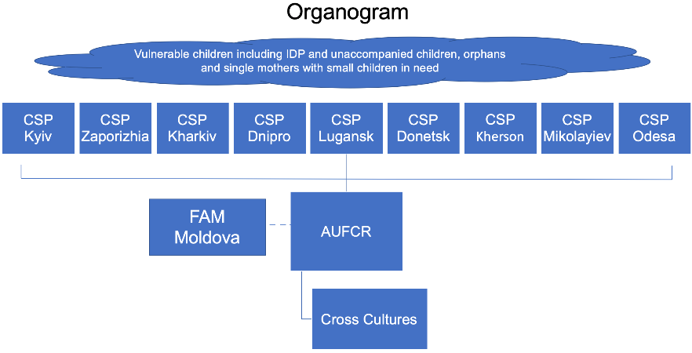
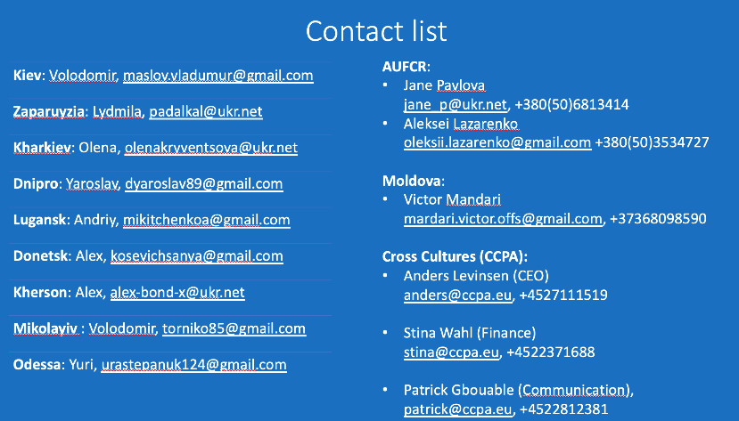

2.2 The partnership:
a) Kindly explain whether you have entered into partnership agreement(s) the main features of such agreement(s) and whether the agreement(s) were developed with the local partner.

Cross Cultures and AUFCR’s ongoing partnership through 5 years, funded by EU (1,1 million EUR), has been developed collaboratively at the start and throughout the project, that has not yet come to an end. The project has so far contributed to enhance reconciliation, social integration, peace building and child protection by establishing a coordinated and united effort with a broad range of non-state and state actors, who are in direct daily interaction with children and youth, particularly IDPs, at the local and national level.
The underlying assumption is that successful integration should involve all professional actors who work with children on a daily basis, to collaborate.
The original agreement of our partnership focused on the contributions, roles and responsibilities of the partners in order to achieve our deliverables of training 1836 young voluntary coaches to engage 61,600 vulnerable children (50% IDPs) in inclusive sports activities, and to establish a CSP-network conducting child protection for 80,000 pupils and 80,000 parents. The roles and responsibilities of the agreement, as we will elaborate below, will continue in this proposed project, however all activities have been adapted to life saving activities.

b) Describe the contributions, roles and areas of responsibilities of all partners (including the Danish CSO) within this intervention.
AUFCR will be responsible for overseeing organisation, implementation, and monitoring of the project activities, including coordinating and managing the CSP-network, ensuring that the local units are well supported in their endeavours to help and assist the afflicted target group. Cross Cultures carries overall responsibility for the programme management and administration, including supervising, planning, and monitoring the progress of the action. Furthermore, Cross Cultures provides necessary professional, technical, administrative, and moral support, financial management and accounting, and prepares narrative and financial donor reports and fundraising.

Local strengthening (describe within max. 1 page)

3.1 How does the intervention strengthen local capacities and avoid negative effects (CHS 3)?

The main concern of unintended consequences that can unfold as a result of our activities is that it is insecure to move around in the war affected communities and on the roads. This project aims at mitigating this risk by working cross-sectoral through our CSP-networks. We argue that a functional and well-coordinated cross sectoral effort can enhance the security and minimize the amount of moving around needed. Likewise, because the CSP-network in its essence is a network of different local and national actors, the very activation of this network will strengthen local capacities because the action will involve and support these local and national actors (CHS 3).

3.2 Describe strategies for informing and involving affected people in the intervention (CHS 4)

As previously described, our local CSP-networks are a key factor in informing and involving the affected people of the intervention, because of their already established foothold in the communities and with the target group (CHS4). With 5 units of min. 10-15 volunteers across 5 regions the informational work is done through existing social network and by word of mouth.

3.3 Environment marker (only for monitoring purposes)

a) Choose which of the following three descriptions best characterises your intervention (tick only one box)

MARK |  | DESCRIPTION |  | EXPLANATION
☒ | → | The intervention includes environmentally harmful components without incorporating mitigation measures to reduce anticipated impact | → | The intervention duly identifies and considers the environmental impact of its collective activities as harmful without being able to apply substantiated remedial action (e.g. sourcing, procurement, supply chains, logistics, transport, waste and service delivery).
☐ | → | The intervention includes environmentally harmful components and incorporates some mitigation measures to reduce anticipated impact | → | The intervention duly identifies and considers the environmental impact of its collective activities as harmful and applies some substantiated remedial action (e.g. sourcing, procurement, supply chains, logistics, transport, waste and service delivery).
☐ | → | The intervention includes environmentally harmful components and incorporates significant mitigation and environmental enhancement measures to reduce anticipated impact | → | The intervention duly identifies and considers the environmental impact of its collective activities as harmful and includes significant substantiated remedial action as well as environmental enhancement components (e.g. sourcing, procurement, supply chains, logistics, transport, waste and service delivery).

b) Briefly explain your answer.
Cross Cultures and AUFCR assess that with the severity and dynamic situation of the war in Ukraine, the project will refrain from applying efforts to avoid or reduce negative environmental effects. Since this project proposes a rapid response, and since environmental management is not naturally within the capacities of the project partners, we argue the capacity building those environmental efforts would inquire, is conflicting to the intention of the DERF call and the project proposal.

4. Risk Management & MEAL (describe within max. 1 page)

4.1 Describe the intervention’s risk management approach and which systems and mitigation measures are applied. Describe how the chosen risk management approaches are appropriate in the specific context?

Security: Warfare and Russian annexation of a given area is of course impacting the security situation. In this case the CSP-network will assist local authorities to provide safe shelter and security to the vulnerable children. Furthermore, it is insecure to move around in war affected communities due to the uncertainty of attacks. Our risk management to this approach is described above in 3.1

Accessibility: There is a risk that the warfare will lead to closing off all roads and corridors, preventing us from accessing the people in need. To mitigate this risk, we will rely on our local network, who knows how to navigate off-road paths.

Supplies: The third risk is that local banks and markets will close operation or run out of the needed supplies. To avoid this, we will establish a supply chain with procurement of products in Moldova and transport the supplies to the Ukrainian border, which will subsequently be picked up and distributed by the Ukrainian network partner.

4.2 Describe the implementing partner(s) approach to monitoring, feedback and accountability systems (CHS 5), including the contextual complaint mechanisms.

Besides the monitoring and reporting systems described in section 1.2 c, Cross Cultures has established a logistical mechanism that ensures that supplies are traced and accounted in all steps of the supply chain. Secondly, Cross Cultures has appointed a person at the headquarters to receive complaints from our beneficiaries, volunteers and coordinators. The contact information of this person will be available to all and highlighted in alle activities. The complaint will be assessed at the headquarters of Cross Cultures and appropriate action will be set in motion subsequently (CHS 5).

4.3 Describe how learning and reflection will be applied in terms of improving future humanitarian interventions (CHS 7)?

To see how our CSP-network adapts from development activities to life saving activities in Ukraine and navigates in the current context, will be an important experience that, through lesson learned meetings between AUFCR and Cross Cultures, will serve to improve future humanitarian interventions (CHS 7).

5. Coordination (describe within max. 0,5 page)

5.1 Describe how the intervention complements the humanitarian and/or development efforts of the national and local authorities, as well as those of other stakeholders?

As previously described, the CSP-network comprises already, among other, staff and actors from the local oblasts, school psychologists, actors from schools and sport clubs, ministry of interior, community police and other relevant local activists dealing with vulnerable children and families. Be completion of this project, the intervention will complement national and local authorities’ efforts by functioning as a coordinating unit cross-sectorally.

5.2 Describe how the implementing partner(s) participate in relevant coordination mechanisms?

AUFCR will, besides implementing this project, participate in, assist, and support local, regional, and national coordination mechanisms through their membership in the Child Protection Cluster of UN OCHA Ukraine network.

9 units in the 9 regions: Kyiv, Kharkiv, Odesa, Dnipro, Zaporizhia, Lugansk, Donetsk, Kherson, Mikolayiev.

