Danish organisation | Denmark Lesotho Network
Title of the intervention | Climate Proofing for smallholder farmers of Lesotho
Partner name(s) | Rural Self-Help Development Association
Amount applied for | 4,365 mio dkr
Country(ies) | Lesotho
Period (# of months) | 36 months

- Objective and relevance (the world around us)

  - Purpose of the intervention, and challenges it addresses
1.1.1 Objectives of the intervention
The long-standing partnership between RSDA and Denmark Lesotho Network has consistently supported smallholder farmers and their organisations in Lesotho, most recently through the Lesotho Agriculture and Food Forum (LAFF) platform, elevating farmers voices and providing a mechanism for advocacy and engagement with national government. RSDA is now well positioned to expand their support to farmers, and this intervention seeks to build the resilience of farmers to the climate change. Impacts which they are increasingly experiencing.

The target group (smallholder farmers) as well as the thematic area (agriculture) are heavely impacted by the increasing variability in climate patterns in Lesotho. 60-80% of the population in Lesotho depend on the outputs of, predominantly rain-fed, subsistence farming. The nature of their agriculture practices leave them vulnerable to the increasingly erratic variations in seasonal weather patterns such as increased incidence of drought, late onset of rain, early onset of frost amongst others. This intervention targets 5000 farmers by leveraging their own structures of farmers groups and organisations to support the uptake of farming practices which are more resilient to climate variability as well strengthen the parts of the system (value chains, markets, enabling policies) which ensure their farming operations can deliver strong financial returns.

The key intervention components are outlined in the diagram below.

Impact:
Agriculture practices and systems that reduce vulnerability to climate by creating sustainable production and increased income for small holder farmers.

Fundamental to the intervention is the promotion of the types of agriculture practices which can improve the resilience of small holder farmers production in the face of climate change. These practices represent emerging best practice to ‘climate-proof’ the agriculture sector and include the concept of Climate Smart Agriculture and Regenerative Farming (Box 1 & 2 for further explanation of these concepts). Smallholder farmers in Lesotho are quite well sensitised to many of these practices from previous interventions and government extension, but often lack the practical support or resources to implement them. This intervention focuses on the practices that the farmers have chosen as their own highest priority to implement.

Box 1. Climate Smart Agriculture
Laid out for the first time in 2015 by the Food and Agriculture Organisation (FAO) of the United Nations, Climate Smart Agriculture is an approach for transforming and reorienting agricultural production systems and food value chains so that they support sustainable development and can ensure food security under climate change. It has since been adopted as best practice in Agriculture Development particularly in low-income countries. Climate Smart Agriculture has three pillars and aims to;
- Sustainably increase agricultural productivity, to support equitable increases in farm incomes, food security and development.
- Strengthens resilience of Agriculture to the impacts of climate change
- Reduce greenhouse gas emissions from agriculture (where possible)
CSA is not a set of practices that can be universally applied, but rather an approach that involves different elements embedded on-farm and beyond the farm and incorporates technologies, policies, institutions, and investment. Contrary to conventional agricultural development, CSA systematically integrates climate change into the planning and development of sustainable agricultural systems.

Box 2. Regenerative farming
Regenerative farming is a system of farming practices that seeks to rehabilitate and enhance the entire ecosystem of the farm by placing a strong focus on soil health. There are 5 core objectives;
1. Keep the soil surface covered as much as possible
2. Try to limit the amount of physical and chemical disturbance of the soil as much as possible
3. A wide diversity of plants is encouraged to increase soil biodiversity
4. Keep living roots in the soil for as much of the year as possible
5. Integrate grazing livestock into the system

As well as supporting and training farmers with specific agriculture practices the intervention will also address value chain gaps - labelling for green products (narrative labelling) agreed with smallholder farmers and multi-stakeholders , which is necessary as part of the produce aggregation and quality control required by consumers. Narrative labelling is explained in box 3 below:
Box 3. Support for green value chains (Slow Food Narrative Labelling)

According to Slow Food Movement, a narrative label does not replace the legal labels, but supplements it by providing additional information regarding varieties and breeds, cultivations and processing methods, areas of origin, animal welfare, and advice on storage and use.
They can be printed on the package or downloaded by using a QR code. Labels and packaging can indeed constitute effective instruments to inform consumers about how the product was made and its links to local terroir, culture, and traditions. They can contain storytelling elements, and thanks to QR codes they can link to multimedia narrations hosted on websites and social media. Adopting a narrative approach to labelling can permit to influence consumers at points of sales during their comparison of purchase alternatives and successfully differentiate heritage products from lower-priced alternatives.

Under the support for green value chains, the intervention will launch a process of activities which evaluates;
1. What the narrative label for Lesotho smallholder farmers (SHFs) products should be
2. Determine possible barriers to launching of the label and support advocacy activities for enabling environment
3. What production methods will be set in the production protocol
4. How the small holder farmers will be monitored and how to keep traceability
5. Training of smallholder Farmers.

Whilst the green (sustainable, organic, biodynamic) market systems are not as developed in Lesotho as in Europe there is an opportunity to access premium prices for products which may be selected from dry beans, sorghum, and grass- fed red meat and milk.

The intervention will also promote and support public-private integrated agricultural extension services that promote climate resilient agriculture and e-agricultural extension services to reach out and provide updated information on weather and climate alongside the regenerative farming practices and value chain information.

Working together with likeminded CSO and the private sector in the network “Lesotho Agriculture and Food Forum - Partnership” (also initiated within the DLN-RSDA Partnership), the intervention will widely build the capacity and provide the necessary infrastructure to allow smallholder farmers’ organisations and forums to both speak with one strong voice in advocating to government regarding their needs. Additionally, this platform can serve the function of aggregating the volumes of green products and quality control.

1.1.2. The Climate Challenge for smallholder farmers
This intervention has been designed to respond specifically to challenges created by the climate change impacts on agriculture production and the smallholder farmers of Lesotho. A selection of key stakeholders and smallholder farmers were asked to identify the climate related impacts on their production. Centring the analysis around crops for food, crops for fodder and the linkages from fodder to livestock production, the following problem tree was constructed linking the climate hazards to the direct and indirect impacts and risks to smallholder farmers.

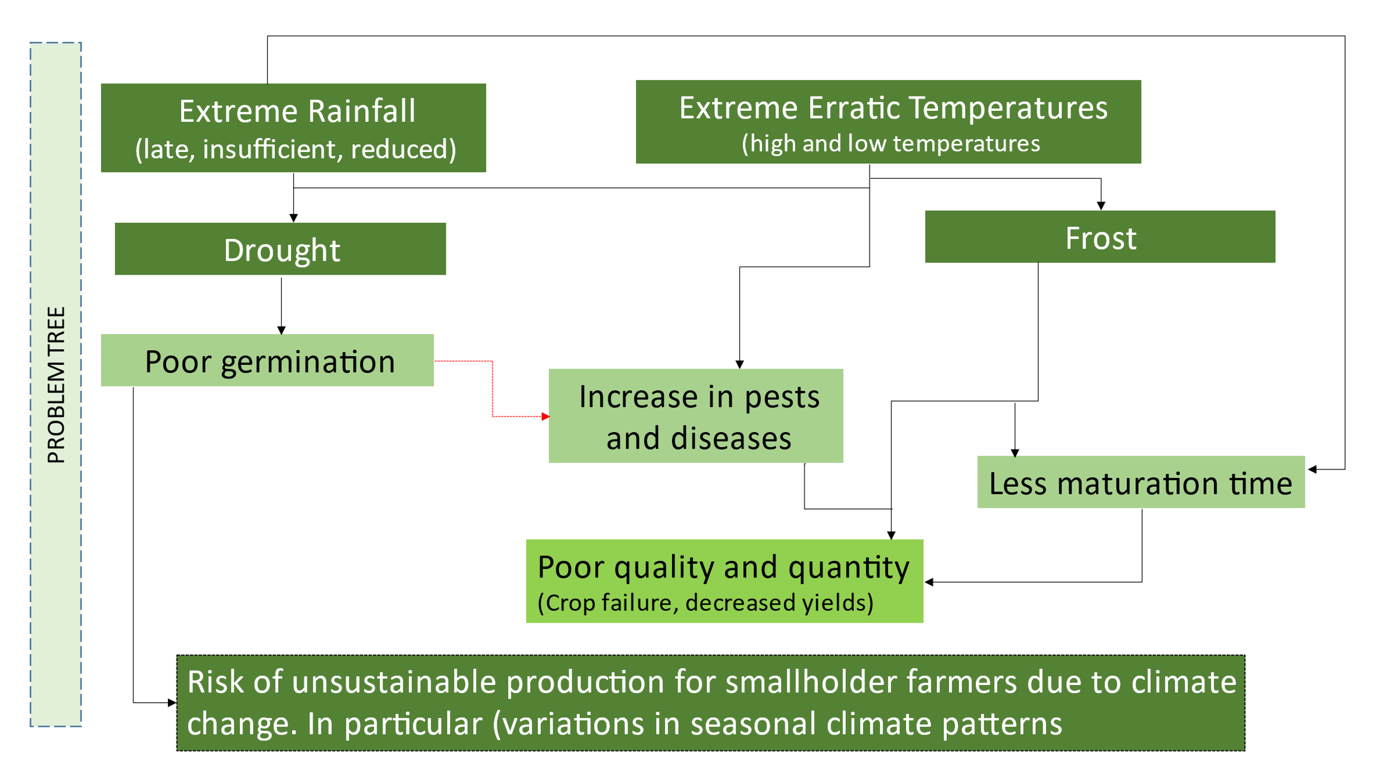

Changing extremities in weather patterns were the primary climate hazards identified for smallholder farming systems; particularly late onset and/or reduced rainfall and extreme lows and highs in temperature. These hazards led to several core critical impacts which significantly threaten the success of smallholder farmers, including poor germination of crops, an increase in pests and diseases, less maturation time, poor quality and quantity of output (failure, decreased yield), poor soil quality and poor livestock health and productivity. This problem tree allows a more targeted response to farmer vulnerability and formed the basis for RSDA’ climate risk assessment study on sustainable agriculture production to help future programming.

1.2.1 Understanding drivers of climate risk for smallholder farmers in Lesotho
Climate Risk Assessments are the tools that are used for understanding the risk (and therefore challenge) climate change brings to projects and communities. Using an international best practice methodology aligned to the International Panel on Climate Change (IPCC) 5th Assessment Report methods for conceptualising and analysing climate change impacts; hazard profile, vulnerability (sensitivity and capacity) and exposure were analysed by RSDA (based on stakeholder inputs) for sustainable agriculture production by smallholder farmers. This tool builds on the problem tree and allows RSDA to target intervention at actual points of exposure or vulnerability small holder farmers face. The tool provides better understanding of vulnerabilities and leads to choosing responding adaptation measures that are based on farmer experience and evidence rather than guess work. The RSDA application of the tool have formed the basis for the intervention proposed here. The figure below represents the framework and vulnerabilities which we are targeting.

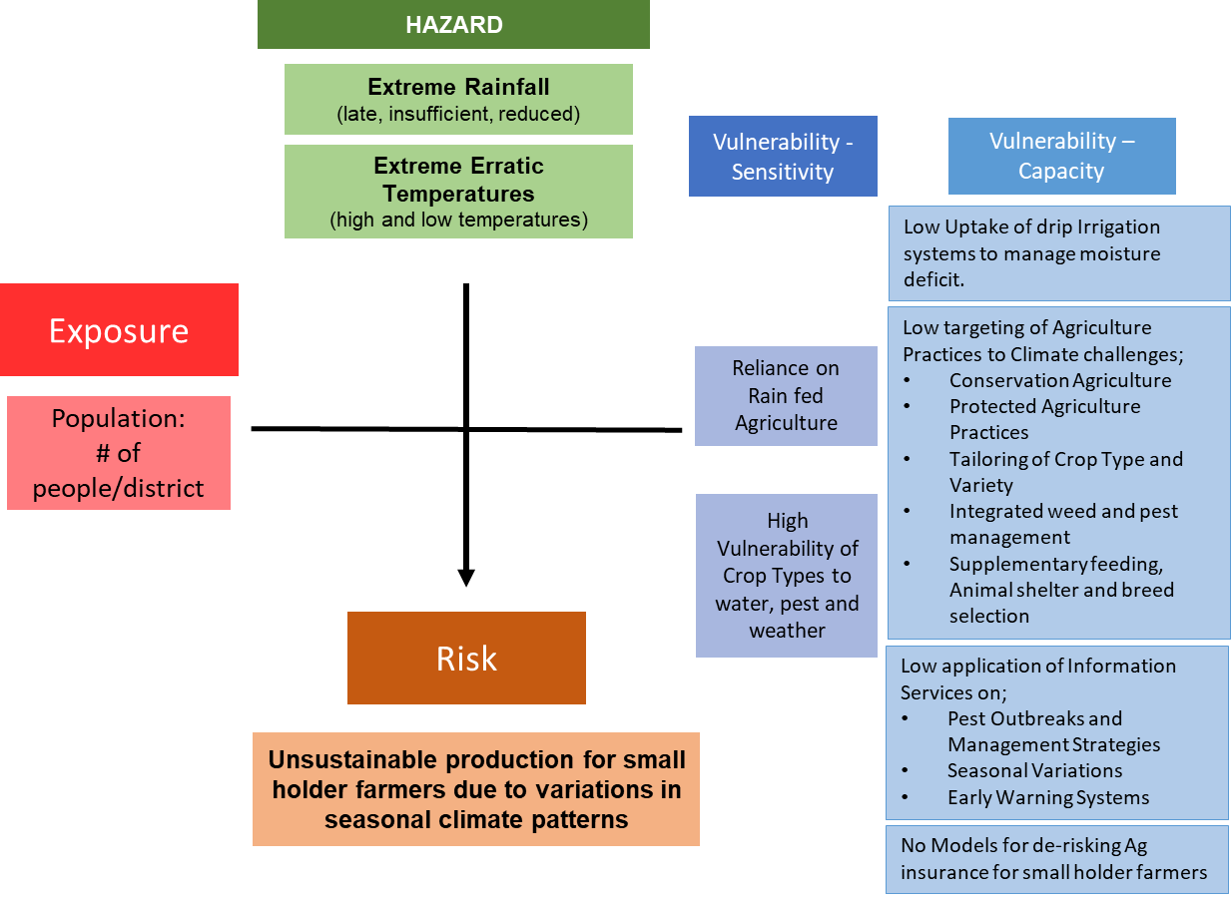
Final Climate Risk Analysis Framework,2019

1.2.2 Challenge of Erratic Rainfall on Rainfed Agriculture
Climate change in Lesotho includes erratic weather patterns, primarily: increasing temperatures and decreased and erratic rainfalls. Lesotho experience higher temperatures, increased climate variability, and an increased frequency and intensity of extreme weather events all with impacts on crop and livestock production, water security, and rural infrastructure. Dependence on rain-fed agriculture is one of the primary challenges in Lesotho. Reduced annual rainfall is predicted to continue in the future and combined with increased incidence of drought and delayed onset of rainfall is creating challenges to sustainable production, and therefore also impacting household income, and food security. Especially where farmers are entirely dependent on one commodity their resilience is challenged, and they will have difficulties coping and adapting in cases of extreme and variable weather patterns. These challenges are recognised nationally by the Basotho and the Government of Lesotho, to threaten food and water supply.
Solution: Regenerative Farming Practices which focus on conserving, protecting, and managing soil water, help protect and make the most of scarce rainfall (Strategic Objective 1, henceforth ‘Objective 1’).

1.2.3 Challenge of post-harvest losses and market access
The system which enables farmers to achieve good income from their efforts does not end at the farm gate, but historically many agriculture support programmes focused on farming practices only. In Lesotho, like the rest of the sub-Saharan Africa, 30%-50% of food produced for human consumption is lost or wasted along the value chain every year. These losses equally affect nutrition, food security and income and create a reliance on imported supply which poses a risk of conflicts and unstable political conditions. Adopting a value chain approach ensures the sustainability and climate resilience of interventions by making sure all elements of the systems within which smallholder farmers operate are healthy. These elements include access and use of their farm inputs, farm practices, processing and marking of outputs, the enabling environment created by policy and regulation.
Solution: Improve access to markets by strengthening key functions for labelling of green products using Slow Food Methodology and reduce food loss. Improve aggregation and support marketing and labelling which gives access to improving the sustainability of production as well as building climate resilience (Strategic Objective 2, henceforth ‘Objective 2’).
Solution: Leverage the existing coordination platform (LAFF) which is well positioned to advocate to governments, and private sector so that their actions better meet the needs of smallholder farmers and consumers (Strategic Objective 3, henceforth ‘Objective 3’).

1.2 Context of Intervention
The context for this invention includes the existing social, economic and political conditions in Lesotho which can all impact on the need for, and success of this intervention at building smallholder farmers households’ resilience to current and anticipated climate changes. The range of these unique contexts is summarised below.

1.2.1 Social conditions
Agriculture remains an important sector in Lesotho for food security and employment creation; it is the “backbone of the rural economy” where 65.8 percent of the population lives (Most recent 2016 Census). Agricultural sector contribution has declined over time, from a high of 15.2 percent in 1984 to 5.2 percent in 2014, and slightly increased by 6.9 percent in 2016. Regarding employment, the agriculture sector is estimated to employ 8.5 percent of the urban population and 50 percent of the rural population.

Thus, Lesotho is an agrarian society: 50% of the rural population rely on farming as their main livelihood source, 90% of which are subsistence farmers, and up to 80% of the total population engage in some form of agricultural activity (Food and Agricultural Organisation-FAO, 2016). However, with only 9% of its land available for arable agriculture and low agricultural productivity levels, there is a high dependence on imports from South Africa, and households manage low levels of income. The low agricultural productivity is, among others, a result of market barriers, which lead to low adaptation to high yielding technologies and poor adaption capacity to climate change. As a result, Lesotho is faced with food insecurity and malnutrition. After three years of poor agricultural harvest, food security has improved slightly in 2021 with the Integrated Food Security Phase Classification (IPC), a cluster of UN and government agencies, analysing that 12% are facing high acute food insecurity (IPC Phase 3) in the current period from July to September 2021 set to increase to 21% of the population from October 2021 to March 2022. Phase 3 is where people may require humanitarian action to reduce food gaps, protect and restore livelihood and prevent acute malnutrition.

Due to the gender gaps in the agricultural food production, the negative impacts of climate changes, influence women more than men. Women make significant economic and social contributions in paid and unpaid work, in the family, the community and the agricultural workforce. Women’s large presence in agriculture in Lesotho shows that they are a key factor in transforming agriculture and thus improving the lives of rural households. The access to participate in, adopt to and benefit from climate-smart agriculture practices will be especially important for rural Basotho women.

1.2.2 Economic Conditions
The Covid-19 pandemic has provided a gap in the market for more fresh food outlets. There is an increased demand from both local households’ markets and commercial markets. The lockdown restrictions resulted in border closures and the country ran out of most imported essential food items. Prices increased; more people went hungry. A lot of companies permanently shut down resulting in job losses. Most Basotho people are producing their own food and are looking for markets to sell their excess produce. At the same time caring for and protecting the natural environment is a priority to the nation.

1.2.3 Political conditions
The intervention expects to take place in a rewarding and stable context. The Government of Lesotho is committed and is in the process of implementing fundamental national reforms after a growing recognition that Lesotho needs to undertake far-reaching reforms to ensure stability and prosperity. The rationale being that Basotho, as everybody else on earth, have the right to live in a stable, peaceful, and secure environment thus to be assured their rights and necessary national support. To date, the National Reforms Authority (NRA) has been set up and given a mandate to articulate activities leading to national dialogues set to build stakeholder consensus on the reforms themselves; and that of building long-term national unity and reconciliation.

Another major task at present of the Government of Lesotho is to prepare the country for the September 2022 National elections, which will result in a new parliament to set up a new government. Even though the national environment is expected to remain stable, historically Lesotho has experienced major challenges, even riots, following national elections, when gathering new parliaments and negotiating change of governments.

However, these disruptions rarely impact on the execution of day to day, work and RSDA has the experience of working and implementing projects within these fast changing, unpredictable contexts which are typically experienced only for short time frames. In terms of mainstreaming CSA into core Government policy, the Government of Lesotho has made some strides supported by FAO. The CSA approach provides the means to help stakeholders from local to national and even international levels identify agricultural strategies suitable to their local conditions. Hence, space exists for the intervention multi-stakeholder forum to advocate for agricultural strategies to secure sustainable food security under climate change. For example, advocating for providing incentives for adopting CSA, such as payments for environmental services, encouraging farmers to take on climate-smart practicing and to overcome initial investment barriers is one area that may be explored.

1.3 How intervention builds on previous results to strengthen Civil Society
RSDA has a long history of initiating and facilitating smallholder farmers’ organisations, the civil society sector, the private sector, and especially linkages with relevant government ministries (e.g., the district-based Ministry of Agriculture financed agricultural extension service). This has culminated in the formation of the Lesotho Agriculture and Food Forum (LAFF) which supports the Ministry of Agriculture’s extension strategy and has developed a report with government entities. The establishment of LAFF has left RSDA and LAFF uniquely and incredibly well placed to facilitate innovative platforms and for the lobbying for community-supported agriculture and market access. LAFF fills a unique gap that is the hardest challenge to fill in typical agriculture development programming. That is the coordination and advocacy platform that brings together relevant stakeholders and gives farmers a voice to interact with public and private sector players whose actions influence their wellbeing. This intervention will build on the implementation structure from the LAFF project which is shown below. The structure will be further extended such that both LAFF-P and the district farmers forums’ which form LAFF will be entry points for training and capacity building and strengthen their producer commodity value chains to be active in the LAFF innovative and lobbying platforms.

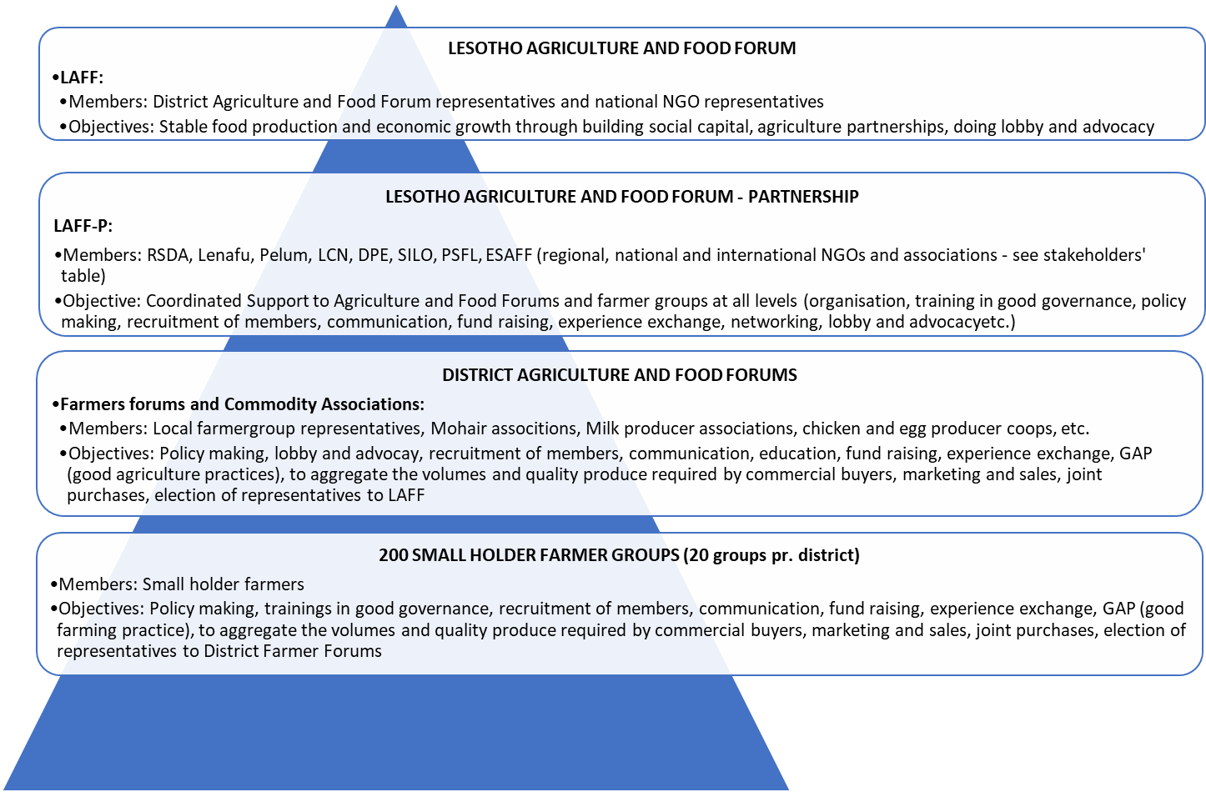

1.4 Climate- and environmental conditions
As already outlined smallholder farmers in Lesotho are facing increasing climate risks, particularly extreme rainfall patterns (late, insufficient and reduced) and erratic temperatures (more extreme highs and lows). Farmers have identified the link between these hazards and a number of core critical impacts which significantly threaten their success; poor germination, increase in pests and diseases, less maturation time, poor quality and quantity of output (failure, decreased yield), poor soil quality, poor livestock health and decreased productivity (Keam, 2019). Responding to these environment and climate conditions is a fundamental objective of this intervention which builds on the advanced climate risk and impact assessments completed by RSDA under previous projects such as the GIZ funded Climate Resilient Agriculture Production. This foundational work to understand direct and indirect climate impacts enabled the tailoring of this intervention to the specific vulnerabilities which are increasing the climate hazard risks for smallholder farmers. By its very nature this intervention will have a positive impact on the environmental conditions for smallholder farmers and pro-actively reduce their climate risks.

2. The partnership/collaborators (our starting point)
The RSDA and DLN partnership is by now 18 years old. The proposed project will utilize the achieved results from previous projects, especially the impact of the now well established and nationally recognised smallholder farmer organisation “Lesotho Agriculture and Food Forum”. The partnership is now responding to the emerging needs of civil society and smallholder farmers as they adapt to the changing climate and try new approaches that are more resilient. In delivering this support the partnership use delivery mechanisms which will at the same time spread, elevate, and consolidate the results accomplished so far by the partnership.

2.1 Experience and Capabilities of Partners
2.1.1 Denmark Lesotho Network
DLN is a membership-based organisation, which was founded in 2002 by former development workers to allow the society of Denmark to assist NGOs in Lesotho to alleviate the consequences of poverty. The mission of the Denmark Lesotho Network is:
- To support initiatives for improved living conditions and promotion of development in Lesotho
- To promote contact and exchange between people of Lesotho and Denmark.
The DLN-RSDA working group comprises various competences such as business development, teaching, farming, consultancy, project management and financial management. The group was established in 2004 and has a mix of new members and members who have been involved in the RSDA projects since 2001. Several members have been posted in Lesotho and have good knowledge of the context. During project visits in Lesotho and visits by RSDA in Denmark, the group has gained extensive knowledge of the previous political, economic, and social developments in Lesotho as well as RSDAs strategies and methods for organising smallholder farmers to implement and speak with one voice.

The project at hand will bring a LAFF delegation led by RSDA to Denmark. Some of this study tour will be focusing on Danish farmer organisations’ way of organising and their way of doing lobby and advocacy. Most of the study tour will be focused the part of the Danish agricultural extension services that promote climate resilient agriculture and e-agriculture as well as regenerative agriculture and green product labelling. A part of the study tour will be people to people information work.

A joint DLN-RSDA effort of the development of this project proposal has ensured equal responsibility, shared ownership and professionalism regarding problem analysis, meticulous planning, careful organisation, and writing. It has furthermore ensured a fine tuning and a common understanding of the objectives of the intervention, the cost level and expected implementation period, target groups and participants regarding the strategy and the sustainability of the intervention. CISU advisors have fed valuable planning, monitoring and evaluation techniques, perspectives, and thoughts throughout the process. A process that was initiated September 2020.

2.1.2 RSDA
Rural Self-help Development Association (RSDA) was registered as a non-governmental organisation on December 9th, 1991. Over the past 30 years of its existence RSDA has built a commendable track record and experience as a provider of advice and support to the smallholder farmers in Lesotho on both crops and livestock. As a national leader within technical advice to smallholder farmers RSDA has unique experience in engaging with farmers at community level. This advantage is supported by its physical presence in the field through placement of technicians and community animators. This presence allows RSDA to be aware of the constraints at farmer level through daily communication with participants and unparalleled knowledge of their issues and needs.

RSDA is a recognized NGO in Lesotho, both within the civil society movement and as a partner of the Lesotho government. RSDA has been involved in several projects under the Ministry of Agriculture and is previously implementing a climate change vulnerability assessment for a sorghum value chain for Lesotho Government - Department of Agriculture Research. RSDA’s role is to lead and undertake the climate risk assessment of the value chain, doing research on existing good practices, and produce a report which will be a benchmark for a visibility study and ensure the experiences of smallholder farmers shapes investment planning for the Department of Agriculture Research. This recognition and respect accorded RSDA by government helps RSDA deliver their advocacy activities on behalf of smallholder farmers and via LAFF.

In terms of governance, RSDA’s constitution stipulates that the Board of Directors is the supreme governing body. Subject to its statutory obligations under the RSDA’s Constitution, the Board of Directors has the responsibility to lead, control and set the strategic direction of the organisation. The RSDA Board Charter provides guidelines on how the board carries out its mandate of leading and directing the organisation. The role of the Board of Directors includes monitoring of RSDA’s financial position, business affairs, appointment of auditors and approval of budgets and plans. RSDA has proven experience, capacity, and financial systems to spend and account for more than US$700,000.00 (annual budget).

The local farmer groups, the district umbrellas (now to be known as District Agriculture and Food Forums) and the national body (now to be known as Lesotho Agriculture and Food Forum) are rather autonomous. But they all consider themselves part of RSDA. Primarily because RSDA has been active in the rural areas for more than 30 years, and thus has a personal knowledge of many farmers and their associations.

In 2019 RSDA led the regional Climate Resilient Agriculture Production Programme funded by GIZ. The implementation was led by RSDA and involved a collaboration between the Departments of Agricultural Research in Lesotho and Botswana to undertake a climate risk assessment of sustainable agriculture and climate-smart agriculture (CSA) best practices in both countries, using the sorghum value chain as a reference case where necessary. Following the development of a Climate Risk Assessment and the identification of CSA practices suited to the contexts of the countries, the programme conducted a study of the feasibility of scaling up CSA-based production in both programme countries to inform the development of a scaled investment proposal. In delivering this programme RSDA convened regional stakeholder workshops and built capacity of Department of Agricultural Research’s for climate risk assessment, and community engagement across both countries. RSDA is now positioned to communicate the needs of farmers within the frameworks that the government of Lesotho has established for their climate response.

So RSDA and RSDA Staff already have the most needed competencies for this intervention. They have:
- Practical knowledge about farming methods and the small holder farmers knows it and trust RSDA as their advisors
- They have a well-functioning network with farmers organisations, which RSDA have facilitated for several years
- RSDA has been the initiator and driving force founding the now local, regional, and national very well established and recognized Lesotho Agriculture and Food Forum (LAFF)
- RSDA is a central partner for smallholder farmers, for them to benefit from government paid extension officers. The extension officers are situated all around the country and will be encouraged to support this intervention (RSDA Staff has a persistent practice of working alongside government paid extension officers).
- RSDA staff have grown their knowledge of climate change impact chains and adaptation planning over the past 5 years and now have a strong understanding of the science of climate change and best practice tools in responding along with the lived experience farmers face.
RSDA has its own webpage and is active on Facebook where more information about the organisation can be found.

2.2 The Partnership RSDA and DLN
The partnership between DLN and RSDA separates itself from RSDA’s other international co-operations by being a true partnership where RSDA is involved in the entire process and thereby securing more sustainable outcomes. Thus, DLN has been a valued partner for the RSDA leadership during all years of the partnership. DLN and RSDA have frequent online meetings, jointly keeping track of results, threats and opportunities. The partnership has also strengthened RSDA’s position for political influence. The constant Danish support and reliable financing during years and implementation of a bouquet of projects, have created great respect among RSDA stakeholders. RSDA has become a natural “listen-to-partner” for ministries and departments in agricultural matters. RSDA has become a central partner and stakeholder for the most important decision makers. Fundamental for the years of partnership between RSDA and DLN, the partners have gained broad experience on how the development triangle, the strategic service delivery, capacity building and advocacy and lobbying reinforce each other. The overall project historic of the RSDA-DLN partnership may be mapped as presented below: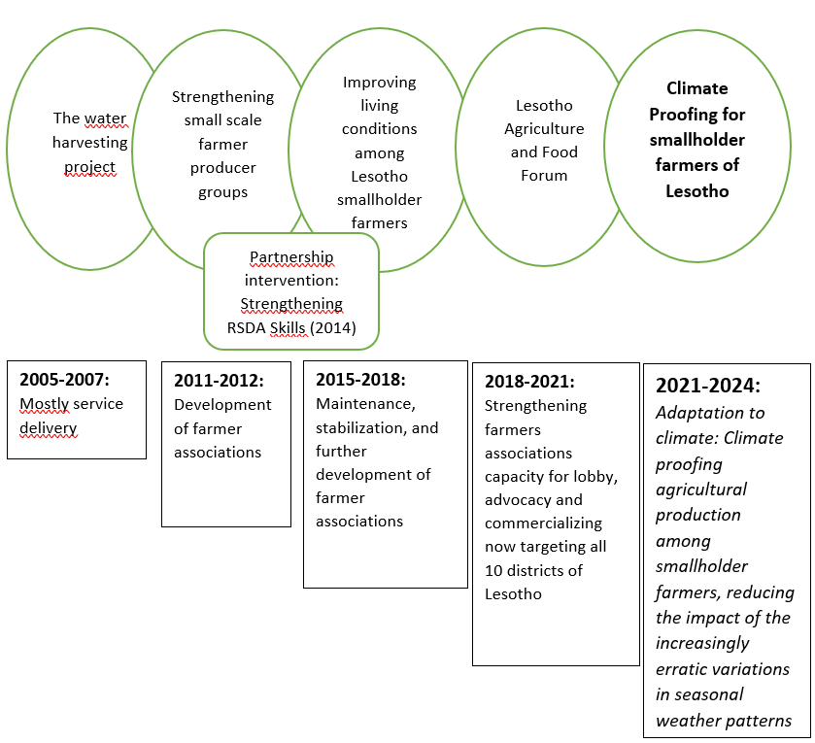
The 4 projects implemented by the partnership so far, have provided RSDA and DLN with specific experiences which will further materialize in the proposed intervention. RSDA and the smallholder farmers now have the perfect organisation for this intervention. Having this organisation and the associated LAFF running smoothly is an important basis for succeeding with this climate change response project.

RSDA and DLN consistently develop the project LOG-frames and project proposals jointly when planning interventions. The LOG-frame and the proposal for this project has been further qualified by external professional Liesl Keam, who is also a Principal Climate Resilience Advisor at Mott MacDonald, and provides ad hoc technical and pro-bono support to RSDA.

This project is by now the most well-prepared intervention building on the history of RSDA-DLN projects. The partnership, however, is prepared to adjust, modify, and adapt to changes as we move along. This to ensure that we keep on moving towards the overall objectives and keep on track for the specific objectives to be accomplished according to plans.

2.3 Roles and responsibilities of the partners and other actors.
The intervention will be implemented by RSDA, and Denmark Lesotho Network will oversee implementation and monitor progress and reports to CISU. RSDA implements the intervention through dedicated project staff who are budget holders responsible for achievement of project results within the agreed time and budget.
DLN undertakes both the financial and programmatic focused monitoring role. The monitoring role is done via visits undertaken by DLN to RSDA Lesotho. Monitoring also includes virtual communication meetings with RSDA and other intervention participants. DLN will use monitoring tools for governance and finance (Mango) to check on bookkeeping and financial management system.

2.4 Relationship and collaboration between the partners

2.4.1 Strengthening relations with other actors
The projects prior to this project have strengthened the capacity, the unity, and the collaborations between DLN and RSDA, RSDA and the farmer groups, umbrella organisations and district farmer platforms involved. The positive experiences from earlier projects have uninterruptedly strengthened the relationship between RSDA and the smallholder farmer associations as expected. The farmer groups and district platforms (now District Agriculture and Food Forums), who were part of the former projects, now realise the power of farmers speaking with one voice. They are now exerting influence on government policies, for Government of Lesotho to improve farmer friendly conditions for producing and marketing of quality food.

More important at this point is the recognition by national and regional decision-makers (e.g., Ministry of Agriculture) of LAFF and LAFF-P to be important partners for authorities, to represent and communicate the needs of smallholder farmers and provide a platform that both public and private sector can engage with.

2.5 Carrying out advocacy
RSDA started engaging actively on advocacy initiatives in 2015 (The DLN_RSDA project “Improving living conditions among small-holder farmers through lobby and advocacy” 2015-2018). The method used has been capacity building of farmer organisations and their leadership and to take advantage of partnerships with likeminded civil society organisations engaging with farmers. RSDA has partnered with LCN, Civil Society week and DPE for community Parliament to engage with government, Private Sector Foundation of Lesotho and The Silo Magazine for National Agriculture Expo and thus interacted and lobbied with corporate sector. All these platforms have provided space for farmers to influence government and the corporate sector and push for partnerships. RSDA achieves an exceptional level of collaboration and partnership building in their programming and this intervention typifies this approach with its focus through objective 3 on utilising platforms to engage with public and private sector stakeholders in support of farmers’ agenda. The partnerships and collaborators for this intervention are organisations regarded as partners necessary to strengthen smallholder farmers and civil society organising, mobilising, and cooperating for climate resilient communities in Lesotho. Continuing to leverage existing relationships provides the opportunity to expand smallholder farmers’ access to resources and financing and sustainability of the intervention.

3.0 Target groups, objectives, strategy, and expected results (our intervention)

3.1 Target Groups: Participation, Benefits and Involvement

3.1.1Primary Target Group
5,000 smallholder farmers from the 10 districts of Lesotho (of which 60% are female) are direct beneficiaries of the intervention. The anticipated participation of the beneficiaries is as follows:
- Support for Climate Smart Agriculture through participating in training and receiving support for the uptake of regenerative farming practices. These activities provide farmers with the knowledge to independently implement these practices which over time will improve the quality of the soil and ecosystem on the farm making it less vulnerable to the climatic variations. (CSA & Regenerative Farming) – 5000 smallholder farmers. Each of 10 districts targets 500 farmers.
- Developing e-agricultural extension services/ICT to reach out, provide updated information and respond better to weather/climate information. These activities will explore and deliver the best method to provide smallholder farmers with information on the weather/climate and what actions they can take in response to the information. – 5000 smallholder farmers.
- Value chain strengthening. Establish systems and provide necessary resources to farmers organisations for product aggregation, quality control and labelling that allows farmers to access markets that offer higher prices for production following specific processes (ie green products) by smallholder farmers – Support for at least 5 agriculture commodities.
- Capacity building smallholder farmers in earth markets innovations. Providing information to smallholder farmers on how they can access the above value chains, including accessing product packaging capacity established – at least 10 earth markets (1 per district) for dissemination and sharing held per year
- Innovative platforms/forums formed of Climate Smart Agriculture and labelling for green products participants meant for networking and advocacy work. Participation by small holder farmer nominated leadership and spokespersons in national coordination platform including support to prepare and communicate their needs and concerns to the relevant public and private stakeholders such as government, other civil society organisations and private sector leaders – farmer leadership from 10 Districts, at least 40 farmer leaders per district participating in each LAFF convening.

The primary target group, smallholder farmers, were involved in the development of the intervention. This target group made their input through village-based sessions that were held in their districts to understand their challenges and perspectives on how they are affected and impacted by climate change and what their preferred responses are.

3.1.2 Secondary Target Group
Household members across the 10 districts form the Secondary Target group, as the activities outlined above are anticipated to affect the livelihoods and resilience of the entire household of each farmer in the primary target group. Secondary target group is also made up of organisations regarded as partners necessary to strengthen smallholder farmers and civil society organising, mobilising, and cooperating for climate resilient communities in Lesotho. This serves to expand smallholder farmers’ access to resources and financing and sustainability of the intervention. The table below identifies the key organisational stakeholders, their participation in the project and their involvement to date with RSDA and the development of this intervention. Whilst there may be benefits to these stakeholders this is not the primary objective of the intervention which prioritises and centres the needs and benefits to smallholder farmers.

Stakeholders | Participation and benefits | How target group was involved
Department of Agricultural Research (DAR) | DAR is key for seed, soil testing and phyto-sanitary measures.  Technical backstopping and certification  Technical Focal point for climate change issues. | DAR has been a lead collaborating government agency for climate change risk assessment for climate resilient agriculture production study undertaken by RSDA which provides a baseline for this project.
Department of Planning and Policy (DPP) | Project link to policy and planning on climate resilient agriculture  Focal point for CAADP and NAIP processes. | DPP has been in the core team for the risk assessment study responsible for policy.
Department of Field Services (10 district agric. offices)  -Agric. Information Services | To support smallholder farmers and their forums | They participated in the project formulation planning sessions
Department of Marketing | Supports the farmers earth markets, it sets the environment for the marketing of agricultural products for smallholder farmers. | Government Department which carries the mandate for marketing of local produce.
Slow Food Movement South Africa | Inspires and technical support on disseminating Slow Food Values of Good, fair, clean food. | Key partner on green products labelling and they participated in the formulation of the project.
National Climate Change Committee (NCCC) | NCCC coordinate climate action coordination and provision of early warning | RSDA is a member of the committee for knowledge sharing and information
Lesotho Council of NGOs (LCN) | Leads NGO weeks and public budget dialogue.  Innovative platform. | Participates in the LAFF-P and hosts agric. commission meetings.
Lesotho National Farmers Union (LENAFU and ESAFF) | National umbrella for farmers  Advocacy Capacity building | Participates in the LAFF-P
Private Sector Foundation of Lesotho | Networking  Alliance building of the business sector for market access | Participates in the LAFF-P
The Silo | Content development  Media and agriculture expo partner | Participates in the LAFF-P
Integrated Catchment Management (ICM) | Carries mandate for integrated catchment approach- water and natural resource management | RSDA is a partner in the implementation of the programme and links well with the proposed project.

and another ais

3.2 Strategy of the intervention
The Strategy of the intervention is responding to the small-scale farming systems gaps based on entry points that were identified in the Climate Resilient Agriculture Production Feasibility Study, undertaken by RSDA with funding from GIZ- ACCRA programme. The components of this intervention have been developed to provide a comprehensive set of activities along the farmers value chains. Targeting the full scope of beneficiaries as well as the enabling environment required will support the uptake of sustainable and future-proof agricultural production among smallholder farmers. It will lower the impact of the increasingly erratic variations in seasonal weather patterns.

The intervention addresses the risk of unsustainable production for smallholder farming community in Lesotho due to variations in season climate patterns. The farming community is vulnerable due to overreliance on rain-fed agriculture and high vulnerability of crop types to water, pests, and weather. The intervention builds capacity of the smallholder farmers and strategic services for climate smart agriculture (CSA) practices, use of ICT for uptake of climate information; and de-risking of post-harvest practices and labelling of green (climate friendly) products (capacity building). Of outmost importance is advocacy action geared towards duty bearers carried by innovative platforms formed around CSA and green products labelling building on LAFF and District Farmers Forums capacitated in the ongoing project (advocacy).

The strategy will adopt a farming systems framework to deliver on the intervention results:

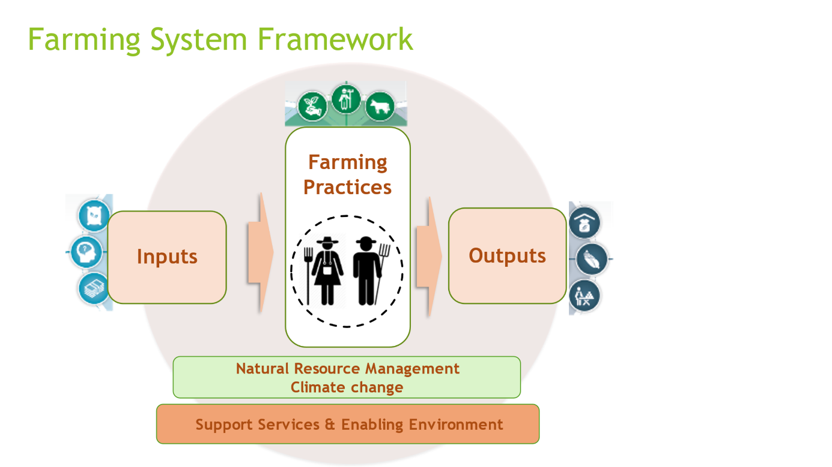

This strategy is reflected in Outcome 1, 2&3 (Output 1.2, 2.1, 2.2 & 3.1) and will be addressed as seen below:
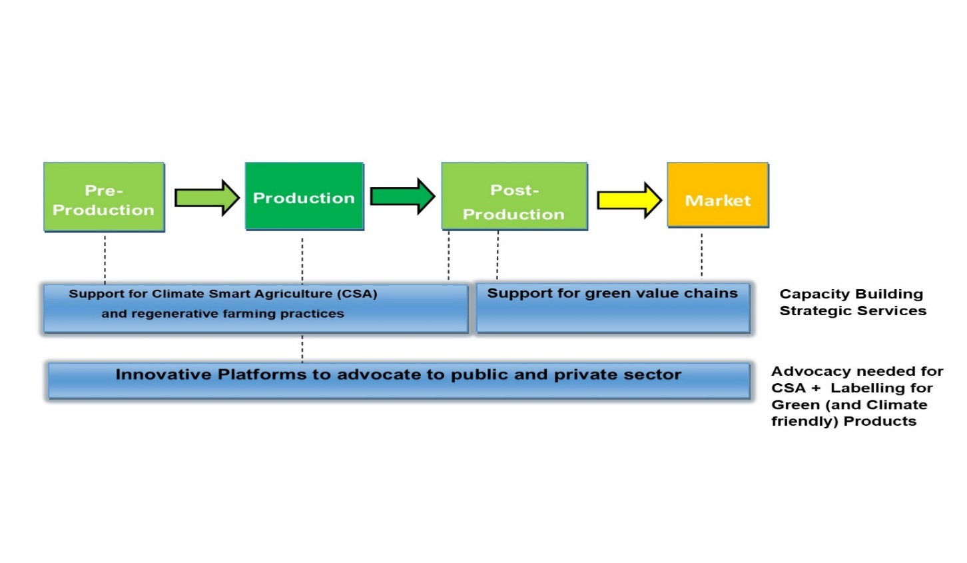

3.3 Objectives, Activities and Expected Results

3.3.1 Outcome 1- Smallholder farmers resilience to climate impacts is improved through their practice of climate resilient and regenerative farming methods that improve their adaptive capacity

Expected Result 1.1: Support for Climate Smart Agriculture through Regenerative Farming Practices
The intervention activities will provide technical support to smallholder farmers for CSA practices and approaches that increase the resilience and productivity; action learning cycles to ensure that result-based approaches can be quickly scaled by farmers. The activities will include development of CSA production protocols and training materials to be implemented by smallholder farmers, establishment of demonstration plots which will build capacity of farmers on the following practices;
- Diversification (mixed farming): integration of diversification in crop practices with livestock rearing for co-benefits. Diversification presents not only a means to diversify food production and improve nutrition at household level, but also a way for farmers to fortify their income and mitigate risk of loss if a famer is entirely dependent on one or the other.
- Sustainable fodder production allows farmers to meet the demand of forage for their livestock: By producing fodder crops, farmers are able to supplement livestock grazing and provide a more nutrient-rich addition to animal diet. Intercropping crops for consumption with forage can help farmers maximize limited land space. Improves productivity, enhances climate adaptation and promotes mitigation.
- Soil Health: Promotion of practices for crop production which focus on low tillage, low soil disturbance and maximum land cover. These practices improve the quality of soil by maintaining soil nutrients, preserving soil moisture, and minimizing drying and erosion.
- Support for Climate Smart Agriculture through participating in training and receiving support for the uptake of regenerative farming practices. These activities provide farmers with the knowledge to independently implement these practices which over time will improve the quality of the soil and ecosystem on the farm making it less vulnerable to the climatic variations. (CSA & Regenerative Farming) – 5000 smallholder farmers. Each of 10 districts targets 500 farmers.
Expected Result 1.2: Support farmers to access existing and customized e-agricultural extension services/ICT to access updated GAP and weather/climate information
The activities will involve ccustomizing management information system/ICT to reach out, provide updated CSA practices information and respond better to weather/climate information. Management Information System for agricultural production is a system that collects production data (inputs: land, fertilizer, seeds etc) from farmers and estimates harvest/yield. The system is made up of modules such as production, harvesting etc. The system gives summary statistics such as percentage losses per crop, amount and number of inputs used among others. It has about 5 modules being registration, production, harvesting, farm management and extension services modules.
Use of social media and virtual conferencing platforms will be explored for communication and information sharing including early warning information sourced through National Climate Change Committee. These activities will explore and deliver the best method to provide smallholder farmers with information on the weather/climate and what actions they can take in response to the information. – 5000 smallholder farmers.
3.3.2 Outcome 2- Smallholder farmers are participating in sustainable green (climate friendly) agriculture commodity production.

Expected Result 2.1: Product labelling for green/climate friendly products by smallholder farmers
Developing green (climate smart) product labelling, will be initiated via platforms to create partnerships between market players. Under the support for green products labelling, the intervention will launch a process of activities which evaluates; What the narrative label for Lesotho smallholder farmers (SHFs) products should be, determine possible barriers to launching of the label and support advocacy activities for enabling environment, what production methods will be set in the production protocol, how the smallholder farmers will be monitored and how to keep traceability and training of smallholder Farmers.

Expected Result 2.2 Capacity building of smallholder farmers in aggregation and resource mobilisation to support green market innovations.
RSDA has already built experience on aggregation of farmers produce from the ongoing LAFF intervention. So the intervention will continue to build capacity of smallholder farmers to aggregate for collective marketing of their products.
Smallholder farmers will be supported to improve on post-harvest storage and product management to help farmers to reduce losses after harvesting, increasing their food, nutrition and farm income. Farm income is also a requirement for farming community to engage on collective resource mobilisation. Earth markets will be introduced as innovations. Providing information to smallholder farmers on how they can access the above value chains, including accessing product packaging capacity established – at least 10 earth markets (1 per district) for dissemination and sharing held per year. This activity will be done through support from Slow Food South Africa.

3.3.3 Outcome 3- Smallholder farmers are linked into private-public partnerships and national platforms for climate proofing agriculture and national climate responses.

Expected Result 3.1: Innovative platforms for Climate Smart Agriculture and labelling for green products.
A Multistakeholder Forum will be facilitated, and discussion initiated on what the green/narrative label should be for Lesotho smallholder farmers’ products, what CSA production methods to be set, how they will be monitored, how to keep traceability. Determine possible barriers to launching green product label and produce policy briefs. Engage coaches – To develop and deliver a guide for CSA and regenerative farming practices and production protocols, including training materials such as decision tree infographics. Producer, Public, Private dialogues will be held in the 10 districts to advocate for enabling environment for CSA, green product labelling and procurement of farmers products. Information will be shared through social media, website, and dialogues.

3.4. How will the results be achieved?
The above results will not be delivered in isolation, but each component is brought together in a comprehensive activity plan which delivers the outputs concurrently. The following approach will be adopted to achieve this:
- Inception meeting with Multistakeholders to align and agree on how to interact especially due to the uncertainty brought by global covid-19 crisis and restrictions.
- Facilitate a Multistakeholder Forum and initiate discussion on what the green/narrative label should be for Lesotho smallholder farmers’ products, what CSA production methods to be set, how they will be monitored, how to keep traceability. Determine possible barriers to launching green product label and produce policy briefs. Engage coaches – develop and deliver a guide for CSA and regenerative farming practices and production protocols, including training materials such as decision tree infographics.
- Deliver training to 5000 farmers organizations on the farming practices, set up demonstration plots and undertake ongoing follow up visits to provide ongoing support and trouble shooting.
- Deliver required resources such as machines and processors to farmers organizations for aggregation and labelling and train representatives in their use.
- Customize Management Information system, ICT and train human resource
- Promotion and show casing of products from CSA and farmers earth markets.
- Facilitate multistakeholder dialogue events and engage with duty bearers/policy makers and business. Financial services, insurance and credit products supporting the resilience of farmers (advocacy).
- Monitoring, reporting and evaluation of intervention results.
3.5 Log Frame
The log frame below outlines the climate change proofing approach that ensures the intervention activities attain the necessary results. Results that are tailored to the outcomes that are needed to achieve the project objective.

Category | Detail | Indicator | Activities
Impact: Climate Resilient Agriculture that reduce vulnerability by creating increased income, food and nutrition security for Lesotho.
Outcome 1 | Smallholder farmers resilience to climate impacts is improved through their practice of climate resilient and regenerative farming methods that improve their adaptive capacity. | No. of commodities/varieties produced (diversification)
Output 1.1 | Support for Regenerative Agriculture Methods (RAM). | Climate smart agriculture (CSA) production Protocol document  No. of farmers trained in CSA production protocol | 1.1.1 Develop CSA production protocols to be implemented by smallholder farmers.  1.1.2 Develop training and visibility (infographics) materials.  1.1.3 Train smallholder farmers on CSA practices.  1.1.4 Support demonstration plots based on production protocols
Output 1.2 | Support farmers to access existing and customised e-agricultural extension services/ICT to access updated GAP and weather/climate information. | No of Farmers accessing CSA –good agriculture practices.  No of farmers with improved access to weather and climate information | 1.2.1 Customise and train staff on digital database for producers (MIS).  1.2.2 Use social media & virtual conferencing platforms for sharing early warning information and knowledge sharing.
Outcome 2 | Smallholder farmers are participating in sustainable green (climate friendly) agriculture commodity production. | No. of farmers selling to aggregators in green production chains.  No. of aggregators within project regions
Output 2.1 | Product labelling for green/climate friendly products by smallholder farmers. | Narrative labelling guidelines document available and shared  No. of green products ready to be launched | 2.1.1 Develop Narrative labels for green and climate friendly products for product packaging and tracing  2.1.2 Implement narrative labelling
Output 2.2 | Capacity building of smallholder farmers in aggregation and resource mobilisation to support green market innovations. | No. of farmers trained aggregation  No. of farmers trained on green products and value chains. | 2.2.1 Support smallholder farmers’ capacity on aggregation and Farmers Earth markets  2.2.2 Facilitate resource mobilization  2.2.3 Engage in Slow Food Movement and Mountain Partnership for expert technical support and information.
Outcome 3 | Small holder farmers are linked into private-public partnerships and national platforms for climate proofing agriculture and national climate responses. | No. of national dialogues convened by RSDA  No. of organisations represented in dialogues  No. of new initiatives launched through RSDA convened platforms.
Output 3.1 | Innovative platforms for Regenerative Agriculture and labelling for green products | No. of policy briefs produced | 3.1.1Support smallholder farmers’ forums for knowledge sharing and collective action  3.1.2 Facilitate Producer, Public, Private dialogues in the 10 districts (learning journeys methodology).  3.1.3 Establish Multi-stakeholder forums for grains and livestock (diversification) commodities.  3.1.4 Information dissemination (technical, early warning policy briefs and updates: Social Media and Website).
Project Delivery |  |  | 4.1.1 Conduct Baseline  4.1.2 Conduct Field visits  4.1.3 Conduct study visit to Denmark  4.1.4 Participate in National Climate Change Committee (NCCC) meetings and Processes.  4.1.5 M& E and reporting meetings  4.1.6 Progress reports -Quarterly, Annual and mid-term)

3.6 How the intervention contributes to establishing sustainable and lasting improvements
There is a high potential that smallholder farmers may shift from Conventional to Regenerative Agriculture practices as a result of the intervention. The global world is dominated by conventional agriculture. Conventional agriculture is normally heavily reliant on inputs such as energy and Agro-chemicals (fertilizers, pesticides, herbicides etc.), intensification of stock or crops, monocultures and maximises extraction from soil and ease of land management. Smallholder farmers of Lesotho, especially those residing in the mountainous areas, have not derived benefit from these types of practice. Historically access to fertilizers, pesticides, herbicides have been difficult, not affordable, or not available at all for smallholder farmers of Lesotho and the conventional farming practices have degraded soil, created soil erosion, and left farms more vulnerable to the more variable climate impacts. With support farmers can transition to farming and grazing practices, that among other, build soil organic matter and restore degraded soil biodiversity – resulting in both carbon drawdown and improving water cycle. Implementing the tools of Climate Smart Agriculture and regenerative farming will benefit everyone, smallholder farmers, agribusinesses, customers, governments and of course the environment. With combined practices of no-till farming, soil and water management, integration of cover and relay crops, and chemical free inputs production costs can be reduced by a substantial amount, and at the same time yields and profits will stabilise with potential to increase.

The intervention will monitor the number of farmers accessing CSA –good agriculture practices, farmers with improved access to weather and climate information, farmers selling to aggregators in green production chains and number of aggregators within project location.

3.7 Analysis of risk
An analysis of the potential risks that might be encountered has been undertaken as per the risk analysis below. Corresponding mitigation measures have been identified and incorporated into the project design and delivery.

Risk | Consequence  (H, M, L) | Likelihood  (H, M, L) | Mitigation Measures
Covid pandemic limits travel, delaying or preventing the delivery of training and support activities. | H | M | Project activities are scheduled across the whole 3 year project period and the schedule flexible and phased with decision gates to allow adjustments.
Covid pandemic limits travel, preventing DLN travel to Lesotho. | M | M | Virtual communication between DLN and RSDA as well as with project beneficiaries is possible and will be used
National Emergency (drought and or other) impacts on implementation by smallholder farmers during critical time of implementation. | H | M | Early warning information for the beneficiaries will be mitigated against adverse effects
Apathy within the stakeholder groups, particularly the LAFF & Government entities to participate in the project. | M | M | Contribute and support coordination efforts and in building of productive relationships as well as exploiting use of virtual communication.

3.8 Monitoring, evaluation, and learning
The intervention will be monitored closely through monthly meetings and quarterly reports to DLN. Annual reviews will help to generate action-learning cycles and utilise gained experiences along the way. At the end of the intervention an external evaluation will be carried out to document the impact of the project and to keep gained learnings. A good practice in the ongoing LAFF project has been the use of virtual monthly meetings with DLN. These virtual meetings will continue between DLN and RSDA.

Virtual meetings via -WhatsApp, Microsoft teams and/or Zoom will be held for reporting and documentation progress on intervention activities to document activities. The partners (farmers, RSDA and DLN) will continue to share real time photos & videos with short captions of activities taking place in real life. This gives a good overview of the extent to which we are on track.

Quarterly reporting on achieved results: RSDA will submit quarterly narrative as well as financial reports to DLN. The narrative will use the provided template on progress towards achieving the planned results. As part of the quarterly report, stories will also be shared to contribute to information in Denmark.

End of project external evaluation of outcome indicators: A final evaluation will be carried out which will focus on the achievement of the indicators presented in the logical framework. As part of project inception of the intervention a baseline study will be carried out to enable measurement of the extent to which actual progress is made towards climate smart agriculture, narrative labelling and advocacy resulting in smallholder farmers becoming climate resilient. Both baseline and evaluation will be carried out by an external team of researchers.

Denmark Lesotho Network monitoring and learning visits in Lesotho: DLN will undertake both financial and programmatic focused monitoring visits in Lesotho. Monitoring will include field visits with RSDA, meeting with farmers in their villages and other participating multi-stakeholders. DLN will use monitoring tools for governance and finance (Mango) to check on bookkeeping and financial management system.

4 Intervention-related information in Denmark
The information work will be organised around a visit from RSDA to Denmark. The visit has several purposes. The main purpose is to raise awareness about Lesotho and showcase the results of the DLN-RSDA cooperation. The secondary purpose is for RSDA to engage with Danish national and local farmers’ organisation to build networks and learn from the Danish farmers. The target group for information activities is the public and individuals and organisations with an interest in development, Africa and/or Lesotho. The secondary target group is DLN members. The information work relating to the visit will be disseminated through DLN’s own media: Lumela Newsletter, website, and Facebook profile. Efforts will be made to have media coverage through articles in local and national newspapers. The information work will be carried out by the DLN-RSDA project group and the DLN Communication Group.
The expected outcomes are:
- Dissemination of information about DLN, RSDA and the project in Denmark
- Establishment of contact between RSDA and potential alliances in Denmark.

Next national census due 2026

