Danish organisation | FANT Denmark
Title of the intervention | Preparing children, youth and parents for engaging in change processes
Partner name(s) | FANT Sierra Leone
Amount applied for | 999.902 DKK
Country(ies) | Sierra Leone
Period (# of months) | 1/1-22 to 31/12-22 (12 months)

Development interventions
To strengthen civil society organising to promote the fulfilment of rights and equal access to resources and participation and to bring about lasting improvements for poor, marginalised and vulnerable target groups.

To make partners reach out to, mobilise, and cooperate with the wider society and other actors. This serves to expand partners’ access to resources and financing, while boosting the effect and sustainability of all their actions.

please note before writing the application:
- NUMBER OF PAGES: The application text must not take up more than 25 pages (Calibri, font size 11, line spacing 1.0, margins: top 3 cm, bottom 3 cm, right 2 cm and left 2 cm). Applications exceeding this length will be rejected.
- LANGUAGE: The application text must have been drawn up in cooperation between the local partner(s) and the applicant Danish organisation. Accordingly, there must be a document available in a language of relevance to the local partner. The actual application, however, can only be submitted to CISU in Danish or English.
- CONTEXT: Remember that the application will be assessed depending on whether the intervention will take place in a stable or fragile context. Section 2.4 in the Guidelines outlines how to analyse and describe how fragility is expressed in the context. You can also read more on CISUs website (in Danish) www.cisu.dk/nexus
- THE SUSTAINABILITY MODEL: in the sustainability model in section 1.2.7 of the Guidelines you can find inspiration on how to describe your intervention and how to address climate- and environmental sustainability as well as social justice.

GUIDANCE on submission of applications is available at www.cisu.dk/skemaer (the website is presented in Danish, but many documents are also available in English, French and Spanish.)

NB: DELETE THIS GUIDE BOX WHEN YOU ARE READY TO SEND IN YOUR APPLICATION.
1. Objective and relevance (the world around us)
1.1 Overall objective, project goals and status on current intervention
The overall objective of this intervention is to strengthen the capacities of FANT Sierra Leone within the local communities to increase the impact of FANT Sierra Leone among children, youth and parents towards supporting the above in participating and affecting local and national decision-making, so they become an active part of the change they dream of.

Project goal 1: The ten local associations in FANT SL have improved democratic structures and a strengthened relationship between top (coaches and board) and bottom (players and parents) of the club

Project goal 2: 500 parents/caretakers have been supported in difficulties regarding child rearing and have gained new knowledge about consequences of child abuse

Project goal 3: In each of the ten local associations a formal youth section of FANT SL has been formed (FANT Youth) which is supported in advocating for the local and/or national changes that they dream of

This intervention is an extension of the project Using football associations as a platform for building the capacity of marginalized young adults to implement advocacy projects and for the empowerment of children that will end on the 31st of December 2021. The project was planned to be two-year project but because of the COVID-19 crisis it was extended with six months. In overall the expected results of the intervention has been reached but we also acknowledge that because of certain circumstances, especially the COVID-19 crisis, the intervention also had challenges and areas where the hoped success rate could be higher. After the first nine months the project had to be paused for eight months due to the COVID-19. It was resumed on the 1st of January 2021 and ends in late December 2021 which leaves four months less for the implementation of activities than planned and furthermore a break of eight months in the middle of the project implementation. For now, most activities have been implemented, with the remaining being political football events that will take place after the rainy season in Sierra Leone and lastly the final evaluation of the project.

The current project, which this new project is an extension of, has the overall aim Through capacity building of young adults and FANT SL to implement five specific advocacy projects, gain practical and theoretical experiences hereof, and to empower children to prepare them for future advocacy interventions. Project goal 1: 200 young people have been educated about human rights, how to do advocacy and have been supported in selecting five main challenges in their everyday lives is reached. The 200 young persons are now partaking in the last advocacy campaigns, but we can already now conclude, that expected results within this project goal will be reached. Project goal 2 is focusing on education of children and building up self-confidence through sport activities. It has been the first project to include children in workshops, which has provided us with important experience and knowledge that we have used in the project formulation of this new project. Most important to mention is the acknowledgement that some of the main problems for children are connected to parenting and therefore parents is and interesting group to involve in a higher degree in future projects. The expected results from current project regarding project goal 2 will be reached but we realized that the hoped change in the children’s lives will need another strategical approach including a new primary target group of the parents/caretakers in a much higher degree. Children are a primary target group in the current project being implemented and parents/caretakers are secondary. In this new project this is flipped around.

Project goal 3 was to strengthen the capacity of FANT SL which has been the most obvious success of the current project. FANT SL has taken big steps both when looking at internally factors but also regarding how they deal and connect with target group and relevant stakeholders. FANT SL has become a strong civil society organisation ready to support long-lasting changes for target groups. But there is unfortunately a downside to this because when you focus intensively on something you sometimes forget about something else. For the last two projects supported by CISU main attention has been on developing and strengthening the umbrally organisation FANT SL. As said, it has been a success. But it has also affected the attention given to the local associations which are the member organisations of FANT SL. This project therefore turns focus back to these ten local associations to make sure they are maintained, and important routines and structures are not neglected. It is in these local associations that the everyday education about democratical principles is exposed. These associations have existed for almost ten years and with this project we wish to ensure that the core fundamentals for the project are in place and spotlighted.
This new intervention is built on knowledge and experience provided from past projects between partners. In the current project being implemented youth groups from the ten local associations have pointed out five main challenges, that they are doing advocacy campaigns on. The identified challenges are
- CHILD MARRIAGE
- SEXUAL HARASSMENT
- FEMALE GENITAL MUTILATION
- CHILD LABOUR
- WATER SCARCITY
For the first four challenges there are already laws in place to prevent these things from happening. But there is still a lot to be done to strengthen and enforce the existing laws – one example could be female genital mutilation. It is by law that only women above the age of 18 years can legally get circumcised. But according to UNICEFF more than 80% of girls under 18 years in rural Sierra Leone are circumcised. The five identified challenges are the core foundation for this new intervention and has set the frame for the advocacy part of the project.
Because of the difficulties faced in the current project but also because of the ambitions of the project and overall objective, some of the challenges the new intervention seeks to address are similar to previous interventions, but in this project, we will focus on a new target group; parents. Children and youth in Sierra Leone face several challenges that make it hard for them to get actual influence in their own life and create the future they hope for. Child abuse is not just common but accepted which creates individuals suffering from low self-confidence and bearing a mistrust to society and people in general. Old traditional thinking obscures youth between what they have been taught to think and do, which often puts them lowest in the hierarchy and forces them to act on behalf of family or tribe instructions that are in direct opposition to their own dreams and modern philosophy about democracy, equality, and freedom. The few in power in Sierra Leone are rarely being challenged and generation after generations keep repeating the patterns. This project together with previous projects aims at challenging the relationship between those in power and those without. FANT DK and FANT SL have been working together for almost ten years to accomplish these joint visions and even though the overall national situation in Sierra Leone seems unchanged we believe to have created a key impact in FANT SL’s ten priority communities. New ideas of child rearing are being discussed, youth are experiencing how they can express feelings and opinions and are being listened to – and the maybe even create real changes. This project continues the visions shared by FANT SL and FANT DK about giving the youth of Sierra Leone a voice and the children a safe childhood.
All previous CISU projects between FANT SL and FANT DK are important when understanding the background for this intervention. They are described in overall terms below to create an insight into the history of earlier lessons learned and focus areas that have been important reaching this current stage. Target groups of all former interventions has been FANT SL (including the local sport associations which constitute FANT SL) and marginalized children and youth. Parents have been involved in projects as a part of secondary target groups, but this intervention seek to involve parents in a far higher degree than before. Besides the four previous projects described in the figure below, a DERF intervention implemented in 2020 has also provided important knowledge especially about parents. This knowledge has been included in this project formulation. This will be elaborated in section 3.3 Local legitimacy and involvement of target groups in project development and implementation.
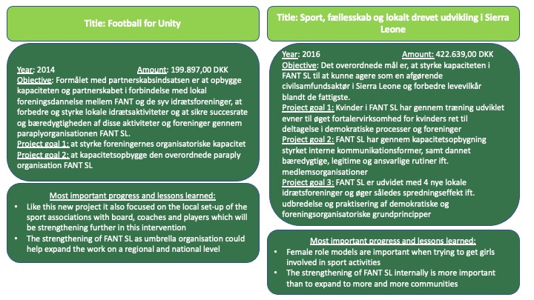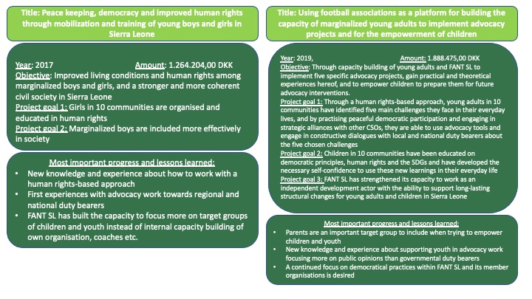
1.2 Context of intervention leading to the main challenges to address
Sierra Leone has been - and still is - afflicted by various catastrophes and conflicts. Over and over Sierra Leone is faced to challenge new issues including war, the ebola virus, mudslide, flooding’s, fire catastrophes and the most recent COVID-19 crisis. Again, the population has been forced to distrust each other when all physical contact was forbidden. Avoid Body Contact (ABC) was the rule during ebola and again with COVID-19, where family members turned against each other in the fear of getting affected with the virus. The above-mentioned challenges most often affect the poorest part of the population which is estimated to be 43% of the population in 2018 by The World Bank which actually is a significant decline from 54,7% in 2011. Unfortunately, it seems that Sierra Leone’s trajectory of poverty reduction has been disrupted by the COVID-19 pandemic. Also, despite the improvement in poverty rates, inequality is rising. The Gini coefficient rose from 0.33 to 0.36 between 2011 and 2018.

This section has its starting point from the below problem three conducted by FANT SL and FANT DK in collaboration as preparation for the project formulation:
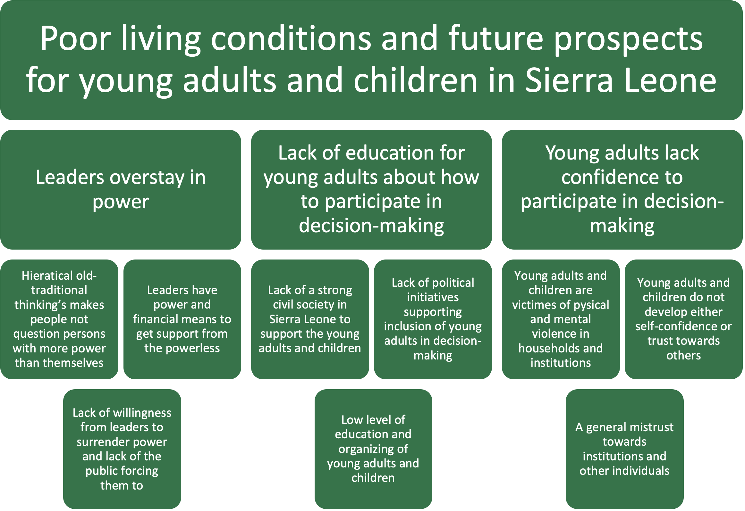

As the problem three displays children and young people face several challenges in Sierra Leone and most of the challenges will be linked in much more complex systems than shown by our figure. The main challenge that this intervention seeks to address is the uneven balance between those in power and those without. This section will elaborate further on three key issues leading up to this main challenge:
- Lack of democratic structures in organisations and institutions in Sierra Leone
- Hieratical old-traditional thinking
- Poverty and inequality
Lack of democratic structures in organisations and institutions in Sierra Leone
In general, there is a lack of democratic and transparent structures both in civil society organisations and in government institutions in Sierra Leone. The organisations that are democratically built will most likely lack routines and practises that will make it functional. This is a problem for those who wish to get influence in decision-making in these organisations/institutions and it helps the once’s in power to stay in power regardless of their performance and results. But the issue is not only repeated because of the once’s in power are overstaying, it also has roots in citizens not challenging these structures. Sierra Leone does not educate their youth in democratic thinking or understanding, hence, their capabilities of participating in public discussions are weak. Sierra Leoneans do not really know about democratic principles and how to pursue them in real life situations. To understand organisational structures demands a certain level of education – making it a lot easier to understand the constitutions etc. if you can read and write. And furthermore, there are very few good examples to look up to and imitate.

Children and youth grow up experiencing organisations and institutions that do not live up to their responsibility. And the youth is faced with a feeling of powerlessness about how to act when being mistreated or disappointed about the services provided by these organisations/institutions. This project will address this issue in two ways. Firstly, when helping FANT Youth groups organize themselves in democratic groups with transparent structures. When creating an organisation for themselves they get important knowledge about what makes an organisation effective, fair, trustworthy, and strong. They are taught how to make decisions in groups, listen to other perspectives but also stand up for own beliefs. The whole setting-up of FANT Youth is an education in being a citizen in a democracy, using your voice. Secondly, the project addresses the problem when afterwards supporting FANT Youth in analysing and creating dialogue with specific civil society organisations and governmental institutions.

The issue of youth participation in decision-making has a strong echo in Sierra Leone because it to some extent was political and social marginalization of young people that provoked the civil war of 1991-2002. In the years following the civil war, a strong effort was made to introduce structures and programs that served the needs of young adults, including the establishment of a National Youth Commission focusing on the promotion of youth issues. Despite these well-intentioned initiatives, most of the young adults in Sierra Leone are still marginalized and socially, economically and politically disempowered. Being young should be a human development process that will lead to the individual becoming a member of society, earning rights and facing responsibilities.

This general lack of democratic and transparent structures has created a mistrust towards institutions and organisations. A mistrust that FANT SL also deals with on an everyday basis when interacting with people from outside the organisation. Most people assume that organisations will be working to benefit themselves and not the target groups as supposed. The mistrust initiates unfortunate behaviour from the institutions and organisations when being meet constantly with accusations – they perform defence. When you play defence, you are being protective instead of open and welcoming. It is not a solid starting point for creating trust, transparency, and dialogue. And the result can be ineffective institutions and organisations which fulfils the evil circle.

This project addresses this problem when supporting the ten local sports associations in having – and performing – democratic structures and routines that allow bottom and top of the organisations to interact with each other. FANT SL will be one of the examples of organisations/institutions, that FANT Youth groups will be presented to and work with when analysing transparency and democratic structures. FANT SL is not a perfect organisation but ready to be transparent, open and to enter dialogue with FANT Youth.

Hieratical old-traditional thinking
Especially the youth in Sierra Leone are caught in the middle between hieratical old-traditional thinking and beliefs and dreams about individual freedom and happiness. These old beliefs allow specific people to have more power than other people and therefore create an acceptance of inequality among citizens. There are several examples of this, some being men vs. women, old vs. young, parent vs. child or coach vs. player. It is normal and natural to have different power relations between people but some of the above-mentioned are blocking youth in Sierra Leone from participating in decision-making and from being a part of the change, they dream of. And even before a person becomes a “young person” the old-traditional way of undertaking childcaring in Sierra Leone will in most cases have developed a terrible starting point for an individual to become a strong, happy and independent “young person”.

Girls in Sierra Leone have countless responsibilities within the family to uphold. Most girls or women do not have any impact on power structures, be it political or social, and are repeatedly victims of violence and abuse. Violence against girls is unfortunately common both inside the family and in marriages but also in schools and other public institutions, which are supposed to serve as safe spaces for the girls. Simply by being a girl, this vulnerability is already inherent based on your sex, adding (sexual) abuse to the list of inevitable experiences in a girl’s life in Sierra Leone. Violence is often used for disciplining, which also affects girls, since many of them do not know how to defend themselves physically or verbally. Men have the strongest voice in most decision-making processes, and women are not included and/or have a weaker social position to influence decisions. Females are generally unaware of their rights and their value in a society and as a key factor for creating positive development. Most women depend on a man, and hence, often react and behave in coherence with expectations from men, instead of following own dreams and ideas. It is difficult to change fundamental structures of a society, e.g. the relationship between a man and a woman. The traditional thinking places the man as the provider and the woman in charge of the household. Changing this way of thinking is part of the long-term strategy of the intended ripple effect of the project.

Children in Sierra Leone are facing numerous of problems including poverty, lack of health care, female genital mutilation, lack of education, violence counting sexual abuse, child labor, child marriages and pregnancies and the lack of an official identity because of low registration of births (around 50%). In a poor country like Sierra Leone not much attention is given to the special protection of children and very few of the articles under the Convention on the Rights of the Child are a reality in Sierra Leone. Like the rest of the population in Sierra Leone, children suffer from the widespread poverty, but the violation of children’s rights is sadly also connected to cultural and social structures.

The understanding of parenting in Sierra Leone differs a lot from the international agreements. Article 19 states “Children have the right to be protected from being hurt and mistreated, physically or mentally.” Sadly, one of the biggest threats that children in Sierra Leone face is the mental and physical violence from parents or substitutes for parents. Sierra Leoneans are often using the old saying “If you spare the rod, you spoil the child” which is meant very literally in this context. There is a general belief that you cannot discipline children without using violence, which causes the parents to use violence extensively. Children in FANT SL’s football associations often have bruises or scrapes after being hit by parents. Most families lack financial resources but also a lot of other subjects, one of them being parenting skills. Article 18 states “Both parents share responsibility for bringing up their children and should always consider what is best for each child.” The average fertility rate is 6.5 children per woman which does not leave much parent-attention to each child. Most adults in Sierra Leone would not say that they were brought up by their parents – but by their older siblings. Children lack the presence of adults in their lives to look up to and learn from.
Article 31 continues “Children have the right to relax and play, and to join in a wide range of cultural, artistic and other recreational activities.” In a society where everyone is fighting to survive there is little room for playing and recreational activities. Children are expected to contribute to the household from a very early age, which leaves no time for enjoyable activities. Some children do not go to school because they are forced to do physical labor to support the survival of the family. There is not much space for a childhood in Sierra Leone, the seriousness of life begins from a very early age. In general, Sierra Leoneans do not recognize the advantages of investing time, love and attention in your children, so children are left to themselves without any guidance other than the rod. Some of the consequences are weakened learning skills, low self-confidence, and the reproduction of violence.
Poverty and inequality
There are several issues related to poverty pointing towards why most people in Sierra Leone are excluded from decision-making, including our target group of children and youth. Societal structures like the lack of access to education, lack of employment opportunities, social exclusion of decision-making, exposure to poor housing conditions, (sexual) violence, teenage pregnancy and marriages, no access to health services, drug and alcohol abuse, criminal activities etc. make it difficult for the youth to become independent well-being contributors to society. The potential of the youth is increasingly evident as key for improving national growth, development and security. With eight out of ten individuals in Sierra Leone being under 35 years, the focus on youth should be central in development efforts. Being a citizen in this society with extreme poverty, lack of education, every day-violence and no room for expressing frustrations or being heard creates a high risk of riots and radicalization among the people. Unemployment and boredom are some of the major problems in Sierra Leone. The high amount of young unemployed boys without any real education is a constant threat to peace and stability in the country.

FANT SL includes some of the most marginalized young adults in the communities; the ones who have dropped out of school for one reason or another and are now hustling through life. Almost none of them have permanent jobs but take day-to-day jobs in the constructing sector or survive by selling a few items on street corners or while walking around in the community. Many of them have problems at home where older family members expect them to chip in on the finances. Especially for the boys, the football training becomes their free space where they can forget their everyday problems and exist in the moment of joy and solidarity with their teammates. They become someone when playing football. Community members will know their names and respect them if they represent the community well.

Poverty has been a national issue for Sierra Leone for as long as it has been an independent country. It has become a part of a national DNA feeling – being poor. The state of Sierra Leone is primarily financed by two sources of income – natural resources and development aid. The government is not dependent on collecting taxes from the citizens, which is creating a distant relationship between citizen and state. When one does not pay taxes, one does not have the same interest in how the state is using or misusing the money. In general, the population seems fatalistic when talking about corruption and abuse of power. ’TIA’ – This Is Africa is commonly heard when discussing this subject. People and organisations in Sierra Leone often look for support from outside the country instead of addressing the real duty bearers. For decades foreign NGOs has provided healthcare, sanitation, electricity, housing etc. for the most marginalized and poor groups. It is only natural that these groups – when in need of support – will reach out to foreign NGO’s instead of the national government institutions. But it is a problem because the general public in Sierra Leone is taught that foreign NGOs are responsible for local and national problems that should have been handled by national or local government/duty bearers.

A good example is a fire accident in the slum area Susans Bay - one of the FANT SL communities - in March 2021 destroying more than 300 shelters. International organisations like the Red Cross, Safe the Children and Half Moon provided necessary and life-saving support for the affected families the days after the incident. The community people also reached out to FANT SL because they are one of the most active and visible organisations working in this community. But FANT SL provides very different assistance to Susans Bay than emergency help which complicates the situation a bit. FANT SL does not have huge funding resources like the other bigger organisations but on the other hand they are looked upon as one of the most important organisations in the community and a lot of the community people knows FANT SL and appreciates their work. We believe that FANT SL has this legitimacy in Susans Bay because of several different reasons, one of the most important being that FANT SL is an actual part of the community and not an NGO coming from outside. FANT SL has local coaches and leaders living in the community who therefore have important understanding of the community that organisations coming from outside not always hold. It is understandable that the community people in Susans Bay expect FANT SL to support in situations like this, but it is very difficult for FANT SL to live up to this expectation – and it takes attention away from where the community people really should be pointing their fingers which is at national government institutions. In the end, FANT DK helped raise money among members and supporters in Denmark which supported 100 families in Susans Bay with food supplies. The point of the story is that there is a need to debate these expectations from the general public towards NGOs. Often FANT SL and FANT DK are requested to help with projects that goes beyond our expertise and purpose and people will be disappointed because they have unrealistic expectations. When educating youth about local and national institutions they create an awareness of responsibilities within organisations and institution – both government institutions and civil society organisations which can be a first step solution.

When people are poor and uneducated, they are also easy to “buy” or convince. Politicians in Sierra Leone will organise campaigns giving out free t-shirts, rice etc. which can buy voters from poor people. In general people in Sierra Leone can somehow be said to be “waiting” for someone or somebody to support and help them instead of acting on behalf of themselves. Reasons for this are sometimes misunderstood as laziness or unresponsiveness but is really an understandable reaction to all of the above-mentioned issues in the society – not being able to partake in decision-makings.

1.3 Strengthening of civil society organising
The core aim of this intervention is to strengthen the civil society organisation. It takes place at mainly three different levels, which all are a part of the aim to educate and prepare the new generation in Sierra Leone to be able to partake in decision-making helping to reduce inequality and fight poverty. The biggest circle and the core foundation for all of this intervention is the umbrella organisation FANT SL which (among others) includes the ten local sport associations which constitute next circle. FANT SL is working at a national level with directly contact and dialogue with ministries and other national institutions. The ten local sports associations are based in ten local communities and they have their main focus here. They deal with players, coaches, parents and local institutions and organisations based in the communities. Lastly, and as a new part in this intervention is the FANT Youth groups, that will be formed during the project implementation. Strengthening of civil society organisation is the main focus of the intervention – sport and primarily football is the tool to mobilise the different target groups.

1.4 Climate and environmental considerations
All the partners in the project are aware of the need to address climate challenges and continue rethinking how to implement sustainable interventions creating social justice for marginalized people at the same time as not affecting the environment or climate negatively. One of the most effective ways to reduce our carbon footprint is to reconsider how much, and how often we travel. FANT DK recognizes the importance of lowering our carbon footprint and has planned the four monitoring visits so they connect to other projects that will be monitored on the same trip (therefore only two tickets are included in this project). FANT DK is together with partners in Sierra Leone and Ghana implementing several other projects, and it is always considered how to plan monitoring visits, so it combines monitoring of more than only one project. The necessity of each monitoring visits is always considerated and planned regarding to which person(s) from FANT DK have the needed knowledge and capacity to do the desired monitoring.

All FANT DK’s projects are impacted by a “reduce your footprint” thinking. FANT also talks to partners about local transportation, printing and general behaviour that can help taking better care of our planet.

2. The partnership/collaborators (our starting point)
This intervention is a collaboration between FANT SL and FANT DK. The past three years has been a very important journey for both organisations but also regarding the partnership between the two. Both in Sierra Leone and in Denmark the organisations have gone through an important development from small grass roots organisations to more professionalized organisations ready to lift larger projects and improve their impact. This section will elaborate on these progressions.

2.1 FANT DK
FANT DK was founded in 2012 and is today, nine years after the founding, an expansive organization constantly developing and seeking new collaborations and projects. More than 23 individuals are participating actively as volunteers on a weekly basis in both Denmark and Sierra Leone. FANT DK consists of a Board of Directors that has the overall responsibility and decision-making and is run on a daily basis by the Head of Secretariat Cecilie Hauerberg and Administrative Leader Josephine Touray together with a dedicated team of volunteers. The volunteers, board and trainees are mainly located in Copenhagen, Århus and Freetown and have different competencies and expertise within theoretical and practical knowledge about development work, SoMe strategies, press and media, marketing, project administration, financials, fundraising, sports management and communication. Most individuals involved in FANT DK have visited Sierra Leone and worked closely with the local partners (through e.g. monitoring visits; capacity building workshops; coaching seminars etc.). Therefore, there is a strong knowledge base across the FANT DK team, including practical knowledge with development work in Sierra Leone.

In the past year, FANT DK has developed at a higher pace than ever before. Only three years ago, FANT DK was driven 100% from voluntary powers, with a big load of work and responsibility by co-founder Cecilie Hauerberg. Within the past two years, it has become possible to provide full-time salary to both Cecilie Hauerberg and Josephine Touray which have made it possible to increase projects in south, take in several new volunteers and create better structures for the volunteers. Also, there has been a thorough replacement in the Board of Directors, which have led to a more professional management and more insight and commitment from the top of the organisation.

The figure below provides an insight to the structures in FANT DK. Everyone listed in the figure is participating to the work of the organisation on a weekly basis and fulfil various assignments.

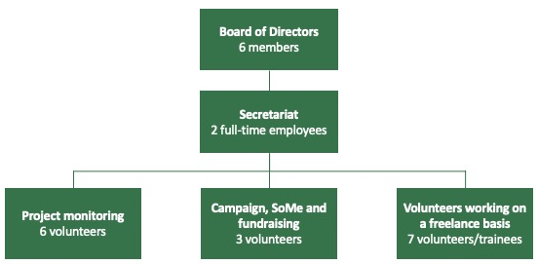

The two employees at FANT DK’s secretariat have different important knowledge and competences required for this intervention. Cecilie Hauerberg is the co-founder of the organisation and possesses great knowledge about context and capacity of partners in Sierra Leone because she has spent from 2-5 months a year in Sierra Leone since 2012. She has a master’s degree in African Studies from Copenhagen University and has supported different partner organisations implementing CISU-funded projects. Cecilie has great experience in project coordination, monitoring and facilitation of workshops in Sierra Leone and has worked with sport in development projects for more than nine years. She has been a part of the creating of both FANT DK and FANT SL which gives her a thorough understanding of how both partners work including weaknesses and strengths. On the first monitoring visit planned Cecilie will be facilitating act. 4.3 Preparation week on five challenges together with management group of FANT SL as one of the first activities of the project, that is intended to prepare the different fractions of FANT SL to the project implementation. As a part of this project, we wish to start a dialogue about a sustainability plan where FANT SL is even less financial depended on FANT DK as now. In the current project being implemented FANT SL has built important capacities within local fundraising and mobilizing of support (courses held by WACSI from Ghana). Cecilie will together with the management in FANT SL work with this theme ongoing through the project. Besides participating in act. 4.3 Cecilie will do a general monitoring of the project and be a part of the evaluation process (act. 4.4).

Josephine Touray was a member of the board of directors of FANT DK since 2017 but stepped out of the board in June 2020 when she became a full-time employee in the secretariat. She played at the Danish National handball team from 2001-2008, in total 123 games representing Denmark. She won an Olympic Gold medal in 2004 and the European Championship in 2002. Besides her former professional handball carrier, she has a master’s degree in commercial law and business from Copenhagen Business School. Josephine has a great network in the sport arena in Denmark, not only within handball. She has great networking skills which helps FANT DK to expand our network of Danish partners which has also let to that FANT DK has received another artificial turf. In the fall of 2021 this turf donated by the Danish professional football club AGF will be shipped to Sierra Leone and will be placed in one of the ten local sports associations of FANT SL (Aberdeen football club). To support a local community with an artificial grass is a very big thing in Sierra Leone and will also have positive influence on this intervention in several different ways (among others more female participation). Josephine also possesses administrative and financial skills that will ensure a professional management of project funding and spending and is responsible for the financial monitoring of partners in the project. It is a part of the sustainability strategy of FANT DK to increase the individuals in the organisation possessing contact and knowledge to context and partners in south why a monitoring visit is also planned for Josephine but is not budgeted with a flight ticket because it will be in connection to monitoring of our HAND project, also supported by CISU. To increase Josephine’s insight about local partners and circumstances will in the long run be of great benefit for FANT DK because important knowledge is shared and not only stays within one single person.

The volunteers in project monitoring all have a master’s degree in development studies, African Studies, Anthropology or like which gives them the theoretical knowledge about development issues and challenges. They contribute to FANT DK by helping with the formulation of project application to CISU, set up monitoring structures for projects and participate in project evaluations. The team has planned a monitoring visit to Sierra Leone in October 2021 to visit another of FANT DK’s partners, The Flying Stars Amputees. At this visit they will also meet with FANT SL and get an insight into their organisation, projects, and methods. Within the project monitoring volunteer team is a team coordinator, Katrine Fritzen and Cecilie Hauerberg from the secretariat is the team facilitator.

The volunteers in Campaign, SoMe and fundraising are mostly educated within communication and project management. They help FANT DK raise awareness and financial funding in Denmark via different campaigns and events. They will be involved in the planned intervention-related information work in Denmark. Within the project monitoring volunteer team is a team coordinator, Kanishka Sons Sina and Josephine Touray from the secretariat is the team facilitator.

FANT DK has established a large membership base which adds a legitimization dimension to FANT DK. FANT DK also receives funding from a wide range of partners, which includes private companies, professional sport athletes/clubs as well as private and public funds. FANT DK is constantly working on expanding its network and creating positive relationships within the private business sector and other relevant partners.

FANT DK has for the past two years been expanding with new projects and partners. We are planning to begin a new project in Gambia in January 2022, which will give FANT DK four partners in three west African countries. The development from being a small grass root organisation only functioning by volunteer forces to have two full-time employees and more than 20 dedicated volunteers working on a weekly basis has made it possible for FANT DK to increase projects and partners. But it has also been possible because FANT SL has developed their organisation as well – becoming much more independent and self-driven regarding project implementation.

FANT DK and FANT SL have together formulated this project application on background of meetings and discussions with the local sport associations and target groups of youth, children and parents. FANT DK will assist with relevant material and knowledge etc. as part of monitoring and facilitation the project. FANT DK is responsible for the overall monitoring of the project, reporting to CISU and participating in relevant meetings/workshops/activities held in Denmark. FANT DK will conduct four monitoring visits in Sierra Leone (only two tickets included in this project) to facilitate workshops, conduct a financial check and provide technical advice and assistance also with evaluation of the project. FANT DK is also accountable for the final development of relevant materials to share among stakeholders both in Denmark and in Sierra Leone, including reports to CISU. FANT DK will be the main facilitator for one workshop in this intervention: 4.3 Workshop about sustainability of current project and future plans for fundraising. FANT DK will facilitate and participate in additional activities in the intervention, when possible, but not as the main facilitator.

2.2 FANT Sierra Leone:
FANT SL is a member-based umbrella organization including ten local sports associations, six female handball clubs, one amputee football club and nine local football clubs called friendly clubs. This CISU intervention will elaborate on the work FANT SL has already done with the ten local sports associations, which are the core communities constituting FANT SL. FANT SL has a very close contact to these associations because they have been connected since the foundation of the organisation.

Sport associations | Handball clubs | Amputee football club | Friendly clubs
Aberdeen community | Hill Station community | Freetown community | Central community
Murray Town community | Kenema community |  | Lakka community
Congo Town community | Juba community |  | Tokeh community
Kroo Bay community | Bo community |  | Waterloo community
Wilberforce community | Makeni community |  | Tombo community
Goderich community | Misiaka community |  | Grafton community
Susans Bay community |  |  | Hastings community
Hill Station community |  |  | Dwazak community
Maburaga community |  |  | Amolton community
Rogbesseh community

Sierra Leone is a difficult country to get a foothold in as a development organization. Despite the big challenges, constant alterations, and a high degree of unpredictability, FANT SL has managed to create a unique organization, which started with the project “Football for Unity” implemented in partnership with FANT DK. For nine years, FANT SL has built up sports associations directly benefiting more than 10,000 children and young people every week. All bodies of the organizations are democratically founded with inspiration from the Danish association structure that builds upon transparency, accountability, responsibility and trust. The democratic structures extend from the actual structure of an association (board, secretary, volunteers etc.) to the more practical activities (workshops, events, football, games etc.). FANT SL and its group of volunteers have more than nine years of experience with planning, implementing, administrating and monitoring development projects in Sierra Leone, in partnership with FANT DK.

The highest body of FANT SL is the Board of Directors. Each Chairman of the board in the ten local sports association is automatically a member of the Board of Directors of FANT SL. This structure helps member organizations become equally represented in the umbrella organization and allows the members (players) of the sports associations to get influence on the board of FANT SL as they elect the local board in their community. The target group of FANT SL therefore has a direct influence on the Board of Directors, who makes the overall decisions about the organisation.

Each of the ten local sports associations are run on a daily basis by a local management group consisting of an organiser, a head coach and a female coach. The daily work in the umbrella organisation FANT SL involves 1. an office working group of 17 individuals where 14 of them also have positions as the organizer/coach/female coach in their local communities and 2. the remaining coaches and organizers in the ten communities, in total 34 individuals. This structure provides FANT SL with a strong and in depth understanding of the local as well as the regional and national context of young adults and children in Sierra Leone. This understanding and legitimacy has been developed through many years of dealing with this target group, both when implementing projects for them, but recently in a far higher degree with them or by supporting them. FANT SL’s work with marginalized children and youth has helped to develop the capacity and skills, including financial management, leadership and communicative abilities to implement development interventions. FANT SL has especially in the current project implementation period shown great ability to collaborate with other local partners and authorities, which will be taken to next level and continued in this new project.

Because FANT SL has grown to take more than one project a time, it has been decided to put down a specific working group from FANT SL office group for this intervention. Earlier the management of FANT SL would oversee the implementation of the project, but because they are used to dealing with several projects, they have found it useful with different working groups for different projects. FANT SL has a management group of three individuals: Richard Jimmy as the Country Director, Bob Rogers as the Finance Manager and Mamadu Bah as the Project Manager. They overlook all projects, support working groups, control financials, report to FANT DK and ensure that all projects are implemented according to time and objectives. The working group will report to the management group on a weekly basis. Besides the management team the FANT SL office group are divided in following groups:

- Media
- HAND
- Controllers & Equipment
- Staff empowering
- Partners
- Event & Fundraising
- Communities

For this project FANT SL will establish a new working group consisting of six individuals, Football CISU. The members of Football CISU have been a part of all the previous projects, some mostly in the communities and some from the FANT SL Office. They possess different skills and capabilities, that will contribute differently to the project. The hierarchy in the working group is flat and they are expected to divide the assignments and responsibilities within the group.

The individuals in the HAND working group are:
Ibrahim Bangura, Community Coordinator | Isata Sesay, Community Coordinator & Organiser Susans Bay
Momoh Rojers, Community Coordinator & Head Coach Aberdeen | Abdul Aziz Fofanah, Community Coordinator & Head Coach Kroo Bay
Abubakar Bah, Community Coordinator & Head Coach Hill Station | Bailor Bah, Community Coordinator

The group will get support from the FANT SL management group but also from the other groups along project implementation. The staff at FANT SL office is working together across the groups and always support each other. Every Monday morning FANT SL has a meeting with all the groups where they give an update about progress, challenges etc. The concept of different working groups and Monday meetings have been implemented since January 2021 where FANT SL also had a new and bigger office space that enabled more people to have a daily working space there.

Networking experience in FANT SL
FANT SL is increasingly focusing on advocacy and engaging in networks that can assist the aim of securing a space and a voice for its target groups. This intervention is no exception and will strengthen FANT SL’s network both locally and nationally. FANT SL differentiates from many other NGOs in the structure of the organization, which in itself builds on a remarkable network among CBOs. FANT SL does not only work closely with community organizations, they are a part of these organisations. The catalytic role of an NGO is very important and FANT SL is in its very nature contributing to this when:
- Creating a network consisting of 26 community-based organizations (10 is included in this intervention)
- Creating a space for communities to share ideas, frustrations, challenges and experiences
- Building relations among likeminded CBOs
- Ensuring joint activities between CBOs, e.g. campaigns, meetings and workshops
- Collecting experiences for the development of strategic interventions
- Hosting activities for CBOs that will help build up their organizational capacity, create trust among organizations and generate potential for new alliances and partnerships

FANT SL contributes as a catalyst simply by existing because of the structure of the organization. The solidarity among the member organizations in FANT SL is exceptional in a country like Sierra Leone with many different languages, different religions and a complex combination of tribes. The ten communities have gradually experienced less xenophobia towards each other due to closer contact, because social and sport activities have led to something as simple as trust. When unforeseen problems occur, the member organizations turn to each other and assist each other in the best manner possible. It could be larger societal disasters like the COVID-19, outbreak of Ebola, the mudslide or violent conflicts. FANT SL has created a platform for the member organizations to help each other also on personal levels with burials, illnesses, educational problems etc. FANT SL has shown an incredible drive and commitment, as well as unity and determination internally, which creates a solid foundation for further strengthening and developing the organization, including its member organizations.

FANT SL has created positive changes in the communities which have led to a good reputation of the organization. Especially within the current project implementation period FANT SL has taken milestones regarding networking and creating partnerships with relevant stakeholders. FANT SL has even been asked to uphold activities and responsibilities that lie within government institutions. One example is the professional football league, the Premier League, in Sierra Leone, which has not been playing since 2014. FANT SL has often been asked to organize football tournaments for professional teams when the league was not playing. Instead FANT SL arranged a one-week football tournament with the name “LET THE GAME PLAY”. The tournament was open for all teams and the main purpose was to send a clear message to the Football Association and the Ministry of Sport to stop fighting each other and let the game play. The Premier League is now playing and FANT SL has become the contributor for each “Player of the match” that receives a football from FANT SL. FANT SL is also in close contact with government institutions/ministries among others the Ministry of Sports, Freetown City Council, WAFA (West Area Football Association), Ministry of Social Welfare and Children’s Affairs and Ministry of Youth Affairs.

2.3 Development of partnership between FANT DK and FANT SL
For the past nine years that the partnership has lasted it has been in constant movement. Nine years ago, there was no FANT SL and no FANT DK. When that is considered, we believe to have come very far. And we also believe that it is important to continue to look at the future sustainability for both organizations and the partnership. It is not included in specific activities in this project that this perception has been a part of the considerations but lies as a general and overall reflection in this intervention. The project being implemented currently has shown the partnership between FANT DK and FANT SL to be very strong – also in times of crisis. Because of the COVID-19 epidemic FANT DK did not conduct a monitoring visit for nine months, which is long compared to normal circumstances. FANT SL and FANT DK managed to implement a very successful DERF intervention in the ten local communities during COVID-19 that only made the partnership grow even stronger. Both organizations proved ready to act fast and FANT SL proved to be capable of implementing DERF intervention only with online monitoring from FANT DK.

Within this intervention we continue to progress in creating a strong partnership between two independent organizations that share dreams and visions but also holds very different capacities and knowledge.

2.4 Expanding of networks to relevant stakeholders
It is a natural part of FANT SL and FANT DK’s DNA to constantly seek relevant partners and collaborators to be able to work in the field of sport and development. In earlier projects networking activities in Sierra Leone have been a part of the interventions, which have shown great results. Target groups have been in contact with duty bearers, but the most successful networking has been done by FANT SL staff. It takes time to build up relations and trust and it is only natural that FANT SL has been in charge of taking the first steps towards creating useful partnerships with relevant stakeholders. As a part of this intervention and project goal 3, FANT Youth groups will do a thorough investigation of selected civil society organisations and government institutions in Sierra Leone – including FANT SL. During the past years FANT SL has created important relations to stakeholders in Sierra Leone and this intervention will seek to minimize the distance between these duty bearers and our target group when FANT SL supports the FANT Youth groups in starting a direct dialogue. For FANT Youth to be able to do this we will focus on two main preparations focusing on building organisational resilience – that has already been started in earlier interventions – 1. To be well prepared and have the needed knowledge about the organization/institution/challenge and 2. To create an open and trustful environment for dialogue that does not tricker the organization/institution/duty bearers to act defensive.

3. Target groups, objectives, strategy, and expected results (our intervention)
This section will provide a thorough insight into target groups, strategy and the actual intervention and activities. This intervention has different target groups for each of the three project goals. To reach the overall objective we believe more than one group of people must be targeted. The section will start with a presentation of overall objective, project goals, expected results, activities and target group and is followed up with a more thorough explanation of strategy etc.

3.1 Short overview of intervention
The overall objective of this intervention is to strengthen the capacities of FANT Sierra Leone within the local communities to increase their impact among children, youth and parents towards supporting them in participating and affecting local and national decision-making, so they become an active part of the change they dream of.
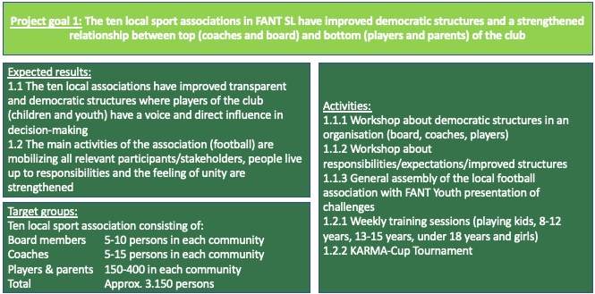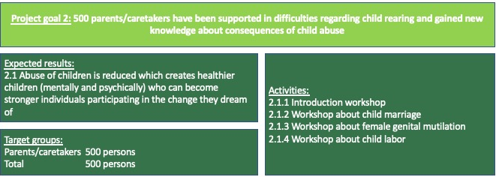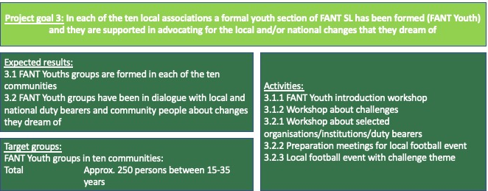

3.2 Composition of target groups:
Within project goal 1 the composition of the primary target group is very diverse. It includes players down to the age of five years and board members above the age of 50 years who are looked upon as some of the duty bearers in the communities. Both in age and in relation to power the target group has diversity. The division between male/female is expected to be approximately 70% male/30% female. Around 50 persons from each community will participate in the first three activities under project goal 1, which will be a mix of board members, coaches, youth players and parents. For training sessions and KARMA-Cup tournament all stakeholders with a connection to the association will be invited to participate. Primary target group will benefit when creating relations and understandings among different persons with diverse views, positions, and opinions in a community. Like a football team – you can have individual exceptional talented players but if the team does not understand how to play together as a team, they will lose the match. Being unified in a local sport association will benefit not only the primary target group when training their democratic skills and being educated about democratic principles but also the secondary target group when benefitting the entire community and creating a platform where persons without power are being listened to, included and have a voice.

Secondary target group within project goal 1 are
- community members
- parents and families of primary target group
- local institutions and organisations

Within project goal 2 the target group is parents for the younger players in the sport associations. This intervention will target parents with children in the age between 5-14 years. The division between male/female is expected to be approximately 35% male/65% female. Around 50 parents from each community will be invited to participate in the planned activities within project goal 2. The activities/workshops will be planned so they are very interactive so the parents will be participating at a high level and not just listening and receiving information. The primary target group benefits when making new reflections about childcaring and problems formulated by some of the children and youth living in their community. This will expectantly lead to the secondary target group (children of the parents) benefitting when parents are guided to understand and handle their children differently for example in case of using violence towards their children or forcing girls to be circumcised.

Secondary target group within project goal 1 are
- the children of the parents including siblings that are not a part of the FANT sport association
- community members

Within project goal 3 the target group is young adults in the age between 15-30 years. The dispersal of the target group will be equally male and female. The young adults will volunteer to join the FANT Youth group, but local coaches will talk about the new initiative and try to recruit some of the youth leader they see great potential in. It is expected that many of the young people who have participated in the project being implemented now will join this new project as well. The youth groups will participate in the activities, first in workshops and seminars and thereafter as more independent implementers of the activities. The ten local communities differ a lot from being slum areas in Freetown to small villages in the rural area. It is expected that all tribes will be represented and that many different layers of the society will be included. They will benefit from the intervention when learning more about how to participate in decision-makings on specific subjects that they have already analysed as challenges in their everyday lives. They will learn how to work in groups and independently when trying to find access to duty bearers and decision-makings.

Secondary target groups within project goal 3 are
- Children and youth in the ten local communities who will participate in the football events
- Duty bearers (NGOs, institutions, and mostly local duty bearers)

3.3 Local legitimacy and involvement of target groups in project development and implementation
For the two target groups of children and youth in FANT SL’s local communities, they have been a part of the projects for the past nine years and it is therefore only natural to include them in project planning processes. For the current project being implemented they have shared ideas, dreams, frustrations etc. at the workshops. Through these workshops and meetings, the working group in FANT SL has discussed future plans and encouraged target group to be a part of the planning process. Most inputs so far have been, that they wish to continue on the path we are on now with football activities, workshops and events that combine football and things learned/discussed at workshops. This wish has been implemented in the setting up of this new intervention.

FANT SL is for each project implemented becoming stronger and stronger when acting on behalf of target groups and maybe even more important – when supporting target groups to directly engage in the change they dream of. The young adults and children are well organized in FANT SL and they have direct impact on how they want to be organized and how they want to carry out activities. FANT SL is a facilitator for the target groups. FANT Youth will be in charge of choosing institutions/NGOs/challenges they wish to investigate and work on. FANT SL contributes to network alliances in the communities to make sure the target group is protected and secured by other actors as well. When different situations occur in the local communities, it could be a flooding in Kroo Bay, people use the platform of FANT SL to communicate, mobilize and organize interventions to help the affected individuals. Using the same principles, FANT SL creates the overall frame for the project and allows the target groups to fill it out and take ownership and responsibility. FANT DK and FANT SL have collaborated on developing the project framework and activities for the last six months. The actual design of the project and the activities have been finalized in close collaboration both between FANT DK and FANT SL but also with inclusion of voices from the local communities this being coaches, board members and players.

For the new target group of parents, FANT SL staff engaged deeply with this group during our DERF intervention implemented in 2020 in connection to COVID-19. An important part of the project was that local FANT coaches did family-visits to talk to parents and children trying to prevent abuse and violence – helping to create coherent families. The experience FANT SL gained from this has created the background for involving the parents in a much higher degree in this intervention. Ibrahim Bangura was one of the FANT SL staff member that did many of the family visits. He explains afterwards how he realised that if you want to make a positive change for the child, you need to involve the parents/caretaker because they are the once’s in power over the child. The parents came to trust FANT SL during the DERF intervention which is a good starting point to continue from. The act. 2.1.1 Introduction workshop will be held to ensure that parents understand purpose of their involvement and to ask them openly, what they hope to achieve through the workshops. They will get information about the overall aims and objectives of this project and get the chance to give their inputs to how FANT SL can arrange workshops that they feel involved in and that they benefit from.

3.4 Strategy and methods leading to reach the overall objective
The projects strategy is like previous CISU-funded interventions inspired by the underlying Theory of Change (ToC), and the strategy has been developed in collaboration between FANT DK and FANT SL. The figures at page 17 & 18 map out the relation between development goals, expected results and activities. The overall aim is to pursue structural and long-lasting changes that will lead to improving next generations future independency and supporting them in participating and affecting local and national decision-making, so they become an active part of the change they dream of. This aim is facilitated by an intervention that seeks to change relationships between duty bearers and rights-holders in conflict over resources and opportunities to participate in decision-making processes. To challenge the relationship between those in power and those not in power, this project engages in empowerment of children, youth and their parents. The activities are planned to challenge feelings, perceptions, behaviour and motivations of individuals, CSOs and government institutions.

The relation between those in power and those without is a complex matter in this intervention. Below figure gives an overview over how this project connects the groups of persons with power and those without. This project focuses at working from three different levels of power being from the perspective of 1. children, 2. FANT Youth and 3. FANT SL. The idea of this strategy of working from different levels comes from the assumption that all levels are important and that different groups will have easier access to different duty bearers or persons with more power than themselves. Children in this project do not engage in advocacy towards parents why FANT SL is speaking on behalf of this target group.

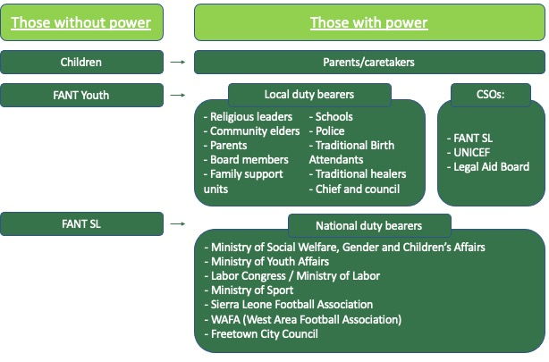

The overall vision of the new project is to create a long-term foundation for advocacy through mobilization and organization of marginalized young adults and children and the empowerment of their parents. The partnership between FANT DK and FANT SL has started to revolve a lot less around strategic service delivery and more around building the necessary capacity for strategic and effective advocacy. The work with advocacy in this new intervention happens at two levels. One is the strengthening and capacity building of the ten local sport assocaitions and the primary target groups and on another level, advocacy will be used in specific activities aimed at influencing structures, institutions and authorities.

Looking at the Development Triangle this project includes activities in all corners of the triangle. The most obviously activities within service deliveries would be act. 1.2.1 Weekly training sessions and 1.2.2 KARMA-Cup, but these activities are the core foundation for mobilising target groups. These activities arranged for children and youth in the ten local communities provide the legitimacy for FANT SL to invite parents to workshops, help teach FANT Youth about democratic structures and organising and talking on behalf of the target groups when engaging in advocacy to national duty bearers. For the activities within project goal 1 they all have an important element of creating a space within the community where persons with different power positions will meet. The workshops will not only capacity build the participants in democratic participation but also and even more important give a voice to marginalized groups to express their frustrations and concerns to community duty bearers. Board members of the local sport associations are local duty bearers with different power positions. With workshops and the general assembly, the board members will be in contact with players, parents and coaches who represent the majority of the community people with very little or even no power and influence on local decision-makings. Act. 1.1.1, 1.1.2 and 1.1.3 are therefore a central part of the advocacy corner of the project on a community-based level.

Within project goal 2 the activities are places between the capacity building corner and the advocacy corner. The reason why we place it here is because the parents are being empowered in child rearing, but it is actually FANT SL engaging in advocacy on behalf the of children. The themes of the three workshops are defined by youth players in FANT SL who have pointed at these challenges to be some of the most destructive for children in Sierra Leone. There are many reasons for the happening of these things and they repeat themselves over and over which will be investigated at act. 4.3 Preparation week in five challenges to ensure that FANT SL has the needed knowledge, support and network within these challenges. As stated earlier in this project application knowledge about the issue/challenge is an extremely important factor in the process of engaging in advocacy. Advocacy and capacity building therefore goes hand in hand when FANT SL facilitates workshops for 500 parents/caretakers.

For project goal 3 the first two activities are in the corner of capacity building when supporting FANT Youth in strengthening their own organisations. The three last activities are in the advocacy corner when arranging a local football event with the aim of creating awareness about challenges and creating dialogue with local duty bearers with powers or connections within the challenges. For the four activities supporting more than one project goal they have the aim of strengthening organisational capacity and replicate democratically structures within FANT SL which must be understood as a part of capacity building. Act. 4.3 Preparation week in five challenges is a part of preparation for engaging in advocacy with the parents and also supporting FANT Youth in their advocacy projects in their local communities. The aim of this week is to attend important meetings with relevant partners like other NGO’s, CBO’s, government institutions etc. The office staff will be divided into five groups where each group will investigate one of the five challenges mostly connected to creating needed relations to organisations/institutions with important knowledge within this field. This preparation week is important for FANT SL to have the required capacity to host workshops for parents within project goal 2 and also being capable of supporting FANT Youth in reaching out to the right and relevant duty bearers. It is the intention that FANT SL will facilitate workshops for parents with participation from other relevant partners that will be identified at preparation week.
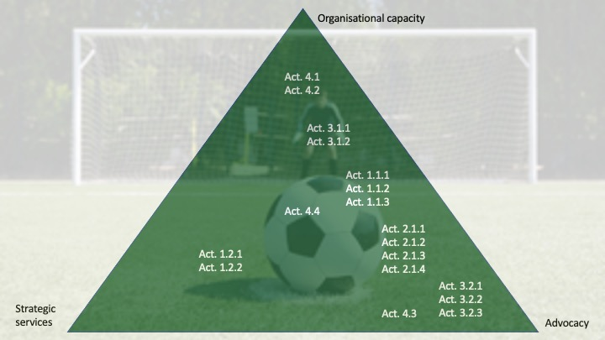

3.5 Sustainability and lasting improvements for target groups
The aim of the project is to support and continue the already started movement of sustainable change for children and youth in Sierra Leone. The capacity building of 500 parents and 250 persons in FANT Youth will ensure that they will be in a stronger position than before, because they have gained new knowledge, skills and have become a part of the broad network within FANT SL. More, the strengthening of capacities of civil society organisations both in the ten local sport associations and in FANT Youth are a part of the sustainability of the project. This project is an extension of four earlier projects and will continue the work already started to create heathy and relevant partners both with like-minded NGO’s and organisations but also to local and national duty bearers. A normal part of the daily work for management and office group in FANT SL is to participate in relevant meetings at ministries, institutions, and organisations. This is not an explicit part of the activities but something that is a part of their organisational work and being.

The intervention will challenge old-fashioned mindsets about relations between old and young which is a sensitive subject, that can create resistance from the public. FANT SL will use its legitimacy to support the initiative and make sure, that the children and youth involved in the project will not be left alone or behind. FANT SL will be in the frontline and be responsible and available for any confrontations, comments, questions along the way.

Salaries in this project will secure that the FANT SL working group get two meals a day and can take care of their families. Salaries are kept low between $200 and $340 a month to make sure the involved are not put in a relationship of dependency after completion the project. This salary is necessary when expecting them to put dedication and time into the project. It will be difficult for some of the FANT SL individuals to uphold other fulltime jobs, why it is only fair to pay a salary. FANT SL is the main implementing partner for the project and have a high responsibility for implementing and monitoring activities.

The results of this project will create long-lasting changes that will not end when the implementation period finishes. The newly gained knowledge, strengthening of internal networks and partnerships, and advocacy experience, will be a constant factor supporting the involved. FANT Youth has gained experience about how to formalise a network, how to work together and create space for different opinions, has learned about discipline, and met role models from FANT SL and their communities; competencies and experiences that they can benefit from for the rest of their lives. They have experienced how to get a voice, and hereby gained personal confidence and motivation for participating in decision-making and effecting essential obstacles that maintain people in poverty and exclude them from policymaking.

This intervention is intended to improve the ability of all partners to act as catalysts, when creating a project strategy where cooperation and relations are not just prioritised but essential. All levels from children -> FANT Youth -> Parents -> Local Sport Associations -> FANT SL are equally important and have central responsibilities to live up to. Besides the implementing partner and target groups in the project relations to local institutions and national ministries are an incorporated part of the project. Lastly, companies and public in both Denmark and Sierra Leone are contributing to the project in different aspects, one being a part of laying the artificial turf in Aberdeen community (AGF, Monjasa, Architects without Boarders, Genbrug til Syd, NKI Kunstgræs etc.). Numerous sport associations and football clubs in Denmark are also supporting when collecting and donating used sports equipment that are used in the daily operation of the ten local sport associations in Sierra Leone. FANT DK also uses its social media platform to communicate to different donors and partners in Denmark about progresses in projects.

3.6 Risk analysis and mitigation strategy
It is important for FANT SL and FANT DK to account for the potential risks that can occur in this project intervention. The risks can potentially threaten the project and the planned activities, which is why we have structured relevant sustainable strategies to mitigate these potential risks. Doing development work in Sierra Leone is risky in general because of the fast-changing context and attitudes of people. The figure below outlines some of the potential risks that in a worst-case-scenario might hinder the fulfilment of the project objectives and our planned strategies for mitigating these risks. It is significant to mention that the risks listed below are tentative and further potential risks will be elaborated as a part of act. 4.3 Preparation week.

Risk | Mitigation strategy
The project meets resistance instead of cooperation from parents. | FANT SL has previously worked with parents in former projects under the civil society fund and in the DERF intervention which gives them some experience with this target group, but it is still a relatively new target group. Also, because of the sensitive issues framing the cooperation it is expected that some parents will go in opposition. Act. 2.1 Introduction workshop is a part of the mitigation strategy to prevent this from happening. This activity shall allow parents to express their opinion and scepsis and help FANT SL to be transparent about aims and objectives of the intervention. Parents/caretakers are participating on a voluntary basis and therefore have the right to leave or not participate in future workshops if they do not feel well treated or acknowledged. After each workshop there will be a brief evaluation where participants get the change to give inputs towards improvements which will be discussed in the working group and incorporated if found useful. At act. 4.3 Preparation week a half day workshop about how to deal with parents will also be included. Parents are also invited to join activities within the two other projects goals which allows them to be a part of the whole organization and to be heard in their community, which hopefully will make them more open to discuss the sensitive issues at the workshops.
The division between girls and boys in FANT Youth will turn up unequal with much more boys than girls wanting to join. | FANT SL has great experience in getting girls involved in sport activities and workshops and will make use of these confirmed strategies that have worked in earlier projects. It is important to have the acceptance and recognition from the parents, why the dealing of above-mentioned risk is also important regarding this risk. Even though FANT SL has done great improvements when involving girls in sports activities we also know that it is a fact that most players in the communities are boys. The boys recruited for FANT Youth will be a part of the FANT players, but local coaches will also try to look beyond the female players when trying to find a minimum of 10 girls who are motivated to be a part of FANT Youth in their community. From the current project being implemented we have a clear impression that almost all the participating girls will continue their involvement in this new project.
The duty bearers invited to events and dialogue meetings do not respond or show up when expected. | Even though the relationship to local and national duty bearers is good now and they usually participate in meetings and events when FANT SL requests for it, it is still difficult to predict. Persons in the different ministries or institutions can change and a lot of things in the context can change. When FANT Youth shall be involved with local duty bearers in three last activities within project goal 3 FANT SL will assist and support them when necessary. They will use their network and legitimacy to open doors for FANT Youth if it turns out to be necessary. National duty bearers are often very busy and powerful which makes them unpredictable. FANT SL has managed to build up strong relations within ministries that help this issue, but it is still a risk that is difficult to mitigate but the continuity of building the relationship and trust is important.
COVID-19 makes it difficult to implement activities because of restrictions and dangers of being gathered and also creates difficulties for FANT DK to conduct the planned monitoring visits. | Sierra Leone has an extremely poor health system that only allows a very small number of the population to get medical treatment. Furthermore, there is a high degree of inequality in the society with regards to economy, access to education, health and human security, with children and youth being disproportionally affected. Nevertheless, the COVID-19 situation in Sierra Leone seems to be improving with numbers of new cases decreasing and almost no restrictions left. Rainy season are just about to end which would be the season with most fruitful conditions for COVID-19 but it seems like the situation is under control for now. If COVID-19 increases in either Denmark or Sierra Leone FANT DK will manage to monitor project online and maybe consider extending the project period if needed.

3.7 Monitoring and evaluation
Throughout the project implementation phase, the working group consisting of six individuals from FANT SL will be responsible for the daily monitoring of activities together with the management team consisting of three individuals. Activities in this intervention are geographically spread between two districts of the country, which will require transportation and accommodation facilities for the working group when operating in Tonkolili district. Reports on project activities produced by the working group will be shared on a monthly Monday meeting and sent by e-mail to FANT DK. The Monday meetings at the office will help working group to plan, monitor, correct and evaluate activities. Representatives from the FANT SL working group will also participate in the meetings in the communities and share information about achievements, challenges, changes etc. when relevant. In terms of evaluation, the listed expected results will be used to get an overview over whether the project has created the intended impact for target groups. One of the weaker areas of FANT SL is their capacities in making thorough evaluation investigations and reports, why FANT DK is planned to help facilitate the process together with FANT SL. The process surrounding this intervention will hold many important learnings for all parties involved, and the complexity of the intervention will demand close monitoring and preparedness for adjusting if relevant. Especially in the new COVID-19 situation. This new project is a product of thorough planning and many discussions of lessons learned from former projects, which have formed a solid foundation for partners to monitor along the way and evaluate at the end of the intervention. Results, documentation and concerns of monitoring and evaluation will, as far as possible, be made public and shared in workshops/meetings with relevant duty bearers, CSOs and other stakeholders.

4. Intervention-related information work in Denmark
FANT DK will use its social media platforms to inform relevant and interested partners about project activities and processes. Totally, FANT DK has a reach of around 9000 followers distributed over Facebook, Instagram, Twitter and LinkedIn. These 9000 followers are interested in the work done by FANT DK and FANT SL and some of them have probably also contributed as a part of collecting used sports equipment, as a volunteer or by donating money. The idea is to make three small videos from Sierra Leone, one that will present a relevant story/person connected to each of the project goals. For project goal one it could be a video from KARMA-cup with an interview with a player or coach, project goal 2 could be a video from a workshop with an interview with a parent and project goal 3 could be a video from one of the football events with speeches and interview with a local duty bearer and representative from FANT Youth. These small videos will be connected to a short text explaining project goals and aims.

5. Supplementary financing
FANT DK will use 24.870 DKK from own financial means to implement KARMA-Cup. Hummel is sponsor for KARMA-Cup both concerning equipment and will also donate the remaining 24.870 to make the tournament as FANT SL dream of. The funding from hummel has been secured but if something should go wrong the amount will be taken from FANT DK’s other donations or KARMA-Cup will be scaled down so it fits the amount available.

https://bmcinthealthhumrights.biomedcentral.com/articles/10.1186/s12914-020-00240-0
https://databank.worldbank.org/data/download/poverty/987B9C90-CB9F-4D93-AE8C-750588BF00QA/SM2020/Global_POVEQ_SLE.pdf
http://opendatasl.gov.sl/sites/default/files/Youth%20Participation%20in%20Council%20Decision-Making_narrative.pdf
https://www.unicef.org/crc/files/Rights_overview.pdf
https://heleverdeniskole.dk/laeseraketten/sierra-leone-i-tal/
https://sierraleone.unfpa.org/en/publications/sierra-leone-2015-population-and-housing-census-thematic-report-children-adolescents
Citat fra Ulandssekretariatet (http://www.ulandssekretariatet.dk/content/sierra-leone)
The Sierra Leonean Premier League started playing again in January 2019 with help and on the initiative from the Ministry of Sport.

