Danish organisation | FANT – Football for A New Tomorrow
Title of the intervention | Plan B phase II
Partner name(s) | HOPin Academy
Amount applied for | 3.518.831 DKK
Country(ies) | Ghana
Period (# of months) | 01.07.22 – 30.06.25 (36 months)

- Objective and relevance (the world around us)

Objective 1: By the 30st of June 2025, 1,000 young footballers in Northern Ghana have participated in rigorous career guidance and mentorship programs on a monthly basis and have increased their formal education level and/or increased their knowledge about job opportunities and rights for uneducated labor

Objective 2: By the 30st of June 2025, the process about establishing a physical space for the Plan-B-Club has started, the club has a membership base of football players and clubs in Northern Ghana and is providing expertise guidance and capacity building courses/workshops/training/seminars on selected topics with support from relevant national and international partners

Objective 3: By the 30st of June 2025 the Plan-B-Club has, in consultation with local duty bearers, the Plan B Mentors, relevant football and educational stakeholders and the young footballers, implemented an advocacy campaign with recommendations to specific policies and initiatives that will enable equitable access and rights to employment opportunities and quality education for young footballers in Ghana and have entered into dialogue with regional and national government institutions

Target group clarification: This project evolves around the term footballers and when used, we mean mainly young boys who dream about becoming professional football players. We do not take a position on whether this dream is possible for the individual or not. The key thing is that they have the dream and want to follow it. Their passion for football – despite talent or not – is what makes them a part of the target group for this project. No matter if they make it as a professional football player or not, they will need a plan b at some point. Some will need it when the dream does not come true, some will need it when their football career is over in a relatively young age.

1.1 The extension of previous interventions
This project seeks to empower and educate vulnerable footballers in rural communities of Northern Ghana with alternative career choices. This will be done by increasing participation in formal education among footballers, improving career guidance and counselling among young footballers through mentorship and enabling employment opportunities for footballers among other strategies. This project will develop and further complement the objectives of the SEED Plan B Project which is creating better livelihood opportunities for young footballers through education empowerment and mentorship.

The Plan B Phase II is a continuation of the two projects
- Sport and Entrepreneurship for Economic Development (01.04.2020 – 30.04.2021)
- The SEED Plan B Project (01.07.2021 – 30.06.2022)
Sports and Entrepreneurship for Economic Development project created a network of 300 young entrepreneurs with an interest in sport from Northern Ghana who advocated for better policies for entrepreneurship in the region. The Seed Plan B Project used this network of 300 young entrepreneurs to educate and train them in mentorship programs targeted young footballers. In The Seed Plan B Project, a civil society organization (the Plan-B-Club) will be established but in the very early stages. The SEED Plan B Project will finish in June 2022 with the founding general assembly. Based on the lessons learned and the overall results from the past two projects this project will scale up the target group of young footballers to 1,000, the Plan B Mentors to 300 and bring a new focus on advocacy and policy change. This project takes a more holistic – or you could say 360 degrees – approach when interacting at three different levels: the individual level, the civil society level and at national level.

The two projects that lies behind this Plan B Phase II have built the foundation, knowledge, and experience for HOPin Academy and FANT to expand the project. The SEED Plan B Project has been a pilot project for this larger intervention. The strategy from The SEED Plan B Project is also relevant in this intervention and is built upon the following
- Interacting at three different levels: the individual level, the civil society level and at national level
- Mentors and voluntarism
- Follow the dream, but be more than just a footballer
- No “one-size-fits-all” approach
- Knowledge is key for change
- If you want to go fast go alone if you want to go far go together
This project will continue to focus on building the structures and capacities that can support young vulnerable footballers to create a second option, should they fail to pursue a football career or when the career is over. The main new parts in this intervention are the upscale of target group to 1,000 young footballers and 300 Plan B Mentors, the priority focus on advocacy and policy change and lastly, the emphasis on the creation of strong partnerships to sustain the project in the future.

This intervention is an upscaling of the mentorship programs and a stronger participation in advocacy. In the project being implemented now, several meetings and workshops with participants from the target group, mentors, and authorities has been held with an interesting outcome. These meetings came with a lot of questions from young footballers and veteran footballers to the football authorities, as to why important information in the findings never goes public to the grassroot footballers and rural football clubs to help them take these opportunities. Some of the topics discussed was the opportunities of scholarships at universities, regulations about footballers in high school and how schools are actually obligated to support the student’s sports activities, rules about selling players from one club to another that are not complied with by clubs and managers, rules about medical insurance for players that clubs do not comply with etc. In the past interventions it has become clear that young football players in general do not know about their rights and therefore have no chances of claiming them. When looking at the football arena in Norther Ghana, there is lack of communication and dialog between those in power and those without. This intervention seeks to challenge this position.
1.2 Major challenge to address
The major challenge that this intervention seeks to address is that an enormous number of young boys in Ghana dream about becoming professional football players and in their attempt in pursuing this dream they drop out of school, fails to focus on learning skills that can sustain their financial independency for the future and end up becoming marginalized young men with limited prospects of escaping poverty. These young men in Ghana find it difficult to establish financial independency, hence affording housing, basic necessities, getting married, forming families and for some, even having a girlfriend, becomes close to impossible. They live in uncertain spaces of day-to-day survival, where they depend on friends and relatives, and take jobs in the informal sector.

It is difficult to find exact numbers of how many young boys in Northern Ghana dream about becoming professional football players and because of this dream drop out of school. But experiences from the two earlier projects shows a huge amount – and a very unexplored problem. Academic research has pointed at the problem for years, but for some reason it is not an issue that the public is discussing or reflecting upon. Nor in Africa or in Europe. The lost potential in Africa for young boys dropping out of school because of their dream about becoming the next Messi is insurmountable.

The precarious nature of a career in professional football fails to deter West African youth, and the pursuit of football stardom typically comes at the expense of formal education and vocational training. In the case of Ghana, the number of amateur football clubs and youth academies is rising, a reflection of broader trends taking place throughout sub-Saharan Africa (see Darby et al., 2007). For example, in March 2011 while registration was still taking place, the GFA regional office in Accra estimated that 700 clubs in 12 regional zones would take part in a new regulated national junior ‘Colts’ league (under 12, 14, and 17). Whilst 184 of these clubs were located in the Northern Region with the number of registered youth players estimated to be in the region of 10-15,000. This is a testament to the high interest rate in sports in Northern Ghana as the number of sporting clubs is increasing.

This new intervention is addressing a challenge that has been described in the academic world for many years but has attracted very few call-to-actions. People all over the world love football – HOPin Academy and FANT are no exceptions. It is in the love for the game that this project will have its rising point.

1.3 Context of the intervention
This section will look deeper into the context for the understanding of why this intervention has been planned and what makes it relevant. It is divided into two sections whereas the first section will explore football in Ghana with a more general approach while second section will investigate how low living standards and football are connected in the context of Ghana with a more in-depth approach.

1.3.1 Understanding the meaning of football for young boys in Ghana
Ghana, a small African nation sitting on the Atlantic Ocean, is one of the world’s most prominent exporters of footballing talent (Poli, 2010). In order to better understand the reasons for this dynamic, it is pertinent to be conscious of the current socio-political climate in the country. It has a population of around 28 million people who live under a multi-party democratic government. Despite having a developing economy, Ghanaian ministers face sizeable budget deficits of which they have pledged to reduce (The World Bank, 2018). The real deficiencies of this economic growth reside in what the economy is built on and the manner in which it is distributed (Esson et al, 2015). Both of these factors have an influence on the career projections of Ghanaian youth.

There is a significant income imbalance favoring urban areas over rural areas, resulting in an expansive poverty gap between the two (UNICEF, 2016). Despite the clear existing barriers to professional development, young Ghanaians are sequentially expected to achieve personal success under neoliberal reforms. They are entrapped in a reality of the double-edged sword, an existence in which pathways to social becoming are blocked from all angles. Ghanaian youth are faced with a potentially unstable livelihood in the informal sector and an inaccessible, over-saturated formal sector. Those situated in far-flung rural areas such as Northern Ghana, are possibly the most isolated of all, restricted to their immediate surroundings by a lack of transport and a lack of finance to migrate to more prosperous regions. Northern Ghana is the rural area of the country and is the poorest part of the country. The extensive global media coverage dedicated to professional, particularly European football, and the cult of stardom attached to footballers playing their trade on this lucrative stage, are claimed to have popularised the myth of a career in football as a means of upward social mobility (Christensen and Sørensen, 2009, Poli, 2010). There seems to be a linear connection between poverty and young boys that dream about a professional football career. The Right to Dream Academy located in the southern part of Ghana recruits most of their players from the Northern part of the country because this is the place with the highest numbers of players.

As much as 35% of the population in Ghana is between 15-35 years, and this group is highly affected by the social, political, and economic development in the country. They experience social injustices and inequalities in several areas of their lives, but they are also the main drivers of future change and ensuring that they have the capacity and supporting structures to participate and influence the development is therefore essential. The youth is marginalized at all levels of society, from the home to the institutional level, especially in rural communities meaning the part of the country where this intervention is being implemented. Families take pride in the number of children they have, but children are seen mainly as sources of labor for farm and housework and not regarded as contributing to the development of their communities – again a trend that is much more common in the northern part of Ghana. The youth is therefore not exposed to much information and enlightenment. This affects the social development of most young people who lack the confidence to express themselves or their talents. Furthermore, the development of children and youth in Ghana’s northern regions is affected by a poorly functioning educational system. According to a World Bank analysis (2010) on the efficiency and effectiveness of Ghana’s education sector, the poor in the northern regions of Ghana receives less than 30% of Ghana’s national resources per school-age pupil compared to their southern counterparts despite the poverty profile of northern Ghana. This results in inadequate educational infrastructure and poor quality of education due to a lack of qualified and committed teachers in deprived areas.

Often age itself is a vector of inequality, excluding young people from access to financial resources, work opportunities, social welfare mechanisms, and decision-making spaces, despite their rights to it all. The youth tends to be excluded from discussions that concern them and their future and are poorly represented at all levels of decision-making structures in the community and beyond. Positions of power in Ghana, and in Northern Ghana, in particular, are culturally related to high age, which implies respect for elders but also tends to leave young people without the courage and self-esteem to air their views in the presence of elderly people. The inequality between elders and the youth is also illustrated in the frequently used local expression “big men and small boys” where high age, influence, wisdom, and wealth make up the term big men, and youth, ignorance, and lack of resources constitute the term, small boys. Traditionally there have been some opportunities for male as well as female youth, especially in rural areas, to take up youth leadership positions within the chieftaincy. In the government system, at the local, regional, and national levels, however, youth is poorly represented.

Football is one of the most important recreational activities that create national unity in the country at a time when socio-political and economic challenges threaten to tear apart the national fabric. The sport has been growing steadily, employing many people directly (players, coaches, referees, sports journalists, stadium managers, sports betting companies) and indirectly through the sale of sportswear and other activities.

A growing number of Ghanaian players are currently moving to Europe, South America, and parts of the Middle East as a way of advancing their careers. The majority of these players is motivated by the salaries offered by these foreign football clubs and the opportunity to play alongside and against some of the world’s best players. Such transfers often have a positive financial impact on players, their families, and the country at large. However, the process and activities involved in international player transfers are more complex than it is locally. It requires effective leadership in the local football clubs to ensure that players and their agents are empowered when it comes to negotiating international contracts and understanding the laws and regulations of the new country. It may take some time for them to understand these rules. A complex release clause makes it difficult for a player to move from one club to another before the expiry of the existing contract, as was witnessed recently in the case of Lionel Messi (Kilcline, 2019). Some players from Africa, Ghana included, have complained of racism and discrimination, both inside and outside the field, in these foreign countries primarily because of their skin color. Some personal decisions, based on an individual’s interest, may also affect the ability of a player to move from one club to another.

Lack of basic education also continues to see some successful footballers still becoming the most vulnerable off the pitch across the world. Ghanaian players are not excluded from this problem as their progress in the game overshadows the importance of education in their careers. For those whose hopes of a football career fail to materialise, they become the hardest hit as they are muscled out from the rapid globalisation of other sectors because of their lack of education.

Education is a problem in association football, especially in parts of the world where education, in general, is on the low. Players need some form of education, which will also help in the future after their football career. An educated player is able to better understand himself, the world and the game. Football has certainly improved in terms of professionalism, but the aim is to understand that well educated and intelligent people will improve the quality of the game. It does not matter if you are a player, a coach or a member of staff. The game will be better if people understand it better. Receiving some form of education by a footballer will improve in diverse ways to support the players or staff. It ranges from learning the laws of the game, learning the proper diet that will improve player performances, and securing an insurance package for the future after football. Players with some form of education can better negotiate for contracts because they can get a better understanding of the terms and conditions that are stipulated to be agreed upon.

1.3.2 Understanding the relationship between low living standards and football
This section will take its starting point at below figure – the problem tree. The construction of the problem tree has supported us in understanding the challenge this intervention is addressing and furthermore what information or knowledge we need to continually study and investigate. The problem tree was developed as a part of the process of planning this intervention, to make sure it would set in at the most needed areas, and that both HOPin Academy and FANT would have a profound understanding of the underlying challenges that the target group is facing.

Problem tree:

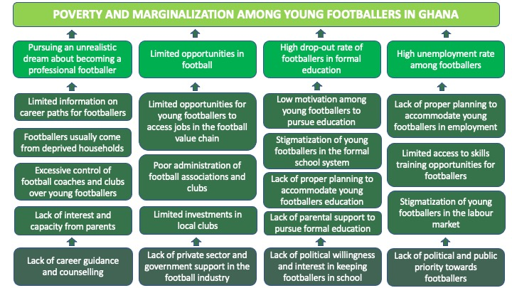

Pursuing an unrealistic dream about becoming a professional footballer
The first pillar of the problem tree helps us understand some of the reasons why there seems to be a linear connection between poverty and young boys dreaming about playing professional football. The lack of career guidance and counselling for young vulnerable boys leads to them pursuing unrealistic dreams about becoming professional footballers. If parents, teachers, coaches, or other individuals looked upon as role models to the young boys in a higher degree provided guidance and counselling about career possibilities and helped them understand the industry of football it is questionable if as many would still put all their eggs in one basket and without considering other options pursuing the unrealistic dream of professional football. In poor households with plenty of children parenting is often reduced to the children’s survival where parenting in less deprived households more often will reflect direction and conversations with the children. It leaves the young boys from poor households with a huge individual responsibility for assessing right information on career paths and if they fail, the popularised and idolised myth of a career in football can seem like the only way to escape poverty. This intervention will provide this needed career guidance and counselling through mentorship programs.

Limited opportunities in football
Despite that football in Ghana without uncertainties is the most popular sport there is a lack of support and investment coming from both private and government bodies. The market for football is not well developed within the country and the best players will look for opportunities outside of Ghana. This falls withing the expression of brain drain of Africa. The opportunities of actually creating a career in the football industry in Ghana are very limited whether this would be as a player, coach, administrator, physiotherapist or the like. In a country like Denmark, it is not uncommon to see former professional football players continuing their career within the football industry after they finish as a player. In Ghana this is very unlikely and only possible for a very limited number of individuals because of the limited job opportunities in the industry. It is also worth mentioning that even in the best football league in Ghana (can be compared to Superligaen in Denmark) very few players can uphold a decent living standard for the provided salary. This fact makes it even more important for the young footballers to engage in a Plan B when realising that even if they do succeed in becoming one of the best players in the country, they must get employment abroad to earn a decent salary. This project will in depth investigate challenges within the industry of football in Ghana and based on the findings implement an advocacy campaign with recommendations to specific policies and initiatives that will enable equitable access and rights to employment opportunities for young footballers in Ghana.

High drop-out rate of footballers in education
Unfortunately, it is very often that young footballers drop out of school at an early age, which will leave them vulnerable when they are finished with football or if the football career does not succeed. Jordan Anagblah, former vice president of the Ghana Football Association: “It is a trend that you will find in the whole of West Africa, that good footballers did not go to school. Those who don’t have good parents and come from poor homes are the people who have the chance to be on the streets every day playing football. A very good footballer therefore often did not go to school.”. The education of young footballers is not a political priority. One of the consequences of this is that schools are not willing to support the footballer in both perusing football and education at the same time. The young footballers feel stigmatised by teachers and the other students – they are put in a box of students from deprived homes and without a real change of making it though the educational system. If you are a footballer expectation from teachers and other pupils will be low. Schools and football clubs do not normally communicate about how to support each other but become in opposition against each other. In Denmark we have a system for young athletes called Team Denmark. It is a special high school system where students with a sports talent can combine their high school with their training by using one extra year in high school. This intervention will through dialog meetings and communications with schools and football clubs seek to create a broader understanding of the dilemma that young footballers feel they are caught in. The Plan-B-Club will work towards implementing systems that can support young footballers in staying in school while still playing football and present these suggestions to national and local duty bearers and stakeholders. Through radio, television, and social media the intervention will tell the nuanced stories of young footballers and seek to prevent the stigmatisation in schools.

High unemployment rate among footballers
Footballer’s poor life condition is in general not an issue that government or the public are preoccupied by. Nor the high unemployment rate among this group. Almost none of the footballers have permanent jobs but take day-to-day jobs in the constructing sector or survive by selling a few items on street corners or if they are lucky, they will be paid minor allowances when representing different football teams. Young footballers without a real chance of succeeding in getting a football career will spend too much time on the pitch which could have been used in a classroom or at improving skills in other areas. It is a decision they make, but it is also supported by the societal structures. Business owners do not want to employee footballers because of different prejudices – some which are true. The young footballers need to be motivated for taking a job or learning a skill and we believe that the guidance they will get through the mentorship program can support this motivation. The more informed they get about the difficulties in achieving a career in football, the more stories they hear from older footballers that have made crucial mistakes when they were at their age, the more they will reflect upon their own choices and make sure they create a safety net for themselves in the future. This intervention will focus on creating a link between footballers and the private sector but also educate the footballers about labor rights for uneducated jobs. Also, there will be activities about innovation and entrepreneurship, which HOPin Academy is specialised in. There is a lack of jobs in Northern Ghana, and a need for the creation of jobs why HOPin Academy will search for potential entrepreneurs among the young footballers.

1.4 Why is this target group important – and maybe even overlooked in today’s development strategies?
For any country in the world, it is not favorable to have a large group of young men without a real connection to the society or state in form of education, job, family etc. These young men have shown easy to recruit for different undemocratic and sometimes violent purposes. A high number of young unemployed boys without any real education is a constant threat to peace and stability in a country. They are also often the financial supporter for the households when looking at most African societies which leaves whole families in poverty if they fail financially.

At the moment there is a strong tendency in western policies to target and prioritize development aid towards girls and women. This also includes the danish development strategy from 2021 FÆLLES OM VERDEN which in the introduction at page 5 clarifies “Vi vil gøre en særlig indsats for ligestilling og piger og kvinders rettigheder …”. Both FANT and HOPin Academy are greatly engaged in projects with the priority of gender equality, which is also an important focus area in both organisations. But we also believe that young vulnerable boys are relevant to understand and include in development projects. Being young – no matter if you are a girl or a boy - is a human development process that will lead to the individual becoming a member of society, earning rights and facing responsibilities. Societal structures like the lack of access to education, lack of employment opportunities, social exclusion of decision-making, exposure to poor housing conditions, (sexual) violence, teenage pregnancy and marriages, no access to health services, drug and alcohol abuse, criminal activities etc. makes it difficult for youth to become independent well-being contributors to society. This intervention is built on the assumption that the youths potential is increasingly evident as key for improving national growth, development, and security. And when understanding the group of “youth”, young footballers are a part of this group.

This intervention includes some of the most marginalized young boys in Northern Ghana; the ones that have dropped out of school and are now hustling through life. Many of them have problems at home where older family members expect them to chip in with the finances. Football becomes their free space where they can forget their everyday problems and exist in the moment of joy and solidarity with their teammates. And maybe most important - they become someone when playing football. Community members will know their names and respect them if they represent the community well.

Football has a significant meaning for many nations all over the world. Football is a part of the national identity, and the game can unite a country like nothing else. We experienced it in Denmark last year at the European Cup when Christian Eriksen had a heart attack during a game played by the national team. The sad side of the football medal is, that many young men create unrealistic dreams about their future in football and the wasted potential is enormous. Perhaps it is the love for the game that makes politicians and the public in general overlook the fact of the wasted potential. Because it is clearly not only the young footballer that dreams about becoming the next football star, but the entire nation that is keen in creating the next Georg Weah.

The project will take place in a stable context.

1.5 Strengthening of civil society organisation
This intervention will strengthen the civil society organisation when building the Plan-B-Club with 2,000 individual members and 20 organisational members (football clubs). It will enable more comprehensive support to young vulnerable footballers and with the backing of the 300 mentors, promote active citizenship and public engagement by empowering the beneficiaries to understand their economic, civil and social rights and learn how to advocate strongly for these rights. The Plan-B-Club will create a space for young footballers from different local clubs to meet and seek guidance but also share experiences, observations and frustrations with other likeminded. A place where they can talk openly about their dreams, insecurities, and worries. The members of the Plan-B-Club will create a large network that can help them grow as footballers but more importantly as individuals and citizens. We believe that it is essentiel to create this club where affiliation to one specific club is of no importance and a new, strong and safe community is created.

Additionally, further resourcing the Plan-B-Club to continue providing guidance, mentorship, education, and training to young footballers will strengthen the civil society organisation around football. Being the first of its kind in Ghana this will be a steppingstone to make the club a meeting point for young footballers to share knowledge, experiences, and dreams while at the same time having the opportunity to get counselling on different topics both within the subject of football but also in relation to education possibilities and planning for the future.

The foundation for the intervention lies in the strengthening of the Plan-B-Club which in its nature is a civil society organisation. Its working to promote the rights for young vulnerable boys who are looking into a life affected by poverty, exclusion of decision-makings, social marginalisation, and unequal access to resources. It will do so on different levels to ensure the impact not just for the primary target group of 1,000 young footballers in Northern Ghana but to kick-start a movement that will prioritize and take actions towards this problem. As elaborated on in previous sections the challenge is highly complex but has mainly been understood as personal stupidity or irresponsibility. The Plan-B-Club organisation wish to challenge this perception because personal choices are based upon the structures and possibilities available for the individual. To change these injurious structures and improve the possibilities for young footballers are the main objective for this intervention – through civil society organising.

1.6 Climate- and environmental considerations
The intervention will make a conscious effort to employ a climate- and environmentally friendly approach as possible. As a result, we have tried to keep the activity and monitoring trips at a minimum to have the least possible number of flights, while balancing the undeniable positive gain of being able to conduct on-ground monitoring and partnership and target group engagement. When conduction monitoring trips to Ghana it will be planned with FANTs monitoring of other projects in West Africa in the attempt of reducing our CO2 footprints. Additionally, patronizing virtual means of communication will reduce the frequency of travel which will prevent environmental degradation. In-between the monitoring trips, we continue to improve our skills in digital and long-distance monitoring and one of the three financial monitoring check will be conducted online instead of on ground in the aim of reducing our flights but also to gain new experience and skills about online monitoring. Besides considerations related to travel, the project will be carried out with respect to minimizing the impact on the natural environment.

- The partnership/collaborators (our starting point)
This intervention is a collaboration between the two organisations HOPin Academy and FANT. A collaboration that has been active for the past three years and among others includes two CISU founded projects. Both in Ghana and in Denmark the organisations have within this period gone through a process from being minor grass roots organisations to more professionalized organisations ready to lift larger development projects and improve its impact. A clarification about the connection between HOPin Academy and the Plan-B-Club is also included with an update about the progress of the club.

2.1 HOPin Academy
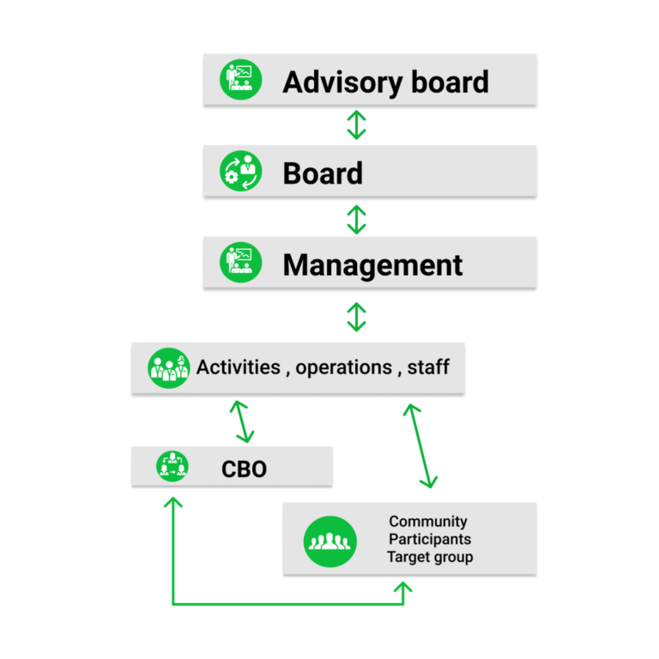
HOPin Academy is a civil society organization that was founded in 2013 as a response to the growing menace of youth unemployment, rural-urban migration and little access to economic empowerment avenues in Northern Ghana. HOPin Academy is located in Tamale, Northern Region Ghana but works across the Savannah Region and North East Region all located in the North of Ghana. The organisation currently has a staff size of 13 and over 50 volunteers supporting the work they do directly and indirectly. The organisation has an advisory board and an executive board that advise and oversee the mission of HOPin Academy. The staff also consists of a management team of three, led by the Co-Founder and executive director, MacCarthy Mac-Gbathy. HOPin Academy’s staff consists of young people who have previously participated in the organisation's skills development programs and showed excelling performance. This has contributed to the organisation growing a strong pool of multidisciplinary talents ranging in digital skills, projects and programs management, financial management and accounting, social media and photography and technical engineering. Past graduates of HOPin Academy’s program also regularly provide mentorship and coaching support to the organisations' beneficiaries. HOPin also regularly receives applications from professionals globally to support the work they do remotely and voluntarily. Additionally, working in the social development sector for years now has exposed HOPin Academy to several international development partners such as UNICEF, GIZ, CISU and the Mastercard Foundation who have also supported the organisation with several capacity building programs and certifications across multiple disciplines which have resulted in HOPin Academy’s dynamic, practice-based and result-oriented module of operations. Below is HOPin Academy’s organizational organogram that iterates the chain of command and operations.

As the organogram depicts, HOPin Academy’s management team reports directly to the executive board and advisory board who provide direction and guidance and resources. The management team also sees to the day-to-day operations of the organization and supervises the work of the staff.

The Plan B Club project delivery will be led by 3 persons from the staff of HOPin Academy together with a working team of 5 staff members from HOPin and approx. 20 project volunteers among the Plan B Mentors. Brief profiles of the leading team are provided below to highlight their competencies for the intervention.

MacCarthy MacGbathy is the co-founder and executive director of HOPin Academy and holds a BA in Marketing and Social Enterprise from the Tamale Technical University. MacCarthy is also a board member and communications director of a network of over 60 innovation hubs in Ghana. He has worked across multiple disciplines in various capacities and is highly skilled in project and program strategy, fundraising, financial management, communication and innovation. He has managed multiple local national and international development projects and also advises on policies to the Government of Ghana through various ministries such as the Ministry for Trade and Industry. He also travels a lot to both African and European nations to network, have dialogue, learn and advise on entrepreneurship, business, technological inclusion, and sustainability. MacCarthy has also managed the previously funded CISU projects and so is in the best position to manage this project.

Ahmed Saalim Iddrisu is a development professional with multi-year experience in non-profit management, fundraising, social enterprise, community, and organizational development and project and program management. Ahmed has a degree in business informatics from the University of Applied Management Germany, Ghana Campus, a diploma in Innovation Management from the International Business Management Institute and certifications in Project Management, Social Enterprise, Operations Management & Sustainability. His experience in this field spans over six years in coordinating and implementing Development programs and projects. Ahmed is the deputy director and manages operations at HOPin Academy. He will be the project coordinator.

Kwame Amamoo Otoo is currently the finance lead of HOPin Academy. Kwame worked as a research and investment analyst at Strategic Hedge Capital before joining HOPin Academy. He has a Certificate in Business Intelligence and Data Warehousing from Metropolitan School of Business and Management, UK as well a Program Diploma in Project Management and another Program Diploma in Global Governance all from International Business Management Institute, Berlin. He also holds a Bachelor of Commerce degree from the University of Cape Coast. Kwame is experienced in finance and accounting and has led the financial reporting of multiple local and international projects with GIZ, CISU and Mastercard Foundation. Kwame will be the accountant on this project.

HOPin Academy believes in forging partnerships for impact and this mantra has influenced the organisations' decision to partner with multiple local and international partners on several fronts and initiatives. FANT has among others played a key role in the growth of HOPin Academy’s partnerships. HOPin Academy has also worked with several local partners from the government and private sectors. An example is HOPin Academy’s partnership with the National Entrepreneurship and Innovation Plan (NEIP) Program of government through which HOPin has supported over 500 SMEs across Northern Ghana to gain access to entrepreneurial skills development and funding and also a collaboration with Deloitte to support HOPin streamline its financial procedures. HOPin has also established partnerships with the Registrar General’s thanks to the SEED project which has made it easier for businesses to formalize their operations in less than a week. HOPin has also worked with UNICEF on several fronts in varying sectors such as water, sanitation and hygiene and their Innovation office to deliver projects and programs in Northern Ghana. HOPin Academy primarily funds its operations and salaries through these projects and program deliveries and sometimes private donations and fundraisers and as the organisation is growing there is an urgent need to continuously forge new partnerships and curate new sustainability strategies.

On associations and networks, HOPin Academy has gained international recognition through its association of Networks such as the Aspen Network of Development Entrepreneurs (ANDE), Afrilabs and is also a founding member of the Ghana Hubs Network, where MacCarthy is a board member. In 2021, HOPin Academy was awarded the Startup Ecosystem Game Changer award by The German Cooperation and Ghanaian Government in recognition of the organisations' efforts in growing the entrepreneurship ecosystem and youth development in Northern Ghana. HOPin was also awarded the best Co-Working Space service provider for Northern Ghana at the Ghana Startups Award event in recognition of the organisation’s commitment to providing an affordable and eco-friendly working environment for small businesses and youth in Tamale.

In HOPin Academy’s bid to scale impact, the organisation now has a presence in the 5 regions of the North of Ghana, HOPin has two satellite hubs in the North East Region and the Savannah Region of Ghana and has established a partnership with local hubs in Upper East and Upper West Region of Ghana. This has facilitated easier project and program delivery to these areas of the north. Additionally, the organisation has partner organisations across the country that have been vetted and assessed by HOPin Academy and can be counted on to deliver projects for HOPin in these areas should the need arise.

2.1.1 HOPin Academy and the Plan-B-Club
The establishment of the Plan-B-Club is a part of The SEED Plan B Project that is being implemented now. In the last part of the project period these four activities are being implemented: 1. Workshop on how to set up the club, 2. The actual setting up of the club, 3. Feedback workshop with stakeholders, local clubs, and the Plan B Mentors and 4. Founding AGM for SEED Sport Club. The actual setting is therefore not yet in place, but the plan is to have a Board of Directors which is elected by the already mobilized 450 footballers and the 150 Plan B Mentors at the funding general assembly. The Board of Directors will decide on a management team of the Plan-B-Club. In the end of the Plan B phase II project the aim is to have 2,000 individual members and 20 football clubs, which will have a voting right for the Board of Directors at the general assembly together with the 300 volunteer Plan B Mentors. The 8 staff members listed in the budget are planned to be a part of the management group in the Plan-B-Club but if few of them are not chosen by the Board of Directors, HOPin Academy and FANT will discuss potential solutions.

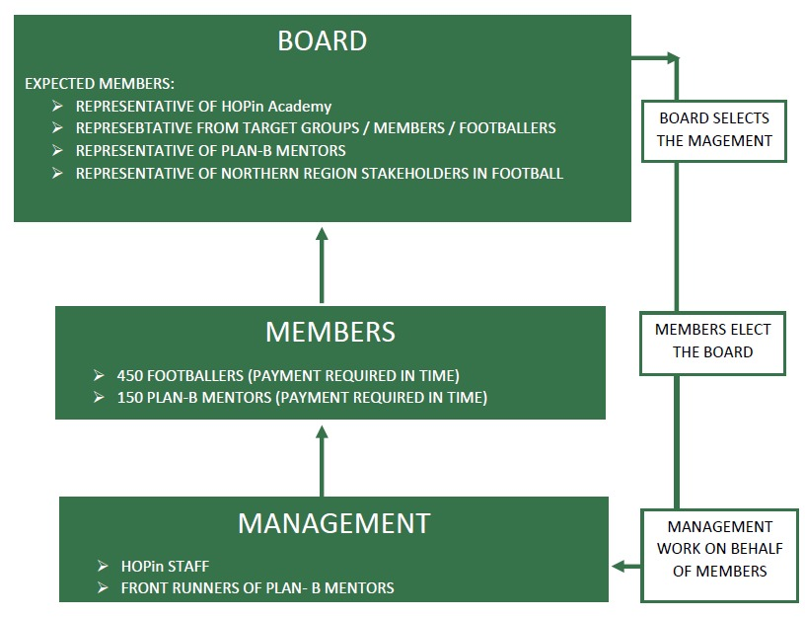
HOPin Academy is the partner for the intervention because the Plan-B-Club is in a too early stage of its existence. During the project period and with the capacity building of the Plan-B-Club it will take more ownership and HOPin Academy will take a role of supervising, monitoring, and supporting. The Plan-B-Club and HOPin will be closely connected to each other but the specific structures and definitions will be discussed, developed, and elaborated on during this 3-year intervention. It is the plan that the Plan-B-Club will somehow be linked or a part of HOPin Academy. The figure shows the planned structures of the Plan-B-Club from where this project takes its starting point.

2.2 FANT
FANT was founded in 2012 and is today, ten years after the founding, an expansive organisation constantly developing and seeking new collaborations and projects. FANT has gained expertise knowledge and experience about how to use sport for society change. FANT has implemented various projects in different countries, with different target groups and with different partners. FANT uses sport and the organization that happens around sport to strengthen civil society organisation, mostly in the materialization as sports clubs. We support the strongest to take the lead as role models, coaches, captain of the team or mentors. In doing so, the sports clubs create a space for the most vulnerable and a responsibility for the strongest.

In the past years, FANT has developed at a higher pace than ever before. Only four years ago, FANT was driven 100% from voluntary powers, with a big load of work and responsibility by co-founder Cecilie Hauerberg. Within the past two years, it has become possible to provide full-time salary to both Cecilie Hauerberg and Josephine Touray which have made it possible to increase projects in south, take in several new volunteers and create better structures for the volunteers. Also, there has been a thorough replacement in the Board of Directors, which have led to a more professional management and more insight and commitment from the top of the organisation. FANT is now in the process of hiring one more employee at the Danish secretariat to keep up with the working load and continuously have the time to create new partnerships, fundraising strategies and in general explore the potential of the organisation. This person is expected to be employed at the beginning of this intervention in July 2022.

The figure provides an insight to the structures in FANT. Everyone listed in the figure is participating to the work of the organisation on a weekly basis and fulfil various assignments.

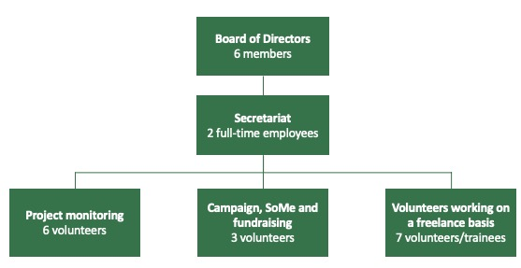
The two employees at FANTs secretariat have different important knowledge and competencies required for this intervention.

Cecilie Hauerberg is the co-founder of the organisation and possesses great knowledge about context and capacity of partners in West Africa because she has spent from 2-7 months a year there since 2012. She has a master’s degree in African Studies from Copenhagen University and has supported different partner organisations implementing CISU-funded projects. Cecilie has great experience in project coordination, monitoring, and facilitation of workshops and has worked with sport in development projects for more than ten years.
Josephine Touray was a member of the board of directors of FANT from 2017 but stepped out of the board in June 2020 when she became a full-time employee in the secretariat. She played at the Danish National handball team from 2001-2008, won an Olympic Gold medal in 2004 and the European Championship in 2002. Besides her former professional handball carrier, she has a master’s degree in commercial law and business from Copenhagen Business School. Josephine has a great network in the sport arena in Denmark, not only within handball. She has great networking skills which helps FANT to expand our network of Danish partners. Josephine also possesses administrative and financial skills that will ensure a professional management of project funding and spending and is responsible for the financial monitoring of partners in the project.

FANT receives funding from a wide range of partners, which includes private companies, professional sport athletes/clubs as well as private and public funds. FANT is constantly working on expanding its network and creating positive relationships within the private business sector and other relevant partners. FANT has gained great experience in creating relations to relevant stakeholders and partners and also – which is a very important part of it - how to get most out of the partnerships. Not all partnership will benefit the process and FANT has learned a lot about how to analyse a potential partnership and be very explicit about expectations and responsibilities. It is a priority for FANT to not be solely dependent on funding from CISU which has forced us to explore a various of different partnerships. If looking at the financial Accounting for FANT this also reflects – government funding accounts for around 50% of the overall income and the last 50% is from private funding. This experience in creating relations to potential donors and relevant partners will be used actively in this intervention and is an important part of the contribution from FANT.

FANT is in a process of escalating new projects and partners. Recently with a new project in Gambia, which has given FANT four partners in three West African countries. The development from being a small grass root organisation only functioning by volunteer forces to have two full-time employees and more than 20 dedicated volunteers working on a weekly basis has made it possible for FANT to increase projects and partners.

2.3 Contributions, roles and responsibilities
FANT and HOPin Academy have together formulated this project application on background of meetings and discussions with several stakeholders in Ghana, not least the target group of young footballers.

FANT will assist with relevant material and knowledge etc. as part of monitoring and facilitating the project. FANT is responsible for the overall monitoring of the project, reporting to CISU and participating in relevant meetings/workshops/activities held in Denmark. FANT will conduct monitoring visits in Ghana, help facilitate activity 2.3.1 Sustainability workshop week, conduct yearly financial monitoring checks, and provide technical advice and assistance also in the midterm evaluation and final evaluation of the project. FANT is also accountable for the final development of relevant materials to share among stakeholders both in Denmark and in Ghana, including reports to CISU. One of the most important contributions from FANT besides the monitoring will be helping to escalate the network of the Plan-B-Club in Denmark and Europe. This is also why a visit in Denmark has been planned for the project director, MacCarthy MacGbathy, to visit and meet potential partners.

HOPin Academy will contribute with all needed expertise to plan and complete the activities of the project and to manage the finance in collaboration with FANT. HOPin Academy has the capacity and power to be the head and the main contributor in the implementing process and can reach the objectives and complete the activities as planned. HOPin Academy is responsible that deadlines, reports, and common agreements always are met. In HOPin Academy, MacCarthy MacGbathy will be the project director and will supervise the project officers to ensure project success. He will be supported by the project coordinator, Ahmed Saalim Iddrisu, and the project finance officer Kwame Otoo.

Payroll costs
The payroll cost related to the intervention has been upweighted in relation to working load and responsibility. For HOPin Academy they have the responsibility of implementing all the activities and monitoring the 400 volunteer Plan B Mentors. They will be engaged in all the project’s activities from monitoring mentorship meetings, visiting football clubs, schools and other relevant stakeholders, take a front role in creating dialogue with regional and national duty bearers and be responsible for all reporting etc. to FANT. Engaging in advocacy is a salary-high activity, which is also reflected in this project.
FANT will take a more behind-the-scenes role, when supporting and monitoring HOPin Academy and most importantly assisting in creating partnerships beyond Ghana to relevant stakeholders in Denmark and Europe. There will be a substantial working load for FANT in coordinating visits in Ghana (act. 2.2.2, 2.2.3 & 2.2.4) and when planning visit in Denmark and Zurich (2.3.2 & 2.3.3). Besides coordinating visits FANT will work on creating connections to relevant partners in Denmark and Europe, why it has also been prioritised to spend the 2% of the budget on information work. A big effort will be put into telling the story about the Plan-B-Club in Ghana to attract partners in the aim of creating sustainable partnerships for the future.

2.4 The development of the partnership
Since HOPin Academy’s first project with FANT with funding from CISU there have been several meetings and coordinations on how to continuously scale the impact both organisations are working on. Additionally, there has been a lot of cross capacity building and learnings as HOPin Academy has learned more about managing sports and football projects from the FANT team and the FANT team has learned about the contextualized project management methodologies of Northern Ghana. Communication and dialogue are frequent and close between the partners. With the recommendation and financial support from FANT, HOPin has now installed a high-speed online Internet connection which will strengthen the quality of the online courses at HOPin and improve the digital cooperation in the partnership.

This development intervention will take the partnership between HOPin Academy and FANT to the next level. The past years have been used to get experience about the organisations’ strengths and weaknesses. And to build up trust in the partnership that inspires a communicative, creative, fun, and stimulating shared space. We now believe to have the needed knowledge and acquaintance to further escalate the partnership. Since both partners are experienced in development work, it is important to have a close relationship with each other to continue to create a high commitment and professionalism among both partners. This will build a better partnership which is stemmed from the experience of both partners with years of experience from different countries. To improve the commitment and strengthen the partnership the physical meetings will be prioritised with yearly monitoring visits in Ghana and one visit in Denmark. Since both partners have developed the project idea for the Plan B Phase II together, this is the starting point for dynamic and high-quality collaboration.

HOPin Academy and FANT have used the past years to create a strong partnership based on trust, equality and honestly. This intervention will use the lessons learned from the past years regarding the organisations’ strengths to escalate on. HOPin Academy is a partner working in high speed and with excellent skills within the organisation to implement development projects. They work independently and professionally. FANT has in the past years invested in the Danish secretariat to ensure stability and professionalism. Through a range of different partners FANT has learned how to engage in strategically partnerships with companies, sports clubs, schools, other CSO’s etc. which will be used actively in the development of the partnership with HOPin Academy.

2.5 Partners’ relations to other actors
We use the saying If you want to go fast go alone if you want to go far go together as a part of the strategy for the intervention. As mentioned earlier it is a priority in this intervention to create collaborations with different actors both in Africa and in Europe. We are ambitious about creating these new partnerships, one reason being that we know the importance of partnerships that can contribute not only as financial donors but also with expertise knowledge, network etc. But the main reason for the high ambitions level in creating partnerships is that we believe there is great potential and interest for this. It is a well-known challenge in Ghana that this intervention is addressing but nevertheless a challenge that has not been addressed with actions like this before. Numerous footballers all over the world talk about the importance of having a Plan B. But there is a lack of projects showing results on a bigger scale. The experiences and results from the past two projects show that our strategy works. With this new up-scale intervention the impact will increase and with the proper documentation and results we truly believe that we can create relations to relevant stakeholders like FIFA for example.

There are three main categories in our strategy for strengthening our relations to other actors:
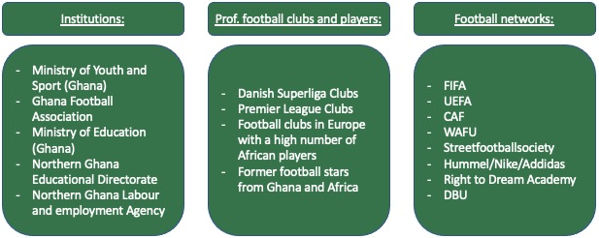

The figure above will be expanded and further developed in act. 2.3.1 Sustainability workshop week, where Cecilie Hauerberg from FANT secretariat and Morten Crone Sejerbøl from FANT board will be participating. They hold great knowledge and network in the football value chain in Denmark and internationally.
The Plan B Phase II intervention will help HOPin Academy develop a strong local collaboration with the local football and sports authorities as well as schools in the region. The intervention is centered around footballers and student footballers, hence it will require the support of local sports authorities as well as local educational authorities. The sustainable relationship with these actors and authorities in the region will strengthen the impact HOPin Academy and FANT can achieve in the future.
- Target groups, objectives, strategy, and expected results (our intervention)
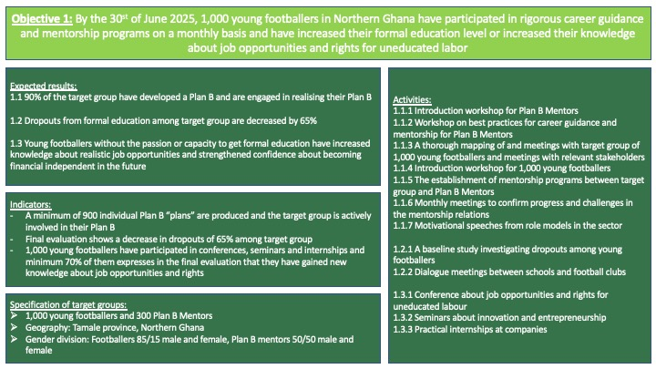

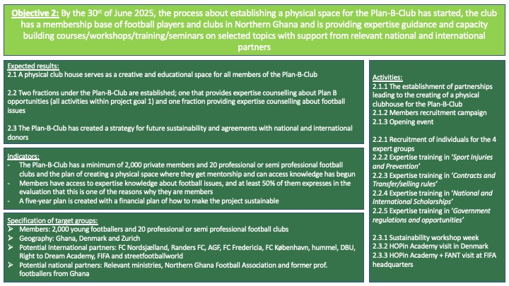

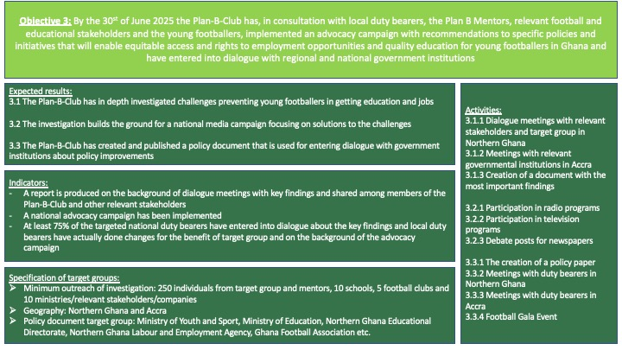

3.1 Composition of target groups
The target groups explained in the three figures above will all directly be involved in the intervention. But the intensity of their involvements differs. The 1,000 young footballers and 300 Plan B Mentors mentioned under Objective 1 is the central primary target group of the intervention. Another part of the target group is HOPin Academy and the Plan-B-Club, when building up their capacity, experiences and network within this field. One of the expected results under Objective 2 is to attract additional 1,000 footballers besides the ones mentioned and 20 local football clubs to sign up as members of the Plan-B-Club, which are also calculated as a part of the primary target group. Lastly, the local and national duty bearers listed under Objective 3, whereas the most central one’s are the Ministry of Youth and Sport, Ghana Football Association, Northern Ghana Sport Council and Northern Ghana Sport Association, are also calculated as a part of the primary target group as they play a key role for the advocacy campaign and the structural changes this intervention seeks to kick-start.

Within the secondary target group there is a broad list of actors including
- Family and friends of the 1,000 young footballers and 300 mentors
- Institutions, football clubs & players and football networks as listed at the figure on page 15
- The public reached through the National Media Campaign
- Schools in Northern Ghana
- Footballers in general in Northern Ghana
3.2 Local legitimacy and involvement of target groups in project development and implementation
For the target groups of young footballers and mentors, they have been a part of former projects and actively involved in the process towards this project application and planning. In the current project being implemented they have shared ideas, dreams, frustrations etc. at different workshops and mentorship meetings. At these activities HOPin Academy has discussed future plans with them and encouraged them to be a part of the planning process by giving inputs and comments. Most reflections so far have been, that they wish to continue the path with mentorship programs. This wish has been implemented in setting up this new intervention.

This intervention is built on a strategy of No “one-size-fits-all” and Mentorship and voluntarism approaches which is important when understanding the involvement of the target group. The key approach is involvement of the target group – for each of the young footballer to reflect about their own skills, dreams, and possibilities and on that background support them in creating a realistic plan for their future when or if the career in football finishes. The volunteer mentors will have one-to-one dialogues with the young footballers and make sure that all of the targeted footballers will create their own individual Plan B and get support on acting upon it.

The management of Plan-B-Club is expected to be a mix of key persons from HOPin Academy, Plan B Mentors, young footballers and local stakeholders. A big part of the primary target groups will hence not just participate in- and benefit from the project but have directly influence on a day-to-day basis. Among the Plan B Mentors are actually numerous of former footballers. Imrana Suhudoo is one of them. He is a veteran footballer in his mid-thirties and explains “This is a good program! I wish some of us had these opportunities earlier. I stopped playing professional football for close to two years now due to an injury and I can play no more. I had also stopped schooling as a result of my football career. Now I have very few options and I think it is quite late for me to continue my education so I am currently learning how to sew so I can design unisex clothes for people here. I am happy to be a mentor as well so I can continuously share my story and inspire other young people to pursue alternative career choices alongside football. The mentorship manual is also very resourceful, and I was particularly happy to learn about injury management and relay it to my mentees”. Imrana is a very active member of the Plan B Mentors and has been a staunch advocate of the Plan B model since its inception. Beyond the mentorship sessions, Imrana also committed to providing apprenticeship training to interested footballers when he starts his tailoring shop. He mentioned due to the flexible nature of that discipline, it is accommodative to footballers so they can also make time for their evening field training sessions.

This project has only been a success so far because of the participation of the target groups at different levels; the personal level with the mentorship programs, the civil society level with the forming of the Plan-B-Club and lastly at a national level (which has only just been touched upon in the previous projects) when doing advocating to duty bearers, schools, football clubs and parents about the issues of the marginalized and overlooked young footballers.

3.3 Strategy of the intervention
The projects strategy is like previous CISU-funded interventions inspired by the underlying Theory of Change (ToC), and the strategy has been developed in collaboration between FANT and HOPin Academy. The figures at pages 16 and 17 map out the relation between objectives, expected results, indicators, activities and target groups. The overall aim is to pursue structural and long-lasting changes that will lead to improved conditions among young marginalised boys that dream about escaping poverty through football. The strategy is through mentorship, civil society organisation and advocacy to support them in participating and affecting local and national decision-making, so they become an active part of the change they dream of. This aim is facilitated by an intervention that seeks to change relationships between duty bearers and rights-holders in conflict over resources and opportunities to participate in decision-making processes. To challenge the relationship between those in power and those not in power, this project engages in empowerment of young footballers. The activities are planned to challenge feelings, perceptions, behaviour and motivations of individuals, schools, CSOs and government institutions. When doing so we interact at three different levels: the individual level, the civil society level and at national level. In general, this strategy can be understood in relation to the three objectives of the project.

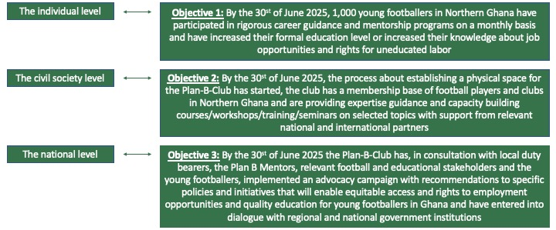

Balancing strategic deliveries, capacity building and advocacy is an inherent part of the strategy, as the three elements are essential to the success of the project. Most of the activities in this intervention is connected to either capacity building or advocacy. The plan of building a learning centre or club house for the Plan-B-Club is linked to strategic delivery but is not a large financial expense in the project but something other relevant partners will be involved in. It is our experience that a specific and tangible part of a bigger scale project like the club house is promising to create company partnerships around. Looking at the individual level and Objective 1, most activities will be connected to the capacity building of the young footballers and the mentors. Likewise at the civil society level and Objective 2, with the capacity building of the Plan-B-Club and its outreach and relationship to target group. Lastly, when understanding the national level and Objective 3, it evolves around advocacy when trying to reach out to duty bearers and the public and creating structural long-lasting changes.

At a monitoring visit in Ghana in October 2021, representatives from HOPin Academy and FANT began the dialogue about this new project application and the underlying strategies that would lead to the expected results and purpose. The most important to elaborate on are
- Mentors and voluntarism
- Follow the dream, but be more than just a footballer
- No “one-size-fits-all” approach
- Knowledge is key for change
The section below elaborates on the discussions and thoughts behind the statements and connects it to the different activities of the project. Some activities are to be found under several of the statements while others are only linked to one specific.

Mentors and voluntarism
It is never easy to challenge the existing line of thoughts among people, build up confidence among vulnerable groups and get people to change behaviors. Personal relations are important when dealing with humans why the personal relationship between the mentor and the footballer is an important part of the project. Two and two and in smaller teams the mentor and footballer will work to conduct a realistic Plan B for the footballer. All of the 300 Plan B Mentors are volunteers which is possible because of different reasons. Firstly, they all have a passion or love for the sport and trust the overall purpose and strategy of the project. Secondly, there is a great culture of voluntarism in Ghana where all students (after university) have to do one year of National Service giving back to the country. Thirdly, the volunteer job as a Plan B Mentor is something that will strengthen their CV and also increase their social and professional network. The project being implemented at the moment is focusing on the empowerment of the volunteers/Plan B Mentors and the experience gained from this has been useful in the planning of this new intervention. The 150 Plan B Mentors in the project have discussed and worked intensively on the concept of a mentor, which has resulted in a Mentor Manual specifically directed at mentoring of young footballers in the Northern part of Ghana. Material and preparations like this make it easier for HOPin Academy to upscale the number of mentors and still ensure that they have the capacity for the assignment (both professionally and personally) to guide and support the footballers. The budget allocated to act. 1.1.6 Monthly meetings to confirm progress and challenges in the mentorship relations is calculated on the background of providing 10 DKK for refreshments for each meeting and 25 DKK in transportation for the Plan B Mentor (who will normally come the footballer). Each of the 1,000 targeted footballers will participate in a monthly meeting for 30 months. Even when expenses for each meeting are held at an absolute minimum it still becomes a substantial part of the total budget because of the extraordinary outreach and consistency. Activities connected and linked:
Follow the dream, but be more than just a footballer
This intervention is not about killing the dream for the young boys. Everyone should have dreams and follow them. But sadly, the statistics show that only very few succeed in living the dream as a professional football player and even for the one’s that do succeed, the career ends when they are still relatively young. The aim of this project is to support young vulnerable footballers to get an education and become someone in life – at the same time as they are trying to achieve their dream. The Plan-B-Club will provide expertise counselling on four football topics as part of the motivation for the footballers to become members of the club. The access to information like this and guidance in these different topics will serve as a big motivation for the footballers to take part in the project. And it will support them in trying to follow their dream but on an informed basis and with backup assistance from their mentor and the Plan-B-Club if needed. Activities connected and linked:
No “one-size-fits-all” approach
The 1,000 footballers in the primary target group are all different persons. They are aged around 13-35 years, they come from different backgrounds, live in different communities, and have different capacities and interests. There cannot be a one-size-fits-all approach in creating a relevant and realistic Plan B for these 1,000 young footballers. Each of them will start an individual dialogue with their mentor about their own personal Plan B - there is no Plan B template. Of course, the Plan B Mentors will have limitations in what and how they can support the mentees but each of the footballers will have a tailored Plan B plan that they are engaged in by the end of the project. Activities connected and linked:
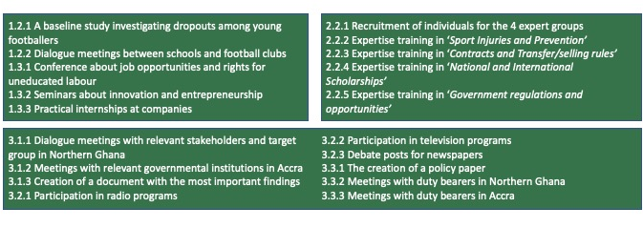
Knowledge is key for change
The Plan-B-Club has no aim of creating professional football players. It has an aim of creating informed and educated football players. The core foundation for engaging in advocacy work, is that the actors have knowledge of the specific challenge, its basic causes, and possibilities for action. The two earlier projects have helped us gain important knowledge about challenges for the target group, but because this intervention has a much more ambitious goal about creating long-lasting structural changes and engaging in advocacy on regional and national level it is important that we continue to investigate and understand the target group and the context. Knowledge is not only important when engaging in advocacy work but also for the individual footballer when they must make important decisions about future career plans. Activities connected and linked:

If you want to go fast go alone if you want to go far go together
In inspiration from the Sustainable Development Goal 17; Partnerships for the Goals, this project has built its strategy around creating partnerships with different relevant stakeholders. It is the essence of the project. Collaboration with local football clubs, schools, academies, communities etc. is essential when reaching out to the target group of 1,000 vulnerable footballers. To engage in advocacy work and challenge existing relations between those in power and those without demands a high level of networking skills on governmental and diplomacy level. And to get the needed knowledge about target groups and different issues (one example being injuries) we need partners with expertise knowledge or access to it. And lastly, when engaging in the plan of making a sustainable set-up for the Plan-B-Club we need many different partners and collaborators to make sure that all eggs are not put in one basket. The strategy of the project is built on partnerships and collaborations both with governmental and private stakeholders. Activities connected and linked:
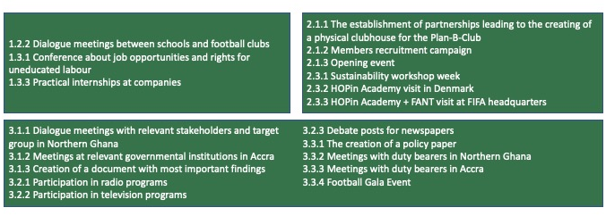

3.4 Timing of activities
The project stretches over a period of three years and therefore it has been useful to make a strategy for the timing of the different activities. HOPin academy needs time to implement each of the activity but some activities are more important to kickstart in the beginning of the project and some activities need preparation from other activities before started. Some of the research are important to conduct before using the findings in the advocacy campaign. And some activities need to be implemented before the results are ready to seek for potential partners or show to stakeholders. HOPin Academy and FANT have based on above discussions decided on the following timeframe:

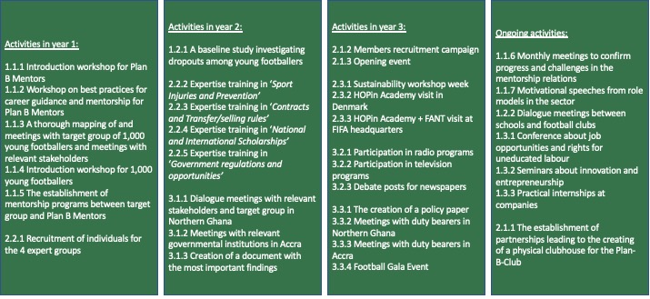

3.5 Sustainability and lasting improvements for target groups
The aim of the project is to support and kick-start a movement of sustainable change for young footballers in Ghana. The capacity building of 1,000 young footballers and 300 mentors will ensure that they will be in a stronger position than before, because they have gained new knowledge, skills and have become a part of a broad network in the Plan-B-Club. More, the strengthening of capacities of the civil society organisation Plan-B-Club and starting a dialogue with governmental institutions and a public discussion are a part of the sustainability of the project. Most activities are set to capacity build either the Plan-B-Club or individuals, but the advocacy campaign is expected to reach not just relevant duty bearers in the ministries but also a considerable number of people in the public. The intervention will challenge old beliefs about lazy, unintelligent, and unreliable footballers and seek to turn the dialogue around to how this vulnerable group can be integrated in the educational system and give value to communities and the country as a whole.

The lasting improvement for the target group happens when they are monitored and supported on a monthly basis through mentorship programs which will not only be beneficial in the period of the mentorship programs but support them in the long run when having made better decisions about education etc. At the same time management from the Plan-B-Club and HOPin Academy will push and work to create structural changes at a national level that can benefit not only the 1,000 footballers targeted in this intervention but all young footballers in Ghana. The creation of a space for the target group to meet and discuss, get inspiration, knowledge and improve their skills will not end when this project ends. Specific activities in this intervention are directed at creating sustainability though partnerships and internal structures in the Plan-B-Club.

The results of this project will create long-lasting changes that will not end when the implementation period finishes. The newly gained knowledge about labor rights, education, advocacy and the practical experience, the forming and strengthening of a civil society organisation and the new network in the Plan-B-Club will be a constant factor supporting the involved. This project is developed on the concept of voluntarism which is also a part of ensuring sustainability because the core foundation is not built on a high amount of salary provided by FANT or CISU.

3.6 Risk analysis and mitigation strategies
It is important for project partners to account for the potential risks that can occur in this project intervention. The risks can potentially threaten the project and the planned activities, which is why HOPin Academy and FANT in close collaboration have structured relevant sustainable strategies to mitigate these potential risks. The figure below outlines some of the potential risks that in a worst-case-scenario might hinder the fulfilment of the project objectives and our planned strategies for mitigating these risks. It is significant to mention that the risks listed below are tentative and further potential risks will be elaborated during the project implementation.
Risk | Mitigation strategy
Several Plan B Mentors do not perform as expected | To fulfill Objective 1 the Plan B Mentors are an extremely important factor. Without their dedication and motivation to the project the mentorship programs will fail. The project being implemented has shown us how different elements can help motivate the mentors which will be used in this intervention. The network and social life are important factors for the Plan B Mentors. HOPin Academy has an open office space that creates a useful space for networking and mingling. All Plan B Mentors are free to come and use the open office space and can also discuss potential observations or concerns about their mentee with HOPin Academy staff or other mentors. The mentors have also requested for continuous training in how to do mentorship, which is also a part of the activities (1.1.1 and 1.1.2). Lastly all of them will get a small “mentorship-kit” with pencils, books, and other relevant material that they can use when having meetings with the young footballers. HOPin Academy will likewise ensure that different committees within the Plan B Mentors are formed (party planning committee, support unit committee, football event committee etc.).
The young footballers fail to their appointments with the mentors and do not engage with dedication in their Plan B. | Fortunate, the previously projects have shown us that the number of young footballers ready to engage in this project is numerous. The footballers will be recruited through the network that HOPin Academy has created to schools, football clubs and communities. Out of 1,000 individuals it must be expected for some of them not to fulfil. The reasons could be many and also reasons that lies outside what HOPin Academy or the project can obviate. The training of the mentors is a strategy for ensuring the quality of the mentorship program and therefore also the motivation from the footballers to participate. The whole idea is that the footballers have a sincere feeling of benefitting from the program why they will prioritise the meetings with their mentors and the different activities. If the midway evaluation shows a high number of undedicated footballers FANT and HOPin Academy will investigate the issue further and on the background of the findings take the necessary actions towards reaching the objectives and overall purpose. Knowledge about the target group is an important element that will help HOPin Academy and the mentors how to deal with the individuals in the best way.
Meetings with important stakeholders in Denmark and Europe are cancelled or unprioritized by partners. | We wish to create relations to relevant stakeholders in Denmark and Europe who can support the project and make it sustainable for the future. Our ambitions are high, and therefore there is also the risk of failing. The mitigation strategy is to be well prepared for the presentations and meetings and know exactly and be clear and transparent about outputs. Also, the potential partners are plenty. If one football club is not interested there is always another club to approach. When trying to create new partnerships you need to be prepared for rejections – and be ready to move on and try again and again. If the visit at FIFA headquarters (act. 2.3.3) turns out difficult another similar meeting will be arranged. Instead, the meeting could be with UEFA, CAF, Nike or the like. FANT will make use of its already existing network in the football chain to ensure that the expected and needed partners are found.
HOPin academy experiences resistance and opposition from duty bearers and the public regarding the creation of structures that can support the target group in a life besides football. | The duty bearers in ministries and at regional level in Northern Ghana has been positive towards the project so far. But many things can happen during a 3-year period. HOPin Academy is responsible for maintaining the good contact with the relevant stakeholders and ensuring a positive relation with respect for dialogue and different views. As explained earlier football is a part of a national identity and to make sure that people support the project in overall it is important to communicate right. HOPin Academy has great experience in this and will use their SoMe platforms to communicate the right messages. FANT will be ready to support HOPin Academy in any way if they should meet resistance. We believe that if the message is communicated clear – that it is not about trying to destroy football in Ghana but to ensure that footballers are not just puppet dols in a game played by powers that cannot be touched.
Some football clubs (potential members) understand the new Plan-B-Club as an opponent among others because of the seminars in labour rights for footballers and feel there is a conflict of interests. | HOPin Academy has already succeeded in creating a relation to several football clubs in Northern Ghana and have in general only been meet with positivity. The continually building of the relations is a part of the activities (act. 1.2.2, 2.1.2, 2.1.3, 3.1.1 & 3.3.4) to prevent misunderstandings and resistance. The football clubs are involved and invited to participate in the work of the Plan-B-Club. The expert knowledge of the four themes will be used not just to give counselling to individuals but also football club members. The Plan-B-Club differs from the normal football clubs in the basis set-up which is an important message to direct to other football clubs that could see it as a potential opponent if they do not understand it correctly.
3.7 Systematising experiences
HOPin Academy will conduct a written report every second month about activities held, budget deviations and potential challenges and successes and a short evaluation of outputs. These reports will be used as a starting point for an online monitoring meeting between FANT and HOPin. It has been planned to conduct a midterm evaluation with participation of FANT DK and also a final evaluation on the background of the external evaluation. The evaluation in the end, is also to ensure that important experiences are collected and shared among relevant stakeholders in Ghana, Denmark and Europe.

HOPin academy will conduct monthly meetings with the Plan B Mentors. The monthly meetings will be designed to put the Plan B Mentors in smaller groups to meet and address challenges, lessons, findings and how to twist their approaches in making an effective output for the young footballers. A WhatsApp page is designed to host the Plan B mentors to be able to have an instant virtual communication among the big group which they are on the field dealing with the young footballers. The combination of both the physical meetings and the virtual meeting to discuss the above elements of their work with the young footballers will help also to collect some primary data for improvement on the go. The staff at HOPin academy will be working closely together and therefore share information every day and be able to set up meetings along the way dependent on needs. But every second month they need to develop the monitoring report to FANT and attend the following online meeting, which will also be a part of their systematising of experiences and data.

- Intervention-related information work in Denmark
FANT will use its social media platforms to inform relevant and interested partners about project activities and processes. Totally, FANT has a reach of around 9000 followers distributed over Facebook, Instagram, Twitter and LinkedIn. These 9000 followers are interested in the work done by FANT but for the past years most updates have been coming from the projects in Sierra Leone. With the information work in this intervention, we wish to tell stories from HOPin Academy, the Plan-B-Club and Northern Ghana because this project and partnership has become an important identity for FANT as well. FANT will also use its network of members and volunteers to share stories when sending newsletter, hosting events etc.

HOPin Academy is very active on social media, and it will be in close collaboration with them that FANT will tell stories from the project. The plan is to use specific events to tell the deeper lying story for the overall purpose and objectives of the project and not least the context and relevance. FANT will make sure that there is minimum one post/story told every month to make sure that there is consistency in the storytelling. The strategy using the opportunity of intervention-related information work in Denmark is linked to the strategy of seeking and creating new partnerships for the sustainability of the project.

Most professional football players end their career before the age of 40 years.
Representatives from Ministry of Youth and Sports, Ghana National Sports Authorities, Ghana Football Association, The referees’ Association and the Regional Sport Council was present.
Ghanaian Football Association
Right to Dream academy is an academy in Ghana with connections to the Danish Superliga club FC Nordsjælland.
George Weah is a Liberian former football player and now President of the country. He played as a striker in his prolific 18-year professional football career which ended in 2003. He was named the world’s best football player by FIFA in 1995 and became the first African football player to become the head of state.

