the civil society fund
Small-scale intervention

“Knowledge sharing, concept development and partnership strengthening in Zimbabwe”

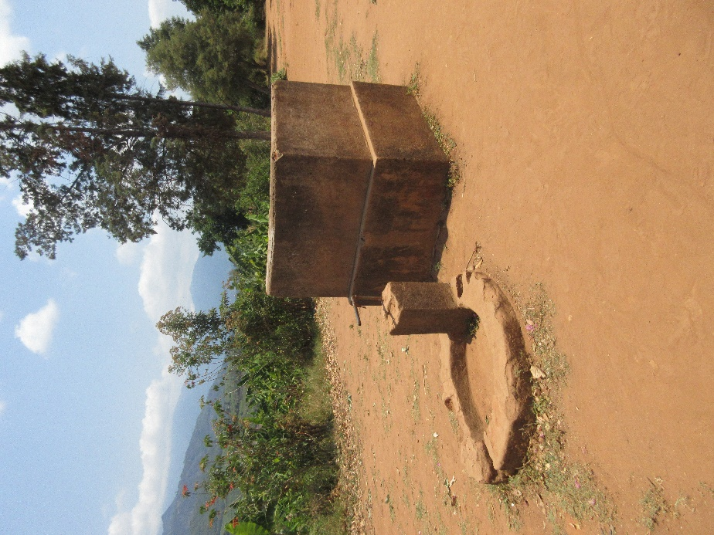

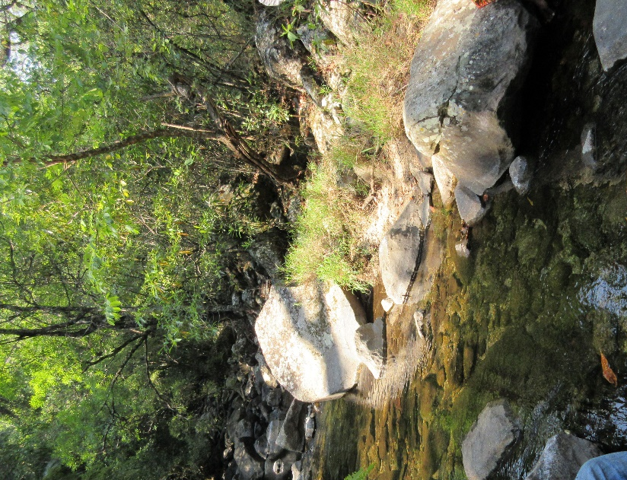

Engineers without Borders Denmark
Application 2019

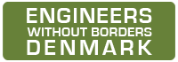

List of content

Background and introduction 2
1. Objective and relevance 2
1.1 What do you want to achieve through the intervention? 2
1.2 Why is the intervention important? 3
1.3 Describe the context of the intervention 3
2. Partnership/partners 4
2.1 EWB-DK 4
2.2 PUTZ 5
2.3 Previous cooperation 5
3. The actual intervention 5
3.1 How do you intend to implement the intervention? What activities will be carried out? 5
3.2 Which groups will benefit from the intervention? How many persons are these groups composed of? How will they participate in the intervention? 7

Background and introduction
EWB-DK’s Board decided back in 2016 to explore Zimbabwe as a new geographical focus area. To facilitate the Board’s decision, a preliminary fact-finding mission was carried out in October/November 2016 in order to study the possibility of cooperating with local organizations in their efforts to support community-based projects in the Manicaland Province. In line with EWB-DK’s strategy, the mission had particular focus on Water, Sanitation and Hygiene (WASH) and the need for secure and stable water supply stood out as one of the main challenges in the visited communities.

The mission found that:
- Partner organizations were available and the Pensioners Union Trust of Zimbabwe (PUTZ) was seen as a relevant new partner
- Three community development projects within the WASH and Food Security sectors were by PUTZ presented to the fact-finding team and they were found relevant for further consideration
- EWB-DK’s long-term experiences with community-based WASH projects in Sierra Leone would be relevant to share as basis for project development in Zimbabwe

Since 2011, EWB-DK has been implementing WASH projects in Sierra Leone, and has had great experiences with the CISU funded project ”Right to Water and Sanitation: Community Development in the Kenema District, Sierra Leone”, implemented in partnership with Engineers without Borders Sierra Leone (EWB-SL). Through strategic service delivery, the project aims at institutional capacity development of Health Development Committees at village level, the district councils and the local partner EWB-SL. Through awareness raising and advocacy training, local communities are empowered to manage their own affairs and express their interest and issues to local duty bearers. In the process, space has been created for local consultation and participation in district level decision-making within the WASH sector. EWB-DK sees this project as a promising practice for how to work with community-based projects. With this intervention, EWB-DK will facilitate that knowledge, experiences and promising practice from Sierra Leone are shared with Pensioners Union Trust of Zimbabwe (PUTZ) and that space is created to collectively explore how this promising practice can contribute to project and partnership development in Zimbabwe.

Objective and relevance

What do you want to achieve through the intervention?
This intervention aims to strengthen the partnership between Engineers Without Borders Denmark (EWB-DK) and Pensioners Union Trust of Zimbabwe (PUTZ). Through exchange of experiences and sharing of knowledge, a collective understanding of organizational practices, working approaches and technical capacities will be established and a robust foundation for the development of the long-term partnership will be formed.

The partnership will be developed in accordance with EWB-DK’s strategy for 2015 – 2020 and in line with the UN Sustainable Development Goals (SDG), setting the agenda for how to work for sustainable development by involving citizens and stakeholders in fighting poverty. The intervention will:
- Facilitate knowledge sharing and capacity development in relation to the Sustainable Development Goals (SDG), the Zimbabwean context and the technical area of community-based WASH
- Establish a shared field-based understanding of working approaches, local needs and contextual working conditions for future projects
- Map and assess capacities of relevant stakeholders, communities and other actors at local and provincial level

Why is the intervention important?
The fact-finding mission in 2016 found a pressing need for water. The visited locations were all located in the Manicaland Province in Eastern Zimbabwe, an area described as semi-arid due to low rainfall on the west facing mountain slopes of the region. The climate conditions make access to clean and adequate drinking water a high priority for the communities. A successful community-based WASH project relies on a thorough assessment of the actual local water resources and dialogue around relevant technical solutions. However, a precondition for long-term sustainability is that the local population takes ownership and engages and participates in all phases of the project. Along the same line, a prerequisite for successful long-term partnerships between civil society actors in the global North and the global South is a shared understanding of context, capacities, visions and working approaches.

This intervention will build up a strong knowledge base and establish a shared field-based understanding of community development, local needs, stakeholders and contextual working conditions for future community-based WASH projects. The intervention will enable EWB-DK and PUTZ to get familiar with each other’s working approaches and enable EWB-DK to assess and work together with the new partner before engaging in a long-term partnership.

Describe the context of the intervention
The situation in Zimbabwe is very complex and fragile with an instable political environment. In November 2017, Robert Mugabe resigned after 37 years in power. His resignation came in the wake of over a year of protest against his government as well as Zimbabwe's rapidly declining economy. In July 2018, Zimbabwe held its general elections, which were won by the ZANU-PF party led by Emmerson Mnangagwa. The new government has not managed to stabilise the country and bring the economy back on track. “Even though the new political administration has taken its “Zimbabwe is open for business” charm offensive to the international community, the political instability at home characterised by contested election results, protests and crackdown on civilians by security agents have proved a major barrier to the country’s prospects of being an attractive investment destination.” The annual inflation rate in Zimbabwe peaked to 66.8 percent in March 2019. The instability and a high level of corruption has made many donor agencies stay away from Zimbabwe leaving the population in increasingly dire situations.

Zimbabwe has not been spared the harm of climate change, which has been aggravated by its geographical position in the semi-arid belt of southern Africa and its reliance on rain-fed agriculture and other climate-sensitive livelihoods options. Climate change has among other things resulted in declining water resources and water quality, reduced agricultural productivity, damaged infrastructure and degradation of ecosystems. The livelihoods of the people of Zimbabwe depend on vulnerable natural resources, and their depletion as a result of climate change will lead to further poverty and set back the country’s efforts to achieve sustainable development.

During the fact-finding mission in 2016 to the Manicaland Province, EWB-DK became acutely aware of the huge challenges the visited communities had with lack of water – water for drinking and household activities as well as water to ensure their smallholder farming. In dialogue with PUTZ, EWB-DK has therefore chosen to look at community-based WASH in the Manicaland Province focusing on capacity development and strategic service delivery in close collaboration with the local authorities and other relevant stakeholders.

Partnership/partners

EWB-DK
Based on extensive experience in international development and cross-sector partnerships, EWB-DK will be the coordinating and administrative entity of the initiative. Established in 2001, Engineers Without Borders Denmark (EWB-DK) is a technical-humanitarian organization of volunteer members with a large range of technical skills and backgrounds. EWB-DK collaborates with local and international NGOs to improve the living conditions for marginalised and vulnerable people in poor countries. EWB-DK provides clean water and better sanitation, builds schools and health clinics, improves roads and bridges as well as establishes solar power plants and waste treatment plants. EWB-DK supports sustainable and resilient communities, where development is generated on the basis of knowledge-sharing, partnership development and capacity building of civil society organizations, provision of sustainable technical solutions, and high level of community participation.

EWB-DK works from a human rights-based approach and will therefore always seek to cooperate with local government authorities and other duty bearers. With many years of experience with technical development initiatives, promoting advocacy in developing countries and strengthening local CSOs, EWB-DK contributes with strong technical capacities, and valuable knowledge within context adaptation, project management and community empowerment.

PUTZ
The intervention will be implemented in collaboration with PUTZ. PUTZ registered as a Trust in 2012. The Trust has a 10 members non-executive Board headed by a Chairman and currently the Trust has more than 20,000 pensioners as members country wide. The Trust has its headquarters in Harare with provincial offices in 4 provinces. The day to day operations of the Trust is carried out by the Program Director who is assisted by the Finance Officer, Project Officer, Business/Evaluation Officer and three administration/office staff.

The Trust works to:
- assist member groups to identify, develop and implement development projects in their own communities
- provide technical and on the job training of members to ensure the successful development and implementation of projects
- assist the groups to raise funds for implementing the projects
- provide monitoring and evaluation of the development projects through the participatory approach where the members are fully involved.
- represent members interests by engaging government and other relevant authorities in addressing their socio-economic challenges
PUTZ has implemented community development projects since 2012 building up strong relationships and well-established network within the target communities. PUTZ has previously implemented a CISU funded community development project in the Mutasa District as partner to the NGO Seniors Without Borders Denmark (Seniorer Uden Grænser).

Previous cooperation
EWB-DK has many years of experience working in partnerships with civil society organisations in several countries to support sustainable technological solutions for the poorest communities. Zimbabwe is a relatively new country for EWB-DK and PUTZ is a new partner. PUTZ facilitated local contact and communication for the implementation of activities during the EWB-DK fact-finding mission in 2016 and has demonstrated solid access to target groups and local authorities. Both partners would like to strengthen the partnership and will, with this initiative, facilitate knowledge sharing and cross-organisational learning in the field and during a 2-day workshop.

It is expected that the activities presented in this application will foster long-term partnership where the partners can draw on each other’s knowledge and strengths and collaboratively work towards achieving the SDGs with special focus on SDG no. 1, 2, 5, 6 and 17.

The actual intervention

How do you intend to implement the intervention? What activities will be carried out?
With the aim to facilitate sectoral knowledge sharing and exchange of experiences between EWB-DK’s technical volunteers and partners in the Global South, EWB-DK wishes to facilitate a knowledge sharing workshop and exchange of field based experience focusing on the WASH sector, and further strengthen the partnership with PUTZ and other relevant WASH stakeholders for improving water and sanitation conditions in local communities in Zimbabwe.
Activities for the intervention will include:
- Capacity assessment of PUTZ and partnership development
- Field visits to share knowledge on working approaches, build relationships with local authorities, identify community capacities and mobilization, and carry out on-site assessments for identifying and selecting technical and geographical areas for project implementation
- Workshop focusing on knowledge-sharing, concept development and establishing a framework for community-based WASH projects in Zimbabwe
- Map and assess capacities of relevant stakeholders, communities and other actors at local, provincial and national level
Roles and responsibilities:
EWB-DK and PUTZ will work together to arrange the knowledge-sharing workshop and field visits. The workshop will be held at district level to ensure participation from local communities, local authorities and other relevant stakeholders.
EWB-DK
The Danish organisation will be responsible for:
- Preparation for field visits
- Drafting programme for knowledge-sharing workshop in coordination with PUTZ
- Facilitation of key workshop sessions
- Initial identification and assessment of possible technical areas for project implementation in cooperation with PUTZ
EWB-DK wishes to send a total of four delegates. The delegates have been selected based on experience and knowledge related to the intervention’s activities and objectives:
- Bent Kjellerup, Project Manager. EWB-DK volunteer. Bent’s key areas of qualification are within the water supply and sanitation sector and range from project identification, formulation, design and appraisal to implementation, operation & maintenance of installed facilities, management of large multi-disciplinary technical assistance projects, contract management and evaluation of projects. Bent has been a strong driver and project manager of EWB-DKs WASH projects in Sierra Leone.
- Per Wehner, Supporting Manager. EWB-DK volunteer. Per is an electrical engineer with almost 40 years of experience of which the major part is within management and processes in technical and business departments/areas. He has participated in various training courses, mainly with focus on management and processes.
- Christina Berg Olesen. EWB-DK volunteer. Christina is a junior engineer with experiences within the field of environmental technology including management of wastewater and bioenergy processes among others. She works in a consulting engineering company as a project engineer and coordinator. Christina has previously been involved in aid projects working on project development in Honduras and procurement of project outcomes.
- Pernille Tind Simmmons. Programme Advisor. EWB-DK staff.
The delegates will be facilitators of the workshop and lead the dialogue in the field.
PUTZ
The local partner organisation will be responsible for:
- Assist with arrangements for the workshop i.e. booking of venue, food and refreshments
- Identification and mapping of relevant stakeholders and participants for the workshop
- Coordination and communication with EWB-DK for program formulation
- Identification and selection of relevant sites for field visit and prepare the necessary programme, transport and accommodation
- Preparation of community- and stakeholder meetings
PUTZ will ensure that senior staff is available throughout the time of the visit to facilitate partnership development and engage in knowledge-sharing and concept development.
Implementation plan:
Day | Purpose | Involved
Day 1: Arrival and initial meeting | - Introduction  - Work through expected outputs and learning outcomes from the field visit  - Discuss and work through the draft workshop programme | EWB-DK delegates  PUTZ leadership (senior staff and board members)
Day 2: Meetings in Harare | Capacity- and partnership assessment and stakeholder analysis | EWB-DK delegates
Day 3 - 6: Field visits | - Field-based knowledge sharing and learning, working alongside PUTZ on needs- and capacity assessment  - Meeting with local communities and authorities to assess needs and capacities | EWB-DK delegates  PUTZ senior staff/ leadership
Day 7: Workshop preparations | Final workshop preparations including workshop programme incorporating field-based learning from the field visits | EWB-DK delegates  PUTZ leadership
Day 8-9: Workshop | Knowledge-sharing, concept development and capacity development needs | EWB-DK delegates  PUTZ staff and leadership  Community representatives  Relevant stakeholders
Day 10: Travel back and concluding meeting in Harare | Debriefing and way forward | EWB-DK delegates  PUTZ leadership

Which groups will benefit from the intervention? How many persons are these groups composed of? How will they participate in the intervention?
For the activities planned for this intervention, the primary target group consists of PUTZ and other relevant stakeholders that will be invited to the workshop. It is expected that 20 – 25 people will participate. Local authorities and community representatives will gain from the dialogue that will take place while the EWB-DK team and PUTZ representatives are visiting the field. EWB-DK has a strong focus on local knowledge and capacities and the team will therefore apply participatory methodologies and ask into existing capacities, mobilization and local solutions. The meetings will underpin future cooperation and the dialogue and interaction will in itself be informative and potentially transformative for PUTZ, the EWB-DK team, the community members and the different local stakeholders.

EWB-DK already works in collaboration with another local partner (CYVAT) on a DERF funded project in the Lupane district in the east. A partnership with PUTZ will enable EWB-DK to expand its reach.
https://www.zimbabwesituation.com/news/zimbabwes-political-instability-and-the-impact-on-business/.
Zimbabwe is number 160 on the Transparency International Index
file:///Z:/IUG%20arkiv/Projekter/Projektmapper/1905%20Zimbabwe%20WASH/ZimClimateChange2ndEdweb1.pdf
Three organizational types define NGOs in Zimbabwe and these are Private Voluntary Organisations (PVOs), Trusts and Common Law Universitas.

