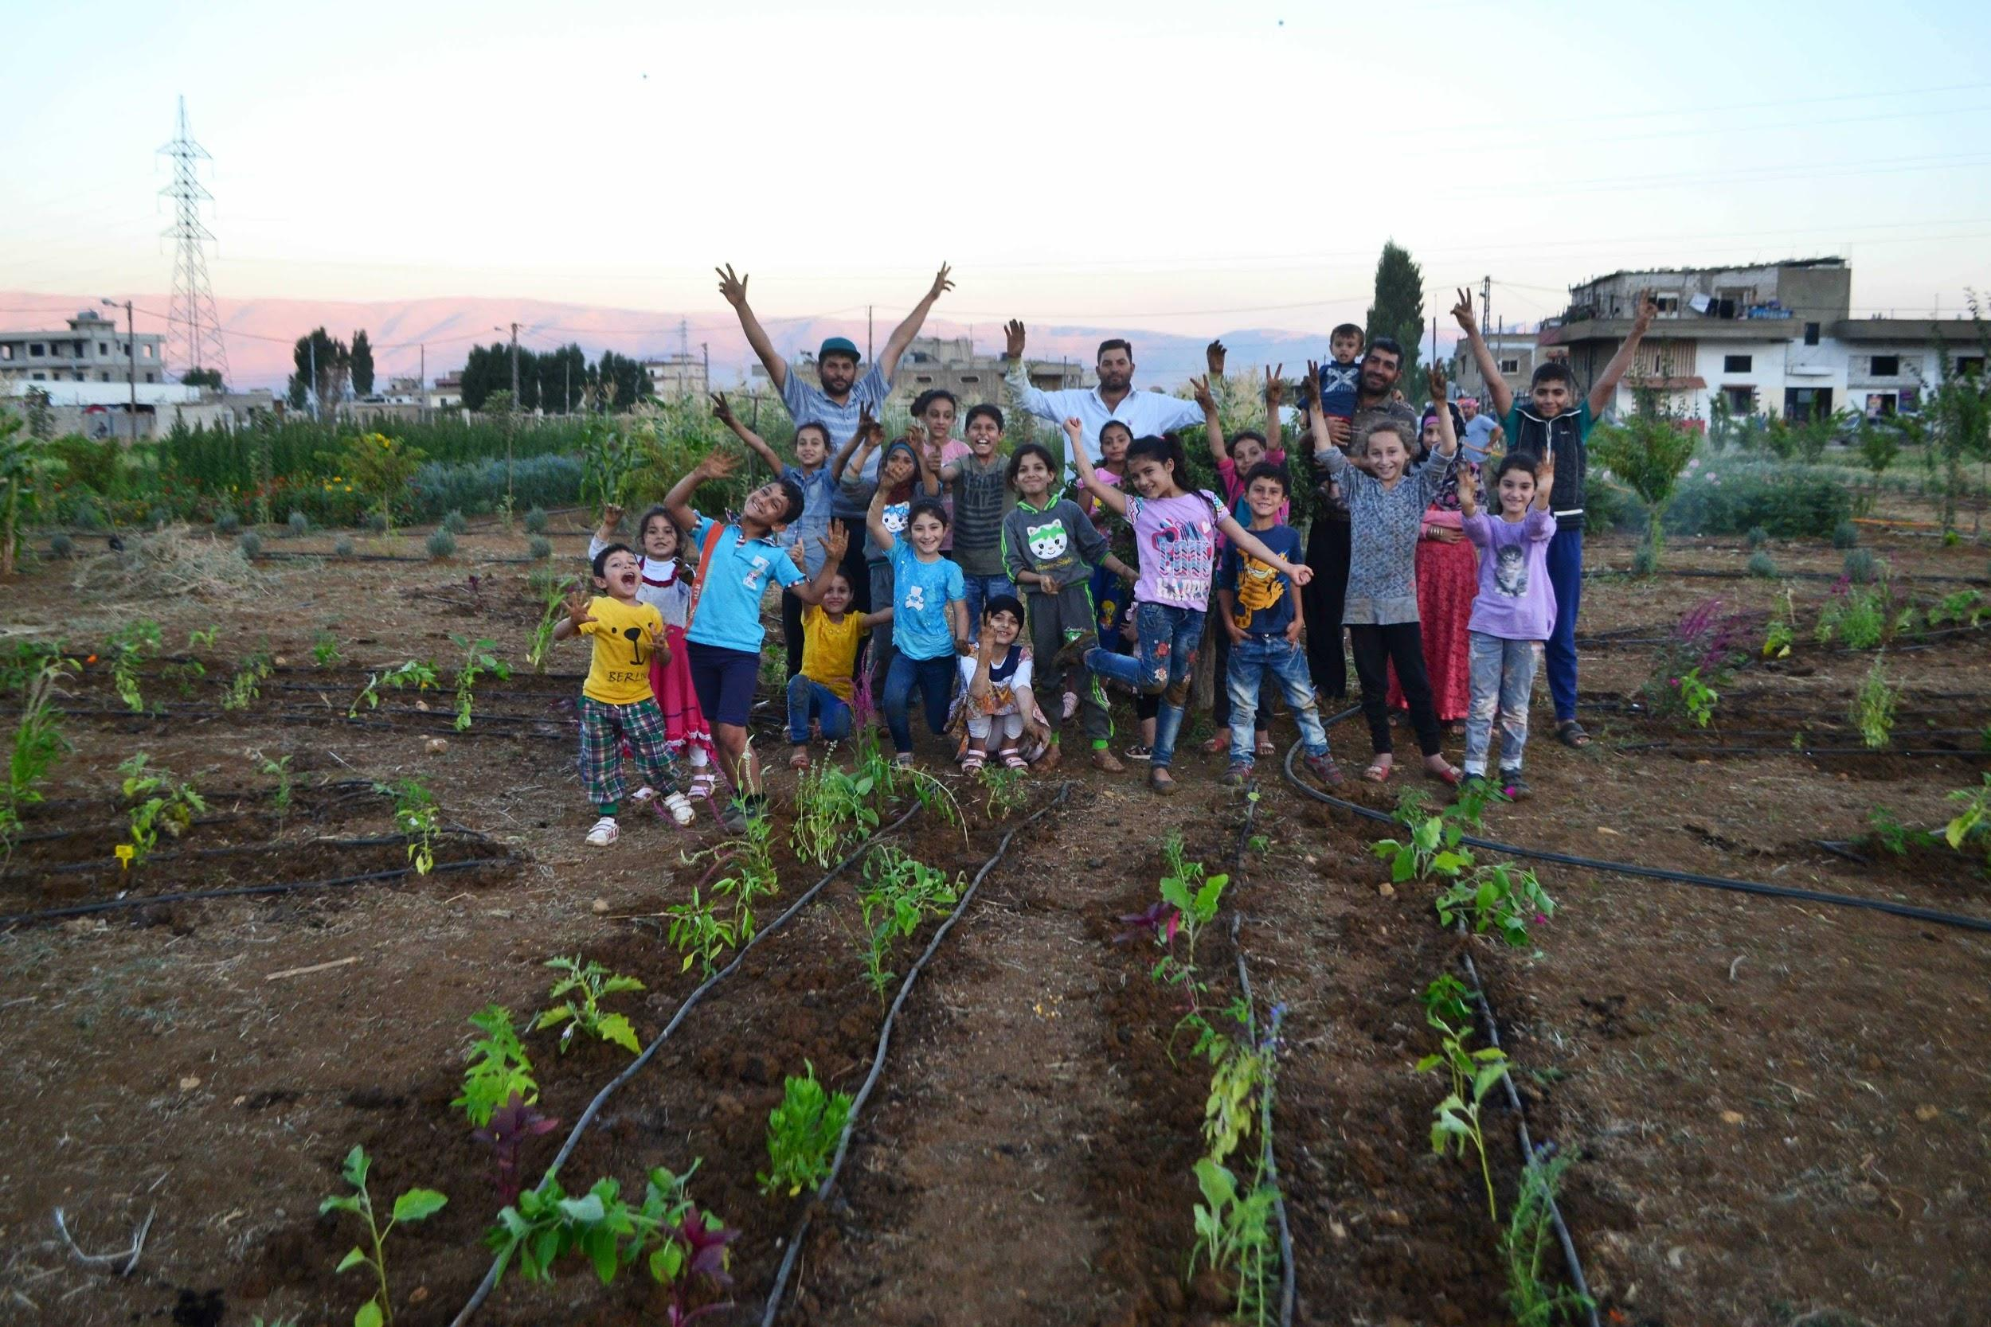

LEARNING GARDENS AS TOOL FOR DEVELOPMENT
IN LEBANON

// EDUCATION, LIVELIHOOD AND CAPACITY BUILDING TOGETHER WITH STIGMATIZED CHILDREN AND YOUTH IN LEBANON //

Application for Citizen Participation Interventions
Civil Society Fund
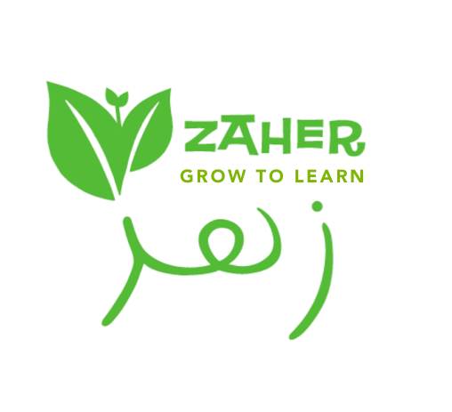
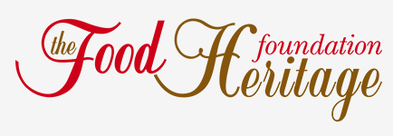
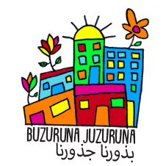
26 February 2019
1. RELEVANCE OF THE INTERVENTION
1.1 OBJECTIVE
Background
Zaher - Grow to Learn has since 2016 worked in Lebanon on building partnerships with local organisations and testing learning garden activities as a tool for development when working with vulnerable children and youth. In other contexts, learning gardens have proven to be valuable tools in order to increase individual life satisfaction, promote healthier eating habits, appreciate locally grown food sources, teach environmental management, promote teamwork and cooperation, engage social development as well as provide a sense of place (Rutgers 2013; Soga, Gaston and Yamaura, 2017; Ohly et al., 2016). Studies highlight how children gain confidence and self-esteem through gardening and they find that developing and maintaining the gardens give the children the opportunity to demonstrate ownership and responsibility (Ohly et al., 2016). Additionally, evidence shows that regular contact with nature is beneficial for health and can improve physical, psychological, and social health and wellbeing, which in a long-term perspective can alleviate and prevent various health issues (Soga, Gaston and Yamaura, 2017).

Zaher believes that offering learning garden activities to vulnerable children and youth in Lebanon serve as a means to empowerment while the learning gardens create social as well as physical environments that promote good health and well-being. Involvement in a learning garden adds new skills and valuable experiences to the participants’ lives that invoke self-esteem and knowhow which they also will be able to benefit from in other spheres of life, here and now as well as in in the future.

In several ad-hoc activities and one pilot garden project initiated by Zaher, the educational, social and environmental aspects of learning gardens have shown great potential to include the children and youth as active participants in their local communities. Zaher’s vision is to build on these experiences and promote learning gardens in Lebanon. With this project, we will create ambitious, sustainable learning gardens at four different geographical sites in Lebanon, that are especially challenged by the current situation in the country. We come to expand the reach of the project to involve more children and youth, and we will build a strong platform of knowledge that will support our local partners to advocate for a learning garden movement in Lebanon.

Objectives
1. Our first objective is to strengthen the education and involvement of the participating children and youth, to develop their knowledge of nature and to increase their livelihood resilience through the learning garden activities. The education will include teaching in organic, inexpensive methods with respect for traditional, local garden practices, as well as healthy nutrition, how to cook and make produce from the garden crops and environmental awareness. By adding extra-curricular learning opportunities to the daily life of the children and youth we aim to enable new experiences and perspectives on their possibilities and self-capability (obj. 1).
2. Our second objective is to facilitate a sustainable garden for the local school and/or community, as a safe-space to enhance social cohesion and activating a space for learning, innovation and entrepreneurship. The garden design takes advantage of a garden’s therapeutic effect in the project design. As the garden activities will serve as a common third for the participants, this will enable commonality across age, gender and ethnic and religious divides. The crops from the garden can be consumed as food and turned into preserves and the local youth can later on become trained learning garden specialists and teachers (obj. 2).
3. Our third objective is to build capacity to consolidate systematic work on learning garden activities within our local partner organisations, and to enhance their ability to advocate for a learning garden movement in Lebanon in order to tackle various social and environmental challenges in the country (obj. 3).
The proposed project aims to incorporate various Sustainable Development Goals (SDG) for a better and more sustainable future. The goals of no poverty (SDG 1), zero hunger (SDG 2) improving good health and well-being (SDG 3), sustainable communities (SDG 11), life on land (SDG 15) and strong partnerships for Goals (SDG 17) are main focus areas of this project. SDG 1, 2 and 3 are improved by providing food security and increasing food access and availability all year round, thus the gardening can be considered as a coping mechanism in severe food insecurity situations. The goals are further improved by enhanced agricultural productive capacity as well as income from small-scale food production. SDG 11 and 15 are both strengthened through capacity building of the participants and by engaging them in agriculture and sustainable cultivation of the soil for the growing of gardens and crops in their local communities. The project further supports inclusion, resource efficiency, resilience to disasters and mitigation and adaptation to climate change. Thereby the project improves SDG 11 and 15. Additionally, by providing access to safe, inclusive and accessible, green and common spaces for children, SDG 11 is strengthened in particular. The goals are further improved by integrating ecosystem and biodiversity values into the learning garden activities, processes and strategies. SGD 17 is improved through increased local resource mobilisation and by encouraging and promoting civil society partnerships for a more sustainable development in the local Lebanese society for Lebanese as well as Syrians.

1.2 RELEVANT ASPECTS OF THE CONTEXT IN WHICH THE INTERVENTION IS TO TAKE PLACE
Geographical and socio-economic context
Seven years into the Syria conflict, Lebanon remains at the forefront of one of the largest humanitarian, political and developmental challenges of our time. The Government of Lebanon estimates that the country hosts 1.5 million of the 6.3 million Syrians who have fled the conflict since 2011. The Syrian refugee population in Lebanon remains the fourth largest refugee population in the world and the largest concentration of refugees per capita (UNHCR 2018). As the Syrian refugee crisis continues, an estimated 80 percent of the refugees lack legal status, leaving them unable to meet survival needs of food, health and shelter; vulnerable to arrest, abuse, and exploitation; restricted in their access to education and healthcare; and further exacerbating protection risks and negative coping mechanism such as child labour, poverty and early marriage. The crisis continues to have an enormous social and economic impact on the host countries, with many local, municipal and national services such as health, education and water under severe strain (UNHCR & UNDP, 2019). Despite the support provided and recent improvements in school and training enrollment, Syrian refugees in the region are becoming increasingly vulnerable and more than half of the displaced Syrian children are still out of school (UNHCR 2018). In order to increase the engagement of Syrian refugee youth, efforts must be done in order to increase school enrollment, increase participation in alternative education systems and vocational skills-training programmes and improve employment opportunities for youth. Thus, the point of departure for this project is the enormous amount of Syrian youth residing in Lebanon at the moment and their lack of educational and skills-training opportunities inside of the Lebanese borders.

The project is planned to take place in two areas in Lebanon; the eastern part of Lebanon, Bekaa Valley, and the northern Lebanon, Akkar Governorate. The two regions in which the project will take place, are in many ways similar and are some of the most deprived regions in Lebanon with the highest proportion of Syrian refugees. Akkar Governorate is the poorest of Lebanon’s governorates with one of the highest unemployment rates in the country at 60%. Thus, there is a major need for livelihood support in Northern Lebanon (OCHA, 2018). The Beqaa Valley is Lebanon's main agricultural region, accounting for around 42% of the total cultivated area in the country. However, Beqaa Valley is also the region with the highest proportion of refugees from Syria, constituting 35.8% of the population (Syrian Regional Refugee Response 2019). Due to the regions’ proximity to the Syrian border, the conflict in Syria has had a strong spillover effect with the arrival of high numbers of refugees. The crisis has also triggered a greater downturn in economic and commercial activities, as the areas strongly relied on trade with Syria (OCHA, 2018) (UNHCR, 2019). Many of the Syrian refugees residing in both Akkar and Bekaa have previously been engaged with agriculture and have great farming experience since they used to be farmers and farm workers in Syria. Before the current conflict, 40% of Syrian livelihoods were connected to agriculture. This project also presents an opportunity for transitioning farming to Syrian youth, which will prevent farming practices, skills and knowledge being lost between generations and furthermore allow the Syrian youth to prepare themselves for being able to rebuild their home country when and if they will be able to return.

1.3 CONTRIBUTION OF THE INTERVENTION TOWARDS STRENGTHENING ORGANISATIONAL EXPRESSIONS IN CIVIL SOCIETY THAT PROMOTE COMPLIANCE WITH RIGHTS AND EQUAL ACCESS TO RESOURCES AND PARTICIPATION
Zaher’s aim is to promote education and livelihood resilience among non-Lebanese children and youth in Lebanon, who due to the ongoing situation in the country are further deprived. For the children and youth to become future citizens, it is vital to their life chances, their communities, the country and region at large, that these people are not left behind.
We work on a strategic level by engaging the vulnerable children and youth and local volunteers/staff/parents in the complete process of turning unused dirt patches into learning gardens, for them to expand their knowledge on cultivation and gardening. Through their active participation in the garden, the children and youth will obtain ownership of the fieldsite while their feeling of responsibility and self esteem will increase, that can enhance feelings of capability in other spheres of life as well. Participants, assistants, caretakers and supervisors of the learning gardens will learn about inexpensive, organic gardening methods which can be shared with their families and communities. In addition, this type of gardening contributes to improving food security by increasing food availability all year round; thus it can be considered as a coping mechanism in severe food insecurity situations. The participants will develop and obtain new skills that can enable them to create agricultural spaces in their settlements in Lebanon, and in Syria (and other potential home countries e.g. Egypt or Palestine) when/if they are able to return and with time they will become more self-sustainable. The participants not only take part in cultivating the garden, they also actively get to cultivate and support their local communities. This will be enhanced by the garden’s innovation and entrepreneurship opportunities, by producing sellable goods from the gardens’ crops and flowers and by training older participants/volunteers/staff/parents to be caretakers, supervisors and teachers for new participants.
The learning garden will function as a social community where the participants can gather and exchange and discuss knowledge and experiences from their lives. Thereby, the garden comes to serve as a safe space, a ‘common third’, that invites the local children and youth to spend time together in order to make the garden bloom all the while creating and maintaining social networks (between Lebanese and non-Lebanese participants). When working together in the garden, the agricultural training will foster strong relations and reinforce social cohesion between the non-Lebanese communities and host communities, thereby contributing to social stability in the region. We have previously experienced these effects from our work in the region, e.g. as neighbours pass by and engage in conversations on the positive communal work in the blooming garden.
It’s of high importance to the project’s sustainability and transparency that the participants take part in the project voluntarily and out of free will. This is to secure the highest amount of engagement with the work in the garden - during the project as well as after. We strongly focus on organisational capacity-building of our local partners in the project. Our partners have previously worked on gardening with underprivileged communities in Lebanon but they’ve not yet been able to commence a structured work on learning gardens for children and youth. This work includes designing the project and the gardens, educational material, workshop activities, seasonal plans and training content based on local experiences and knowledge gained from the international learning garden movement. Through this project, we not only enhance capacity within each partner, we also initiate a local network between the partners and a knowledge sharing platform. The aim of this network is to create a strong foundation, from which our local partners will be capable of advocating for a Lebanese learning garden movement with a broader range of local and governmental stakeholders and decision makers. Such elements of advocacy have been part of the vision of our local partners from the very beginning, especially targeting the Lebanese public school system, and we have experienced the demand of a strong organisational body in order to enter this field.
2. PARTNERSHIP
In order to secure as much local engagement, ownership and responsibility in the project as possible, our local agricultural experts from Food Heritage Foundation (FHF) and Buzuruna Juzuruna (BJZ) will mainly be in charge of the work on the ground. Zaher has previously been running small scale learning garden pilot projects together with FHF as well as BJZ and various groups of Syrian children and youth in Lebanon. Zaher has solely positive experiences from working together with both partners and due to these successful collaborations with a high level of engagement, commitment and professionalism, Zaher will continue working with FHF and BJZ on this project.

Main partners
FHF is a Lebanese non-governmental organization aiming at the conservation of Lebanon’s indigenous culinary knowledge through the preservation, documentation and revival of Lebanon’s traditional food heritage and promotion of organic agriculture and sustainable practices. FHF believes that local food heritage is a potent tool for economic development. It aims to increase consumers’ awareness and demand for healthy home-cooked local cuisine and produce by establishing permanent linkages between urban and rural communities through which small farmers and producers can inform about their culinary and agricultural traditions and directly sell their products. FHF has great experience working with various agricultural projects that increases the opportunity for employment, education, and entrepreneurship opportunities for the participants E.g. FHF is at the moment leading several community kitchens in Lebanon focusing on capacity building to the participants on food safety, healthy nutrition, recipes’ standardization and menu development.
BJZ is a Lebanese non-governmental organization working for the preservation and diffusion of heirloom seeds and farming knowledge on organic agriculture in the Middle-East and particularly in Lebanon. It supports projects of ecological farming in refugee camps in the Bekaa Valley and in social centers in the suburbs of Beirut and southern Lebanon. BJZ is running a school-farm in Sa’adnayel (situated in the Bekaa Valley) where Zaher is renting of plot of this land in order to run a learning garden. At the school-farm, BJZ is taking care of vegetables, trees and aromatic plants, as well as sheeps and goats, while experimenting with agro-ecological farming practices in the specific climate of the Middle East and working with natural preparations for organic agriculture. Several activities are offered at the farming school which includes vocational trainings for adults to organic farming knowledge - targeting non-Lebanese and Lebanese participants from local communities.
In this project, FHF and BJZ will be in charge of the designs, implementation and maintenance of the learning gardens, and they will also contribute with support from their steering committee to design and work out the project plan. As the learning garden workshops take place, BJZ and FHF will take care of the education and training. At each location, the outreach will be handled by local staff with guidelines following the target group description. Based on the local staff’s local network and awareness about the local context, they will be tasked to appoint a group of approximately 15 participants. FHF and BJZ will be in charge of giving workshops on a weekly basis and to include the participants in the gardens. They will ensure the overall maintenance of the gardens by supporting the local staff and they’ll be teaching the participants on nutrition through using the garden crops for cooking and fresh produce. As the project unfolds, BJZ and FHF will each take care of local costs according to the budget.
Alternate partners
Action Aid ​Arab Region​ (AAAR) is part of Action Aid International. In this learning garden project Zaher will work together with AAAR’s community centers in Baalbek and Jib Jeniine in Lebanon. AAAR’s vision is a just and equitable Arab region in which every person enjoys the right to a life of dignity, freedom from poverty and all forms of oppression. AAAR’s humanitarian programs in Lebanon are focusing on the Syrian crisis (protracted crisis), working with hosting and hosted communities since 2013, and conducted through activities in their community centers between local actors with Syrian and Lebanese background. More than 1500 people visit the two centers annually as part of different projects conducted by AAAR together with various local NGOs. Projects in 2018 amongst other included a project focusing on legal documentation for refugees, economic empowerment of stigmatized women and mappings of issues experienced in the communities. AAAR is very successful in mobilizing the local communities around the centers as they work strongly together with local youth volunteers. Due to AAAR’s great engagement with the local communities, AAAR ​will be responsible for recruiting local youth participants and staff for the learning gardens designed by FHF in Jib Jeniine and Baalbek. Furthermore, AAAR will be in charge of maintaining the garden on an everyday basis and they’ll be responsible for allocating per diem for transportation/food to participants and later on for fees to the young garden-responsibles.
Malaak is a Lebanese non-profit organization aiming to support Syrian refugees in Lebanon by offering education facilities. Malaak is dedicated to ending illiteracy in the camps through education and programs that are designed to empower families to achieve self-sufficiency. Malaak offers various social activities to Syrian children and youth in Lebanon. E.g. they offer sport camps, playgrounds, music and art workshops, and they recently built 30 portable classrooms in Northern Lebanon, Halba (situated in Akkar) where more than 400 children currently are enrolled every day. For this project, Malaak will similar to AAAR be responsible for recruiting local youth participants and staff for the learning garden designed by FHF next to the newly build school in Halba. The garden will be linked to the kitchen at the school that FHF helped establishing and thus the garden will also ensure fresh organic produce to the kitchen which serves daily meals to kids coming to the center. Malaak will as well be in charge of maintaining the garden on an everyday basis and they’ll be responsible for allocating per diem for transportation/food to participants and later on for fees to the young garden-responsibles.

Zaher’s areas of responsibility
Zaher will be responsible for all practicalities and administrative work in the project - that is: responsible for funding and facilitating the project, overall taking care of the budget and taking care of communication, external and internal, with Danish as well as Lebanese partners and at relevant festivals and events in Denmark. As Zaher is part of a Danish learning garden community, Zaher will provide our local partners in Lebanon with knowhow on organic learning gardens as educational tools from previous projects in Denmark. Zaher will secure funding for rental of the field sites and Zaher will as well assist in and share knowledge for the project design, highlighting sustainability, diversity and local engagement, and be in charge of monitoring and evaluating the gardens’ workshops and output. The volunteer staff from Zaher will support this work by sharing their experiences from previous projects and relevant work, especially experiences with fundraising and marketing. In order to secure that as many experiences and as much knowledge as possible are being shared, Zaher will coordinate a knowledge sharing platform and they will coordinate network meetings together with the local partners during and after the learning garden project as to ensure that the local partners benefit as much as possible from this project.
3. DESCRIBE THE INTERVENTION
3.1 THE TARGET GROUPS/PARTICIPANTS OF THE INTERVENTION

 | NUMBER OF PPL. | AGE | GENDER | ETHNICITY
PRIMARY  Children and youth participants (obj. 1) | 60 | 6 - 30 | All (50 % female) | Min. 50 % Non-Lebanese
SECONDARY  Local staff/ volunteers/parents (obj. 2) | 16 | 18 < | All (50 % female) | Min. 50 % Non-Lebanese
TERTIARY  Local partners (obj. 3) | 20 | 18 < | All (50 % female) | Lebanese and non-Lebanese
ADDITIONAL  Local communities and society at large (obj, 2) | 400 < | All | All | Lebanese and non-Lebanese
The primary target group of the learning garden activities are stigmatized non-Lebanese children and youth residing in Lebanon as well as stigmatized Lebanese children and youth from host communities. Our secondary target group are the local workers, teachers, parents and volunteers, who through ToT will become in charge of maintaining the gardens on a long term basis. The third target group is our local partners whose organisations will be strengthened through the learning garden activities, and through the established local network and knowledge sharing platform they’ll have the opportunity to become frontrunners for using learning gardens as tool for development on a broader, national scale. Additionally, the local communities will benefit from the garden activities, as the participants bring back homegrown vegetables and knowhow on growing techniques. In total, the project will reach more than 500 people.

Outreach is a focal point to this project. At each location, in correspondence with our local partners, we have carefully considered what groups of children or youth to be included. In Sa’adneyel, a great amount of children from the local communities are not enrolled in school therefore targeting a group of children out of school seems relevant in this context. In Baalbek and Jib Jeniine, AAAR proposed that we support their work on youth empowerment and co-existence at their centers by targeting refugee youth and youth from the host communities. In Halba, the target group will be children from Malaak’s school. As we collaborate with our local partners on outreach, they are to follow a set of core criteria: minimum of 50 % female participant and a minimum of 50 % non-Lebanese, primarily with status as refugee (Syrian, Palestinian, Egyptian etc.) aged between 10 - 30 years.
When aiming to include gender mixed groups of children into the same gardens, we seek to create a safe space where the participants come to value the effort each bring no matter gender and background. This is supported by the idea of garden activities as a common third. As we strive at gender mixed groups we seek to do away with prior conceptions of gendered activities. From our pilot project we know that the young participants are happy to work together and engage into new friendships within gender mixed groups. We also know that such work across genders requires support from the local community for which reason we will prioritize to enter into strong dialogues about the work in the gardens with the local communities.

Each group will consist of around 15 children/youth. During our pilot project, we tested different group sizes, and found this to be the preferable balance of quantity of participants with quality of outcome. The amount of participants is important to take into account in order to ensure a fruitful learning community for all. Additionally 2 - 3 local staff/volunteers/parents will be trained to be able to maintain the garden and they will as well take part in the educational activities. A local project manager will handle coordination of this.

3.2 STEP BY STEP WHAT IS GOING TO HAPPEN AND A PRELIMINARY TIMETABLE FOR THE ACTIVITIES DESIGNED TO MAKE THE INTERVENTION LEAD TO COMPLIANCE WITH THE OBJECTIVE
To enable this project, we apply CISU for 8 month implementation phase. Based on experience from two pilot projects that was conducted together with our local partners, we have developed a structure and timeline for the implementation phase. The structure follows the growing season (May - November) and enables us to ensure that each garden will accommodate the objectives.
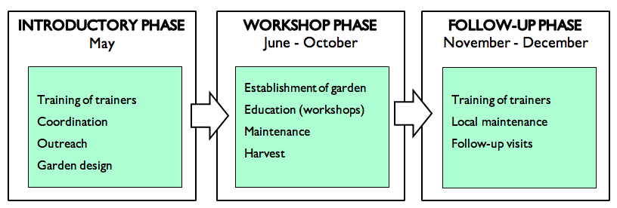
In May, 2019, our local partners will design the learning gardens at each field site and develop a seasonal education plan. This work will be supported by the first network meeting between our local partners, made to facilitate initial experiences and knowledge sharing. Our partners will undertake outreach in close communication with the local communities and conduct two trainings of local staff/participants on teaching and garden maintenance.
In June - October, 2019, a total of 20 workshops will be carried out, each lasting for around 2 hours, including a theoretical and a practical part. Additionally, ad-hoc garden activities for broader groups of kids and youth from the local community can be conducted when/if it seems suitable in the local context. A second network meeting will take place in the autumn, 2019, for our local partners to share further experiences that each can bring back to their learning garden.
In November and December, 2019, the focus is dual on two trainings of local staff/participants in order to carry on the maintenance of the garden as the workshops will be paused during winter while evaluating the season and the project. The season will end with a celebratory event for the participants and their families in each learning garden.
The gardens in Baalbek and Jib Jeniine
To align the project with AAAR’s local work, one participant will obtain a position as garden responsible at each center, and a local coordinator will be hired as well, both being trained to take on the responsibility of coordinating the maintenance of the gardening and for conducting garden activities for children at the centers. The project will additionally teach the participants about nutrition and how to make produce of the crops that can be sold at the community centers.

Project resilience through local capacity building
For Zaher, it is vital to create sustainable learning gardens, not only with regards to the methods, but also in order to make each project as resilient as possible. To reach that goal, we have developed a long-term overall project plan for each garden, that will ensure the local organisations and communities to become capable of continuing the activities and maintaining the garden while becoming less and less dependent on funding and external experts.
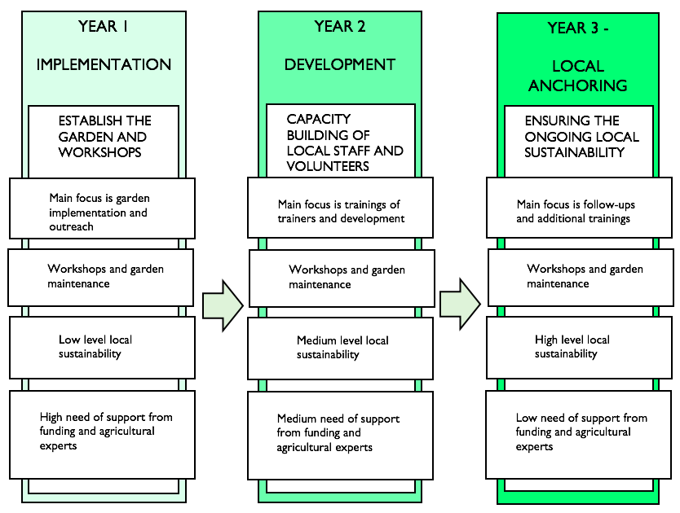
3.3 NEW METHODS, EXPERIMENTAL AND INNOVATIVE APPROACHES TO BE TESTED AS PART OF THE INTERVENTION
- Permacultural growing techniques
In order to build the capacities of the children on sustainable food production and make the best use of local and natural resources while enhancing them, the permaculture approach will be adopted. Teaching children permaculture techniques will encourage them to become connected with nature, understand it and care for it. The children will learn how to appreciate available resources and use them wisely to produce healthy food in a sustainable way.
- Farm to fork-concept The children and youth will be involved in the entire process of creating the organic learning garden: from partaking in sowing seeds, nursing the crops and watching the sprouts turn into vegetables, and harvest, cooking and turning into produce.
- Co-creational knowledge sharing platform As an important development from our pilot project, we will add a knowledge sharing platform co-created with our local partners. We will use Podio, an online customisable work management solution, that is used for similar projects in the region. With Podio, our partners can share and discuss experiences, knowledge, obstacles, educational materials, pictures, seasonal plans, growing techniques as well as monitor the development in their own garden and the project at large. With time, the platform will become embedded in the work of our partners who will continue to add, share and update content.
- Entrepreneurial aspects Food/produce: Teaching participants inexpensive gardening methods and how to turn crops into food and produce. Training program: Local youth volunteers/parents/staff members will be trained to take on tasks of garden maintenance and workshop activities in the gardens. The trainers will obtain certified diplomas for their advancing, as we have come to understand the importance of documenting such capacities.

3.3 THE TANGIBLE CHANGES AND OUTPUTS WHICH THE INTERVENTION IS EXPECTED TO CONTRIBUTE
Immediate objectives |  | Tangible changes and outputs
Obj. 1  Education and involvement of the participating children and youth |  | - 60 children and youth will have improved their knowledge on biological processes, environmental awareness, healthy nutrition e.g. cooking and making produce from garden crops  - 60 children and youth will know how to create a garden by organic, inexpensive and traditional farming methods  - educational material will have been developed and shared with participants to bring home
Obj. 2  Facilitate a sustainable garden for the local school/community |  | - 4 organic learning gardens have been created, each with a space for planting and a space for outdoor classroom  - ad-hoc activities have been held at each location for a broader scope of people from the local communities to be invited into the garden and learn about the work of the participants  - our local partners report on a sense of improved social cohesion in the communities close to the garden
Obj. 3  Capacity building within our local partner organisations, and enhanced advocacy for a Lebanese learning garden movement |  | - A co-creational knowledge sharing platform (Podio) is being created and used by local partners  - 2 network meetings between local partners have taken place  - A strategy for further advocacy for a learning garden movement in Lebanon has been created between our partners

3.4 POSSIBLE FACTORS (RISKS) THAT MAY HINDER OR DELAY FULFILMENT OF THE INTERVENTION’S OBJECTIVE:
- The displaced children and youth from local communities may not have time to participate due to the need of them to obtain day-labor in order to provide household support or they won't be allowed to participate. Preventive measures: Solid outreach and strong communication. A local staff person with connections to the community introduces the project to the families and explains the benefits of enrolling their children. We will further provide snacks and water during the activities.
- The responsibility to maintain the learning garden outside the workshops is not being taken care of. Preventive measures: A training program for local staff/volunteers/parents who will also be granted with diplomas to prove their obtained skills.
- Moving/close down of our partners’ fieldsite. Preventive measures: Zaher rents the learning garden plot in Sa’adneyel, and develop an action plan for such situation with all partners. Podio will make the knowledge and experience resilient to such unlikely events.

3.5 THE PLANS WITH REGARD TO SYSTEMATISING AND USING EXPERIENCES BOTH ALONG THE WAY AND AT THE END OF THE INTERVENTION
See 3.3 for specification. Zaher will be in charge of the ongoing monitoring of the project and coordination between partners, and will ensure that as many experiences and as much knowledge as possible will be brought into the project. Zaher will ensure a transparent process of monitoring along the way through the use of Podio. Every second week, Zaher will reach out to each individual partner (through WhatsApp) in order to touch base on each other’s work and status. Podio will serve as a means to systematise and share experiences from the project along the way and at the end of the project. Zaher’s qualified team of volunteers will conduct an evaluation at the end of the project. The evaluation will be based on follow-up visits to the gardens where semi-structured interviews will be carried out with local partners and participants - especially focusing on collecting positive narratives. Zaher will aim to visit some of the participants’ families in order to explore ‘social cohesion’ between the garden and the local communities. Additionally, Zaher will go through the gathered audiovisual material, the knowledge shared on Podio and the notes collected from partner meetings in order to get an overview of the processes and the outcome from this project. When wrapping up the evaluation of the learning garden project, Zaher will work out a ‘best practices’ pamphlet.
3.6 MATERIALS PRODUCED DURING THE INTERVENTION THAT CAN BE UPLOADED ELECTRONICALLY
- Our participants: Pictures/videos/drawings from the gardens, small narratives
- Our local partners: Pictures/videos from the gardens, educational material, printings/posters, seasonal plans, number and gender of participants, screen dumps from social media, articles
- Zaher: Pictures/videos from the gardens and network meetings, interviews with local partners, screen dumps from social media pages, articles.

3.7 NEW OBJECTIVES, STRATEGIC APPROACHES OR NEW TARGET GROUP
- Our target group will expand from 15 to 60 children and youth and from age group 6 - 12 now to 6 - 30 in order to include young adults in the project as well.
- We will expand from 1 ad-hoc implemented garden to 4 fully developed learning gardens
- A structure and timeline for the implementation phase has been developed on the basis of our experience to ensure each garden reach the objectives
- Due to the arranged network activities and the knowledge sharing platform, our local partners will be better equipped to develop the gardens on a short as well as on a long term
- A structured training of local staff/volunteers/parents will strengthen local ownership

4. PLANNED INTERVENTION-RELATED INFORMATION WORK IN DENMARK
During the project we will run several information projects in Denmark that shed light on active youth citizens and engagement in their gardens. Presenting the learning garden project to a broader audience in Denmark, can serve as a means for discussing human rights, empowerment, biodiversity and entrepreneurship. Every week, we will be posting updates on our Facebook (facebook.com/zaher ) and on our webpage (zaher.dk) where we will invite local participants to share personal stories from their gardens and we will also post pictures, videos and statuses from the ongoing workshops. Every now and then we will be sharing the local Syrian farmers’ tips to a permaculture garden. Our outreach will by strengthened by our collaboration with the Danish NGO ‘Haver til Maver’ (HtM) (www.havertilmaver.dk). HtM has agreed to spread the news from our gardens on their social media, and Zaher will participate in various seminars at HtM’s center in order to share news from Zaher’s work, highlighting how learning gardens can serve as a means to empowerment, self-sustainability and promotion of human rights. In February, 2019, Zaher together with HtM published a column about Zaher’s work with learning gardens in Lebanon. Due to HtM’s collaboration with the Danish organic farming organisation Aarstiderne (www.aarstiderne.dk), this column was distributed in Aarstiderne’s meal boxes reaching out to their 65.000 customers. Zaher will also participate at Folkemødet on Bornholm 2019 with talks and debates on the strengths of creating a local learning garden network in Lebanon. Together with IMCC, OD and potential other NGOs we aim to create an event at Folkemødet where we will discuss our work with sustainable projects in the global South. Point of departure for this discussion will be the Sustainable Development Goals, and based on experiences from the field we will discus how to ensure engagement and inclusion of local youth in a local context, how to improve gender equality and human rights and how to support capacity building and sustainable communities.

due to Ramadan in May, the trainings can also be held between April and June as the local partners find most suiting
International Medical Cooperation Committee
Operation Dagsværk

