Danish organisation | C&C Hjælpeprogrammer (C&C Help)
Title of the intervention | ‘Early Warning System’ for sustainable human trafficking prevention
Partner name | Blue Dragon Children’s Foundation
Amount applied for | 99,850 DKK
Country | Vietnam
Period | 12 months

- Objective and relevance (the world around us)
1.1 Goal of the intervention
The project’s overall goal is to reduce the trafficking of Vietnamese women and girls to China by expanding a tested community-based human trafficking prevention solution that is low cost, effective and sustainable.
The project will form anti-trafficking boards (ATB) at the village-level across 18 villages in three communes in the district of Meo Vac, in Ha Giang province located in northern Vietnam. These boards will be part of a comprehensive and sustainable ‘Early Warning System’ against human trafficking.
The ATBs contribute to the overall goal of preventing human trafficking by enabling the communities to identify the risks and thereby reducing the vulnerability with regards to trafficking. The project sets in place structures with can intervene quickly if trafficking is suspected and links local families and individuals with appropriate assistance. In this way the risk of trafficking will be reduced, and the ATB will also assist survivors living in the community to be referred to appropriate services to help them recover from trauma and rebuild their lives.
This one-year project aims to expand an already piloted model of early warning system, and then enable the government and community agencies to continue the initiative in the selected communes. The project is embedded in the district structures and after the completion of the project, the establishment of ATBs will be duplicated in additional villages until finally the entire district is covered.
1.2 Justification of the intervention
Trafficking in persons is an international crime affecting countries across Southeast Asia. In Vietnam, human trafficking is particularly prevalent in poor communities in remote, rural regions. In these communities, awareness of human trafficking is low. Currently, the law and available public services are not able to assist all vulnerable communities. While Vietnamese law provides many measures against human trafficking and support for victims, action at the local level is uncoordinated and under-funded meaning trafficking is not prevented effectively and many survivors and families in need of poverty reduction services do not receive them.
In a recent report based on data from over 1,600 victims of human trafficking rescued by Blue Dragon, 51%, come from ethnic minority communities in Vietnam. If population is taken into account, ethnic minority people are three times more likely to be trafficked than the Kinh majority population. From Blue Dragon’s research, we know that the most at-risk age group are those between 19 to 25-years-old, especially those who are unemployed and in need of financial resources. The report shows that nearly 40 % of the victims are young women trafficked into forced marriages with men in China. Victims are often tricked with the promise of work opportunities across the border in China. Instead, however, they become trapped in labour, sexual, or domestic exploitation.
1.3 Context of the intervention
Ha Giang province is located in the northwest region of Vietnam and has a 270kilometre long border with China. Ethnic communities, including H’mong, Nung, Dzao, and Tay represent over 85% of the province’s population. Poor, remote and sparsely populated, the province’s mountainous geography limits agricultural or industrial development. In recent years there has been some tourism development. However, this has been halted by the COVID-19 pandemic.
In 2019, Ha Giang’s poverty rate was 29%. Its near-poor rate was 14.29%. This means that over 40% of the province’s population is living in varying conditions of poverty. Coupled with this, Ha Giang province also has a very low school enrolment rate, particularly for girls: less than 50% of children are enrolled in secondary school, of whom only one fifth are girls. Unfortunately, the economic effects of COVID-19 have made this situation worse.
These factors make Ha Giang province a hotbed for human trafficking. Working with the police, between 2007 and mid-2021 Blue Dragon has rescued 180 victims of human trafficking from the province.
Currently, Blue Dragon is the only NGO working on human trafficking prevention in the province.
1.4 Collaboration, public engagement, civil organisation and social justice
This project aligns with the Vietnamese government National Anti-Trafficking Action Plan (NAP) for 2021-2025, which mandates increased resources for victims and strengthening prevention on the ground. The provincial authorities have recognised the need for more effective prevention efforts and interventions that can reduce vulnerability of ethnic minority communities, and have developed a provincial Anti-Trafficking Action Plan 2021 -2025. However, these plans have not been effective in bringing down the number of cases. This is partly due to widespread misconceptions about human trafficking, which for instance have led to under-reporting of cases and low awareness about the real risks. Only 14% of the 180 victims of human trafficking rescued by Blue Dragon were registered as human trafficking cases.
Blue Dragon is partnering with local authorities and organisations to implement initiatives in line with the Action Plan that will change this situation and make a significant reduction in the prevalence of human trafficking over the longer term. The involved partners include the police and the Women’s Union. The establishment of ATBs will engage both local authorities and community leaders in the fight against human trafficking and this community-based model is a way to reach out into the structures of the communities and to reach as many individuals as possible.
Each ATB is made of eight community leaders and members of the commune and village. The Boards are formally established through a decision of the commune People’s Committee and in most cases is integrated with existing Crime Prevention Committees. In this way the ATB will be an integral part of the existing structures, which will assist in ensuring the sustainability of the ATB.
Through preventative measures that will reduce vulnerability to human trafficking and other human rights violations and support to victims, this project will contribute to protecting the basic human and socioeconomic rights of victims and those at risk of human trafficking.
1.5 Pilot-project
Blue Dragon has been working in Ha Giang since 2018 to reduce the prevalence of human trafficking. Initially, the province’s authorities and community leaders wanted to solve the problems of human trafficking in the area, and they had attempted a few community-based solutions, including communication campaigns.
However, these efforts did not have an impact on the number of cases and the risks that communities are facing. Therefore, the leaders contacted Blue Dragon, who they knew to be an active partner in the fight against trafficking in the area.
The model of village-level anti-trafficking boards (ATBs) was then developed in cooperation between Blue Dragon, the local community leaders and authorities including the local police and the Women’s Union. Initially a single ATB was created in one village during 2020-21, and it was quickly seen that the approach had good effect and potential. Local leaders and authorities from other villages saw the results in the first village and they requested support from Blue Dragon to expand the model to more villages in the district.
The pilot project shows that once established, the ATB is a sustainable system that will ensure ongoing community education, and the identification of people at high risk of trafficking as well as human trafficking cases. The model creates a reporting and response mechanism that ensures quick intervention in cases of suspected human trafficking. It assists victims and those at risk of human trafficking get the support and assistance they need to reduce their vulnerability.
This project includes 18 villages and based on the process and results of this project, the aim is to expand it to the entire district and also share it with other provinces and national government to form effective anti-trafficking measures nationwide.
Blue Dragon has the position to do this, as it is a well-recognised NGO in Vietnam and has for many years been involved in lobbying and other political work at the national level.
1.6 Environmental conditions
Ha Giang province is a mountainous region that sees heavy rainfall, and as such is known for frequent flash floods, landslides and soil erosion. Climate change and environmental factors play a large role in the livelihoods of communities in Ha Giang province and contribute to increasing poverty-induced social issues such as human trafficking.
With regards to the project, the planning and implementation is considering environmental factors. Blue Dragon has an environmental policy and for instance all transport in Vietnam is done by ground transportation. The planning between Blue Dragon and C&C Help has been done through videoconferences and there are only two international flights included in the project. A C&C Help board member will travel to Vietnam for monitoring purposes halfway through the project and for final evaluation. The flights are CO2 compensated through another C&C Help project.
- The partnership/collaborators (our starting point)
2.1 Previous cooperation between the partners
Since 2018, C&C Help has been cooperating with Blue Dragon on a variety of projects including human trafficking, career development for disadvantaged ethnic minority youth, and emergency support for street children in Hanoi.
In the first two years of our partnership, a grant from C&C Help supported the rescue of 21 victims of human trafficking and provided career education for 109 disadvantaged youth in Vietnam.
When COVID-19 struck Vietnam in early 2020, C&C Help worked with Blue Dragon to provide emergency support for 149 families and 70 street children in Hanoi, Vietnam. The collaboration was extended through 2020 and into this year, as C&C Help granted funds to enable Blue Dragon to rescue 146 street children from homelessness, providing them with food, shelter, and healthcare. Through Blue Dragon, C&C Help also ensured that these children received the psychological counselling they needed to stay safe and rebuild their lives.
In 2021, Blue Dragon and C&C Help renewed the partnership for a year and are working together to promote career development and life skills training for vulnerable children as a means to prevent human trafficking and improve the life and career prospects for highly disadvantaged young people.
The strength of Blue Dragon and C&C Help’s cooperation is rooted in our mutual commitment to bettering the lives of disadvantaged and vulnerable youth in Vietnam. Our two organizations are mutually complementary. Before each project, Blue Dragon and C&C Help thoroughly discuss the design as well as monitoring and evaluation plans.
2.2. C&C Help
C&C Help is a registered charity since 2014. C&C Help implements development projects in Asia and South America in those countries, where C&C Travel also work. The cooperation with the travel agency facilitates planning and monitoring of the projects as well as awareness creation in Denmark. C&C Help is run entirely on a voluntary basis and any administrative costs in Denmark are covered by C&C Travel.
The board of C&C Help consists of three people with extensive backgrounds in international development. The director is a lawyer who has worked for the Asian Development Bank in Asia. One board member is a social anthropologist who has worked for the Danish development agency, Danida, on several social projects in Asia and Africa. Another board member has specialised in international development including gender balanced development and has worked for Danida, the Red Cross and various NGOs.
C&C Help has been part of the design process of this project and will participate in the monitoring of the project. As mentioned above, one board member will travel to Vietnam to provide technical assistance for the mid-way monitoring and one for the final evaluation. The flights will be sponsored by C&C Travel.

- Target groups, objectives, and expected results (our intervention)
3.1 Beneficiaries
The project’s ultimate beneficiaries are impoverished ethnic minority people in Meo Vac district. As of 2019, the district has a population of just over 86,000 people and the population of the 18 villages included in the project is app. 12,000 people.
While there are no official estimates of how many survivors or those at risk of human trafficking currently reside in these communities, past research and surveys with relevant authorities have shown that Ha Giang province is an area particularly vulnerable to human trafficking.
3. 2 Implementation
The project will establish ATBs in 18 villages of three communes in Meo Vac district of Ha Giang.
They ATB members will be chosen as described above and once selected, they will receive comprehensive training from Blue Dragon and national agencies on human trafficking risk reduction, how to screen households for risk, and a variety of anti-human trafficking communication skills. The skills and knowledge that they gain through training will allow them to fulfil their role of communicating knowledge about human trafficking and identifying citizens in need of assistance.
Following their training, the ATB is responsible for reporting on and keeping track of migration in the village and for connecting families of victims or those at risk of human trafficking to resources at Blue Dragon/other NGOS or the government. Blue Dragon can help in accessing government funds and it also has access to resources from other donors.
These activities of the ATBs may take the form of monthly household surveys to identify families in need of support or missing villagers, reporting potential trafficking or exploitation cases to police for quick investigation and intervention, referring families in need of support to welfare and other government support, and working with schools and other agencies to ensure education and child protection.
The diagram illustrates how to establish an ATB, and the main activities of the ATB.
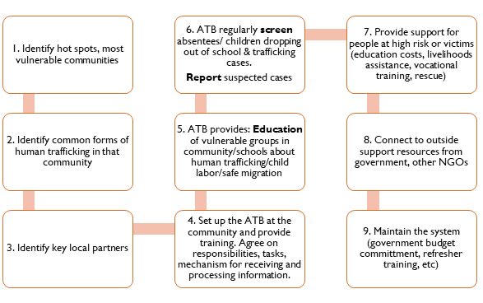

The figure below sketches out how the ATB project will be coordinated at district, commune and village-level.
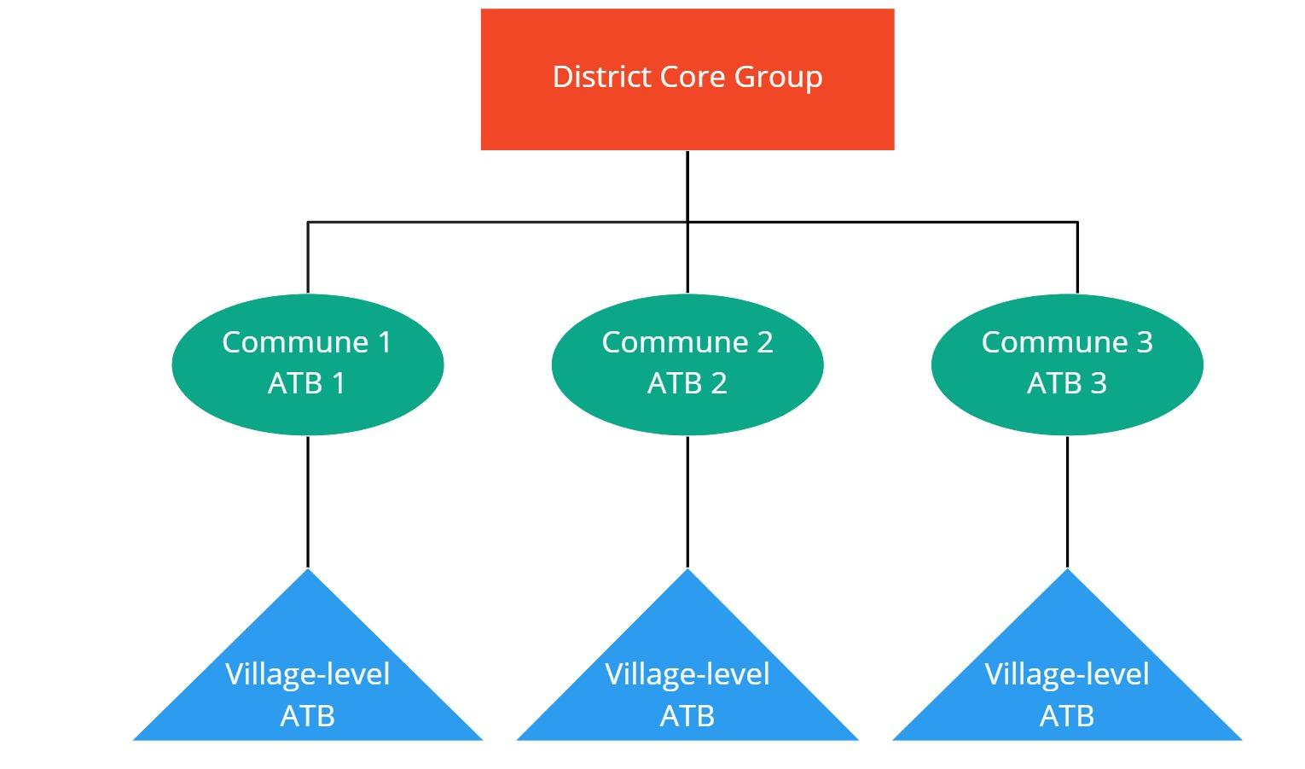
A District Core Group composed of 15 members, including representatives of communes, Vietnam Women’s Union, Youth Union, other government agencies (Education, Welfare, Police, Border Guards) will undergo comprehensive training from Blue Dragon. The District Group will then oversee the formation, training, and monitoring of commune and village-level ATB and report on their progress to Blue Dragon and the relevant provincial authorities.
The commune and village-level ATB, following their training by the District Core Group, are responsible for keeping up to date about migration from the village and educating community members to protect themselves from risks. The commune ATB group will train, support and monitor the activities of the village ATB and are responsible for reporting cases needing assistance to the district authorities for further investigation. For instance, if a potential case of human trafficking is detected, the village-level and commune-level ATB will report this to the District Core Group. As representatives of the District Police are part of the District Core Group, they can immediately investigate, and escalate to the provincial level where necessary. All actions relevant to that case will be reported back to the District Core Group.
For socioeconomically vulnerable households that are at-risk of human trafficking, the District Core Group is in charge of identifying and coordinating referral to the provincial Department of Labour, Invalids, and Social Affairs, the Women’s Union, the Department of Education and Training, local health services, or to non-government organisations including Blue Dragon.
The project will support the training and establishment costs for three communes, including training of trainers for district level ATB members, training for commune level ATB members, and equipment and supplies to establish the ATBs at district and village level.
3.3 Expected Results:
Overall, this intervention will establish a sustainable community-based ‘Early Warning System’ that will reduce the prevalence of trafficking within communities. The project will improve community and individual awareness of the real risks of human trafficking, allow faster response to potential human trafficking cases by streamlining information sharing and coordination between relevant local authorities, and improve impoverished households’ access to assistance and resources to reduce their vulnerability.
As the system is established within existing government agencies with government and civil society members, after the initial set up costs it is a low cost, sustainable mechanism that goes far beyond awareness raising to actually protect communities and support victims. Following the initial training period, the project is sustained by local leaders and community representatives which compose the ATB. The latter are expected to maintain the preventive systems that are put in place, in cooperation with the national government, and within existing budgets. Local agencies such as the Vietnam Women’s Union and the police who are the partners in this intervention have existing budgets for trafficking prevention. Our expectation is that when they witness the success of this project, these budgets can be allocated to the very low ongoing maintenance costs for the ATB system.
- Intervention-related information work in Denmark
The project will be mentioned on C&C Help’s website and also on C&C Travel’s social media channels. The travel agency will in this way assist in creating awareness about trafficking by reaching out to the travelling community in Denmark. This in turn may lead to increased contributions to C&C Help.

The Vietnamese Women’s Union is a national association with chapters in all localities of Vietnam. One of their core missions is to ensure the socioeconomic wellbeing of households across the country.
C&C Help has planted 80.000 mangroves in the Philippines which compensates tons of 8.000 tons of CO2 each year.
C&C Travel is a Danish travel agency. All travelers have the option of donating 75 DKK per person to C&C Help and C&C Travel match these donations.

