Danish organisation | FANT – Football for A New Tomorrow
Title of the intervention | ‘Backway’ is not the solution phase II
Partner name(s) | YAIM – Youth Against Irregulated Immigration
Amount applied for | 999.542 DKK
Country(ies) | The Gambia
Period (# of months) | 1,5 years (01.01.23 – 01.07.24)

1.1 Aim and project objectives
The overall aim of this intervention is to improve self-reliance among young boys and girls in the Gambia to prevent irregulated migration
Objective 1: The central administration of YAIM has strengthened its network with local and national duty bearers, gained experience about local fundraising and developed important internal capacities that will support a sustainable growth of the organization.
Objective 2: YAIM has established regional chapters of the organization in all seven regions of The Gambia that mobilizes a minimum of 210 young boys and girls either in the danger of partaking in irregular migration or returnees through football activities and capacity building workshops.

1.2 Extension of intervention, main challenges and important lessons learned
This intervention is an extension of the project ‘Backway’ is not the solution 21-3709-CSP-MI that ended on the 31st of July 2022. This project has built important organizational capacity within the partner organisation YAIM, created awareness to the public of the existence and purpose of YAIM through weekly radio programs and implemented a pilot project in KMC (Kanifing Municipal Council) region with the aim of mobilising their target group through football activities. The incorrect and limited information provided to the public about issues related to irregulated migration is one of the most urgent challenges that this new intervention seeks to address by supporting the project partner from the Gambia, YAIM, in strengthening their work with issues related to irregulated migration on several different levels.

Organisational capacity:
YAIM has held several workshops within the organization and the management of the organization (approximate 20 persons) with different capacity building themes. More basic capacity building activities like revisiting their constitutions and creating anti-corruption and anti-sexual harassment policies has helped YAIM becoming a more attractive partner to bigger organisations like the IOM (International Organization for Migration) but also towards government institutions. Especially the focus on targeting government institutions as potential partners will be elaborated in this new intervention. The past intervention also included more in-debt capacity building activities like how to understand and implement transparency and accountability in an organisation, how to understand leadership and a workshop about how to engage volunteers and handle voluntarism in an organisation. These workshops have educated and prepared YAIM for the next steps towards expanding their reach towards all seven regions of the Gambia. Lastly six members of the management of YAIM has been engaged in private lessons in English and computer training – skills that are essential when YAIM must approach potential partners like international organisations and government institutions but also regarding saving important lessons learned from projects, being aligned with CISU-requirements and being capable of monitoring activities also from a distance. All these above-mentioned lessons learned regarding organisational capacity will be used in this new intervention when the management team of YAIM will pass on their new learnings and knowledge to the 7 regional chapters and their management teams (activity 2.1.5 Bi-monthly meetings, 2.2.2 Public speaking skills and 2.2.3 Leadership seminar). When networking with duty bearers and other relevant stakeholders the strengthening of the organisational capacities is important for the self-confidence of the management team when they present the organisation, but it will also help validate their work when they can present thorough and usable internal politics for one example. These politics can furthermore show to be important when expanding the organisation and outsourcing different responsibilities to regional levels.

Awareness campaign:
Every Friday YAIM has engaged in a radio discussing program on the national radio station KING FM 94,7. Every week has had different subjects whereas some to mention are “Is backway journey a suicide mission?”, “Who is doing the most to curb irregulated migration?”, “Global compact for migration: What is the Gambia doing?”, “Diaspora & remittances”, “Insights from the diaspora: a conversation with a Gambian youth living in Germany”, “How do communities see returnees? A conversation with a Gambian youth”, “Discussion on the challenges of reintegration with a returnee” or “How does return connect to the challenge of integration abroad?”. These radio programs have helped YAIM creating awareness about the matter of irregulated migration that they are fighting to prevent but also helped them in making YAIM a more recognized organisation within the arena of organisations working with this matter. At the YAIM office the management closely follows national and international news and initiatives about irregulated migration, and the radio discussions support YAIM in having a voice and an opinion about any actions – or non-actions – taken from either international or government institutions. 90% of the management in YAIM are returnees who have tried going to Europe through the ‘backway’ – a popular Gambian expression for the overland journey towards Europe. The ‘backway’ relates to notions of traveling with limited funds and without the required papers during parts of the route and with tremendous risk taking. They therefore have an important voice and knowledge in these matters which the radio program has helped them express and share to the public. The focus on radio programs will remain in this new intervention to continually support YAIM in providing information about irregulated migration to the public, to support YAIM in having a voice and giving their ideas, thoughts, and opinions value and lastly to make sure that persons in the danger of partaking in irregulated migration and young returnees know about the existence of YAIM and the support they provide to this marginalized group.

Pilot project:
In the project currently being implemented YAIM has implemented a pilot project in the region of KMC (Kanifing Municipal Council). This pilot project has helped YAIM getting experience about how to
- mobilize youth through football activities
- create regional chapters of their organisation
This experience will be important for this new intervention that aims to expand these regional chapters to all the seven regions of the Gambia. The aim of the pilot project was to mobilize 30 young boys (and potentially girls) in KMC but actually 48 individuals have signed up as regional members of YAIM – including 14 girls which was also above the expected number. Within the regional chapter in KMC a management group has been elected consisting of a
- President
- Vice President
- Secretary General
- Treasurer
- Social Secretary
- Advise/assistant
This group will be responsible for the general contact to the management in YAIM with the overall responsibility being at the President. They have also established an advisory board consisting of two elders from the community who have relevant experience about migration issues. This was done as a part of the experience learned by the pilot project to ensure that parents and elders from the community supports the initiative. Activity 2.1.4 Community and parents’ meetings is a direct result of this important learning.
The above explained set-up is planned to be used in this current intervention for the six other regions, so the communication and monitoring structures are similar.

YAIM has used football as a tool to mobilize their target group before but only for specific awareness creating events. In this intervention the aim is to include the target group as regional members of YAIM to make sure to develop a more in-debt relation to the target group. This intervention is not aiming at implementing one-time events but to make the target group a part of the organization and create ownership and engagement. A method for this is to use football to create unity among the group by creating a YAIM football team (for the pilot project YAIM KMC). YAIM has gained experience in this from the pilot project which will be used when expanding further.

One of the main challenges that this new intervention seeks to address is to prevent irregular migration by making the target group trust, that they can create a decent future for themselves in the Gambia. This requires work on different scales – government regulations and support, private sector investments and individual guidance, education and information. This intervention will mostly direct the activities towards individual guidance, education and information but will seek to strengthen the possibilities of working on the two other scales when building up relevant capacity and network within YAIM.

This intervention will use the approach of mobilising young boys and girls through football activities and workshops, but the target group will expand from 30 individuals in the last project to 210 individuals from all seven regions in the Gambia. The strategy is to continually capacity build YAIM as a civil society organisation and to support them in reaching a larger target group and taking first steps towards supporting the target group in creating sustainable changes for themselves.

1.3 Context of the intervention
Introduction to the overall challenge:
Worldwide, the issue of migration from South Saharan Africa to Europe has become a highly politicized and controversial matter. Thousands of young Gambian boys and girls have left for the ‘backway’. You can find rural villages in the Gambia, where nearly every young boy has left for the ‘backway’ with the hope of a more promising future. These boys, of which you can still call many of them children, are going on a highly dangerous journey, risking abuse, kidnapping, prisoning, torture, rape, thefts etc. They travel through some of the most politically unstable countries in Africa and end up in Libya, which becomes the ending point of the journey for most. As of today, very few succeed in taking the ‘backway’ and making it all the way to Europe. The majority is sent back to the Gambia from Libya with the IOM (International Organization for Migration). When they return, they deal with stigmatization after having failed to reach Europe and at the same time having spent most – if not all – their family savings.

Migration
The intervention will take part in the Gambia, a small West African country with a population of only 2,35 million people. Despite its size, migration plays a significant role in the Gambian society. Overseas remittances from an estimated 118,000 of Gambians living abroad, account for over 20 percent of the country’s GDP. Over the past years, the pursuit for socio-economic advancement – especially among the youth – has driven many to undertake irregular migration with the aim of reaching Europe or other westernized countries. Over 35,000 Gambians arrived in Europe by using irregular means between 2014 and 2018, and many others have ended up in Africa along the Central Mediterranean Route opting for voluntary return. In 2016, approximately 10,500 Gambians entered Italy after crossing the Mediterranean Sea from North Africa. That makes the Gambia the fifth-largest sender of migrants to Italy from sub-Saharan Africa in 2016 despite being the smallest country on the African mainland. What sparked this immense migration phenomenon is presumable a combination of several cultural, political, and social factors. Representatives from YAIM point at two major factors for the increase in young boys taking the ‘backway’. First and foremost a high unemployment rate and secondly social media.

Between 1991-2019 the average unemployment rate for youth (age 15-24 years) was 13.05 percent. Young boys are frustrated with not being able to create a financial decent life for themselves, and this has a huge impact on them going for the ‘backway’. Also, because they see on social media that others, who have left their country behind, are living improved lives in Europe, the eagerness to try for themselves has grown. The representatives from YAIM explain that they are aware that the pictures of ‘the happy life’ as an illegal immigrant in Europe do not tell the truth, but that it is something very easy to put on social media. One of them explains: “This dream is an illusion and not the solution”.

The village of Njaba Kunda on the north bank of the River Gambia is unfortunately a perfect example of a community with very few young men left. In a few years, some of 700 villagers out of a population of 3,600 left for the ‘backway’. In three years, more than 90 young boys lost their lives en route and many more are still missing.

Politics:
The Gambia has a history of long-term ruling Presidents since its independency in 1965. The current President, Adama Barrow, became the third president of the Gambia in January 2017. The Gambia was run by Yahya Jammeh from 1994 to 2016, which is 22 important years to look at, when trying to understand why irregulated migration has increased so rapidly within the past 10 years. The ‘backway’ emigration took off during the rule of President Yahya Jammeh. It is commonly known in The Gambia that President Jammeh led a repressive regime, where media critics, positioning politicians, dissidents within the security forces and civilians, who openly did not favour his ruling tactics, were brutally silenced. When asking returnees directly, few of them say that the political repression under Yahya Jammeh had anything to do with their choice to take the ‘backway’. But at a deeper level, some of them recognize that the powerlessness under Jammeh’s regime to express their opinion or to be part of a wanted change, made them feel like it was impossible to change anything from within The Gambia. They needed to go to Europe to get a better life.

After many years of political repression, the population of the Gambia wanted change; both democracy and institutional change. There was a broad conception among the population that the government was not working towards the best of the country, but instead working for their own pockets. Unfortunately, when you ask around in the Gambia today, they have still not seen the change that they were searching for, when they elected the current president Adama Barrow.

Bai Mustapha Sallah from YAIM explains how many things unfortunately have changed to the worse. The level of corruption has increased, and there is political division which makes it difficult to get something implemented politically. Before, everyone was afraid of the President, which is Bai’s answer to why level of corruption has increased. He points to freedom of expression as the only immediate benefit from the political change. But freedom of speech is an important change that makes it realistic for the youth to advocate for the change in society that they wish for. There was political election for government in December 2021, and YAIM worked to help returnees register as voters for the election, because they wanted to help this group participate in the democracy and to be a part of the change that they want to see for their country.

Most of the youth that FANT and YAIM has engaged with in the Gambia expresses a disbelief in political leaders based on experiences of being economically, politically, and socially marginalized. The ‘backway’ is perceived as an escape from the results of decades of political mismanagement, which has characterized the country since independency. “We go backway, because we don’t want to be poor like our parents,” one of the returnees explained.

Youth in the Gambia
As for many other African countries, youth constitutes most of the population in the Gambia. More than half of the population is under the age of 20 years. Besides the numerous amounts of young people in the Gambia, it is not wrong to say that being young puts you at the margins of the society. Nearly 60 percent of the poor in the Gambia are under the age of 20 years. The transit from education to work is extremely difficult, both because of a lack of good and useful education, but also because of an exorbitant unemployment rate. Youth in the Gambia finds it difficult to establish financial independency, hence affording housing, basic necessitates, getting married, forming families and for some, even having a boyfriend or a girlfriend, becomes close to impossible. They live in uncertain spaces of day-to-day survival, where they depend on friends and relatives, and take jobs in the informal sector.

98 percent of the Gambian society is Muslim, and the young men in particular are expected and obliged to support their families as a part of a social system of intergenerational reciprocity. Women usually remain in the home until they marry, and then move to the family compound of the husband. In the face of limited opportunities for social and economic mobility, many young men, including their families, see migration to Europe as a pathway towards a better future. Migrants based in the Western countries hold high status due to their ability to provide a steady source of remittances back to the relatives in the Gambia. Because of the above-mentioned issues for young men in the Gambia, we understand this group as marginalized when standing outside their society, seeing only the solution of escaping their home country as an approach to improve life conditions (politically, socially and economically).

1.4 Strengthening of civil society
This intervention will be strengthening civil society in the Gambia when capacity building the partner organisation YAIM internally but also regarding their partner network to other relevant organisations and institutions. As for now, YAIM is functioning as an organisation with great knowledge and outreach to target groups of returnees and risks, but they have a strong dream of professionalising the organisation so it can become an even stronger civil society player and attract more partners in the future. YAIM consists of approximately 20 main members of the organisation (which we call the management) and additionally around 50 volunteers who are activated when YAIM implements different activities that have been outsourced from other bigger organisations or institutions. For the past intervention being implemented YAIM has built important capacities towards taking more ownership and responsibility in outsourced activities from IOM as an example, but the project has only been for 7 months and there are still areas to improve further on. When supporting YAIM in professionalising their organisation, it will benefit the target group of returnees and risks in the future, because they can create an even higher impact for the target group and reach an even higher number.

Secondly civil society will be strengthened when expanding the pilot project from KMC to all seven regions of the Gambia. The establishment of seven regional chapters is an establishment of seven new civil society organisations under YAIM. Activity 2.2.4 National Migration Camp will further ensure that the seven civil society organisations are connected under the umbrella of YAIM which will give them an even stronger voice and expand their personal network with other likeminded. The intervention will continue to include radio awareness programs where listeners can call and share their opinions and experiences and so get input from a larger group than the 210 targeted individuals. YAIM wishes to create a network of young men (and women when relevant) in the Gambia that fosters participation and equality. Young boys are in general frustrated about being unemployed, and this project will help them seek solutions to the problems that are keeping youth in poverty and help them get a voice that can challenge people in power and structures that are preventing young men from escaping poverty. This project takes the first step of mobilising target group through football teams and will reach the amount of (minimum) 210 persons.

1.5 Climate- and environmental considerations
YAIM is in many ways a modern CSO, also when considering climate- and environmental problematics. Recently they have engaged in a project with the Spanish organisation Fundación ITT regarding beach cleaning and access to the beaches for the locals in the Gambia. In all FANT projects, we are aware of trying to minimize our footprint on the environment. There are many considerations like how many flight trips are necessary and could we use online platforms for some activities that have earlier called on face-to-face meetings. FANT also talks to partners about local transportation, printing and general behaviour that can help taking better care of our planet. FANT will do a close monitoring of projects, because the partnership is still very new and will be aware of talking to YAIM about climate- and environmental issues when planning activities. We have considered it necessary to plan three monitoring trips to the Gambia (one financial visit) whereas at least two of the trips will be planned in connection to other monitoring visits in West Africa to reduce flight traffic and our CO2-emissions. Through the monitoring visits, FANT will get an improved insight into local environmental conditions in the Gambia that could be useful to incorporate or at least discuss along the project period.

2. The partnership
This intervention is a partnership between YAIM – Youth Against Irregulated Migration and FANT – Football for A New Tomorrow. This intervention is the second for the partners to engage in together but both organisations have important experience from previous partnerships and projects. This will be further explained here.

2.1 YAIM – Youth Against Irregulated Migration
It is a self-evident reality that the Gambian youth feel disempowered, dispossessed, and discouraged because of how difficult it is for them to access sustainable and rewarding life opportunities. Thinking of it as the only solution out of poverty and hardship, most of these young people have decided to migrate irregularly to the West, exposing themselves to serious risks and repercussions. In the past years, YAIM has been at the forefront of the fight against the backway mentality, by engaging the youths and showing them alternatives to going abroad at all costs.

2.1.1 History and foundation of YAIM
YAIM was set up by Gambians while in detention in Libya after taking the Backway. En-route they experienced first-hand many human rights abuses and economic exploitation, inspiring them to establish an organization that aims to dissuade people from embarking on such life-threatening journeys and support the youth of the Gambia to engage in the changes for the country they wish for. Awareness-raising campaigns in the Gambia generally have limited success as they are perceived of as inaccurate, biased Western propaganda or poorly informed. YAIM’s awareness raising campaigns counteracts these assumptions, however, since the imparters of the information are people that have taken the journey and face the same issues that the average person in the Gambia faces. People only trust information if they share a relationship or trust the transmitters and YAIM members not being part of the elite reinforces that trust. Also, YAIM can contribute to creating a more sustainable return process by providing guidance and information.

YAIM members have travelled to Libya with the hope of crossing to Europe through the Mediterranean in search of jobs, but now they are back because that dream has not been achieved. Now urging the government to provide job opportunities for Gambian youth to prevent them from endangering their lives looking for greener pastures abroad.

The core method of YAIM is activism. The organisation is made up by personalities who truly believe in the cause and aim of YAIM. This is one of their main strengths because they can inspire others with their dreams and beliefs. They have come together in the shared dream that they can change things in the Gambia for the better through awareness campaigns and by partaking in the (newly established) democracy. Their insisting belief in this is very important when they wish to convince other youth that they can make a difference and become independent and self-reliant. When Margaret Mead said “Never doubt that a small group of thoughtful, committed citizens can change the world; indeed, it’s the only thing that ever has.” she must have had groups or organisations like YAIM in her mind.

Representatives in YAIM are not speaking on behalf of a target group – they are the target group, and they have all experienced the ‘backway’ firsthand. They know how it feels to be a part of this group. The strong community within YAIM is quite unique. It sends out an atmosphere of welcoming which attract other young people to join. The hierarchy is flat and even though Bai Mustapha take a leading role he takes great honor in pushing others upfront for example in the radio programs or in workshops. The strong personalized unity among the management and members is an essential and valuable asset for YAIM and despite the aim of creating more professionalized structures within the organisation and strengthening its professional image there will be focus on sustaining the strong and familial unity within YAIM.

This new intervention will seek to support YAIM in strengthening its internal structures when understanding and improving how decision-makings are functioning in the organisation. Activity 1.4.4 Decision-makings and structures in YAIM will facilitate that the management in YAIM reflects on how to create sustainable decision-making structures that can allow the organisation to grow and maintain its authenticity and accountability towards partners, members etc. For now, the organisation is made up by the volunteer management team, 20-30 individuals (called the members) that are participating actively occasionally and the new branch in the KMC region. With the new focus on expanding to all regions in the Gambia it is necessary to look deeper into the internal structures to ensure roles and responsibilities are clear, well-known and rightfully divided.

2.1.2 Experiences and capacities in YAIM
YAIM has partnered with the leading inter-governmental organization in the field of migration and works closely with governmental, intergovernmental and non-governmental partners working to help ensure the orderly and humane management of migration, to promote international cooperation on migration issues, to assist in the search for practical solutions to migration problems and to provide humanitarian assistance to migrants in need, including refugees and internally displaced people. A part of this project is continually to support YAIM in becoming an even more attractive partner for some of these above-mentioned stakeholders. This intervention will include several of the above-mentioned partners through activity 1.3.1 Weekly radio program, 1.3.2 Partnership and networking events and 1.3.3 Information meetings for returnees.

Regarding experiences that YAIM has of working in the field of irregulated migration and with different partners (besides FANT) can be mentioned:
- Youth Against Irregular Migration and Gambia Returnees from the Backway (GRB) has partnered with IOM to conduct a nationwide survey on the Perception of Youth in Migration during the Pandemic and Awareness Raising activities on how to engage communities and local stakeholders in reintegrating returnees and deportees the amount of the budget was 5000 Euros in 2020. IOM was doing the payment directly to the participants from YAIM and GRB why it did not go into the organization of YAIM.
- YAIM partnered with National Youth Council and UNICEF in a project call Children On the Move. It was a nationwide awareness raising project focusing on the dangers of irregular migration and its alternative. The activities targeted school children and minors within the communities who are potential migrants. During the activities YAIM also used football as a tool to engage the youth within the communities and it is always a fun and good approach to mobilize the youth. The amount of the budget was D869,000. All the financial management was done by National Youth Council and YAIM was responsible for the implementation of the activity.
- Members of YAIM are participating in the Migrants As Messengers Volunteers Network, operating in seven different countries in West Africa created and funded by IOM and its partners. The network is there to amplify the voice of the returnees in combating irregular migration within the sub region.
- YAIM partnered with COOPI in a 3-day community awareness campaign raising and 6 months radio program in 2019. The community activity was held in two regions, North Bank Region and Central River Region with the objective to create more awareness on the effects of irregular migration and the opportunities available. The amount of the budget was all together D521,100.
- Between 2018 to 2019 YAIM received 3 million Dalasi funding from The Federal Republic of Germany through its Councilor office in Banjul to conduct a nationwide awareness raising activity on the dangers of irregular migration and they were funding the activity region by region.

2.1.3 Contributions, roles and responsibilities of YAIM
YAIM is responsible for implementing the project in the Gambia, as well as writing bi-monthly reports to FANT and provide necessary information for FANT to monitor the project, and to obtain and nurse a good relationship to the important partners in the project like the regional chapters, schools, government institutions, IOM Gambia, etc. The management of YAIM will be responsible for implementing and monitoring activities within the regions also and providing the necessary support to the regional chapters.

2.2 FANT – Football for A New Tomorrow
FANT was founded in 2012 and is today run by a secretariat with two full time employees and three parttime. FANT is supported by a board of Directors, who are responsible for the direction of FANT. The fulltime employees are Cecilie Hauerberg who is Head of Secretariat and Josephine Touray who is the Administrative Leader. Josephine is managing the administrative part of the organisation and in project implementations including financial monitoring of both FANT DK and partner organizations. Cecilie, being the co-founder of FANT, has since the beginning been involved in development projects, and therefore spends 2-5 months a year working with local partners in West Africa. By doing so Cecilie has a great knowledge on implementing, facilitating and monitoring activities. FANT has expanded projects in a rapid speed the past three years why it has been decided to work towards employing another parttime worker at the office that will support the monitoring of the project with YAIM in the Gambia. The workload with monitoring and supporting all the partners in the Gambia, Ghana and Sierra Leone will with this new intervention increase to a level where it can no longer be done by only one person. The plan is from the 1st of January 2023 (also the project beginning for this intervention) to get Rebecca Bannor-Addae as another part-time employee at the secretariat in FANT. She is already a part of the process as she has been participating in online meetings with YAIM, counselling meetings with CISU and participated in the process of conducting this project application.

Rebecca Bannor-Addae (born 1976)

Academic qualifications:
2019 MA African Studies, CAS, University of Copenhagen. MA thesis (12) based on fieldwork in the Gambia researching migration, youth, and return. Close collaboration with members of YAIM
2003 BA African Studies, SOAS, University of London

Relevant work experience:
2011-2018 Documentary producer, Radio 24syv. Three times nominated for European radio awards
2008-2009 UNICEF/the Central African Republic, Communications Consultant
2007-2008 UN peacekeeping mission/Liberia, Public Information Officer
2005-2007 UN headquarters/New York, Public Information Assistant

Since 1995 I have gained broad experience in the field of social work. A few experiences of relevance:
- Paideiaskoven, Care Worker Care facility for unaccompanied refugee children (6 boys)
- AAB afd. 58, Project Responsible Creation of interactive app (’Jeg er Nørrebro’) in collaboration with young tenants as part of social housing integration project
- Mændenes Hjem, Care Worker Independent organisation for the homeless and vulnerable (male 80%) accommodating 400-600 daily users
Because Rebecca is not yet a part of the secretariat, she is not included in the figure below but will hopefully be from 1st of January 2023. The budget provides important payroll for both Rebecca and Cecilie which has been considered necessary. Rebecca is new in the FANT organisation and it is an investment not only in this project but in the organization as whole to get her onboard. When she understands the structures, working-methods, and DNA of FANT, Rebecca will have the potential to support and assist Cecilie with all FANTs projects in West Africa which can be a crucial point in the sustainability of FANTs work in south in general. For the past years the monitoring of projects in West Africa has in many ways relied on primarily one person but FANT is growing and professionalizing why this step is an important one. To begin a new job is a process that demands extra hours for both Rebecca and Cecilie and because the partnership with YAIM is still new we estimate a substantial investment is made in this. Rebecca will participate in activity 1.1.1 Introduction Workshop in January 2022 and Cecilie will facilitate activity 1.4.1 Fundraising seminar. Josephine will be responsible for conducting a financial monitoring visit.

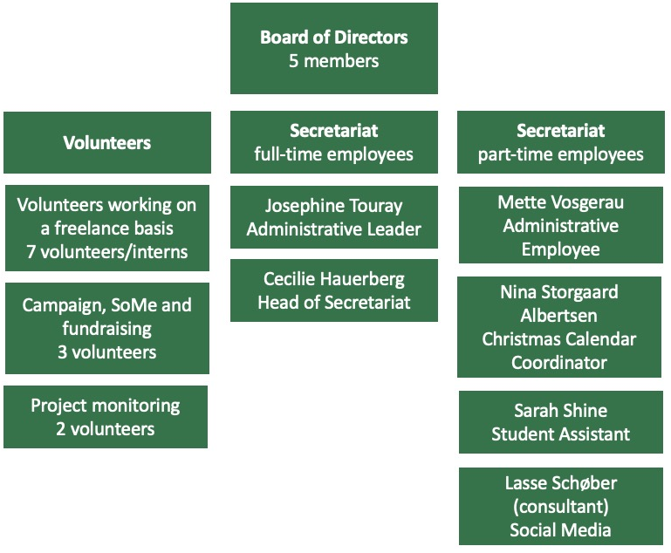

For this application, FANT is the main applicant and carries the responsibility of the overall intervention. FANT is responsible for the overall monitoring of the project, reporting to CISU, and participating in relevant online meetings/workshops/activities. FANT secretariat and volunteer groups will provide technical advice and assistance to YAIM during the project period when needed. FANT is also accountable for the final report to CISU at the end of the project. Several employees from the secretariat will be visiting Gambia during the project to monitor, support and participate in different activities. From the current project being implemented the partnership has had a great start without any mentionable challenges, but because of the upsize of the project (both budget and project period) FANT still finds it necessary to have close contact with the management of YAIM to ensure that the expected outcomes for the project are achieved but most important to further develop and nurse the partnership. For specific activities like the two fundraising events FANT will contribute with experiences from Denmark, Ghana and Sierra Leone and support YAIM to get understanding on local fundraising at an early stage of the partnership.

2.3 Previous cooperation and contribution to a development of the partnership
Some of the most important experiences from the current project being implemented has been elaborated on in section 1.2. When looking more specific at experiences from the partnership or collaboration it is worth mentioning that both FANT and YAIM have been very excited to develop the alliance. As for now there is a clear understanding between the two organisations about responsibilities and capacities, but this is of course an ongoing process that needs to be revisited on a regular basis.

We truly believe that the potential of developing the partnership is great. YAIM is an organisation built on a strong purpose and a strong belief in the cause, and FANT has great experience in supporting grassroot organisations with a purpose to develop their organisation and how to reach their target group by using sport. YAIM has provided FANT with new knowledge about migration issues – issues that are not just relevant in the Gambia but also when looking at Sierra Leone and Ghana where FANT is engaged in other partnerships. This intervention will help the partnership to grow even further when creating a space for both partners to be specialists in each of their subjects.

3.1 Target group
There are two primary target groups for this intervention
- A minimum of 210 young boys and girls between 12-35 years (expected gender division of 20% female and 80% male (based on pilot project numbers))
- Management team of YAIM consisting of 20 persons between 18-35 years (expected gender division of 25% female and 75% male)
The management team in YAIM is a part of the primary target group to secure the capacity building of the organisation. They will be reaching out to the six remaining regions and help community members to form local football teams and management groups. The management team of YAIM is consequently both implementing partner and target group when strengthening organisational structures and capacities besides building individual capabilities. Seven out of the 20 persons in the management team will be on a minor salary while 13 persons of the management team are participating on a volunteering basis. 90 percent of the management team of YAIM are returnees themselves. YAIM will benefit from the intervention:
- By expanding their network towards relevant organisations and institutions (private and governmental) for advocacy work in the future
- By improving fundraising skills and strategies
- By building personal capacities within English and computer skills
- By getting more experience about how to mobilize target groups
- By becoming a stronger organisation and therefore increasing the potential for important partnerships with other relevant organisations and institutions (private and governmental)
In each of the seven regions of the Gambia (the region chapter in KMC is already established) YAIM will establish a football team and a management team consisting of approximate 30 persons. YAIM already has local contacts (mostly schools and community elders) in all the regions from earlier projects that have been implemented. The aim is to mobilize target group of primarily young boys in a mix of returnees and young boys in the risk of taking the ‘backway’ (50/50 division). Even though we divide this target group into two (Risks & Returnees) they can also be seen as a part of the same group - just being at two different stages in their lives. All of them are young men with a relation to the ‘backway’ and the dream about escaping poverty. Some of them have already tried the ‘backway’ and some of them will maybe try if no actions are taking.

YAIM will make a thorough mapping of schools, football clubs, elders, mosques, local government institutions etc. that will be approached as a part of act. 2.1 Mobilisation of target group. Most returnees are in general boys but in the regions where there are female returnees, they will of course be invited to join the regional chapter as well. The target group of 210 persons at the region chapters will be participating directly in all the activities related to Project Objective 2. They will benefit by:
- partaking in capacity building workshops
- being enlightened with information about the dangers and risks of taking the ‘backway’
- being a part of a network with other like-minded and share difficult personal stories from when they took the ‘backway’, frustrations, dreams, worries etc.
- taking part of a movement that strives to make secure youth access to sustainable and rewarding life opportunities
Secondary target groups are:
- Approximately 3,000 young boys at risk of taking the ‘backway’ being reached through media campaigns
- Approximately 400 parents and community members will be reached when target group explain about the activities in this intervention and when being invited for activity 2.1.4 Community and parents’ meetings
- Approximately 1,000 siblings and close friends to primary target groups are expected to be reached with information about the dangers of taking the ‘backway’ through primary target group
- Relevant stakeholders like: IOM, Home for Migration Associate, Voice of URR Migrants, Gambia Participate, Peace Ambassadors The Gambia, Red Cross Gambia, Ministry of Justice, National Youth Council, Gambia Returnees from the Backway, Migrant as messenger and Youth Talent Academy
This intervention is based on experience from the project ‘Backway’ is not the solution where target group and relevant partners have been involved. YAIM has legitimacy to act as champions of the target group not just because they are themselves a part of the target group, but also because they have specialised in the topic of migration. They know not just the feelings, dreams, disappointments, and pressure returnees/risks are dealing with but also rules and regulations from a political perspective. As a returnee you have some rights which only few are aware of. Act. 1.6 will help YAIM strengthening their relation to the target group of returnees when arranging meetings where returnees can participate and get guidance and counselling about these rights. Some know that they are entitled to get a certain amount of money, but information about how they actually get this money will not be provided to them. YAIM will host these open meetings which will also give legitimacy to them as to be the voice of the target group.

3.2 Objectives, activities, expected results and indicators

The overall aim of this intervention is to improve self-reliance among young boys and girls in the Gambia to prevent irregulated migration

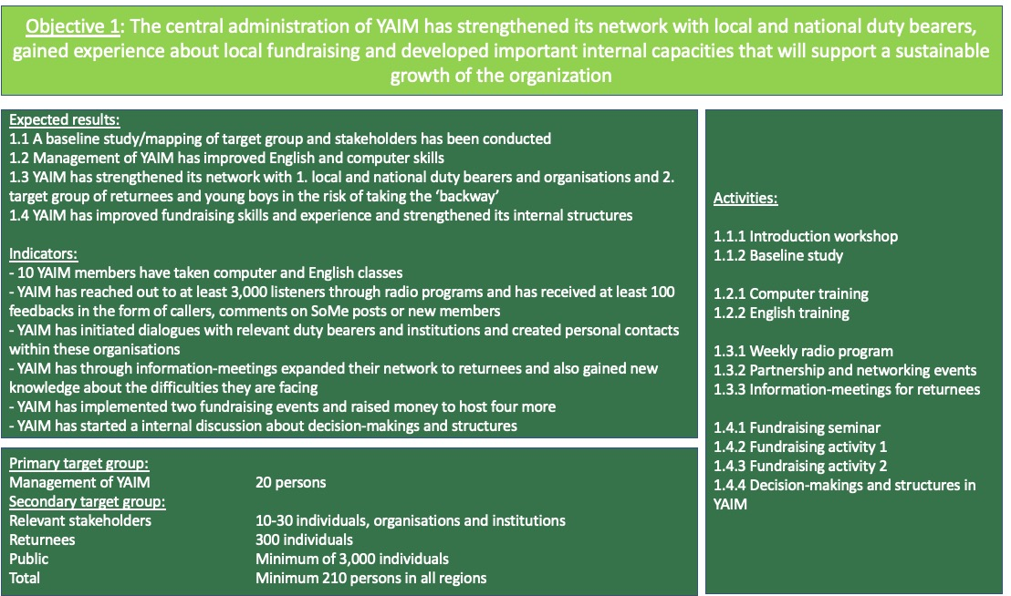
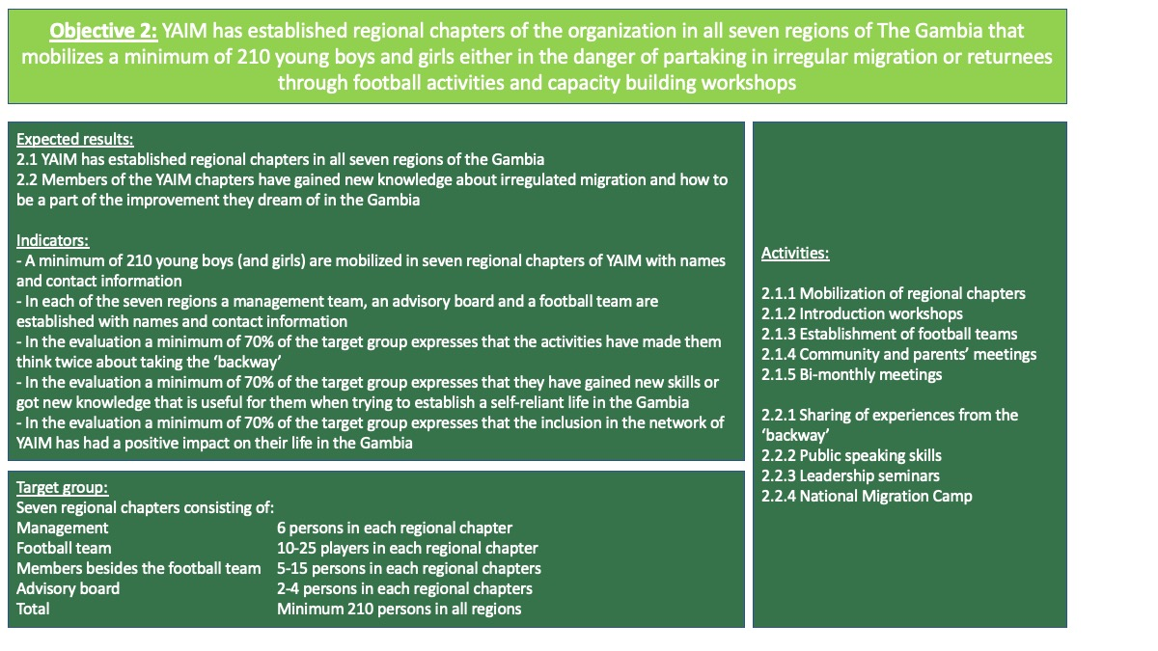

3.3 Strategy of intervention
The projects strategy is like the previous CISU-funded intervention inspired by the underlying Theory of Change (ToC), and the strategy has been developed in collaboration between FANT and YAIM. The two figures above map out the relation between objectives, expected results, indicators, activities and target groups. The overall aim is to pursue structural and long-lasting changes that will lead to improved conditions among young, marginalised boys and girls that dream about escaping poverty through irregulated migration. The strategy is through football teams, workshops, civil society organisation and advocacy to support them in participating and affecting local and national decision-making, so they become an active part of the change they dream of. This aim is facilitated by an intervention that seeks to change relationships between duty bearers and rights-holders in conflict over resources and opportunities to participate in decision-making processes. To challenge the relationship between those in power and those not in power, this project engages in empowerment of YAIM, returnees and the group of young men (and women) at risk of going for the ‘backway’. The activities are planned to challenge feelings, perceptions, behaviour and motivations of individuals, communities, organisations, duty bearers and government institutions. When doing so we interact at three different levels: the individual level (act. 1.2.1, 1.3.1, 2.2.1, 2.2.2, 2.2.3 and 2.2.4), the civil society level (1.3.2, 1.4.1, 1.4.2, 1.4.3, 2.1.1, 2.1.2, 2.1.3, 2.1.4, 2.1.5 and 2.2.4) and at national level (act. 1.3.1, 1.3.2 and 2.2.4).

Activity 2.2.4 National Migration Camp has an important role to play in the intervention as a whole. This specific activity can also – as the only one - be understood in relation to all the three levels explained above (individual, civil society and national) when aiming at
- Improving individual capacities among members regarding knowledge about irregulated migration
- Improving individual capacities among members regarding self-reliance opportunities and methods of challenging current structures of power
- Creating unity and understanding among the seven regional chapters and the members
- Providing YAIM with important experience about hosting national events
- Making media attention about irregulated migration and creating a voice for marginalised youth
The National migration camp will be the flagship of the intervention and kind of sum-up the whole intervention and making sure experiences are shared. The migration camp will run for a week and include several different activities like skills theoretical classes, political discussions, sharing of experiences from the ‘backway and football activities. Topics touched will be the root causes and risks of irregular migration, entrepreneurship and life skills, agriculture and value chain, voluntarism and team building, peace-building and conflict resolution, gender equality and gender-based violence. It will include campfires and storytelling, cultural night (drama and musical performances), interactive sessions with inspiring figures (national footballers, entrepreneurs, returnees, musicians, and politicians) and a closing ceremony with handing over of certificates and trophies. The expected outcome of the national migration camp is a strengthened membership of YAIM’s regional chapters as well as more resilient youths who will have learned more on crucial topics and benefitted from engaging in different kinds of activities.

3.3.1 Balancing the development triangle
Balancing strategic deliveries, capacity building and advocacy is an inherent part of the strategy, as the three elements are essential to the success of the project. Most of the activities in this intervention is connected to either capacity building or advocacy. What YAIM lacks in terms of organisational capacity they win in dedication and knowledge to the cause. The potential for YAIM to become a strong civil society player is massive but they need to build a strong foundation to expand from. Previous intervention and this intervention therefore has a strong intention of working in the capacity building corner of the triangle. In this intervention it is not only capacity building of the central YAIM organisation but also the seven regional chapters.

There are activities related to strategic deliveries like the establishment of football teams in the regions, but this is a part of the strategi of attracting, mobilising, and organising the target group at an eye-to-eye level. The football teams are important to create trust and unity among members – and to have something else than poverty and frustration to meet around. The football teams will help YAIM attract some young men that can be difficult to reach otherwise. It is an investment for this intervention to establish the football teams but when it is done it creates sustainability to the project because workshops, seminars, meetings and other activities will be held once in a while, our experience is that the football activities and the unity around the team will sustain itself naturally without needing too many inputs from outside.

Lastly, this intervention also includes activities related to the advocacy corner of development triangle with activities 1.3.1 Weekly radio programs, 1.3.2 Partnership and networking events and 2.2.4 National Migration Camp. YAIM has great experience and results from reaching the target group of youth but still needs experience in approaching duty bearers and governmental institutions. The weekly radio programs will continue to support YAIM in approaching the public and trying to create attention to irregulated migration. The partnership and networking events will support YAIM in reaching out to bigger scale organisations, institutions and duty bearers to create connections and dialog with those in power. Lastly, the national migration camp will allow YAIM to connect both the public and power holders when creating a platform for young, marginalised men to have a voice. Both media and duty bearers will be invited to the camp and because it’s the first time ever in the Gambia that something like this has been held it is expected to create a bit of an attention. The aspect of including football in the migration camp will add another layer to the potential curiosity from the public.

This project prioritizes a rights and evidence-based approach to advocacy. YAIM will support the seven new regional chapters in exploring their knowledge of human rights, absence/neglect of adhering to these rights by duty bearers and general thoughts/beliefs about the rights of migrants and youth. They will engage in discussions with the public in activity 1.3.1 Weekly radio programs and with institutions and duty bearers in activity 1.3.2 Partnership and networking events but also locally with relevant local duty bearers to understand the context regarding mindset, beliefs, knowledge and practises at activities 2.1.4 Community and parents’ meetings and 2.1.5 Bi-monthly meetings. The core foundation for engaging in advocacy work, is that the actors have knowledge of the specific challenge, its basic causes and possibilities for action. Therefore, most of the project activities seeks to empower, educate and capacity build YAIM and target group of young men.
3.3.2 Football as a strategy
It is the belief that the unity around football can be very effective when building the capacities of marginalised groups. If organised well, sport can help build up confidence among the target group but also create an atmosphere of trust and harmony that allow target groups to share beliefs and challenges that they otherwise carry inside themselves. The football teams will serve as a safe space for the target group; a space that supports them understanding issues they are facing daily and help them reflect upon sustainable safe solutions.

When you interact in sports together you create special ties, you are dependent on your teammates, and they are dependent on you. Sports is often used as team building methods for good reasons. The aim of this intervention is to put two different groups together as a team to ensure sharing of important information – or maybe you could also call it beliefs. The Returnees have important stories, experience, and knowledge to share to Risks why the target group is a combination of those two groups. Football will compliment meetings and workshops as a way of creating trust and unity among the two groups. The community around football in the Gambia will supposedly lead to young men having a place to share not only the game of football but also more serious subjects that can lead to improved living conditions for the group. When combining football activities with workshops/debates/education we have experienced how participants who do not know each other from beforehand will quickly build relations and trust among each other which is very useful when debating difficult and sensitive issues. Some young men will participate mostly because of the football activities but along the way find themselves debating about youth unemployment (for one example) and getting different perspectives on these issues which they did not expect for. Through the community of these football teams, they will hear new stories and getting to know people with motivation for being a part of the change in the Gambia instead of leaving.

It is important to point that these young men have lost hope for a life in the Gambia, that is why they end up going on the very dangerous ‘backway’. To make them believe that participating in the change process in the Gambia can actually be a solution will be the hardest part. In a combination of football, workshops and meetings Returnees seems to be an advantageous method that YAIM already has had good experiences with.

3.4 Sustainability and lasting improvements for target groups
The aim of the project is to support and kick-start a movement of sustainable change for young men in the Gambia. The capacity building of 210 individuals will ensure that they are in a stronger position than before, because they have gained new knowledge, skills and have become a part of a national network through YAIM. More, the strengthening of capacities of the civil society organisation YAIM and the seven regional chapters and starting a dialogue with governmental institutions and a public discussion are a part of the sustainability of the project. Most activities are set to capacity build either the YAIM or individuals, but the advocacy part is expected to reach not just relevant duty bearers but also a considerable number of people in the public. The intervention will challenge old beliefs about migration being the only and safest escape from poverty and seek to turn the dialogue around to how the youth of the Gambia can be integrated in society and bring value to communities and the country as a whole.

The results of this project will create long-lasting changes that will not end when the implementation period finishes. The newly gained knowledge about irregulated migration, leadership, fundraising, public spaeking, to advocacy and the practical experience, the forming and strengthening of a civil society organisation and the new regional network will be a constant factor supporting the involved. The target group have experienced to be a part of a team, to work together, have learned about discipline, and meet role models; competencies and experiences that they can benefit from for the rest of their lives. They have experienced how to get a voice, and hereby gained personal confidence and motivation for participating in decision-making and effecting essential obstacles that maintain people in poverty and exclude them from policymaking. When this 1,5-year project is finished the newly founded regional chapters, including the football teams, will continue the activities and hopefully be able to include even more people and make future plans for how they wish to develop. The strategy is to help the establishment of the regional chapters in the first difficult beginning and from there see how and if potential collaboration or future projects should be planned. Local ownership of the chapters and teams is a key stone in the strategy.

This project is developed on the concept of voluntarism which is also a part of ensuring sustainability because the core foundation is not built on a high amount of salary provided by FANT or CISU. There are salaries provided to the administration of YAIM to ensure the needed time and effort can be invested in the intervention. The activities related to support YAIM in engaging in local fundraising will also ensure that YAIM becomes stronger and more independent as they learn how to create funding from different places. One fundraising event will be a drama and poetry event whereas the other fundraising activity is planned to be a debate and quiz competition.

3.5 Risk analysis and mitigation strategies
It is important for project partners to account for the potential risks that can occur in this project intervention. The risks can potentially threaten the project and the planned activities, which is why YAIM and FANT in close collaboration have structured relevant sustainable strategies to mitigate these potential risks. The figure below outlines some of the potential risks that in a worst-case-scenario might hinder the fulfilment of the project objectives and our planned strategies for mitigating these risks. It is significant to mention that the risks listed below are tentative and further potential risks will be elaborated in activities 1.1.1 Introduction workshop and 2.1.2 Introduction workshops and during the project implementation.

Risk | Mitigation strategy
The geographical distance between YAIM and the regional chapters creates difficulties in monitoring and communicating | This risk has been discussed thoroughly between YAIM and FANT as it is one of the most obviously obstacles. Different actions in the intervention have been planned to mitigrate this risk whereas these can be mentioned:  - Improving English and computer skills among the secretariat of YAIM  - Creating transparent and similar structures in the regional chapters  - Hosting introduction workshops where this can be discussed  - Providing phones for selected positions in the regional chapters  - Providing motorbikes for YAIM to be able to move to the regional chapters  Despite the above actions already incorporated into the intervention following actions can be taken if YAIM is finding it difficult to monitor on the distance:  - Plan meetings to discuss difficulties  - Use network in the communities to get needed information  - Reach out to FANT for support and guidance
YAIM experiences opposition from bigger organisations and governmental institutions working with migration | As a part of activity 1.1.1 Introduction workshop, this risk will be elaborated on and discussed. It is important for YAIM to be aware of potential resistance towards them and come up with solutions to how to deal with it. Activity 1.3.2 Partnership and networking events will create a space for YAIM to connect with individuals from these organisations and institutions which is a good way to establish understandings instead of resistance.

3.6 Systematising experiences
YAIM will conduct a written report every second month about activities held, budget deviations and potential challenges and successes and a short evaluation of outputs. These reports will be used as a starting point for an online monitoring meeting between FANT and YAIM. It has been planned to conduct a midterm evaluation with participation of FANT DK as well as a final evaluation. The evaluation in the end, is also to ensure that important experiences are collected and shared among relevant stakeholders in the Gambia and Denmark.

YAIM will conduct bi-monthly meetings with the regional chapters (activity 2.1.5). The bi-monthly meetings will be designed to meet and address challenges, lessons, findings and how to twist their approaches in making an effective output for the target group. A WhatsApp group will be established to ensure that chapters are able to have an instant virtual communication among the big group. The combination of both the physical meetings and the virtual communication to discuss the above elements of their work will help also to collect some primary data for improvement on the go. The administration of YAIM will be working closely together and therefore share information every day and be able to set up meetings along the way dependent on needs. But every second month they need to produce the monitoring report to FANT and attend the following online meeting, which will also be a part of their systematizing of experiences and data. The process surrounding this intervention will hold many important learnings for all parties involved, and the complexity of the intervention will demand close monitoring and preparedness for making adjustments if and when relevant.

4. Intervention-related information work in Denmark
This intervention differs from some of FANTs other projects in Sierra Leone and Ghana because of its focus on migration. Migration is a subject discussed massively in Europe and we find it obvious to use the attention to get a voice in the migration discourse. The purpose of the information work is to paint a more diverse picture of migration and be the voice of the poor voiceless migrations from Africa. Migration is rooted in poverty and injustice power structures in the world. We need to understand the roots of the problems to be capable of solving them – the answer is not to build fences around Europe.

The target group of the information work is the followers on FANTs SoMe pages (Facebook, Instagram, LinkedIn, Twitter and TikTok) and guests that will visit FANTs homepage www.fant.dk. Through posts on social media and through an under page (with more in-debt material) at the homepage FANT will tell the personal stories of the YAIM members.

https://gambia.iom.int/
Hultin, Niklas, and Jallow, Baba and Lawrance, Benjamin N. and Sarr, Assan 2017 ‘Autocracy, Migration, and The Gambia’s ‘Unprecedented’ 2016 Election’, African Affairs, Vol. 116, No. 463, pp. 321-340
https://www.theglobaleconomy.com/Gambia/Youth_unemployment/
Youth Against Irregular Migration 2018 Report on Youth Against Irregular Migration (YAIM) Nationwide Awareness Raising Caravan 2018 in the North Bank Region (NBR) from 15-18 January, The Gambia.
https://openknowledge.worldbank.org/bitstream/handle/10986/5923/638450PUB0Exto00Box0361527B0PUBLIC0.pdf?sequence=1&isAllowed=y
MA Thesis “Someone to fear and someone to rescue”, Center of African Studies, Rebecca Bannor-Addae
MA Thesis “Someone to fear and someone to rescue”, Center of African Studies, Rebecca Bannor-Addae
The 7 regions in The Gambia are: Banjul City Council, West Coast Region, Lower River Region, North Bank Region, Central River Region and Upper River Region.

