Containing the spread of the COVID19 epidemic and safeguarding livelihoods of vulnerable groups in slum areas, Freetown, Sierra Leone

Supporting the Global Humanitarian Response Plan on
Strategic priority 1 and 2

June – November 2020
X Yes: reference no.: 17 83 OC Financial ceiling: above 200.000 DKK
No – if no, an OCA application must be submitted together with the intervention application.
Has your organization prequalified for DERF funding?
Do you plan to submit more than two applications under this call? | X No
Index
1. The humanitarian intervention 1
2. The implementing organization 6
3. Local strengthening 7
4. M&E, learning and accountability 7
5. Coordination 8

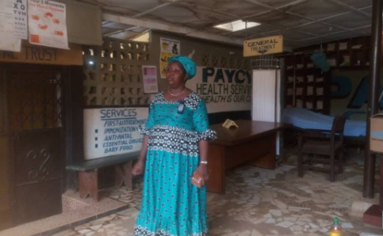
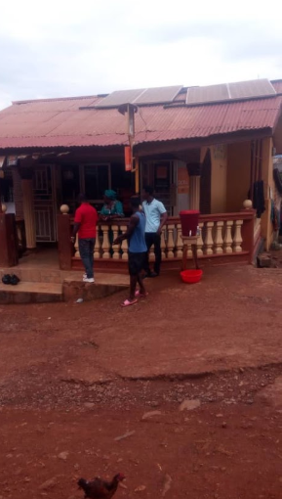

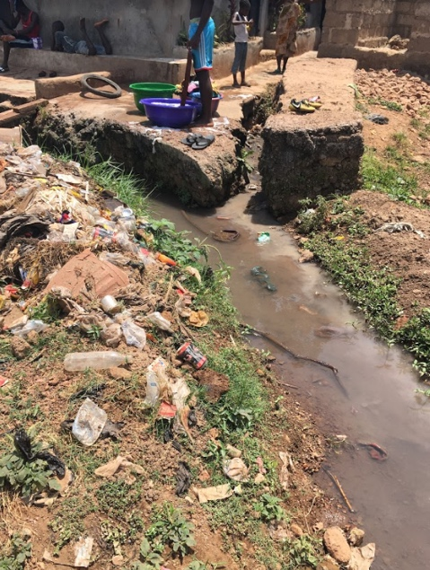

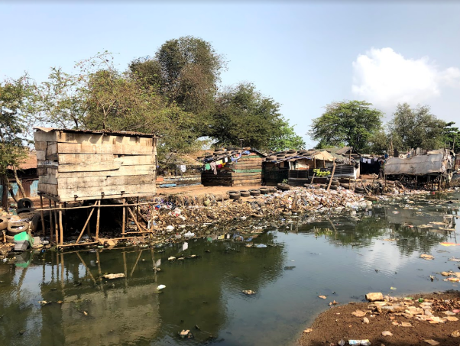

The humanitarian intervention

What is the overall purpose, including the objectives, activities, expected results and indicators to be applied? Engineers Without Borders (EWB-DK) in partnership with World Hope International Sierra Leone (WHI-SL) propose to implement community based social interventions to decrease impact of the COVID19 and to prevent further spread of COVID-19 in particular vulnerable populations in slum areas in the capital Freetown through improved hygiene and access to safe community water supply combined with community awareness on preventive measures. The intervention is aligned with the Global Humanitarian Response plan (updated May) will focus on strategic objective 1 Contain the spread of the COVID-19 pandemic and decrease morbidity and mortality and strategic objective 2 Decrease the deterioration of human assets and rights, social cohesion, food security and livelihoods “ hence the intervention is a combination of DERF modalities early action and lifesaving interventions. The intervention will seek to support the local health service through improved hygiene at health facilities, secure medical service and referral and awareness raising on COVID as preventive measures. The intervention will also provide food distribution to vulnerable people in the targeted communities – classification of vulnerable people is also aligned with the GHRP.

Current situation is (26. May) is 735 confirmed cases, 42 deaths. According to GHRP Country and regional plan – New Plan (Sierra Leone) the priorities are public health as in sufficient capacity to secure preparedness and focusing on to limit human-to-human transmission; identify and reduce transmission from animal sources, communicate critical risk and minimize socio-economic impacts of the pandemic. Current challenges are: capacity and equipment gaps in the health system, needed to engage the public for surveillance and other activities, lack of personal protective equipment for health workers and overall to maintain key social and health services, including sexual and reproductive health, gender-based violence support, and education. Food distribution systems is according to the national plan also a severe need due high level of poverty and vulnerability of large groups of the population. Social protection measures that support basic needs, particularly those in the informal sector and agriculture should be adapted for rapid expansion. After the devastating and deadly mudslides in 2017 in Freetown EWB-DK and WHI-SL have jointly implemented a disaster WASH intervention in the same locations as is targeted in this intervention. Hence valuable information of the level of the various dimensions of vulnerability, WASH issues and also community and authority contacts has already been established. The partners are also implementing a climate adaption project in Kaningo and Potter providing for a slid understanding of context and communities in focus.

Objectives of the intervention:
Immediate objectives

- Prevention of community spread of COVID – through referral of COVID19 cases, improved hygiene (access to safe community water supply, community awareness on hygiene, and improved WASH hygiene at two health centres in of Kaningo and Potter communities - both in the surrounding slum areas Freetown region) – supporting GHRP strategic objective 1.1, 1.2 and 1.4.
- Safeguarding livelihoods and decrease impact of the COVID19 through the roll-out of community-based programming to provide social support services at the household-level to vulnerable families - supporting GHRP strategic objective 2.1, 2.2 and 2.4

Expected Results: The project timeframe is six months. By the end of the implementation period, the partners (EWB- DK and WHI-SL) expect to have contributed to the global response on COVID through a reduction in COVID19 cases (and other infectious diseases) linked to poor hygiene and lack of access to safe WASH facilities/water supply under objective 1. Have improved hygiene at family level and in the two health points while mitigate or prevent the spread of the virus within two vulnerable communities in the Slums of Freetown, Sierra Leone also under objective 1. It is also expected that the impact of lock downs and quarantine have been mitigated for the most vulnerable families in the two communities through distribution of food supply (e.g. female headed households, people living with disability, elders, pregnant women, those living with TB or HIV, etc.). Other vulnerable group targeted in present intervention is the patients at two community health facilities supporting the efforts under objective 2.

Key activities include:
Immediate Objective 1.
- Communicate updates on COVID-19 prevention and control through community mobilization, radio programs, jingles, and printed material (1.1)
- Establish new water sources/repair water points at health facilities, including latrines, plumbing, and waste management facilities (1.1)
- Equip Community Health Workers (CHWs) with supplies and training to identify, report, contract trace, and refer potential COVID-19 cases to the health facility and conduct community awareness sessions (1.2)
- Install/secure procedures to treat other diseases and to provide essential services, such as for sexual and reproductive health, are adapted to minimize the potential exposure of patients and other service users. This includes distribution of personal protective equipment, and increased water supply, sanitation and waste management (1.4)

Immediate Objective 2.
- Provision of food, clean water, consumables (e.g. gloves, masks, etc.), and psychological first aid for households identified as vulnerable and/or in quarantine (2.1)
- Establish handwashing stations (veronica buckets and soaps), temperature checks using infrared thermometers, and a supply of bleach for each community checkpoint (2.2)
- Rapidly asses water points in targeted communities with water quality and pumping tests (2.2)
- Establish new water sources/repair water points at the community level (2.2)
- Training of the trainers (for the CHW workforce) to provided psychosocial first aid and support for individuals impacted by COVID-19 (priority to full application of the child protection policy) (2.3)

Indicators
Immediate Objective 1.
90 % of community successful referrals
90 % of households prioritizing social distancing, handwashing, disinfecting with bleach
50 % of households with masks
100% of community health workers trained in community surveillance and contact tracing
100% of health workers trained in PFA
Immediate Objective 2.
100 % of the targeted population people most vulnerable to COVID-19 have received livelihood support through food distribution
100% of the targeted population in the two communities (29.550 persons) have access to safe, functional and non-infected essential services assistance (safe clean water)
100% of responders in targeted communities trained in child protection policy

How does your selected response consider the specific context within which you plan to implement an intervention? Sierra Leone and its health system was significantly damaged by the Ebola Outbreak in 2014-15. Though there has been an increase in investments post-Ebola to strengthen the health system, health facilities in Sierra Leone are still understaffed, under-resourced, and often without a regular supply of running water or power leaving healthcare workers and their patients highly susceptible to contracting and spreading COVID-19. Additionally, as learned from the Ebola-response, local and community-appropriate messaging on proper health hygiene is key to prevent any mistrust between the community and the health facilities, and to mitigate the spread and any misinformation on COVID-19. Therefore, at the relatively early stage of the COVID-19 outbreak in Sierra Leone, it is crucial to provide prevention measures based on lessons learned from Ebola (CHS 1, 2). WHI-SL, with a history of implementing health and WASH programming in Sierra Leone will work within the guidelines of the Ministry of Health and Sanitation (MoHS) Standards and Guidelines on WASH in Health Facilities in Sierra Leone when determining the design and scope of activities with sign-off by MoHS and local governing staff. Lastly, the WHI-SL team have led response to multiple humanitarian crises. WHI-SL is well equipped to implement and coordinate actions that is appropriate for the context and is ethical based on standard humanitarian principles and lessons learned from previous humanitarian interventions. Interventions developed in the partnership with EWB-DK has a strong community based focus and actively involves CBOs particular youth groups as seen in joint emergency WASH intervention in the aftermath of the mudslides and flooding in Freetown in 2017 and also in current joint climate adaptation project. Both initiatives were and are working in the communities targeted in present intervention. WHI-SL is well positioned to work with key local stakeholders as the CBOs, the community health workers and the management of the health facilities as working relationship on health are dating back to activities during the Ebola outbreak. With the particular working knowledge at community level the identification of particular vulnerable families ((e.g. female headed households, people living with disability, elders, pregnant women, those living with TB or HIV, etc.) is ensured. All activities rests on a strong local involvement to secure feedback and communication from the beneficiaries in order to redirect or adapt interventions if needed (CHS 9)

How does your selected response consider the strategic priorities and the immediate objectives of the COVID19 Global Humanitarian Response Plan (GHRP)?
Present intervention addresses the two main strategic priorities in the global GHRP plan (1 &2): To contain the spread of the COVID19 epidemic through improved hygiene at community level but in particular at critical infrastructure as health facilities which at present moment are operating under deplorable hygiene level (no safe water and run-down latrines). It is envisioned that the pressure and intake of patients will increase due to the particular general poor health status of the population in slum areas. The other focus area is to decrease the deterioration of livelihood through basic socials service as provision of community WASH facility and food distribution (the late to be provided to the most vulnerable families in Kaningo and Pottor.
Is this intervention appropriate and relevant (CHS 1) High rate of communicable diseases, malnutrition, and other health conditions characterises the population targeted in this intervention hence they are particular more vulnerable to a COVID-19 related mortality. The population density and the lack of ability to socially distance due to socioeconomic factors is also contributing to the particular vulnerable situation. Therefore, making local based health facilities a critical site of intervention to prevent the spread of the virus and to protect the vulnerable population already receiving healthcare services at these facilities for other illnesses or conditions is imperative. The bulk of the activities will be focused on prevention, while also equipping health facilities with the WASH facilities to prevent the spread of COVID-19 along with other infectious diseases. Community-level interventions and facility-based interventions will be conducted with a clear referral pathway between them to ensure linkage to care and social service for the most vulnerable groups within the community. Furthermore, the additional social support in the form of meals and clean water (along with the other consumables) will be provided to any contact and suspected cases that are in quarantine prioritizing e.g. pregnant women, those living with TB or HIV, etc. All confirmed cases will be reported to the MoHS and transferred to designated facility managed by the MoHS.

Effective and timely response (CHS 2) The CHW will be quickly trained on COVID-19 identifiers and provided the appropriate consumables to stay safe. A design for masks has already been developed and tested using fabric, mouldable steel wire, and rubber straps with ongoing conversations with another EWB-DK partner in Sierra Leone to produce them locally. CHWs are members of the communities they serve and will likely already have relationships with any particular vulnerable household. Additionally, within the households they serve, they will already know who is particularly vulnerable (e.g. pregnant women, those living with TB or HIV, etc.) and will immediately be able to provide assistance and support with linking the particular patient into care as required.

Resources management - effective, efficient and ethical (CHS 9)? WHI-SL’s close proximity to the implementation and direct participation on ground will secure responsible management and use of resources. The close coordination with other strategic actors at local and state level will also facilitate adjustments to secure appropriate use and relevant actions.

Besides the targeted social service to be provided to particular vulnerable families, the staff and patients at health facilities are especially vulnerable to COVID-19. There is a particular risk of transmission due to lack of WASH facilities, especially when it comes to latrines and proper waste management. The two intervention sites were chosen due to the particular vulnerability of the community, the lack of WASH facilities, and is located in the surrounding community of Freetown (the most populated slum area of country, making it especially vulnerable to COVID-19). The patients seeking treatment at the two health facilities does not due to their economic situation have other choice of care provision of safe wash facility will reduce their risk of contagion the COVID19 during care significantly.

The interventions outlined are based on the Core Humanitarian Standard principles to be coordinated (CHS 6) and structured in a way that is based on local needs and strengthens local capacity (CHS 3, 4). WHI-SL has an established relationship with the MoHS and the local governing bodies. WHI-SL and EWB-DK is currently working in the targeted area with activities on climate adaption hence a strong tie exist with community level leaders and also a community base volunteer groups which secures the interventions ability to address needs of assistance with urgency. Channels of communication already exists along with the trust and confidante of delivery towards the implementing organisation. Currently the staff operates at a daily basis in the communities. WHI-SL well informed of the context and needs on the ground and the current conversations ongoing among the various ministries under the Government of Sierra Leone, UN and donor agencies, and other implementing partners – therefore is well-placed to work with EWB-DK to support the Danish Emergency efforts in developing capacity for service delivery, particularly in vulnerable communities like Kaningo and Potter. WHI-SL’s close proximity to the implementation and direct participation on ground will secure responsibly management and use of resources. The close coordination with other strategic actors at local and state level will also facilitate adjustments so as to secure appropriate use and relevant actions.

How you will start your activities within 7 days of the Danish CSO receiving the first transfer? The assessment of the health facilities in Freetown and the surrounding communities have already been completed, which has enabled the partners to identify the targeted health facilities and begin the more technical work rapidly. With staff already in place, geophysical surveys using vertical electrical soundings can be conducted immediately. Procurement for WASH construction and rehabilitation can be done within one week. Due to WHI-SL’s work in the area mobilization of CHWs and health facility staff can initiate immediately and enable the project team to quickly mobilize training activities.
Planned target population (direct target group only)
 | Female (by age) |  |  | Male (by age) |  |  |  | Total
Type of Activity | Under | Between | Over | Under | Between | Over
 | 18 | 18-50 | 50 | 18 | 18-50 | 50
Provision of food, clean water, and consumables | 70 | 200 | 100 | 60 | 180 | 120 | 730
Referral of COVID19 and other health related cases (patients in the health facilities) | 500 | 1000 | 500 | 500 | 1000 | 500 | 4000
Beneficiaries of access to clean water and improved sanitation/WASH (community and health facilities) | 3200 | 9500 | 2300 | 3150 | 9000 | 2400 | 29550
Equip Community Health Workers (CHWs) with supplies |  | 22 |  |  | 16 |  | 38
Training CHWs to conduct community awareness sessions and identify, report, contact trace, and refer |  | 22 |  |  | 16 |  | 38
Training of trainers on psychosocial first aid (PFA) |  | 20 |  |  | 10 |  | 30
Support training of frontline healthcare workers in PFA |  | 60 |  |  | 80 |  | 150
Establish handwashing stations (veronica buckets and soaps), temperature checks using infrared thermometers, and a supply of bleach for each community checkpoint | 3200 | 9500 | 2300 | 3150 | 9000 | 2400 | 29550
Establish new water sources/repair water points at the community level | 3200 | 9500 | 2300 | 3150 | 9000 | 2400 | 29550
Provide personal protective equipment (PPE) and other consumables for healthcare workers |  | 20 |  |  | 15 |  | 35
Total:
Total adjusted for double counting*: | 3200 | 9602 | 2300 | 3150 | 9106 | 2400 | 29758
Total vulnerable persons of the above | 570 | 1200 | 600 | 560 | 1180 | 620 | 4730

How do you calculate the number of people who shall be assisted through the various activities?
The average household in Sierra Leone comprises of 7 to 10 people, the partners estimate approximately 100 households (700 – 1000 persons) are estimated to require additional support and/or put into quarantine. The total population of the two intervention sites is 29.758.

Which particularly vulnerable groups are you specifically targeting amongst the crisis-affected population? Present intervention will specifically target the community members using the health facilities and particular vulnerable persons (e.g. female-headed households, people living with disability, elders, pregnant women, those living with TB or HIV, etc.). As particular exposed group patients in the facilities and the health care workers and community mobilizers to engage with the population is also targeted. During the Ebola crisis, it became evident how vulnerable community healthcare were, hence protection and training is essential to protect the few human resources available in the health care system. A general awareness campaign will target the general population in the communities and protective measures will be implemented. The two health care facilities (Kaningo and Pottor) are the center of action in the intervention. The identification of the specific person/families to include in the food distribution will be determined between the health local care workers, the Ward (administrative representative from community towards the local government) and the project mobilizer of WHI-SL due to their specific local knowledge on the particular vulnerable persons.

Source of goods: Briefly explain how you plan to source your goods and tick the boxes that apply.
- Internationally
- Regionally / neighbouring country /
- X In country / locally

Does the intervention include cash-based programming? No
Financial localization of the intervention
% of DERF intervention funding which is spent by local or national partner CSOs, from the intervention budget: 89 %
% Funding spent on activities & goods for crisis affected persons, from the intervention budget: 72 %

The implementing organization
What is the capacity, experience and expertise of the proposed partner organisation(s) (CHS 8) undertaking the proposed intervention substantiating whether the Early Action can be delivered up to standard and to the needs of particularly vulnerable persons? EWB-DK and WHI-SL have since 2017 worked with emergency response on WASH and climate adaption in the specific area of intervention, see annex I. map of the area of intervention. Both organisations have an extensive experience in WASH and health related interventions with particular vulnerable populations as in present intervention. EWB-DK has been working with various partners in WASH since 2009 in Sierra Leone. During present COVIC19 crisis knowledge and local knowhow on artisan mask production has been shared between EWB-DK’s partners.
Since 1997 WASH combined with a strong poverty focus has been a key pillar of WHI-SL’s work. WHI-SL has more than 100 local staff. Wells at health facilities meet the UNICEF standards, with training integrated into both health facility and community-level WASH programming. During the Ebola outbreak, WHI-SL provided borehole water wells and sanitation facilities for the Ebola treatment centres, this including gravity tower-tank systems and minor and major WASH upgrades at government and mission health facilities to promote IPC measures. In a recent evaluation of WHI-SL wells, WHI-SL found that 97% of their previously drilled wells provided a year-round supply of clean water to the community or health facility.
At the community level, WHI-SL is committed to providing the resources and training to the communities for them to be able to not only have access to clean water and sanitation facilities, but to be able to maintain them. WHI-SL trains local water committees at the community level to ensure that water points are well maintained, this will also be done for this proposed humanitarian intervention. The partners ability to access the people at risk rests on the use of trusted source of information (the CHWs) to communicate information on COVID-19 prevention with a focus on vulnerable people in their communities while health facilities and water points are constructed/repaired. As WHI-SL already has a well stablished relation to community leaders, volunteer groups and a working relationship with the staff at the health facilities it is expected that access to the people at risk is properly secured and genuine. As WHI-SL already on earlier occasions has provided emergency assistance to the two communities the knowledge af needs is high in particular with respect to health related and communicable disease risks. WHI-SL as a recognized partner in Sierra Leone and in the two implementation sites, meaning WHI-SL will be able to get sign-off and begin activities rapidly and deliver the humanitarian interventions with support from the local governing bodies.

Is the Danish CSO proposing to self-implement? No
Partnership:
EWB-DK and WHI-SL have thus so far implemented several joint project in Freetown and in Kenema district. All project is managed in the frame of a project agreement. Present initiative rests on a strong working relationship and joint experience in emergency interventions. Each project is based on a project agreement containing a part on the partnership (the core content and values of the partnership) and the specifics on the project.
Roles and responsibility
EWB-DK: Is responsible for transferring funds to WHI-SL and liaison with donors, responsible for overall monitoring spending and activities carried in the intervention, must provide input and participate in midterm/end evaluation and inspection of the intervention, EWB-DK will secure relevant and qualified staff/volunteers to support the intervention.
WHI-SL: Is implementing local partner, responsible for carrying out activities on the ground as described in the application, local financial management in accordance with budget, monitor/asses intervention and propose adjustments and changes according to local needs, facilitate and secure liaison and communication with strategic actors in the project at local / and national level, including the handling of any claims and problems arising during intervention (in close coordination with community Wars persen and local Government), facilitate inception/midterm and end evaluation.

Local strengthening
How does the intervention strengthen local capacities and avoid negative effects (CHS 3)? Partnership with Government of Sierra Leone and local governing bodies (e.g. District Health Teams, City Council, etc.) are critical in the sustainability of the project. Training will be integrated at each key stage of intervention to ensure that local facility staff and the community health workforce are trained on maintaining the WASH facilities and equipment so that water sources remain clean and active, and are equipped with the information and consumables to stay safe while providing key COVID-19 prevention messaging and services. Before and during construction WHI-SL will work in partnership with the local leadership, including the Water Management. The catchment communities will benefit from community hygiene messaging that will not only prevent the spread of COVID-19, but other illnesses linked to limited WASH capacity and poor hygiene practices such as cholera, diarrheal diseases (one of the top causes for under-five mortality in Sierra Leone), and typhoid. Masks will be made locally, with a particular focus on providing sources of income for women working in the informal sector.

How are the local actors including the target group informed and involved (CHS 4)? With a long time working relation with the targeted population, WHI-SL has a solid knowledge of the local context and it has continued to develop and deepen the relationship across the various changes in Sierra Leone governmental administration at municipality and national governmental levels. The existing collaboration with the community Ward person is essential to secure proper communication with the involved communities, as the Ward person works on a daily basis in the communities overseeing and supporting social and development issues. The specific communication on the intervention will have as point of departure the two health care facilities from which all relevant information will be communicated towards the local population and community leaders (formal as informal).
As a result of the concentrated and country-wide efforts, WHI-SL well informed of the context and needs on the ground and the current conversations ongoing among the various ministries under the Government of Sierra Leone, UN and donor agencies, and other implementing partners – therefore is well-placed to work with EWB-DK to support the Danish Emergency efforts in developing capacity for service delivery, particularly in vulnerable communities like Kaningo and Potter.

How have you applied a no regret approach ensuring that the intervention will be beneficial for the target group in the unexpected event that the anticipated crisis in the “on watch country” does not arise? As the target, population is currently suffering from access to income and food due to the lock downs applied on an ongoing basis by the national government, social service/food distribution will be of significant value in the coming months. The lack of income placed them in a particular vulnerable situation which the distribution of food supply will mitigated significantly. The improved hygiene at community level due to access to clean water and information campaign is due to the already precarious situation of a significant value for the target population. Intensified focus on referral of health related cases will also improve the general health situation of the vulnerable population in the target areas and will be important even if the spread / impact of COVID19 is limited.

M&E, learning and accountability
How are risk management systems applied in the appropriate context? A special focus will be given to the training and management of the health posts as it is envisioned that a significant number of people will visit the facilities due to COVID19. Hence provision of safety gear, such as gloves, and training forms part of the intervention along with community based information.

How do the implementing partners apply monitoring, feedback and accountability systems (CHS 5), including a complaint mechanism that works in the specific context? Local CBOs and strategic partners and direct beneficiaries will play an active and integral role in monitoring the effectiveness of the project with communities providing a role in validating the results of the end line review. During the intervention, the project team will facilitate community stakeholder review meetings (at CBO level - small groups) in order to secure input and feedback from local beneficiaries. The two health posts involved will be fitted with information and contact information on WHI-SL office in order to facilitate a direct and more anonymous contact if needed. Due to the close working relationship between partner and community based groups and leaders claims will be handled in jointly and mitigating measures will be developed if needs arises. In case of disputes which cannot be settled or if anonymity is required the case will be referred to administrative and management level at WHI-SL which in consultation with community WARD (representative of local government) will seek to address the problems/issues. As the two health care facilities are the center of action in the intervention sign posts will be placed informing of the intervention and contact details of the Ward persona and WHI-SL project manager.
At present EWB-DK and partner WHI-SL has generated a standard working mode with online meetings and bi-weekly project reviews – often with participation of a CBO representatives. This approach will be applied in the present initiative depending on the restrictions of movement for the CBS representatives.

How will learning and reflection be applied in terms of improving humanitarian action (CHS 7)?
The implementing team will use a three-pronged approach to make sure learnings are applied to improving humanitarian action: 1) Support local governance structure to develop, oversee, and monitoring initiatives to improve community-led management service delivery with results and lessons learned shared at the national level to inform future WASH humanitarian action; 2) Promote appropriate community-led management seeking behaviour and aid the delivery of quality preventative and early warning interventions that can be used and modified for any future humanitarian action; 3) Improve the supporting framework that allows for community-led advocacy, targeting vulnerable communities to increase their risk resilience and behaviour with the goal of these communities to be more equipped (e.g. less vulnerable) in any potential future outbreak.

Coordination
Is the implementing organisation(s) involved in a coordination mechanism? Yes - WHI-SL will be the main implementing partner in Sierra. With WHI-SL’s long history in Sierra Leone working in partnership with the government and UN agencies, WHI-SL will also be involved in the Freetown WASH Coordination group and other new and existing coordinating mechanisms linked to WASH activity and COVID-19 response. WHI-SL’s office in Freetown will be the main centre of operations, with WHI-SL staff providing logistic support for the EWB-DK support team. WHI-SL also works across sectors implementing health, education, anti-trafficking, and agriculture/social enterprise initiatives and is actively engaged with their corresponding technical working group. Currently, WHI-SL is a member and represented in the following technical working groups: WASH, Food and Nutrition, Malaria, Social Welfare/Anti Trafficking, and the CHW working group. WHI-SL also sits in the Health Sector Steering Group (HSSG), the highest level of coordination in the MOHS.

How does the intervention contribute towards coordination and complementarity of humanitarian assistance (CHS 6)? WHI-SL has responded to previous humanitarian emergencies such as the Ebola-response efforts and the flooding and mudslides in 2017 and regularly receives large donations of medical supplies, which is then distributed in partnership with the MoHS and local District Health Teams to health facilities across the country. Therefore, WHI-SL is considered a trusted partner, both in development and humanitarian response programming in Sierra Leone. To maintain this relationship and to ensure effective coordination, humanitarian assistance efforts will continue to be done in alignment with government response protocols, with WHI-SL staff dedicated to playing an active and engaged role in the any coordination efforts in response to COVID-19. WHI-SL participates in psychosocial pillar, clinical management and social mobilization pillars. These pillars meet regularly to share information and develop materials for COVID-19 response. WHI-SL is represented at district level in Bombali and at national level in the capital city, Freetown.

https://www.unocha.org/sites/unocha/files/GHRP-COVID19_May_Update.pdf
https://reliefweb.int/sites/reliefweb.int/files/resources/GHRP-COVID19_MayUpdate_Annexes.pdf
https://iug.dk/en/maskeproduktion

