**THE CIVIL SOCIETY FUND**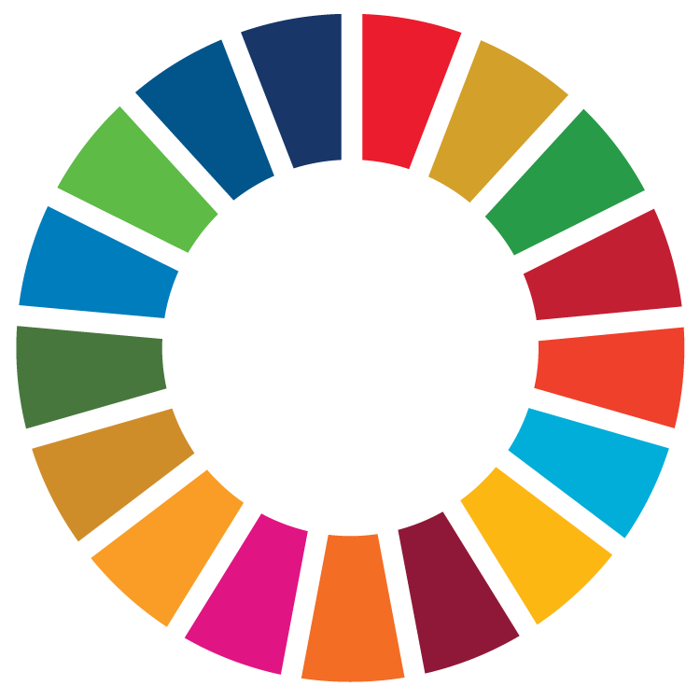

**CITIZEN PARTICIPATION INTERVENTIONS**

**Sierra Leone Institution of Engineer’s contribution to engineering a sustainable future in Sierra Leone:** Partnership to strengthen S.L.I.E.’s work on sustainable development according to the UN’s Sustainable Development Goals

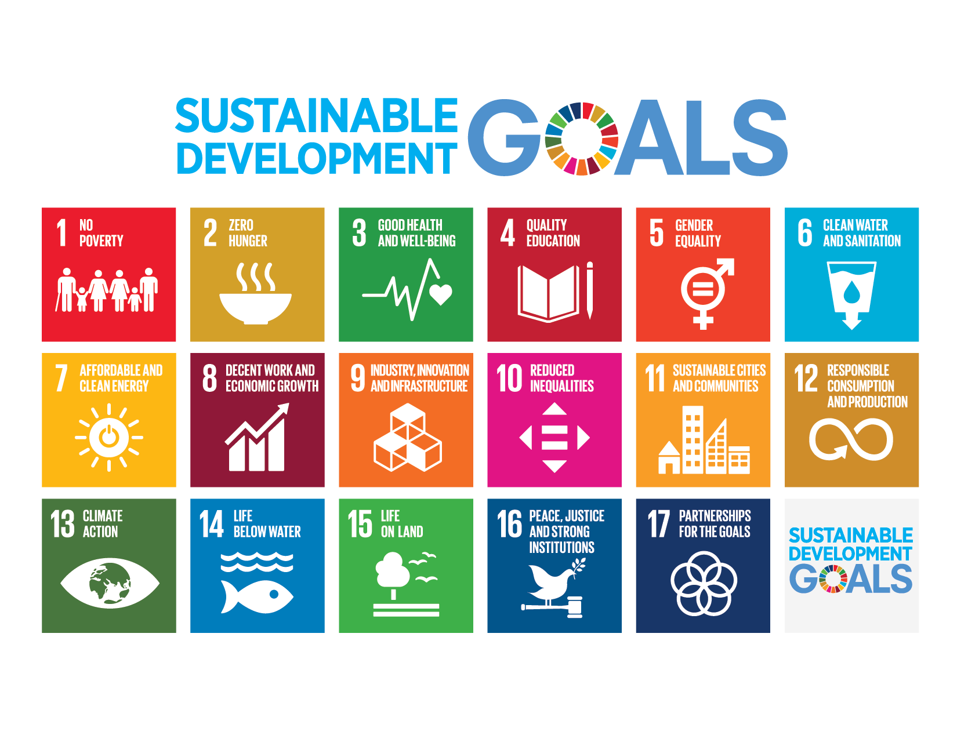

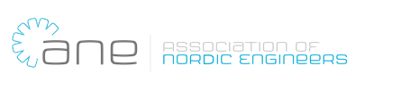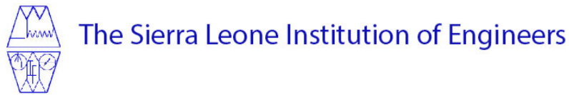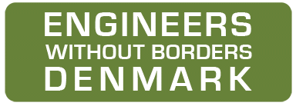

**List of content**

1. Objective and relevance (the world around us) 1

1.1 Purpose and challenges to be addressed 2

1.2 The context of the intervention 3

1.3 Strengthen of civil society organising 3

2. Partnership/partners (our starting point) 4

2.1 Experiences, capacities, and resources of the partners 4

2.2 Partnership 5

2.3 Roles and responsibilities of the partners (in present initiative and beyond) 6

2.4 Strengthening the relationship and cooperation 6

3. Description of the intervention Target groups, objectives, and expected results (our intervention) 7

3.1. Target group and how they will participate and benefit 7

3.2 Objectives and expected results 7

3.3 Strategies, outputs and activities of the intervention 8

3.3.1 Strategies 8

3.3.2 Output and activities 9

3.3.3 Risk analysis 10

3.3.4 Time schedule 11

4. Systematisation of experiences 11

5. Intervention-related information work in Denmark 11

6. Supplementary financing 11

# Objective and relevance (the world around us)

## 1.1 Purpose and challenges to be addressed

To eradicate extreme poverty and inequality, promote economic growth and prosperity, to create robust communities in face of the effects of climate changes, to improve health and education and protect the planet engineers play an important role in making this happen. In the developing world it is often basic social infrastructures as water supply, health installations, schools and other social infrastructures which are the central elements in social development. Achieving these targets in Sierra Leone, one of Africa’s poorest countries, will need integrated engineering solutions that provide resilient infrastructure, but it will also call upon the engineers sector to be a vigilant and active part of the civil society to promote an efficient use of the funds invested in Sierra Leone’s development and to raise the issues of quality and transparency in public infrastructure investments. Present initiative constitutes a unique opportunity to share from the platform of the Association of Nordic Engineers (ANE) it’s many years of experience in advocating for green development, inclusive labour markets, youth employment and many more areas forming national political agendas as part of civil society with the engineers in Sierra Leone. Sierra Leone Institution of Engineers (S.L.I.E.) was established 1970 and is the sole association representing the engineers in Sierra Leone. Despite their lack of means and resources they have positioned themselves as an influential civil society sector promoting the above-mentioned goals, hence the potential for a fruitful partnership is at place.

The partnership between ANE, S.L.I.E. and Engineers Without Borders Denmark (EWB-DK) was sealed during a 3-day experience-sharing workshop in Freetown in August 2019. The discussions included sharing experiences working with the SDGs and a SWOT analysis, which clearly revealed that S.L.I.E. is in a unique position to advocate for and draw the required attention to the technical solutions and skills needed to promote sustainable development in the frame of the SDGs, but also central issues as promotion of an inclusive labour market (gender issues) and youth employment. As a government recognised institution S.L.I.E. is well positioned and has institutional legitimacy as representative for its sector. It is visible for most relevant stakeholders in Sierra Leone and it has recently increased its active participation in government boards and committees. With very limited resources and not least due to a large voluntary engagement, the organisation has managed to deliver relevant services to its members as well as to the public. However, S.L.I.E. and the engineering profession as such face a number of challenges, not least as employment opportunities for engineers in Sierra Leone, particular for women and youth, are limited. At the present S.L.I.E. does not have the required management and administrative capacity to advocate for and represent its members and to advocate for a sustainable approach to the country’s development. Present initiative will address internal organisational development towards more membership involvement/democracy, however the initiative will also launch incipient initiative in relation to S.L.I.E as advocate for gender and youth inclusion in the labour market, decent pay and transparency in the use of public SDG investment.

Based on EWB-DK’s strong presence and longstanding experience in Sierra Leone, the tree partners are pursuing a long-term peer-to-peer relationship based on sharing of knowledge on strategic, policy, technical and organisational issues. The aim for the partnership is to strengthen S.L.I.E.’s ability to influence national policies, enhance its attractiveness towards its members (and potential) and also strengthen organisational structures towards transparency, democratic leadership, representation and advocacy even further, but also to demonstrate sustainable development initiatives in practice.

Sierra Leone has during the last years both from international[1] and national sources[2] identified and condemned a shrinking space for civil society advocacy and activism, hence present initiative is situated in a context where it is more important than ever to defend and extend the platform civil society operates on, and its dimensions of influence. Numerous organisations have witnessed that when raising concerns on governance issues, organisations representing civil society have increasingly experienced threats and violence form government and police.

## 1.2 The context of the intervention

Sierra Leone is a post-conflict and fragile country in Western Africa of roughly 72,000 square kilometres and with about 7.5 million inhabitants, still struggling to rebuild itself after the end of 11 years of civil war in 2002, and the more recent Ebola epidemic of 2015. The country is also increasingly suffering from the effects of climate change and environmental degradation, which in particular impacts the livelihood of the poorest segments of the population. Much work in terms of reconciliation, reconstruction and rehabilitation has been done with international support, albeit inadequately, and much focus remains on the reestablishment of public service delivery and reforming and strengthening governance systems. It is estimated that about 60% of the population live under the poverty line, and 97% of the rural population do not have access to electricity[3]. In general, economic recovery has been slow, basic infrastructure is still scarce across the country’s rural areas and meeting the UN Sustainable Development Goals is a major challenge for Sierra Leone.

Many civil society organisations are working in Sierra Leone with basic social service as education, health etc. Such NGOs based in Sierra Leone are contributing to improving living conditions and to development of the country. However, their resources are scarce and in general, civil society organisations lack influence on national development strategies.

The engineering sector has an important role in development of nearly all sectors of the society, as seen in the Nordic countries and many other countries, not least in relation to the SDGs, as they are largely both technical and humanitarian. Hence, the sector must not only have the relevant technical competence and capacity, it must also have communication skills as well as skills in networking and advocacy in order to take its place as an important civil society actor. The sector is an important contributor to the definition of priorities end development plans in societies in general, and examples from the Nordic countries include the strong focus on green technology, STEM (Science, Technology, Engineering and Mathematics) and women in engineering. The organisations advocated and supported implementation of these themes in relation to the education systems based on the overall structural needs with respect to the workforce composition in the future. The same discussion is a rising theme in many developing countries, including Sierra Leone.

## 1.3 Strengthen of civil society organising

In the Nordic context both EWB-DK and ANE largely rely on volunteering and engagement from its members, hence present initiative rest on a strong civil society engagement from the Nordic countries. Communication on the project’s goals and results will raise awareness of international development issues in a membership base of 500.000+ of ANE’s members in Scandinavia. Voluntarism and civil society engagement in Sierra Leone are ensured as the project will be implemented through a participatory and inclusive membership approach. S.L.I.E.’s members are invited (for the first time) to participate directly and democratically in the formulation of the future vision, mission and strategy of S.L.I.E. The project will facilitate and draw on a strong participation and involvement of both the volunteer base made up of mainly S.L.I.E.’s governing council but also ANE and EWB-DK volunteers. Three of the initiatives’ aims are to secure democratic involvement of the membership base, increase S.L.I.E.’s membership base in numbers and in engagement and activism, hence actively engage more of its members and interested students in its work in particular towards addressing the SDGs.

As much as the initiative will seek to further develop the internal democratic structures and experience in S.L.I.E., the initiative also has an external and more advocacy-oriented focus. Sierra Leone is a country in which direct participation and influence of civil society is relatively limited when addressing national development policies. However, due to its official recognition and strong ties with government institutions, educational institutions and the private sector, S.L.I.E. is in a unique position to influence decision makers and the authorities regarding appropriate technical solutions, procedures and expertise in order to develop strong considerations of sustainability in the country.

Fostering a sector cooperation from engineers to engineers through this kind of long-term partnership and sharing of knowledge and expertise will carve out an additional platform in Sierra Leone’s civil society, and address the lack of influence that civil society organisations have on national development strategies. It is envisioned that S.L.I.E. will harvest organisational experiences from its Nordic partners’ solid experience with establishing platforms for placing engineering matters on national development agendas. Furthermore, S.L.I.E. will complement its incipient experience of policy advocacy with the Nordic partners’ extensive experience in advocating for example for decent and safe working conditions and focus on women in engineering.

The participatory and democratic development of an organisational strategy has proven to be a fruitful first stem in other partnerships in Sierra Leone, as it creates a large degree of internal ownership of the organisational development process. EWB-DK is presently implementing a somewhat similar project with another of its partners in Sierra Leone, The Opportunity Training Centre (OCT), also supported by CISU. In that project, the objective is also to equip OCT with a strategic platform, enhance its organisational capacity and strengthen its advocacy capacity on behalf of its target group. With OTC the development of an organisational strategy with participation of its organisational base has proven highly successful.

***1.4 Climate- and environmental conditions to respond to***

Sierra Leone is increasingly suffering from the effects of climate change as in August 2017, where a devastating mudslide followed by several flash floods occurred in Sierra Leone’s capital, Freetown, claiming more than 1000 lives and displaced over 5000 people. The flooding is posing a threat every year regarding the spread of waterborne diseases as cholera. Much work in terms of reconciliation, reconstruction and rehabilitation has been done with international support, albeit inadequately, and much focus remains on the reestablishment of public service delivery and reforming and strengthening governance systems. Through the partnership with ANE and EWB-DK (SDG 17) it is envisioned that S.L.I.E. will be in a better position to advocate for and communicate measures required to prevent e.g. landslides like the one that occurred in Freetown in 2017. In the wake of the disaster, S.L.I.E. prepared two papers: one public report on the lessons learned and the way forward, and another on drainage control as a major factor in disaster management in Sierra Leone. S.L.I.E has also conducted a survey on the working conditions for engineers with a particular focus on women in engineering (SDG 5), and as a trade union it is advocating for decent work and pay for its members (SDG 8). However, at present S.L.I.E. does not have the means nor solid experience to launch strategic campaigns at a national scale and follow up on the issues it raises in a structured manner. Present initiative will be based on promotion of membership involvement, capacity building and sharing of experience to support development of a clear strategic focus (mission/vision) followed up by specific experiences in improved targeted communication/advocacy (SDG 16). It is envisioned that S.L.I.E. will gain enhanced ability to communicate with and influence the Government, other influential actors as well as represent and involve present and potential new members with higher level of impact. It must be noted that with now 50 years in existence the organisation has never formulated an overall strategy.

# Partnership/partners (our starting point)

## Experiences, capacities, and resources of the partners

***Sierra Leone Institution of Engineers***

S.L.I.E. is the sole association for engineers in Sierra Leone and was formed 1970. S.L.I.E. has graduate members, fellow members, and corporate members, in total more than 700 members. S.L.I.E. is a non-political institution and is not affiliated with any political party. It has legitimacy through the act of parliament, which stipulates that S.L.I.E. is the only legitimate organisation representing the engineers in Sierra Leone. It presently has 5 permanent staff, headed by The Executive Secretary. A Council (volunteers) with a President and 3 Vice Presidents plus 19 other Council members have monthly meetings regarding all important and strategic decisions, between the Annual General Assemblies in June. The council makes its mandate operational through specific sub committees as the PR/Events committee and the policy formulating committee. For the first time in S.L.I.E.’s history, a female President was elected in June 2020.

The organisation has several objectives, including: Advising Government on all engineering matters; ensuring academic and professional standards; promoting environmentally sound engineering practise, engineering education in schools and gender participation in engineering. S.L.I.E. is represented in the board of most engineering parastatals and is now regularly invited by the government to participate in discussions of policy issues related to engineering. Recently it became a member of the National Disaster and Risk Management Council of the Office of the National Security. S.L.I.E. has also established strong ties with sister organisations in Ghana and Nigeria and has collaboration with organisations in UK and seeks opportunities for partnerships with other like-minded institutions worldwide. S.L.I.E. is a member of the World Federation of Engineering Organisation (WFEO) and Federation of Africa Engineering Organisation (FAEO).

***Engineers Without Borders Denmark***

EWB-DK is a technical-humanitarian organization of volunteer members with a large range of technical skills and backgrounds. EWB-DK collaborates with local and international NGOs to improve the living conditions for marginalised and vulnerable people in poor countries. Through collaboration with local partners EWB-DK contributes to the realization of the SDGs mainly from a technical perspective. EWB-DK’s partnerships ensure local anchorage, ownership, and lasting local solutions. EWB-DK holds a long-standing experience in working in partnerships in Sierra Leone and presently hold three other larger partnerships in the country. The joint technical focus (strategic service deliveries) are often used as leverage to advocate for improved livelihood and social basic rights. Based on its experience in international development and cross sector partnerships, EWB-DK will be the coordinating and administrative lead entity of the initiative. With many years of experience with technical development initiatives, promoting advocacy in developing countries (since 2009 in Sierra Leone) and strengthening local CSOs, EWB-DK contributes with valuable knowledge within project development, management, and context analysis. Besides assisting S.L.I.E. in its growth as a civil society structure, present initiative holds a strong strategic potential across EWB-DK’s local and regional partners in Sierra Leone. Combining S.L.I.E’s potential to advocate at policy and national levels for the realisation of the SDGs, EWB-DK and it partners gain valuable access to a future joint platform to promote and share innovative and positive results from its other partnerships at a national level. The initiative hence holds a solid future potential for development of south-south relations and alliances.

***The Association of Nordic Engineers***

ANE is a binding cooperation between The Swedish Association of Graduate Engineers (Sveriges Ingenjörer); The Danish Society of Engineers (IDA); The Norwegian Society of Engineers and Technologists (NITO); and The Association of Chartered Engineers in Iceland (VFÍ); and Engineers Finland. Together, ANE represents 500,000 engineers in the Nordic Region. ANE promotes the interests of Nordic engineers in international affairs, reinforces the Nordic cross-organisational cooperation and raises awareness of the Nordic engineers’ work-life balance model. ANE makes the crucial role of engineers in society more visible and strives to find common solutions to current global challenges, as well as influencing the cross-border decisions at EU level. ANE represents a longstanding technological experience and can contribute with valuable knowledge and solutions to the achievements of the SDGs. Regarding the long-term goals of this North-South partnership, ANE holds a valuable long-standing experience of influencing national political agendas and underlining the importance of the engineering sector’s contribution to national growth. ANE has a long history of strong organisational democratic traditions, building their internal and external legitimacy towards their membership base and their constituency. Therefore, the association will also be able to contribute with valuable experience regarding influencing national agendas and promoting engineering matters for development. Issues as women in engineering, youth employment and the SDGs are high on ANEs agenda.

## Partnership

EWB-DK and S.L.I.E. initiated an informal dialogue a few years back, however the more specific collaboration started in early 2019 with the objective to form a partnership between EWB-DK, ANE and S.L.I.E. with the goal to contribute to the country’s development with a focus on sustainability in the frame of the SDGs, and to grow from each other’s experiences and skills. The partnership was consolidated in a workshop in 2019 (funded by CISU), partner meeting in SL in 2020 and lately a memorandum of understanding outlining the future perspectives in the partnership. During the last half-year, these elements have been specified and further elaborated. The partnership represents a platform for evidence-based advocacy from local/regional community development towards national and more policy-oriented levels. Itis a unique opportunity to foster peer-to-peer relations based on a common joint focus on the SDGs. In the present project the transfer of knowledge from all parties involved is seen as an important strategic component, in particular S.L.I.E.’s capacity building in both organisational development, political advocacy, transfer of new technical and sustainable solutions for the country’s core challenges and how to engage its members to actively address these challenges. In order to meet that requirement, this application outlines the specific areas of cooperation for the first year of an envisaged long-term collaboration between S.L.I.E, ANE and EWB-DK. Present proposal is prepared jointly in a cooperation between the three partners during onsite meetings in SL and in a continued online dialogue.

## Roles and responsibilities of the partners (in present initiative and beyond)

ANE will:

* Identify and select delegates from their big network of Northern partners to assist joint capacity building and knowledge sharing activities
* Secure political support from its membership base in the Nordic region
* Actively seek to raise funds to secure financial support to project activities (EWB-DK/ANE)
* Raise awareness on the need for exchange of technical knowledge and knowhow in relation to the implementation of the SDGs in a developing context
* Facilitate contact to engineering organisations in the Nordic countries

EWB-DK will:

* Be the main responsible administrative partner in the project and report to donor(s) on implementation
* Assist and advice in the identification and recruitment of local consultants to work with S.L.I.E.
* Coordinate and communicate with local partner for project implementation
* Facilitate synergy with other EWB-DK initiatives in SL or with other relevant national and international alliances/partners
* Fundraise and dialogue with donors (EWB-DK/ANE)
* Communicate and secure alignment with donor agreements
* Administer donor funds (EWB-DK) – ongoing and final reporting
* Identify and select members to assist joint activities (capacity building and knowledge sharing)

S.L.I.E. will:

* Assist with local information regarding needs assessment and context analysis
* Secure political, members’ and potential members’ support for the initiative, in particular to contribute to the strategy development process
* Liaise with relevant local stakeholders e.g. universities and others to secure support and strong local alliances to support the project
* Identify key beneficiaries, involve key human resources, and secure commitment and engagement
* Securing local administration of funds (a separate account will be opened for the partnership ANE/EWB-DK/S.L.I.E.)[4] and provide local progress reporting

## Strengthening the relationship and cooperation

It is expected that S.L.I.E. will increase its organisational knowledge and capacity on how to become a strong civil society advocating actor and influence development agendas. It is also expected that the organisation will increase its membership base, as it develops its initiatives for the members and thereby becomes more attractive for the individual members to engage actively in S.L.I.E.

For ANE and EWB-DK, the long-term strategic partnership with S.L.I.E. will result in increased knowledge and insight understanding of the challenges and the potentials for S.L.I.E., the engineering sector in Sierra Leone and its ability to strengthen its support to advocacy, in particular related to the SDGs at national level. The partnership is furthermore potentially offering EWB-DK and its other partners in Sierra Leone a unique opportunity to bring their experiences and concerns in relation to regional/national development plans to the attention of national government and policy level in a coordinated and evidence based manner. The other local EWB-DK partners are highly knowledgeable of the challenges of the poorest communities as well as many of the solutions that work. They also support building the capacity of the communities in advocating at local district level for improved livelihood through these affordable and sustainable infrastructure solutions. However, the organisations lack the channels to influence national development strategies and bring the attention to local needs and sustainable solutions. This is exactly the role that S.L.I.E gradually might be able to provide a platform for, as it has national outreach and access at national level and is regarded as a trustworthy and technically well-founded organisation.

# Description of the intervention Target groups, objectives, and expected results (our intervention)

## 3.1. Target group and how they will participate and benefit

Key target groups from Sierra Leone to be involved in and actively participate in the project will include below mentioned persons. Involvement of particularly women and youth will have priority during all activities.

* S.L.I.E. Council members (23), to participate in the formulation of the strategy
* S.L.I.E. membership base (approximately 400 persons participating in regional and national strategy seminar (30))
* Members of S.L.I.E. and potential members to work as volunteers together with the EWB_DK members (20)
* S.L.I.E permanent staff (5)
* Students and S.L.I.E. members to participate in master class on sustainable development (25)
* Students (both S.L.I.E members and non-members) to participate in the SDG demonstration project and in the installation of the S.L.I.E. solar system (20)

## 3.2 Objectives and expected results

The overall objective is to contribute to sustainable development of Sierra Leone through civil society advocacy for sustainable, relevant and affordable technologies and qualified expertise in meeting the needs and expectations of the population in working towards the SDGs. To work towards this development objective, the project has **two immediate objectives**:

1. S.L.I.E. strengthened at organisational and strategic levels in order to advocate and work for SDGs from an engineering sector perspective.
2. S.L.I.E. and its member base has increased its knowledge, awareness and analysis of how to promote sustainable development and how to implement and advocate for its full realisation from a practical and country specific approach.

Regarding the immediate **objective 1**, organisational strengthening, the focus is to facilitate knowledge, expertise and resources to facilitate the formulation of S.L.I.E.’s first long-term strategy through a participatory and inclusive process. It is also the aim to strengthen basic management and administrative capacity and to enhance S.L.I.E.’s capacity to communicate/advocate to existing and potential members, decision makers within government as well as to the society as such. The member base is to have a more predominant and active role in S.L.I.E.’s future development.

In relation to immediate **objective 2**, promotion of sustainable development, the focus will be on identifying and communicating specific approaches and practical examples of how to work on select SDGs in a Sierra Leonean context of profound poverty and unequal distribution of the country’s resources. Awareness raising on the engineers’ role in sustainable development will also be unfolded during regional seminars and a master class made available for the organisations’ members.

## 3.3 Strategies, outputs and activities of the intervention

## 3.3.1 Strategies

***Capacity building***, definition of a ***clear strategic vision*** and ***membership mobilization*** are the three overall strategies applied during this intervention as illustrated in the figure below. The initiative will also apply advocacy activities but not in a larger scale.

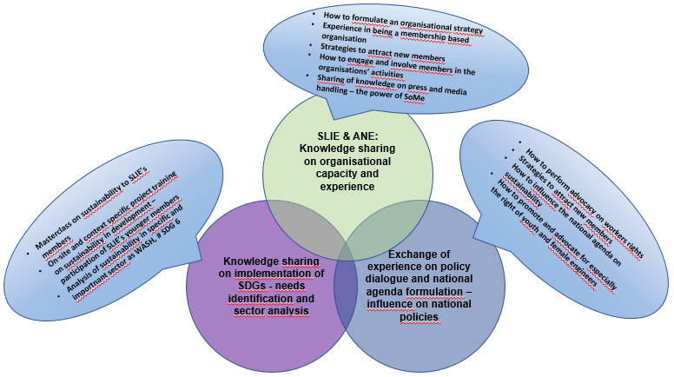

***Strategic vision***

* Internal organisational development through engagement of the membership base in the formulation of the S.L.I.E.’S first overall strategy
* Formulation of a media and press strategy (will enhance S.L.I.E.’s advocacy capability).

***Capacity building***

***Internal - Organisational S.L.I.E. (management and political level)***

* Media handling in order to build capacity and incipient experience in advocacy
* Administrative capacity in order to attract other strategic partners/donors and also in order to enhance transparency towards the organisation’s membership base
* Campaign activity/advocacy
* Project management. The present initiative is the first of its kind for S.L.I.E. hence an important learning process for its members.

***External – within its membership base***

* Participation in a Master Class on Sustainability – a series of lectures on sustainability given by international experts within the specific topics mainly addressed to the younger engineers, and securing a balanced gender participation
* Participation of the ANEs political leadership in the celebration of S.L.I.E.’ 50th anniversary to address how the Engineers institution in the North have gained significant ground in advocating for sustainable development, workers’ rights and national political agendas on STEM.

***Mobilisation of Members***

* Participatory and membership focused strategy development will reach out to members and potential members in order to 1) secure input to S.L.I.E. on how to be an attractive organisation for its members and potential members and 2) demonstrate a democratic and transparent political management with desire to involve and engage members
* The capacity building activities, which are not only to foster awareness on sustainable development of the country, but also as a mean to making S.L.I.E. an attractive option for its members.
* Media presence covering news from all the country’s regions is also aimed at mobilising and attracting new members to the organisation.

## 3.3.2 Output and activities

The output matrix below provides an overview of the expected activities and outputs in order to be able to meet the two immediate objectives.

|  |  |
| --- | --- |
| **Outputs** | **Activities** |
| Objective 1. S.L.I.E. strengthened at organisational and strategic levels in order to advocate and work for sustainable development goals from an engineering perspective. | |
| 1.1. S.L.I.Es mission and vision and strategic focus is defined in a 5 year strategy. Central question - how is S.L.I.E. to be relevant to members and how to influence the national agenda and policy formulation in order to promote sustainable development. | 1.1.1 Development of a ToR for Political Formulation committee for the development of a 5 year strategy |
| 1.1.2. Formulation/circulation of ToR for consultancy (supported by EWB-DK/ANE) |
| 1.1.3 Facilitation of analysis with Council |
| 1.1.4. Field investigation (roll out of regional strategy seminars in 4 regions) - members and potential members in order to obtain input to the formulation of the future strategy of S.L.I.E.. |
| 1.1.5 Analysis with Council of the findings from the regional consultations |
| 1.1.6 drafting and presentation to council of first draft |
| 1.1.7 Public presentation of the first draft in Freetown |
| 1.1.8 Elaboration of final draft and approval by Council |
| 1.1.9 Presentation of new strategy at annual assembly and approval by members |
| 1.2. Strategic stakeholders enrolled, engaged and supportive of S.L.I.E.'s strategy development | 1.2.1 Interviews with stakeholders, participatory and inclusive process regarding the strategy seminar. |
| 1.3 S.L.I.E has gained increased administrative capacity in management of funds and in the management of a contract with an external consultant | 1.3.1 Administrative capacity building seminar held for key staff and committee members |
| 1.3.2. Establishment of joint partner financial managements procedures |
| 1.3.3. Drafting of financial reports and activity reports supported by partner EWB-DK |
| 1.4 S.L.I.E has enhanced its knowledge and capacity to communicate and raise awareness on sustainable development from an engineering sector perspective. Specific topics are decent work, certification of engineers and women in development | 1.4.1 Drafting and circulation of a ToR on consultancy to support the development of a communication strategy (S.L.I.E responsible entity Events and PR committee) |
| 1.4.2. Development a of job profile and hiring of a communications officer |
| 1.4.3 Production of a newsletter 6 times a year |
| 1.4.4 Establishment of a news platform (SoMe) |
| 1.4.5 Development of a campaign on decent work and the rights of especially young engineers (point of departure is the salary survey of 2020) |
| 1.4.6 Documenting the celebration and seminars the 50 year conference and using the material to highlighted the issues of decent work, certification of engineers and women in development |
| 1.5 S.L.I.E. has enhanced it accountability and transparency towards members and external partners | 1.5.1 Production of an annual report and development of a public annual financial report. |
| 1.5.2 Circulation of the annual report 2020 to members in regions, companies and educational institutions |
| Objective 2. S.L.I.E. and its members base has increased its knowledge, awareness and analysis of how to promote sustainable development and how to implement and advocate for its full realisation from a practical and country specific approach. | |
| 2.1. Exchange of experience on working with sustainable development goals | 2.1.1 Master Class held for S.L.I.E. members with a particular focus on young engineers and students at Freetown University. |
| 2..2. Members and potential members along with other strategic actors have raised awareness on sustainable development from the engineering sector perspective. | 2.2.1 Members and non members to participate in regional strategy seminar (4) (in which a main component will be sustainable development contextualised to the country and its development challenges from an engineering perspective. |
| 2.3. SDG demonstration project implemented: WASH | 2.3.1 Design and construction of water supply in one community |
| 2.3.2 Students participating in project design and implementation |
| 2.4 Installation of solar system on S.L.I.E. premises | 2.4.1 Design and installation of solar system |
| 2.4.2 Students participating in design and installation |

*Note:* With regards to output 2.3, SDG demonstration project, this is a separate project funded from other sources. However, it will be implemented in parallel with this project, as the purpose is to attract young engineers and students to become members through their participation in implementation of small SDG projects in local communities. Particular focus will be paid to selection of women in order to promote women in engineering and feed material to S.L.I.E.’s campaign/advocacy.

## 3.3.3 Risk analysis

Possible risks could be lack of ownership, limited interest, and commitment to allocate the time required, corruption and or mismanagement of funds, which would affect the sustainability of the project. To address these risks, the partners will keep a continuous focus on providing sufficient motivation and capacity building to increase knowledge and capacity for implementation of activities that for the S.L.I.E. are new and unfamiliar. An additional risk is the politicization of the intervention hence that political motives are projected towards S.L.I.E. from external parties. Continued open dialogue with authorities and continued transparency and flow of information will be applied as a mitigation measure. With respect to the present corona situation, it is a joint estimation of the partners that most of the activities are not sensitive or in risk of cancelation. It is only the regional seminars, which could be postponed if the public gatherings in Sierra Leone are restricted. However, the country has not had any lock downs recently. It is also not paramount that Danish/Nordic partners are present on site, as support/guiding/exchange of knowledge will be performed in online seminars with local project management. Online support has been the DNA of most of EWB-DK’s projects including two DERF funded COVID 19 interventions in SL at the moment and this will continue under the present situation.

## 3.3.4 Time schedule

The activities related to each of the immediate objectives are implemented in parallel over a 12-month period from October 2020 to end of September 2021. Towards the end of the project an internal evaluation will be conducted, and the findings will be exchanged and discussed with the relevant partners, as well as the lessons learned will inform the design of the next envisaged project with S.L.I.E.



# Systematisation of experiences

Because several strategy documents are direct outcomes of the intervention, these documents will be systemized documentation of the intervention and made public on S.L.I.E.’s homepage. Partners will also keep a log of all media appearances and hold account of the number of persons who has been involved in the initiative. News feeds and video documentation will be produced on select activities.

# Intervention-related information work in Denmark

EWB-DK and ANE’s information work aims to raise Nordic civil society awareness and gain support for Danish development cooperation. EWB-DK uses a variety of platforms: social media, printed materials/flyers, videos, and visual documentation amongst others. The intervention’s information work is expected to lead to a higher awareness of sustainability among EWB-DK’s main target groups, and increased awareness and interest among the organisation’s volunteers. ANE will use its Nordic platform to inform and raise awareness on Nordic collaboration with developing countries from an engineering perspective.

# Supplementary financing

Within present initiative, additional funding has been secured in order for S.L.I.E. to host two international experts in the frame of a five-day master class on sustainable development. Private funding also supports instalment of a solar energy system at the office of S.L.I.E. Present initiative does not depend on the additional technical funding and can be realised even if funding is not secured. Other technical projects to be implemented between the partners in the future is not dependent on present funding or vice versa.

1. <https://monitor.civicus.org/country/sierra-leone/>
2. <https://www.politicosl.com/articles/sierra-leone-civil-groups-decry-%E2%80%98shrinking%E2%80%99-political-space>
3. <https://data.worldbank.org/indicator/EG.ELC.ACCS.RU.ZS?end=2016&locations=SL&start=1990&view=chart>
4. At present SLIE is using Excel for bookkeeping, and a new accounting system and required training is included in the budget.