Civic engagement in public sector delivery: mobilisation and engagement of communities for improved education at rural primary schools in Lupane, Zimbabwe

Index

Outline 1
1. Objective and relevance 1
1.1 Objective of the intervention 1
1.1.1 Contribution to citizen participation, volunteering and/or civil organisation in Denmark as well as in the countries of cooperation 1
1.1.2 Contribution to the UN Sustainable Development Goals 2
1.2 Problem analysis 2
1.3 Context of the intervention 3
2. Partnership/partners 3
2.1 What experiences and capacities each partner brings to the intervention 3
2.1.1 Lead international partner 4
2.1.2 Local lead partner 4
2.2 Other partners 5
2.3 Roles and responsibilities of the partners 5
2.4 Previous cooperation with local partner and how experiences can be used 5
2.5 How the intervention will strengthen the relationship between the partners 5
3. The actual intervention 6
3.1 Step by step – activities, methods and timeline 6
3.1.1 Activities and methods 6
3.1.2 Preliminary timeline 7
3.1.3 Risk assessment 8
3.1.4 Expected outputs 8
3.2 Target group 9
3.3 Plans for systematisation of experiences 9
4. Intervention-related information work in Denmark 10
5. Supplementary financing 10

Outline
This initiative seeks to strengthen local school governance at four primary schools in the Lupane district in Zimbabwe and improve access to education. The initiative seeks to build civic capacity to address local issues related to education, but also, in a wider perspective, to establish more robust and organised local civic structures that can engage and mitigate the fragile situations many parts of the country face. The entry point being schools and education is thus a means and strategic tool to promote civic education and engagement in the wider development agenda working with local strategic stakeholders at four selected rural primary schools in the Lupane District. The activities will be implemented in partnership between Engineers without Borders Denmark (EWB-DK), Care4People, and local partner Christian Youth Volunteers Association Trust (CYVAT).

This application forms part of a strategy to improve learning conditions and secure access to adequate education at selected schools in the Lupane district in Zimbabwe. EWB-DK is currently working with CYVAT to implement a DERF funded project at the four schools that are included in this project. The project partners wish to continue collaborating with the schools aiming to strengthen the capacity of the School Development Committees through support to project management and development of school development plans. The activities in this application include small-scale renovations as a strategic opportunity to work with school governance, capacity building and mobilisation of the community.

Objective and relevance

Objective of the intervention
The long-term vision for EWB-DK’s engagement in the Lupane district in Zimbabwe is to increase the influence of Zimbabwean citizens acting collectively for more democratic and accountable governance, using strategic service delivery in the educational sector as leverage and entry point.

The project aims to strengthen the participation and engagement of parents in securing adequate school facilities and learning conditions for their children. To achieve this, the project has three immediate objectives:
- Well-functioning School Development Committees at all four selected schools, who are able to assess and prioritise needs, develop holistic development plans and mobilise the community
- Selected communities are mobilised, engaged in renovation projects and aware of children’s educational rights
- Capacity building of CYVAT in management and project implementation

Contribution to citizen participation, volunteering and/or civil organisation in Denmark as well as in the countries of cooperation
The intervention is formed around a community-based bottom up participatory approach, focusing on parents, organized in School Development Committees (SDCs), as primary beneficiaries. The intention is that the parents’ body is actively involved and acts as the main source for addressing local issues in public service delivery (education) conducting social audit, identify gaps on implementation and identify/suggest/advocate for improvements. The SDCs will learn about the obligations by Rural District Councils, Ministry of Education and District Development Fund and through collaboration create a strong citizen organisation that can engage in dialogue and cooperation with local school authorities, relevant stakeholders and external actors and established themselves for future advocacy. The activities in this intervention thus contribute to increased citizen participation through civic education targeting the SDCs.

EWB-DK is a volunteer-based organisation. Volunteers with technical knowledge and skills drive the full project management cycle from the initial idea through to the final evaluation. Each project is run by a project group with a volunteer Project Manager responsible for the management of the project, including ensuring that the project meets the requirements and objectives set for time, economy and quality. The organisational structure ensures genuine and strong popular participation and volunteering in projects implemented by EWB-DK.

Contribution to the UN Sustainable Development Goals
This project contributes to the global efforts to fulfil the SDGs, specifically regarding SDG #4 Quality education, #16 Peace, Justice and Strong Institutions and SDG #17 Partnership for the goals.

UN SDG | Target | Connection to this project and long-term vision
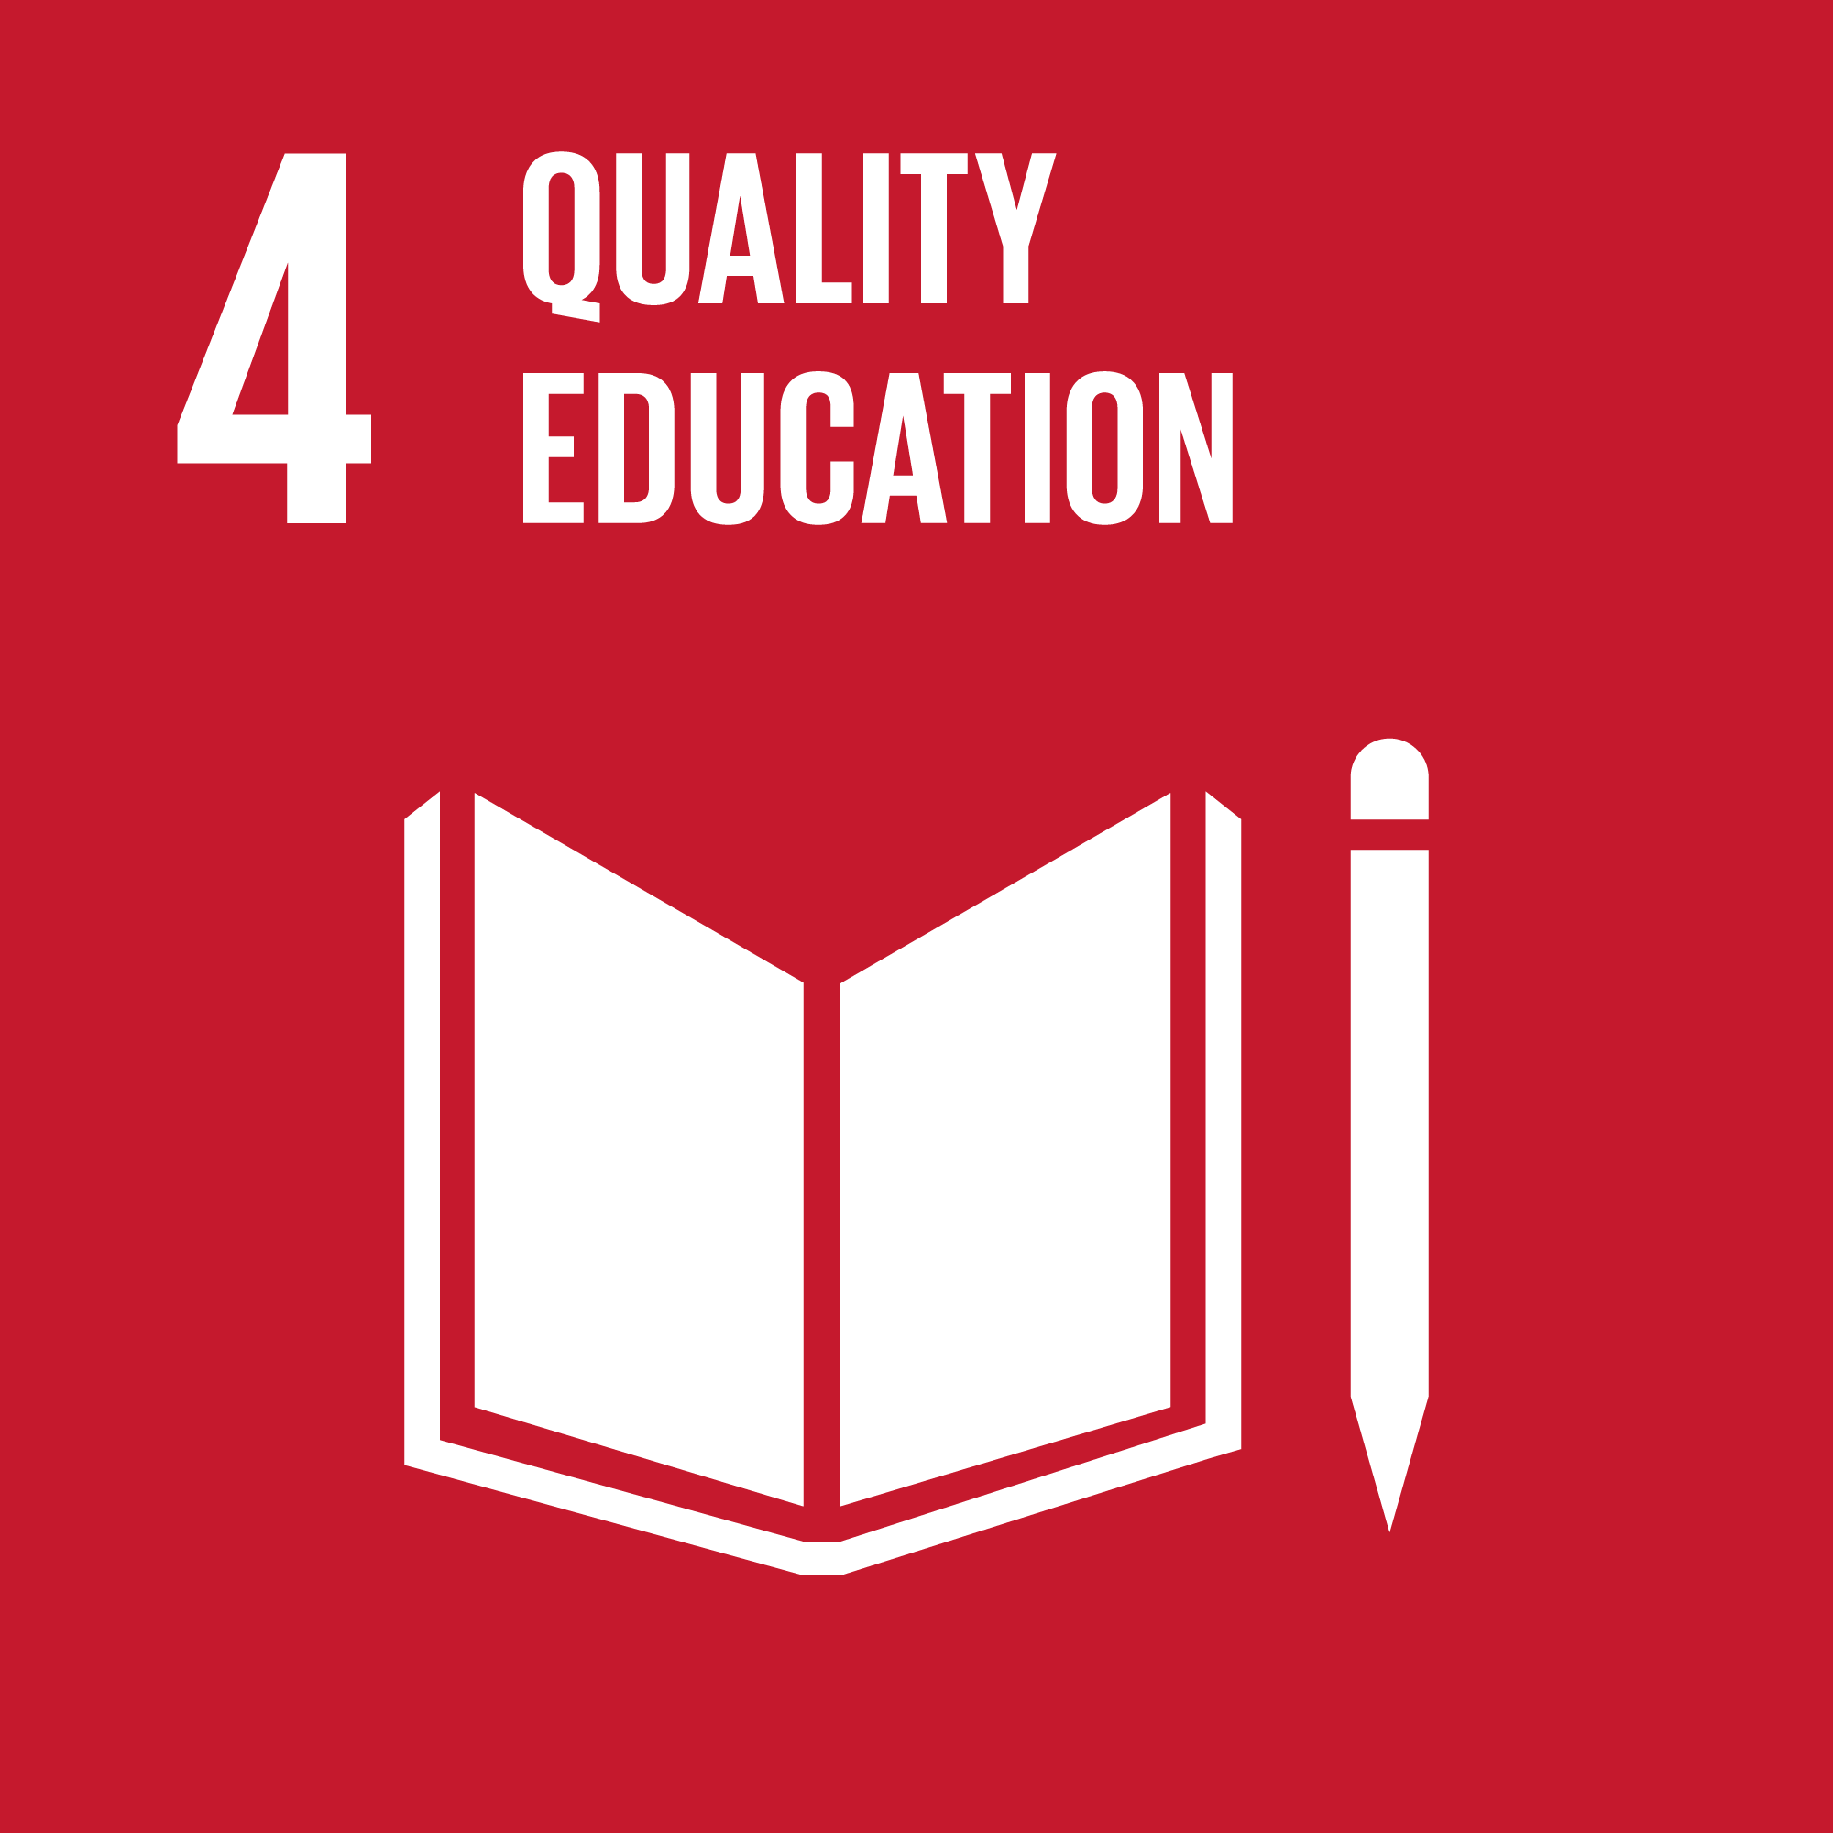 | 4-1: By 2030, ensure that all girls and boys complete free, equitable and quality primary and secondary education leading to relevant and effective learning outcomes | Through enhancing the SDCs capacity for management and influence on school and education matters, the project targets local engagement for improvement of content and quality of education.
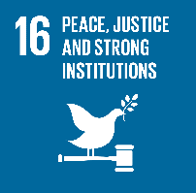 | 16-7: Ensure responsive, inclusive, participatory and representative decision-making at all levels | The project seeks to strengthen the SDCs ability to influence decision making, also based on feedback from parents and the local community, and thereby lay a foundation for future advocacy.
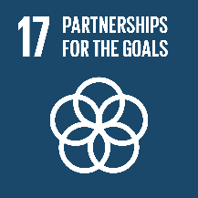 |  | Through capacity building and empowerment of local partner and selected communities, the present initiative contributes to achieving SDG#17 related to partnerships, and a strengthened international effort for sustainable development.

Problem analysis
In Zimbabwe’s current fragile context, public service delivery is suffering under lack of resources and clear political structures and direction. Compared to other African countries, literacy and levels of education is traditionally high in Zimbabwe, but the latest decades financial instability and lack of resources has resulted in an inadequate educational system and poor conditions of schools, especially in rural areas. In 2017, the government adopted a new curriculum and it is clear that in order to achieve full implementation of this, there is a need for more capable local structures for school management.

School Development Committees are a well-established structure in Zimbabwe. They consist of parents and school representative to ensure that affairs of the schools do not elude neither parties, and are based on the notion that schools are owned by parents. The committees consist of 7 members, who are elected at an annual school meeting. They are managed by the school secretariat (usually the head of the school), and meetings are quarterly or when needed. In addition to parents and a senior teacher, the SDCs include the community ward councillor as an ex-officio member during his/her time in office.

SDC members often have limited knowledge of governance, legal framework and financial matters which inhibits the SDCs from performing their intended role. With very limited support from the authorities, the SDCs have for many years been left alone with very limited funds and no means to build their capacity to monitor the budgets, develop plans for school development and ensure school maintenance. An additional challenge is that the SDCs are elected every 12 months and without proper structures and sufficient capacity to hand over knowledge and experience, continuance in SDC efforts is very low.

The present initiative wishes to foster increased involvement in school development from the parents’ side by working with the already existing SDCs and enhancing their capacity for community mobilisation. In the situation where authorities fail to fulfil their responsibilities, there is a huge need for support from the community. Ownership will be built if local communities themselves partake in the selection/prioritisation of what elements they see most necessary to upgrade and funds will run much further if they contribute to implementation.

Context of the intervention
Zimbabwe can be characterised as a fragile context with political instability, long-term economic stagnation, inflation, food insecurity on a crisis level, poverty, limited provisions of basic service, droughts and lack of clean water. Zimbabwe is listed as a low-income country, ranking as number 154 out of 188 countries on the UN Human Development Index with an official inflation rate of 97,9% but an actual inflation rate of above 600%. Civil space for working with rights is becoming smaller and smaller, and monitoring of political actions is more common. According to ICNL Civic Freedom Monitor, the change of leadership following the military intervention in November 2017 has done nothing to address the many issues affecting CSOs, and the culture of violence, disrespect of court orders and unwillingness to do away with laws affecting civic space. As a result, laws that have been used to suppress fundamental freedoms are still in place despite former president Robert Mugabe being removed from power. The current political/security situation in Zimbabwe combined with the severe effect of drought has sparked social unrest and large-scale protests by organised civil society, leading to a particular fragile situation where deteriorating security and critical levels of food insecurity are widespread.

The El Niño climate pattern has the last years been stronger than ever and has resulted in severe flooding as well as severe drought across Southern Africa. The western part of Zimbabwe is particularly prone to severe drought. Schoolchildren are often some of the most vulnerable and their education will be affected when droughts strike. The Zimbabwe Vulnerability Assessment Committee (ZimVAC) documents that school absenteeism, dropout, poor classroom concentration and malnutrition sky rocketed during the 2015-2016 El Niño drought season among children whose caretakers are solely relying on subsistence farming.

In 2019, EWB-DK and CYVAT received DERF funding to implement an emergency intervention targeting supply of school meals at the same four schools selected for the activities in this project. Despite an increasingly challenging political situation, the humanitarian situation has allowed the partners to establish a presence in the area and a cooperative relationship with management at the mentioned schools. The overall conditions of the targeted communities have been dire for a long time and the ongoing emergency intervention has only confirmed the need for the activities in this project.

Taking this into consideration, the strategic service delivery of this project is of high importance as it provides an entry point for working with the communities. Furthermore, it is not the ambition to work with rights-oriented capacity building, but rather with strengthening already existing structures and a focus on the importance of education.

Partnership/partners

What experiences and capacities each partner brings to the intervention
The partners contribute with different experiences and strengths. CYVAT counts for solid local and thematic knowledge, Care4People for long-standing partner relations and local knowledge, and as the youngest in the partnership EWB-DK provides an extensive experience in international project management and humanitarian interventions, so the partners complement each other strongly.

Lead international partner
Engineers without Borders Denmark (EWB-DK) was established in 2001 and has since then gained vast experience in implementing technical humanitarian development efforts in the framework of local partnerships. All EWB-DK’s activities take point of departure in the delivery of strategic services, and encompass community development work with a strong focus on leaving behind sustainable change in the behaviour of targeted groups to improve their livelihoods, also after the immediate intervention is completed.

EWB-DK has since 2016 been working with Zimbabwean partners on development activities, which have given EWB-DK a thorough insight into the context. This, in combination with specific members’ experience, makes EWB-DK a relevant and resourceful partner for development and humanitarian efforts in Zimbabwe. In April 2019, EWB-DK was granted funding from the DERF to initiate an emergency intervention providing school meals at the four schools in this application with CYVAT as the local implementing partner, and is therefore already present and active in the area in question.

The EWB-DK project group contributes with technical knowledge on the organisation of the school renovation process, solid experience with administration and finances and project management, and with organisational knowledge and experience from the Zimbabwean context. The project team includes members with many years of working experience in Zimbabwe, among other the project manager who has worked several years in the country with MS/Action Aid Denmark. Areas of experience are school construction/renovation, educational projects, infrastructure, community mobilisation and outreach, and activities related to education.

Local lead partner
Christian Youth Volunteers Association Trust (CYVAT) is a non-profit, non-governmental, non-political organisation based mainly on voluntary development and humanitarian work. The organisation was established in 1995 and its core mission is to promote local resilience to poverty and make vulnerable groups directly engaged actors in charge of their own development.

CYVAT’s work and engagement in the past years has been focused in rural and most vulnerable communities within the provincial districts like Matobo, Binga and Lupane. The local communities that CYVAT works in experience high levels of food insecurity and a fragile political situation where local authorities have very few means and capacity to fulfil their responsibilities of delivery of basic service for the local population. In spite of the very challenging local situation, CYVAT has managed to continue to work with the local communities promoting community mobilisation and local capacity building. CYVAT assists communities in infrastructural and social development and always involves community leaders and a broad stakeholder engagement in all its activities. For several years, CYVAT has been working with the same SDCs, and is in a well-placed position to initiate and implement the activities included in this application. CYVAT has several years of experience with the four schools selected for this project.

The organisation has extensive experience with small-scale project management. In the last years, CYVAT has completed several projects at schools in the Lupane district, which forms the base for the selection of schools for this project. In 2017, the organisation got a merit award from the Ministry of Education for its “Better Schools” program in Lupane. The award is assigned to service providers who contribute tremendously in the education sector. CYVAT has implemented and cooperated on projects with funding from among other the Embassy of the Czech Republic and DCA. CYVAT has implemented an Early Childhood Development program in 2015-2017 funded by the Roger Federer Foundation, which targeted 30 schools in Lupane, including the four schools selected for this project. Staff has been trained in supervising, administration, coordination, communications, advocacy and policy dynamics, and more. However, the Danish project team that collaborates with the organisation on the DERF funding project sees a need for capacity building to improve systematic and efficient use of formats and financial procedures/schedules.

Other partners
EWB-DK cooperates on its efforts in Lupane with the Danish NGO Care4People, who has years of experience working in the area and with CYVAT. Care4People is part of the Danish project groups and contributes with knowledge on education in Zimbabwe, including school management and parents/school relations. The partners have several activities they cooperate on, including the development and distribution of new teaching equipment, at the selected schools. Care4People and CYVAT have a wide network and longstanding experience of cooperation with the Ministry of Education, local communities and education institutions. Care4People furthermore assists with international communication and contributes with their knowledge and experience from both the area and the partnership with CYVAT. It is partially through the activities and strategic service delivery from projects with Care4People that CYVAT has gained their access to the selected schools and SDCs.

Roles and responsibilities of the partners
CYVAT will as local implementing partner:
- execute and coordinate all activities in country
- monitor the project, enabling all partners, EWB-DK and CYVAT to identify challenges and improve strategies if needed
- report to lead partner EWB-DK on a monthly basis based on predetermined formats (to be established in the project agreement)
- organise/facilitate capacity building of the SDCs

EWB-DK will as lead partner:
- supervise project implementation and monitor progress and results
- be responsible for the reporting on progress to donors and for financial management in DK
- be responsible for financial management, secure/install local capacity to manage funds online (administrative capacity building)
- provide technical support, mainly on renovation issues
- actively seek to identify other Danish NGOs with experience on education in the Zimbabwean context to share experience/learn from each other

Previous cooperation with local partner and how experiences can be used
EWB-DK has been active in Zimbabwe since 2016, and has completed several activities in cooperation with CYVAT, and with CYVAT and Care4People together. In 2017, the EWB-DK project manager cooperated with CYVAT on community surveys regarding school renovations, and regularly communicated online concerning changes and/or need for information. EWB-DK, Care4People and CYVAT have formalised their cooperation in an official agreement recently signed (2019), covering the terms of the partnership. The cooperation between EWB-DK and CYVAT on the DERF funded intervention has not only given the partners experience in working together, but also has enabled access and a strong presence in the selected communities. Furthermore, the ongoing implementation has strengthened CYVAT in their organisational and financial structures and has given them increased experience with local management and implementation of international development efforts.

How the intervention will strengthen the relationship between the partners
The intervention will further consolidate the partners’ presence in the area and their position as relevant actors for development efforts in the Lupane district. The activities will furthermore strengthen the relationship with local authorities and community leaders, which potentially and hopefully gives both EWB-DK and CYVAT a strategic position to expand their development efforts in the area in the future. The capacity building activities in the project will strengthen CYVAT as an organisation, which will make the partnership even stronger and more capable of implementing larger development interventions in the future.

The actual intervention

Step by step – activities, methods and timeline

Activities and methods
The initiative will strategically use the small renovation projects at each school to continue to build capacity in the SDCs to fulfil their mandate as representatives of the parents and civil society with respect to securing the best possible frame for their children’s education. Focusing on methods for community engagement and local ownership, the activities will include:

- Mobilisation of SDCs
As the project relies on existing civil society structures and the success of the initiative rests on support from these, it is important to secure a widespread support and to communicate thoroughly on the process and the expected results via community meetings, informal meetings with community leaders and/or elders and communication on local media if and where possible.

- Participatory local community-based assessments lead by the SDCs
SDC’s at the four schools were involved in ‘Schools Buildings Condition Survey Report’ in September 2017. Detailed Bills of Quantities and drawings were done at the same time by a local consultant. This work will inform the renovation projects. The SDCs will be supported to engage the parent community in a participatory process in order for them to revisit needs and prioritise the projects. This is expected to establish increased involvement and ownership of the renovation process. The members of the SDCs, school authorities and local community members and stakeholders will therefore be mobilised and organised to participate in the identification and assessment of infrastructural needs at the schools. The assessment will focus on strong involvement/participation of the SDC and local community, and will map needs, local knowledge/skills to support the renovation and current and/or future approaches for maintenance.

- Strategic service delivery – school renovation projects managed by the SDC
With the long-term vision of strong civil engagement and the overall aim of this project to strengthen the participation of parents in governance of the schools, the school renovation activities to improve the physical learning environment will strategically be used to engage and build the capacity of the SDCs.

Through the process of planning and implementing the renovation projects (such as renovation of floors, roofs, walls, and potentially water supply) the committees will get familiar with all steps of the project management cycle. They will have identify, formulate and prioritise needs, engage skilled consultants or seek advice from Lupane RDC (Rural District Council) and develop Operation- and Maintenance Plans for buildings and other infrastructure. During the implementation process they will have to reach out to the larger group of parents to engage them in the work. The renovation projects will therefore act as a mean for community mobilization and engagement and should be seen as a motivational factor for the communities to be involved in school development.

The needs assessment, prioritisation and project planning process will build the capacity of the SDC to engage in development of more holistic school development plans. They will get a solid understand of roles and responsibilities within the education system and discuss how best to approach the local authorities with request for support, hence a strong foundation for future advocacy will be established.

- Support to the most vulnerable children
As described in the context analysis, Zimbabwe Vulnerability Assessment Committee (ZimVAC) documents that school absenteeism, dropout, poor classroom concentration and malnutrition sky rocketed during the 2015 – 2016 EL NINO drought season among children whose caretakers are solely relying on subsistence farming. To mitigate this, the most vulnerable children at the four targeted school will be identified and support in the form of school uniforms and/or schools fees will be provided.

- Capacity-building of SDCs
In order for the SDCs to fulfil their intended role and complete the activities in this project, they will participate in capacity building within project management, legal mandates, budgetary and financial oversight, stakeholder relations and the process of advocacy. CYVAT will conduct the capacity building of the SDCs.

- Capacity-building of local partner
CYVAT has already implemented projects and have shown the capacity to manage funds and implement activities. However, the organisation has already identified a number of areas where they would like to strengthen their capacity in order to ensure efficient and high-quality project management and enabling them to grow as an organisation. CYVAT has indicated a wish to strengthen the financial management, Human Resource management, and project management. They have expressed a need to get support to develop HR policies, vehicle policy and a gender policy and would like support to revise their child protection policy. An initial organisational capacity assessment will be carried out at the start of the project and a capacity development plan developed.

The EWB-DK project team members’ different background and experience will ensure that CYVAT will be strengthened in their project management, and supported to develop tools in finance and HR management. The capacity development plan will make it clear where the EWB-DK team will be able to contribute and where it will make good sense to have training and support delivered by external local expertise.

Preliminary timeline
The project will be implemented over an 18 months period.

Activity | Month
 | 1-3 | 4-6 | 7-9 | 10-12 | 13-15 | 15-18
Start-up WS (with Danish participation)
Develop training plan for the SDC
Capacity building of SDC
Exchange visits between SDC
Develop plan for community mobilisation and awareness raising
Community mobilization and awareness raising
Renovation projects
Development of school development plans
SDC to develop criteria for most vulnerable children
Support to most vulnerable children
Mid-term review (with Danish participation)
Organisational capacity assessment of CYVAT and capacity building plan
Capacity development of CYVAT
Participatory project evaluation

Risk assessment
Poor hand-over when the SDC members change: SDC members are elected for only 12 months and there is a risk that acquired knowledge and skills are lost when members change. During the project, strategies for induction of new members will be discussed and structures put in place to ensure that knowledge is shared and procedures and systems understood. Possibilities of ensuring one month overlap after elections and mentorships will be discussed.
Lack of engagement by parents: Even though the project is working with existing structures the project could meet lack of engagement from parents. To mitigate the risk the project will ensure early involvement in determining the interventions and building engagement thru questionnaires and interviews, repeated interviews/meetings during the project execution to show progresses and offering refreshments during the meetings so that parents feel that their work is important.

Corruption and misuse of funds will be mitigated by close monitoring of all financial activities, strict adherence to existing procedures.

Lack of capabilities of contractors/workers: To mitigate the risk of bad construction work constant review of progresses will be done with photograph, frequent meeting during the execution of the project and engagement of Supervisor to validate Progress Reports and proper hand-over procedures before payment is made.

Extreme weather during renovation works: Activities will be attentively planned together with parents, SDC and local contractors to execute the different project activities minimizing risk of weather influenced event: i.e. roofs and ceiling during dry season, internal flooring and walls during wet season etc.

Expected outputs
To fulfil the immediate objectives, the activities aim to achieve the following outputs:

Immediate objective 1: Well-functioning school development committees at all four selected schools who are able to assess and prioritise needs, develop holistic development plans and mobilise the community
Expected output | Means of verification (MoV)
1.1 Four SDCs have improved understanding of participatory methodologies, budgeting and budget monitoring as well as roles and responsibilities | Questionnaire for the SDCs assessing their understanding at the beginning, in the middle and at the end of the project period
1.2 School by-laws revised, adopted and adhered to | Meeting minutes and revised by-laws on record
1.3 Renovation projects identified, planned and implemented at each school | Inspection and approval reports and photo documentation of before and after
1.4 School Development Plans developed for each school | Assessment of written plans
Immediate objective 2: Selected communities are mobilised, engaged in renovation projects and aware of children’s educational rights
Expected output | Means of verification (MoV)
2.1 Communities aware of educational rights and opportunities for influencing and engagement | Attendance records documenting that 48 (12 in each school district) awareness meetings/parent dialogue meetings conducted with minimum 20 participants at each meeting
2.2 Communities engaged in school renovation projects | School records showing that minimum 10 parents have been actively involved at each school
2.3 Most vulnerable children in the communities are identified and their school attendance improved | School records showing that minimum 80 most vulnerable children received support an attend school
Immediate objective 3: Capacity building of CYVAT in management and project implementation
Expected output | Means of verification (MoV)
3.1 Capacity building needs identified and a development plan formulated | Capacity development plan developed with clear improvement indicators
3.2 CYVAT has been trained and has started to put new systems and procedures in place | Assessment of the identified areas for improvement
3.3 Policies formulated for efficient management of financial | Policy documents

Target group
The project will improve the educational conditions at the four targeted schools, working directly with the school development committees and strengthen the capacity of the local partner CYVAT.

The project activities target a total of more than 800 schoolchildren at the four schools and the members of the school development committees:

School name | Girls | Boys | TOTAL
Manganganga | 127 | 124 | 251
Phumakanye | 108 | 99 | 207
Mzola 27 | 92 | 99 | 191
Sitshongo | 80 | 80 | 160
TOTAL | 407 | 402 | 837

SDC: 28 members of the School Development Committees. Ward councillors are given members of the SDC and engagement of the local authorities are therefore ensured.

CYVAT: Staff and management – 20 persons

Communities: The project will also reach out to the local communities around the school to raise awareness of their rights to free education and at the same time engage them in the school project. An estimated 800 people/parents will be involved in dialogue and awareness raising activities.

Plans for systematisation of experiences
The local partner will be responsible for on-ground monitoring with support from EWB-DK. A monitoring plan will be developed as part of the start-up workshop where tools and schedule for activity and financial monitoring will be agreed. Data collection will be done with ViewWorld or another online platform keeping a strong focus on simplicity and relevance to avoid collecting a lot of data that can’t be processed. A mid-term review with Danish participation will be carried out to ensure that collective reflection is done, experiences and learnings are discussed and plans for the remaining implementation period developed. Data collected during the first part of the project will be analysed, linked to the established indicators and, if needed, adjustment of project implementation for the remaining period will be discussed and agreed upon. The final evaluation will be a participatory evaluation where EWB-DK and CYVAT will ensure that experiences and learnings are documented.

A Danish project team is already appointed, and will be in continuous contact with the implementing partner to involve and provide expert support for specific technical needs required for the intervention. Monthly activity and financial reports will be requested from the local partner, and the Danish project team will be responsible for following up on this. Approaches to implementation will furthermore continuously be analysed in relation to the political and financial situation in Zimbabwe, and any changes will be made in close cooperation with the local partner organisation.

EWB-DK will ensure that experiences from ongoing implementation (DERF intervention) and any other experience from the country is made available to the Danish project team and thereby ensure they are always up to date with all relevant information for successful implementation.

Intervention-related information work in Denmark
EWB-DK communicates on all its activities through a variety of platforms (SoMe, printed materials, video/visual documentation) to inform EWB-DK members and the general Danish public on activities and relevance of projects within a wider international development agenda. Information work is conducted through volunteers and staff and reaches a broad variety of domestic groups.

Supplementary financing
In 2018, EWB-DK secured private funding earmarked to community-driven renovation activities at the selected schools. A large part of the funds needed for the smaller renovation of the schools are therefore already secured and only a minor contribution is requested in the budget.

http://www.icnl.org/research/monitor/zimbabwe.html 2019 The International center for Not for Profit Law
https://reliefweb.int/sites/reliefweb.int/files/resources/Press%20release%20USG%20Lowcock%20Zimbabwe_Feb2019.pdf
Three organizational types define NGOs in Zimbabwe and these are Private Voluntary Organisations (PVOs), Trusts and Common Law Universitas. Each of these have different regulations.

