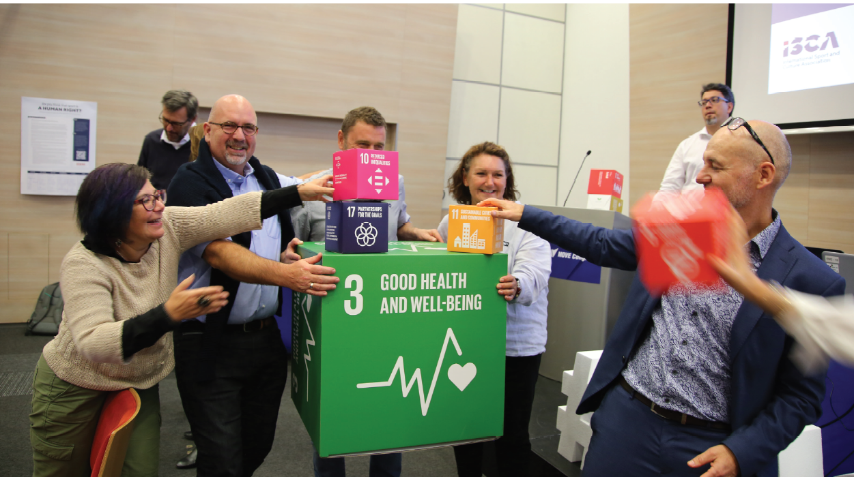
From ISCAs General Assembly 2019

- Objective and relevance (the world around us)

The project Future MOVE has as its primary objective to engage 540 Danish youth attending Gerlev Sports Academy (Gerlev Idrætshøjskole) in development cooperation, where sport for all is used to meet the Sustainable Development Goals (hereafter “Sport for Development projects”)

The specific objectives are
- To develop a Danish conceptual framework and curriculum for Sport for Development projects. This will be tested with 540 Danish students in Gerlev.
- To map, describe and engage with 30 Sport for Development projects across the world, and to empower each of the 540 Danish Gerlev students to engage directly in collaboration with at least one of them during and beyond their 4-month stay at Gerlev
- To widen the reach of the project by sharing the conceptual framework and curriculum with other Danish NGOs, schools and at two workshops and relevant Danish conferences towards project end, and to mainstream the approach in Gerlev for the years to come.

The project is designed to build a deep understanding of the 540 young people at Gerlev of Sport for Development, and to engage them in a purposeful, direct and committing interaction with the 30 mapped Sport for Development projects as well as with Danish NGOs that own or are engaged with these projects. The young people will experience different levels of hands-on involvement in the specific projects, and will be empowered to continue the engagement both as “endorsers”, “contributors” owners” and “leaders” (cf The Engagement Pyramid) beyond their stay at the Gerlev academy.

Sustainability

During the last 4 years, ISCA – International Sport and Culture association – has reflected upon and engaged in the global dialogue on how sport for all and physical activity can contribute to the Sustainable Development Goals. This has been assessed and addressed in very different ways by the World Health Organisation, The International Olympic Committee, The Commonwealth Foundation, The Council of Europe, and others, and there is to date not an agreed common framework. Overall, there is consensus that sport for all in particular can make significant contributions to following SDGs
- 3: Good health and well-being, inter alia by contributing to combating non-communicable diseases and advancing mental health
- 4: Quality Education, inter alia by advancing non-formal education opportunities, life skill development and Physical Literacy
- 5: Gender Equality, inter alia by promoting equal participation to leisure time physical activities and sport
- 11: Sustainable cities and communities, inter alia by enhancing social justice and equal access to sport and leisure time opportunities

ISCA coined the term Human Right to MOVE in 2016 to promote a rights-based approach to sport for all and physical activity, and to embed this in the larger societal framework. And in 2018, the Council of Europe issued the Tblisi Declaration, stating “physical activity and sport for all as a fundamental right of every human being”, thus advancing this agenda further, and broadening the scope of the UN Convention of the rights of the child, including the right to play (art. 31).

It seems fair to state that the field Sport for Development, as indicated in the list of SDGs above, has had a strong focus on social sustainability (or social justice). In fact, this embedded purpose has been so strong that many have questioned the SDG approach to Sport for Development because the social aspects are rather implicit or addressed across multiple SDGs, and not directly in any one specific goal.

On the other hand, the climate and environmental aspects of sport for all have been rather vaguely addressed. Albeit this is outside of the “sport for all” field, major professional sport events have to some extent worked to reduce the environmental and climate impact of the events as well as of major sport facilities. However, in 2018, United Nations Framework Convention on Climate Change delivered the Sports for Climate Action Framework, which gave some attention to the field, although it is still very broad and only partially relevant for the “sport for all” sector.

For the purposes of the current project, the partners have discussed and agreed that the climate and environmental issues must be at the core of any sustainability discussion, and that climate- and environment-specific questions should be included and addressed in the SDG and Sport for Development framework that we will build, alongside the social justice components. Additionally, the project activities have been designed considering their potential environmental impact. In particular, the number of international travels is reduced because the international students at Gerlev will be Sport for Development ambassadors, and thus reduce the need for further international trips to Denmark from the Sport for Development projects.

- The applicant organisation and other organisations/actors (our starting point)

The International Sport and Culture Association (ISCA) is a global, member-based association for civil society organisations working within development through sport for all and physical activity. Created in 1995, ISCA is today a global actor closely cooperating with its 261 member organisations, representing 40 million individuals from 89 countries on five continents, primarily comprising local and national NGOs. Working from our HQ in Copenhagen with our Danish members and partners, such as Gerlev Sport Academy (partner in this application), GAME, DGI, Danish Red Cross, Dansk Skoleidræt, Dansk Flygtningehjælp etc., we have expertise in delivering international development projects with a strong, Danish starting point.

We have very extensive experience in delivering international partner projects, and have to date lead 67 EU-funded projects with co-funding rates up to 1 million euro. We therefore believe that our project and financial management capacity is sufficient to deliver the proposed project. ISCAs international team of 13 paid staff and 5 European volunteers is comprising complementary skills within sport and development, digital strategies, communications, capacity building, online learning, advocacy, and external communications (staff list: http://isca-web.org/english/aboutisca/aboutisca0/oursecretariat).

Our key strength is our network of members and partners from civil society, with a focus on sport for all and physical activity development. 261 member organisations and a large global network of partners from both public and private sectors enables us to deliver development projects all over the world. For the purposes of this project, this network is the starting point to be able to identify the 30 Sport for Development projects that will be the global network with which the Gerlev students will interact, and we will in particular draw upon our international partner sportanddev.org (who has a focus on developing countries) for this purpose.

We consider it a strength that our work is very broad, and encompasses both organisational capacity building, concept development, physical activity campaigns, and advocacy. Our interventions ranges from delivering the European Week of Sport for the European Commission in Denmark, to implementing sport for development projects in Colombia. Working both in developed and developing countries also means that we are able to keep a broader perspective on sport for development, allowing us to address relative disadvantage both within countries as well as between them. For the purpose of the current project, we will of course focus on projects in countries from the OECD/DAC list.

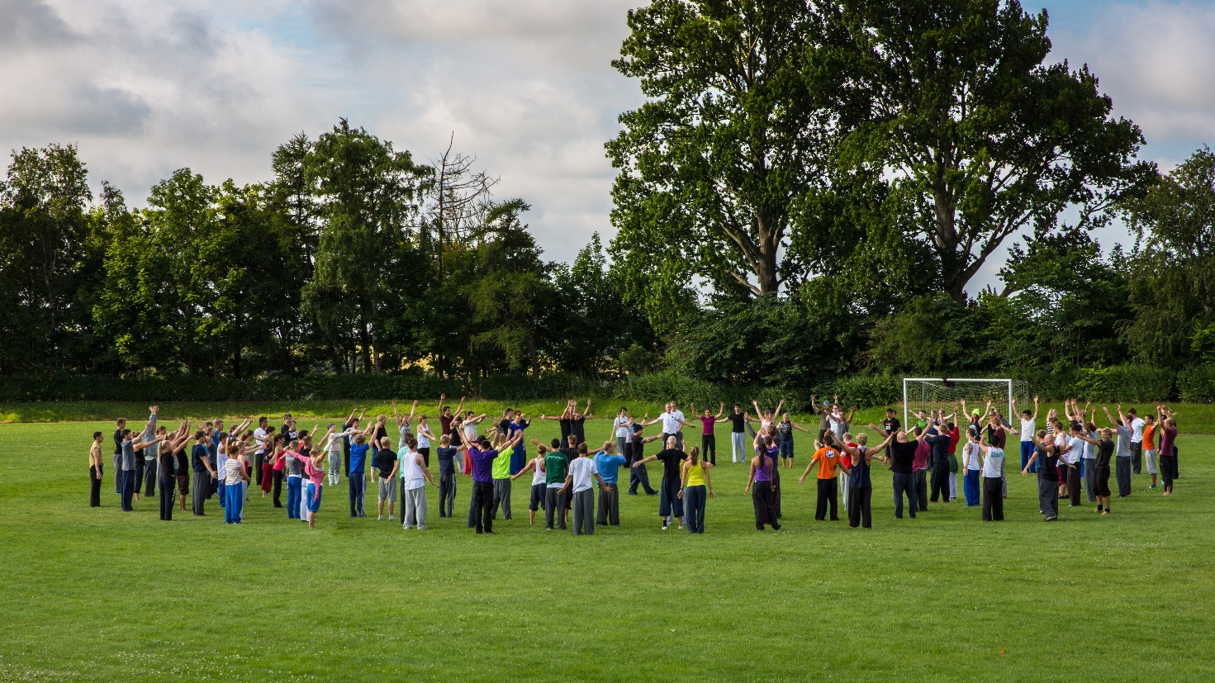

Gerlev is combining movement with learning about global issues in a non-formal setting

In this project, we partner with Gerlev Sport Academy (Gerlev Idrætshøjskole, hereafter “Gerlev”). ISCA has partnered with Gerlev in the past, in identifying international partners and recruiting international students to the school, and joining common international projects in the past. Gerlev is a very internationally oriented folk high schools in Denmark, with a significant number of international students. In a typical year, Gerlev has had 30 international students every semester, before the covid-19 pandemic.

However, Gerlev has not to date fully linked their teaching and curriculum directly to the Sustainable Development Goals, nor has the presence of the international students been exploited to engage the Danish students in specific sport for development projects from the international students’ respective home countries. Tying Gerlev’s global network of former and present international students together with the SDGs and enabling Danish students to engage in Sport for Development initiatives from across the world will therefore allow to “close the circle” in Gerlev’s international work. Simply put, this project will enable Gerlev to “mainstream” the SDGs in their work, and to tie this into specific actions and projects both in Denmark and in developing countries.

Gerlev has a permanent staff group of 37 within teaching and project delivery, and is experienced in international project management. Their experience encompasses EU-funded projects, exchange programmes, and a current international sustainability project together with The Association of Folk High Schools in Denmark (FFD) and 9 other schools.

ISCA and Gerlev therefore complement each other well in the project set-up: ISCA will be responsible for overall project management, SDG concept development, and linking with 30 global sport for development projects. Gerlev will pilot the concept and curriculum, and engage the Danish students directly in the development projects, empowering them to understand and contribute to international development work, during and after their stay at Gerlev.

ISCA will coordinate the partnership with Gerlev, building on our significant experiences and trust, and will set up weekly check-ins between our respective main liason persons. With dedicated staff on both sides that have responsibility for management and delivery in the areas of finance, project management, communications and curriculum and content development, we will additionally make sure that close and direct links are maintained on all levels, and that we exploit our capacities to the full benefit of the project through monthly project coordination meetings and ad hoc contacts as needed. ISCA will handle the primary outreach to the 30 sport for development projects, using its existing networks and relations to many of them, and ensuring a smooth engagement process together with the Gerlev staff and students.

3. The work to be carried out (our intervention)

The target group
The primary target group of the project is the 540 Danish young people that are attending the Gerlev 4-month courses, starting with the fall semester 2022 (concept and curriculum development takes place in the spring of 2022). These students are typically 18-23 years old, and have a roughly equal gender balance. They arrive from all areas of Denmark. The students are voluntarily choosing to come to Gerlev, with its clear international profile, and therefore come with interest, curiosity and energy to learn and engage. The likelihood that they will engage in the specific development projects is therefore deemed to be very high, and we would argue that the Danish Gerlev students represent a unique resource that can make a real difference in sport for development projects and in the awareness of Danish development work in general.

The project has three secondary target groups
- The international students at Gerlev
- The 30 international sport for development project leaders and beneficiaries
- Danish development NGOs and education institutions
Before the covid-19 pandemic, approximately 30 international students attended one of Gerlev’s 4-6-month courses every year. These students are recruited through Gerlev’s and ISCA’s international networks and partners, and have an average age of 23 years. Gerlev has made it a priority to have an international outlook and international students. The students come from all over the world, and represent a wide variety of cultures, from e.g. China, Korea, Brazil etc. And while the covid-19 pandemic has meant a reduced number of international students have been able to come to Gerlev, these international students are potentially a key resource for the project. If this project is implemented, the future recruitment of the international students will include identifying and describing links with existing sport for development projects in their home countries. This will enable Gerlev to both recruit international students with links or experience in sport for development projects, and to use these experiences pro-actively in the teaching in Gerlev: The international students will thus become ambassadors for sport for development projects in their home countries, and will be able to be the “native voice” from these projects and cultures in Denmark. At the same time, they will themselves be beneficiaries of the project because they will learn from the SDG-oriented curriculum at Gerlev, and because they will gain insight and competence from linking to the projects in their home countries.

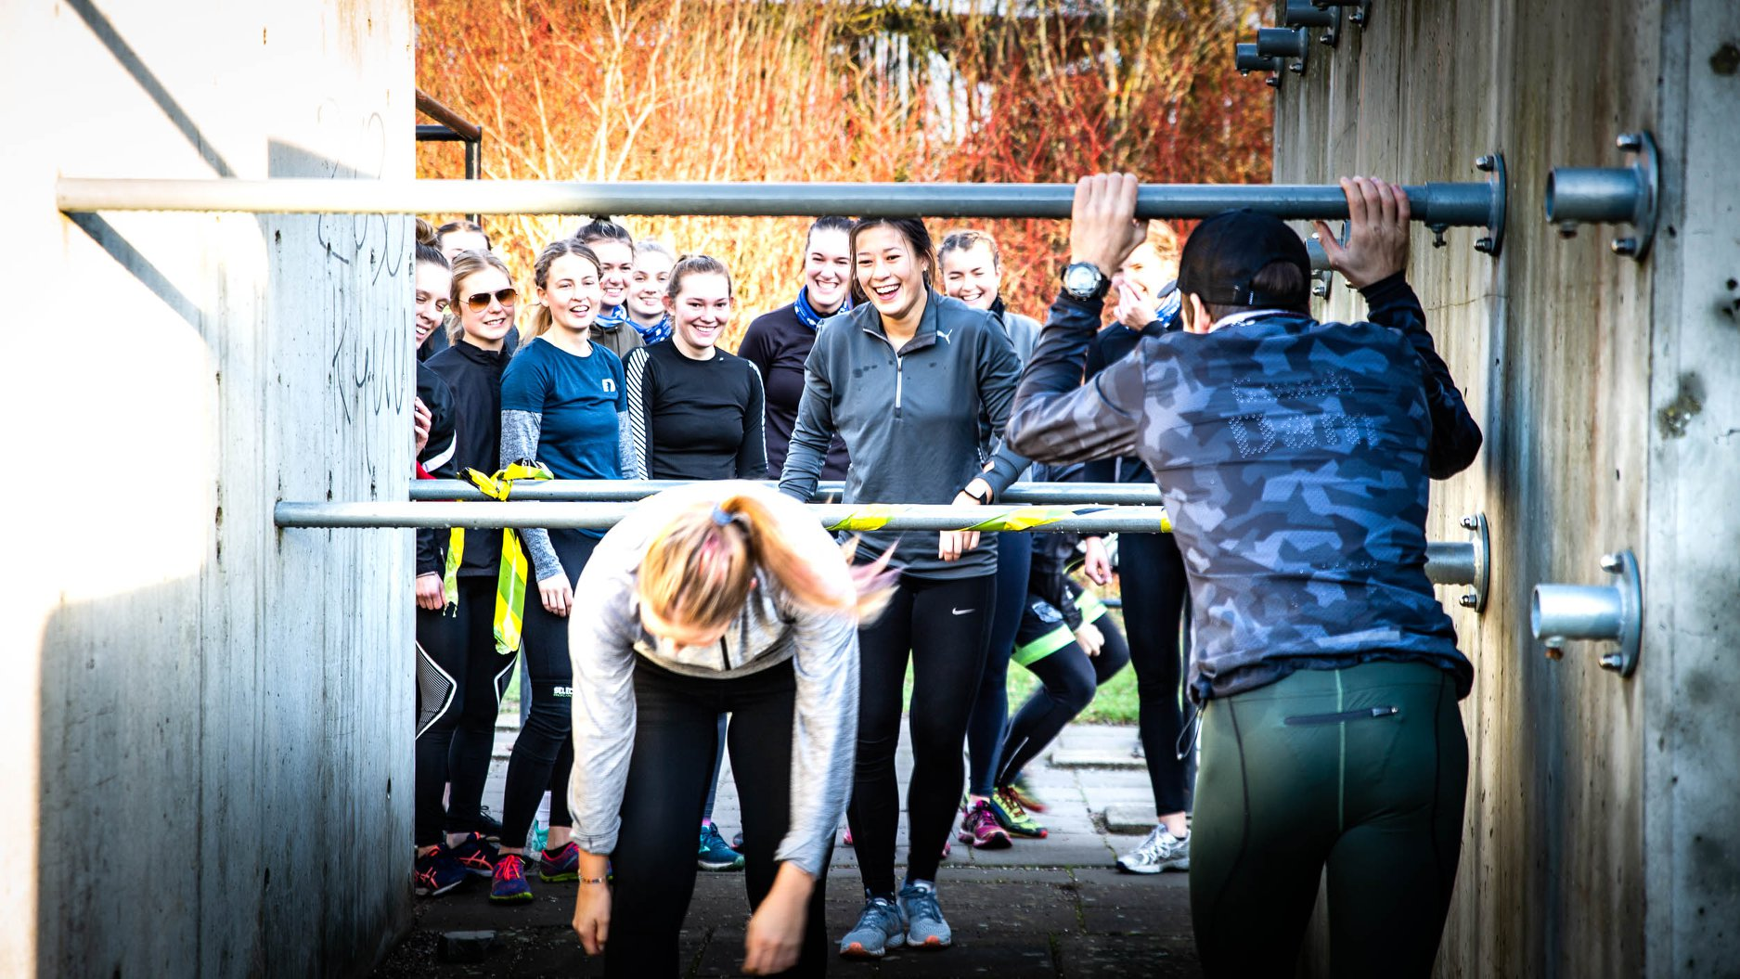

Gerlev is a unique venue to ensure deep learning and engagement.

The 30 international sport for development projects that we will map will benefit from the project through the engagement of the Gerlev students. As described below, this can e.g. be in the form of donations, fundraisers, voluntary work and outreach. Therefore, both the leaders and supporters of the projects will benefit, as well as ultimately the participants in the projects themselves. When selecting the 30 projects, we will take the following criteria into account
- Projects must be from countries on the OECD/DAC list
- Projects that link or could link well with the SDG framework
- Projects that already engage Danish NGOs, citizens or stakeholders
- Projects have prior engagement or links with Gerlev or ISCA and have demonstrated quality and capacity
ISCA and Gerlev have made a preliminary mapping, and consider the following good examples of relevant sport for development projects: GAME Lebanon (linking with GAME Denmark), TAKT North Macedonia (focusing on gender equality through sport, linking with ISCA), Football for Unity Sierra Leone (linking with FANT in Denmark), YOPP Ghana (linking with DGI), Open Fun Football Schools Azerbaijan (linking with CCPA Denmark). Please note that for the purposes of this project, we have already reached out to the partners in Brazil, North Macedonia and Kenya, who have enthusiastically contributed to the project idea, and these countries are therefore the ones listed in the online application form. It should also be noted that we expect some projects that we approach will decide not to engage in this project and the final list is of course only the projects that are eager to participate in the activities.

The final secondary target group is Danish development NGOs and education institutions. Clearly, the above mentioned examples of Danish sport and development organisations will benefit from the engagement of the Danish Gerlev students (and we have reached out to some of them already). Additionally, we intend to work with the other 10 Danish Sport Folk High schools in the development of the project SDG concept and the curriculum, and we expect that the concept will therefore also be of use and inspiration for them in developing an SDG approach, and perhaps engaging even more in international development cooperation. Our concept for SDGs and sport for all is also expected to be relevant to other mainstream sport organisations and schools (such as the “sportsefterskoler” (secondary boarding schools)) across Denmark, and will be shared e.g. at the annual conferences “Idrætsmødet” and through the network of the Danish School Sport Federation, who is also currently implementing SDG-related projects.

Planning
In this section, we will describe the project activities with more detail, linking them to the three specific project objectives.

- To develop a Danish conceptual framework and curriculum for Sport for Development projects. This will be tested with 540 Danish students in Gerlev.

Activity 1.1 Based on speed review of current sport for development approaches in different countries, develop an easy-to-understand conceptual framework for how sport for all and physical activity contributes to the Sustainable Development Goals, both in a Danish context and in international development.
Output 1.1.1: 10 page conceptual framework
Output 1.1.2: 3 infographics (poster format) to illustrate the relevance of sport for development to the SDGs

Activity 1.2 Developing a curriculum for Sport for Development and the SDGs in a Danish and international context. The curriculum will comprise situational analysis; learning objectives; selection of content and sequence on Sport for development and the SDGs; activities, strategies and method of teaching; as well as evaluation methods. The curriculum will take into account the latest international knowledge in the field, in particular drawing upon the ongoing international CHANGE project in which ISCA is a partner (lead by European Observatory for Sport and Employment, and aiming to define skills and competences for sport to act as a tool for development: https://eose.org/our_work/change-sport-for-development/ ). It will be made in a generic version to be shared with other Danish stakeholders, and in a Gerlev-specific version
Output 1.2.1: Generic curriculum for Sport for Development and the SDGs
Output 1.2.2: Gerlev-adapted curriculum

Activity 1.3 Plan and implement the mainstreaming of SDGs in Gerlev’s overall strategy and educational concept. During 2022, Gerlev will create a working group that will deep-dive into the SDG´s and merge them with their own educational concept. In the process, they will reach out to other folk high schools in Denmark working with the topic, in order to enhance quality and accessibility for the youngsters. This is planned as the culmination of many past deliberations to engage and position the school inside an international context and sustainability agenda. As a school, they want to bring important issues to their students and link them with expertise in sport for all, international youth engagement and democratic awareness. Gerlev is known for its practical approach, using the non-formal education as a tool to bring change in local societies, and they want to be able to make the SDGs more concrete and practical in a way where body and movement can be involved. (We note that this strategic work will be done outside the scope of this project, as it does not directly relate to the engagement of Danish citizens in development work, but it is essential to ensure the ownership and long term impact of the project). The key existing tools to deliver the educational transformation at Gerlev are
  - The Gerlev course “Current debates” (aktuel debat): This is designed to engage Danish students in discussions and actions within sport, movement and physical activity in general. The students can also engage in internationally oriented themes, and the course will be at the core of the SDG mainstreaming efforts. The course participants will be the central change agents for the SDG integration at Gerlev – and act as facilitators also for the other Danish Gerlev students, and preparing and delivering specific SDG projects during their stay at Gerlev.
  - The international students: The international students can be transformative through their embodiment of the 30 sport for development projects and the cultural contexts in which they are embedded. They are central to ensuring the voice from developing countries is being transmitted and heard, as described below (under objective 2)
  - The former international students. Gerlev has a strong network of former international students, and they will be called upon to help identify and link with relevant sport for development projects in their countries. Our experience shows that their continued dedication to Gerlev is strong and they typically engage wholeheartedly when requested.

Output 1.3.1: “Gerlev and the SDGs” – overall plan for the school to teach on SDG and international development-related subjects.
Output 1.3.2: The content of the Gerlev subject “Current debates” will be adapted to focus on SDGs and their implication for Danish and international development work, including specific Sport for Development project experience, as detailed below.

- To map, describe and engage with 30 Sport for Development projects across the world, and to empower each of the 540 Danish Gerlev students to engage directly in collaboration with at least one of them during and beyond their 4-month stay at Gerlev
Activity 2.1 Identifying and reaching out to a gross list of 60 Sport for Development projects, and selecting the 30 most suitable ones for this project, based on their interest and the abovementioned criteria (from countries on the OECD/DAC list, link to SDGs, prior involvement with Danish NGOs; and links to Gerlev/ISCA). Categorizing and describing the projects (and contacts) briefly and including this material in the Gerlev curriculum.
Output 2.1.1 Description of the 30 selected sport for development projects for cooperation

Activity 2.2 Outlining “Sport for Development and SDGs” engagement opportunities. Based on the CISU “Engagement pyramid”, ISCA and Gerlev will develop an array of options to engage on different levels with the 30 projects. Naturally, not all engagement opportunities may be of relevance or interest for all 30 projects, so each of them will be asked to identify their corresponding interests, which will be added to the 30 project descriptions.
ISCA and Gerlev have preliminarily developed the following sample list of engagement opportunities, corresponding to the different levels of the CISU “engagement pyramid”:

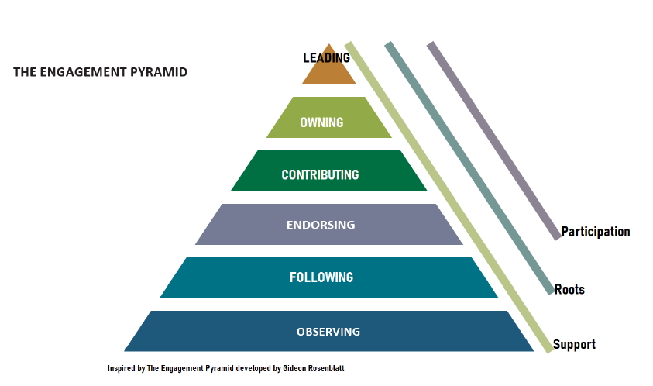
Leading:
  - Initiating a Danish support group, network or NGO to continuously liase in a broad range of functions with the Sport and Development project as a partner (e.g. the Danish network supporting the Danish-inspired gymnastic club TEMPOS in Costa Rica)
Owning:
  - Engaging in Danish NGO Cross Cultures’ Open Fun Football Schools as a volunteer coach over three weeks in Georgia.
Contributing:
  - Organizing social media fundraiser for the sport for development NGO, e.g. in connection to joining a Danish running event
Endorsing:
  - Signing up as a supporting member of Danish NGO GAME, and writing social media content for GAME Lebanon.
It is important to note that for the sport for development projects that are already linked to Danish NGOs or other Danish actors, the engagement will either happen through that Danish NGO, or closely coordinated with them.
Additionally, we will identify and outline a range of opportunities to engage in development work in Denmark in support of the SDGs. This work would also be related to Gerlev’s well-established community links in Zealand and beyond, and e.g. connected to socially disadvantaged groups. This could, for instance, be social outreach work in connection to the European Week of Sport (a European Commission initiative coordinated by ISCA for Denmark).

Output 2.2.1 Inspiration material with engagement examples on the different levels, and description of the mapping of the first ideas for engagement opportunities for each of the 30 sport for development projects.

Activity 2.3 Facilitating engagement. To support the engagement process for the Danish Gerlev students, the following processes will be initiated each semester at Gerlev:
- Engaging the “Current debates” students as project and engagement leaders. They can e.g. develop their own sport for development project while staying at Gerlev. They will furthermore be trained to engage their other peer students at Gerlev in projects in support of the SDGs, functioning as mentors and facilitators in the process, using workshops, project delivery groups, and activity days. Importantly, they will help the other Danish Gerlev students design interventions that they can continue to engage in, also after their stay at Gerlev, thus enhancing the engagement and impact.
- Engaging the international students at Gerlev as voices and ambassadors for some of the 30 sport for development projects. This will be facilitated by the dialogue with the 30 project owners. Each of the international students that have a direct link will plan and deliver presentations, workshops and help facilitate the involvement of the interested Gerlev students in the projects.
- Organising 2 visits per semester from 2 of the sport for development projects. In a dialogue with the project owners, Gerlev and ISCA will extend an invitation to two new projects per semester, and ensure that their insights are shared, a constructive dialogue is ensured and that new opportunities to engage are identified. The international visits will also encompass travel inside Denmark to 3-4 other venues and organisations (typically with other Danish sport for development organisations) to ensure wider value, and to enable a full learning experience for the visiting project representatives.
Output 2.3.1 yearly reports on the collective Gerlev engagement with Sport for development projects.
Output 2.3.2 “Current debates” initiative list once per semester, supported by short videos.
Output 2.3.3 two visits from sport for development projects per semester, 8 in total

- To widen the reach of the project by sharing the conceptual framework and curriculum with other Danish NGOs, schools and at two workshops and relevant Danish conferences towards project end, and to mainstream the approach in Gerlev for the years to come.
Activity 3.1 Our project is building on quite intensive concept development and mapping tasks, and we aim to make sure that this work is also worthwhile for other Danish development organisations that are using sport for all, physical activities and play as components in their international development work. This will naturally happen through sharing of the project outputs, but we also aim to ensure substantial involvement of the other Danish organisations, already in the development of the concept and in the subsequent use, when Danish Gerlev students engage as volunteers, resource persons, trainers and members in the Danish-lead sport for development projects. Key players in Denmark include FANT, GAME, DGI, CCPA, TEMPOS and Skateistan Danmark. But also other development organisations that include sport and physical activities will be involved, including Red Cross and Danish Refugee Council, with whom we are already cooperating.
We will also engage with the already established network of 10 Danish sport folk high schools, and enable (and learn from) their involvement in SDG and international development work. Our preliminary dialogue with them has indicated that they are very interested in developing similar approaches to this field, and we therefore expect our trustful relations to be a good basis for the project results, in particular the concept and curriculum, to be useful for their development journey. The principals of the schools meet regurlarly, so there is ample opportunity for dialogue.

Specifically, we will organize two large, half-day round tables with key staff of the above-mentioned organisations, to widen the interest in the Sport for Development and SDG topic, and to enable further take up of project results and cooperation between the organisations. Additionally, we will set up a dedicated workstream and three forum discussions with the Danish School Sport Federation and the Danish sport “efterskoler” because of their specific interest and relevance.
Finally, we will attend twice the largest annual Danish sport development conference, Idrætsmødet (Aalborg), and present project progress and results to the 500-strong audience: we are already in dialogue with the organisers to enable a stronger international component in the conference.

Output 3.1.1 two half-day workshops for up to 50 Danish Sport for Development stakeholders
Output 3.1.2 three forum discussions with representatives from Danish Schools and Danish School Sport Federation as well as the Danish sport “efterskoler”
Output 3.1.3 Presenting project progress and results at the conference Idrætsmødet in 2023 and 2024

In the below GANTT chart, we have outlined the project activity flow, according to the above description.

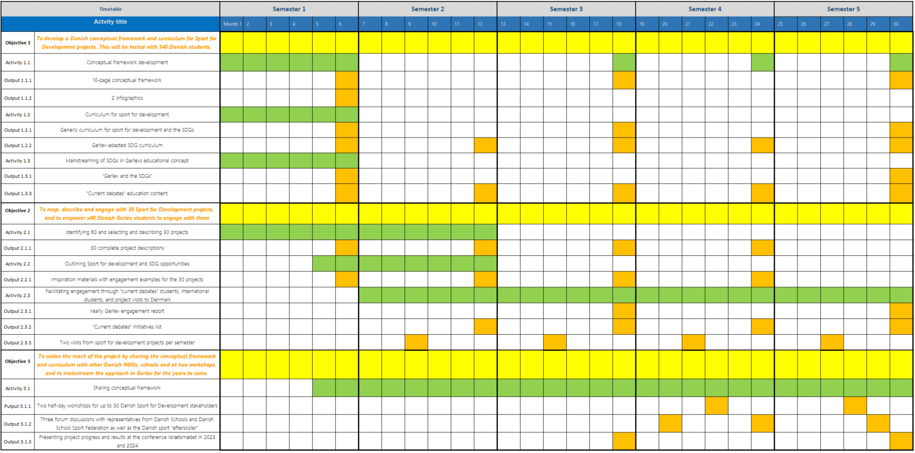

Please note that several outputs are intended to be updated every semester or yearly, to take project learnings into account. The GANNT chart has been included for illustration purposes, and can be forwarded upon request if a more reader-friendly version is needed.

Methods
Our overall methodology is building on the following elements
- Benefiting from Gerlev’s flow of young students that are enthusiastic about sport for all and international relations (the profile of the school they chose). Gerlev’s 4 month courses are a very intense learning period, and given the profile of the students, they are likely susceptible to the invitation to engage in the international cooperation development.
- Tapping into ISCAs strong international network to identify the most relevant 30 projects to engage with. ISCA will in particular draw upon its partner sportanddev.org for this purpose (ISCA has been chairing its Steering Board). ISCAs continuous network development will also allow the list of 30 to be constantly updated, and as needed, expanded.
- Gerlev has a unique opportunity to hear voices from developing countries through its continuous flow of international students, and to make them “ambassadors” for specific sport for development projects in their respective countries. This will enable a much more direct and hands-on learning experience for the Danish students, that will have chances to interact with the international ambassadors in exchanges that are based on the trust already built among them as peer students.
- We firmly believe that building a solid model and understanding of how sport for all and physical activity can contribute to the SDGs is a prerequisite for delivering quality engagement of Danish Gerlev students and other Danish citizens in international development work in this field. Drawing upon ISCAs expertise and prior knowledge, and establishing a concept and a curriculum will therefore allow our initiative to truly mainstream SDG orientation in Gerlev’s approach as a school, and therefore ensure sustained impact, also beyond project lifetime.
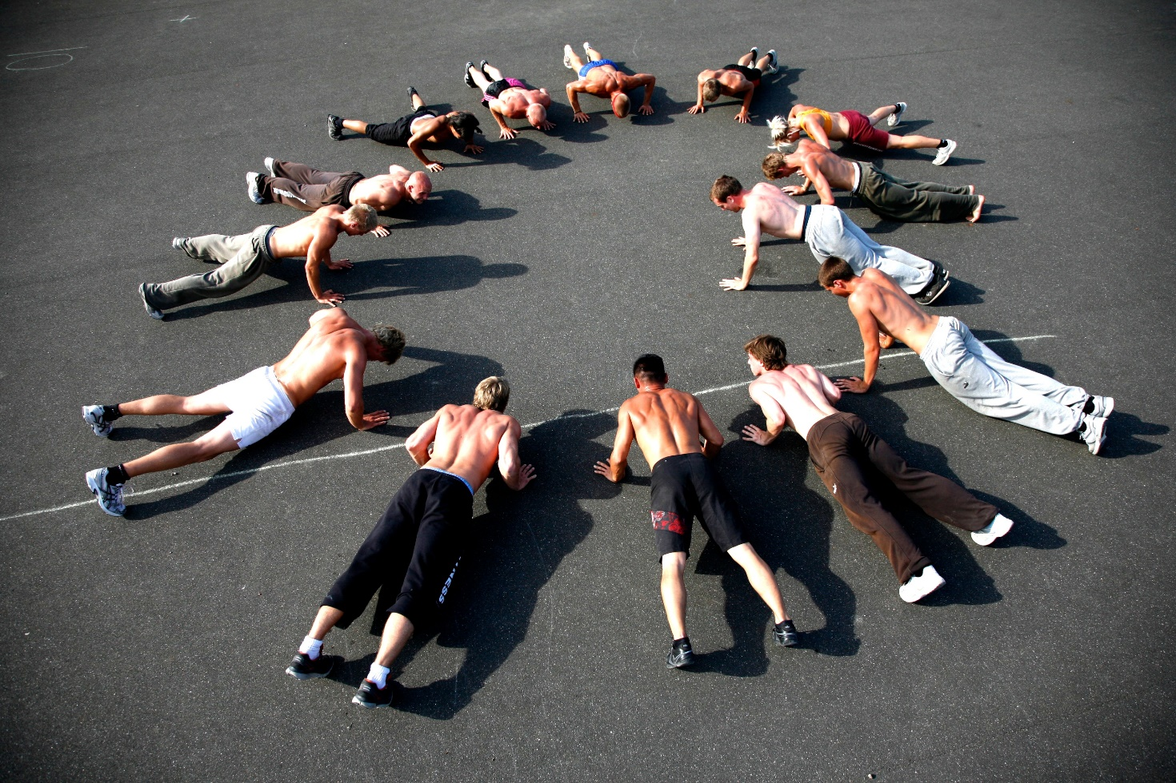
- We have designed a project that relates to sport, movement and physical activity, acknowledging that the covid-19 pandemic is a clear challenge for international travels at the moment. We mitigate this by only starting the first students’ engagement activities in the second half of 2022. We consider the need for the planned international physical meetings to be clear, but can manage with online meetings where necessary (even for the visits from the international sport for development projects)

Gerlev bringing youth from different cultures and backgrounds together for fun and engagement

The countries that our project relates to is at the outset Ghana, Brazil and North Macedonia. This is where partner projects as described have already been engaged in building the project, and where ISCA and Gerlev knows there is a quality partner with capacity to engage in the project, as well as good links to Denmark. The mapping of a total of 30 projects will of course expand this list of countries significantly. The engagement with the projects will differ depending on the interests of the Gerlev students (cf the engagement opportunities listed above), but we expect all of the 30 projects to be involved during the project lifetime, in a process closely coordinated by ISCA and Gerlev.

Ensuring a relevant and nuanced information flow from the involved projects is a particular priority, and ISCA will issue general guidelines for both the projects themselves and the international Gerlev students as project ambassadors, to ensure this. Likewise, the concept and curriculum that the project develops, will put emphasis on this point, ensuring a positive and constructive, yet critical and nuanced flow of information and viewpoints. We believe that the deeper understanding and a critical dialogue will have a key impact for the Danish Gerlev students and ensure their involvement and co-ownership of the projects and processes.

- Supplementary financing
There is no supplementary financing for the proposed initiative. However, ISCA and Gerlev are contributing with their unique international networks and expertise, and Gerlev is occasionally offering scholarships to young people from developing countries to attend the school and thus contribute to the programme.

